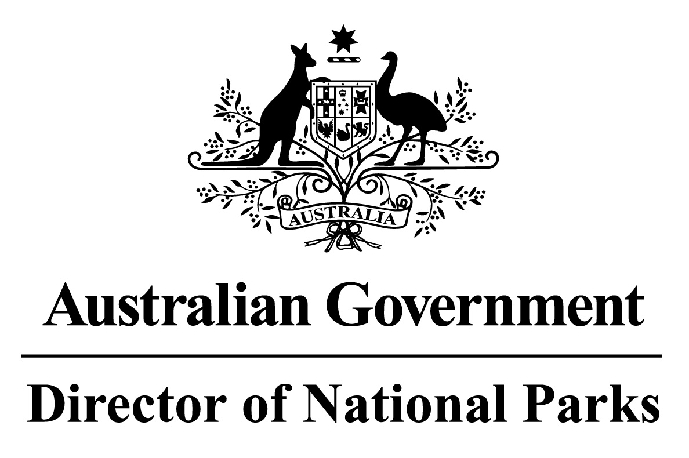

*Environment Protection and Biodiversity Conservation Regulations 2000*

Subregulation 12.56(2)

**DETERMINATION PROHIBITING ANCHORING OR MOORING OF VESSELS**

**COD GROUNDS MARINE PARK**

I, JASON MUNDY, Acting Director of National Parks, under subregulation 12.56(2) of the *Environment Protection and Biodiversity Conservation Regulations 2000*, HEREBY DETERMINE that the Cod Grounds Marine Park, being the area specified in the Schedule hereto and more or less shown on the map in the Schedule, is an area of water where anchoring or mooring of vessels is prohibited.

Note: This determination does not exclude anchoring or mooring in accordance with a permit issued by the Director of National Parks.

AND I HEREBY REVOKE

1. the determination made on 14 June 2017 prohibiting anchoring or mooring of vessels in Cod Grounds Marine Park (F2017N00041); and
2. the determination made on 14 December 2013 prohibiting use of commercial fishing vessels in part of the Cod Grounds Marine Park, notified in the Gazette (C2013G01932) and published on 19 December 2013.

Dated this 27 th day of June 2018

SIGNED

Jason Mundy

**SCHEDULE**

**COD GROUNDS MARINE PARK**

All of that area bounded by the line:

1. commencing at the point of latitude 31° 40′ 19″ S, longitude 152° 53′ 59″ E;
2. from there east along the parallel of latitude 31° 40′ 19″ S to its intersection by the meridian of longitude 152° 55′ 15″ E;
3. from there south along the meridian of longitude 152° 55′ 15″ E to the parallel of latitude 31° 41′ 25″ S;
4. from there west along the parallel of latitude 31° 41′ 25″ S to its intersection by the meridian of longitude 152° 53′ 59″ E; and
5. from there north along the meridian of longitude 152° 53′ 59″ E to the point of commencement.

**Note:** Geographic coordinates are expressed in terms of the Geocentric Datum of Australia 1994 (GDA94) as described in the Commonwealth of Australia Gazette GN35 of 6 September 1995.

