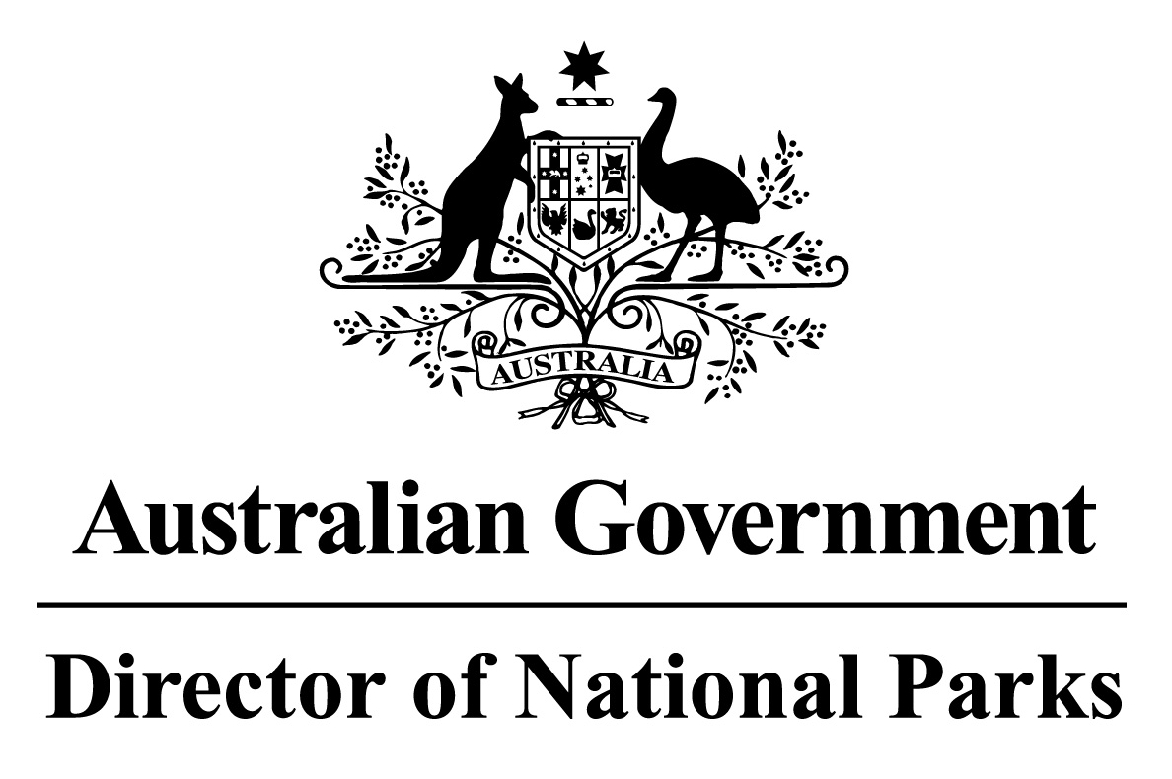

*Environment Protection and Biodiversity Conservation Regulations 2000*

Sub-regulation 12.34(3)

**DETERMINATION OF COMMERCIAL FISHING PRACTICES**

**NORTH NETWORK OF MARINE PARKS**

I, JASON MUNDY, Acting Director of National Parks, under sub-regulation 12.34(3) of the *Environment Protection and Biodiversity Conservation Regulations 2000* HEREBY DETERMINE that for each of the Marine Parks in the Network, being the marine parks listed in Schedule 1 hereto, the following practices in commercial fishing are to be followed:

1. vessels (other than vessels engaged in cage towing) transiting a zone within a Marine Park, that is assigned to IUCN category II (national park), as described in Schedule 2 hereto, must travel at a speed greater than 5 knots; and
2. fish may only be processed or transhipped in zones in which use of a gear type or fishing method for the taking of that fish is authorised by the *North Marine Parks Network Management Plan 2018* or the Class Approval issued by the Director of National Parks for commercial fishing in the Network; and
3. vessels transiting or stopping and anchoring in zones in which fishing, or use of fishing gear on board the vessel, is not authorised by the *North Marine Parks Network Management Plan 2018* or the Class Approval issued by the Director of National Parks for commercial fishing in the Network, must have the fishing gear stowed and secured at all times.

Note: Paragraphs (b) and (c) do not apply to commercial fishing practices conducted in accordance with an authorisation issued by the Director of National Parks.

In this determination:

**stowed and secured** means all fishing apparatus, including nets and lines, are rendered inoperative, including that the apparatus is inboard the vessel, and otherwise completely out of the water; and

**transiting** means the continuous and expeditious passage of a vessel through an area whereby the vessel does not stop for any reason other than in response to an emergency or to render assistance to persons, aircraft or vessels in danger or distress.

Dated this 27 th day of June 2018

SIGNED

Jason Mundy

**SCHEDULE 1**

**NORTH NETWORK OF MARINE PARKS**

Joseph Bonaparte Gulf Marine Park

Oceanic Shoals Marine Park

Arafura Marine Park

Arnhem Marine Park

Wessel Marine Park

Limmen Marine Park

Gulf of Carpentaria Marine Park

West Cape Marine Park

**SCHEDULE 2**

**IUCN II ZONES**

Each of the zones within Oceanic Shoals, Gulf of Carpentaria, and West Cape York Marine Parks that are assigned to IUCN category II (national park), being the areas shown in marine park maps in Schedule 2 and described in Schedule 4 to the *North Marine Parks Network Management Plan 2018*, as specified below:

|  |  |  |
| --- | --- | --- |
| **Marine Park** | **Zone Number/s** | **Clause describing the area boundary** |
| Oceanic Shoals Marine Park | 1 | 2.3 |
| Gulf of Carpentaria Marine Park | 1 | 7.3 |
| West Cape York Marine Park | 1, 4 | 8.3, 8.6 |