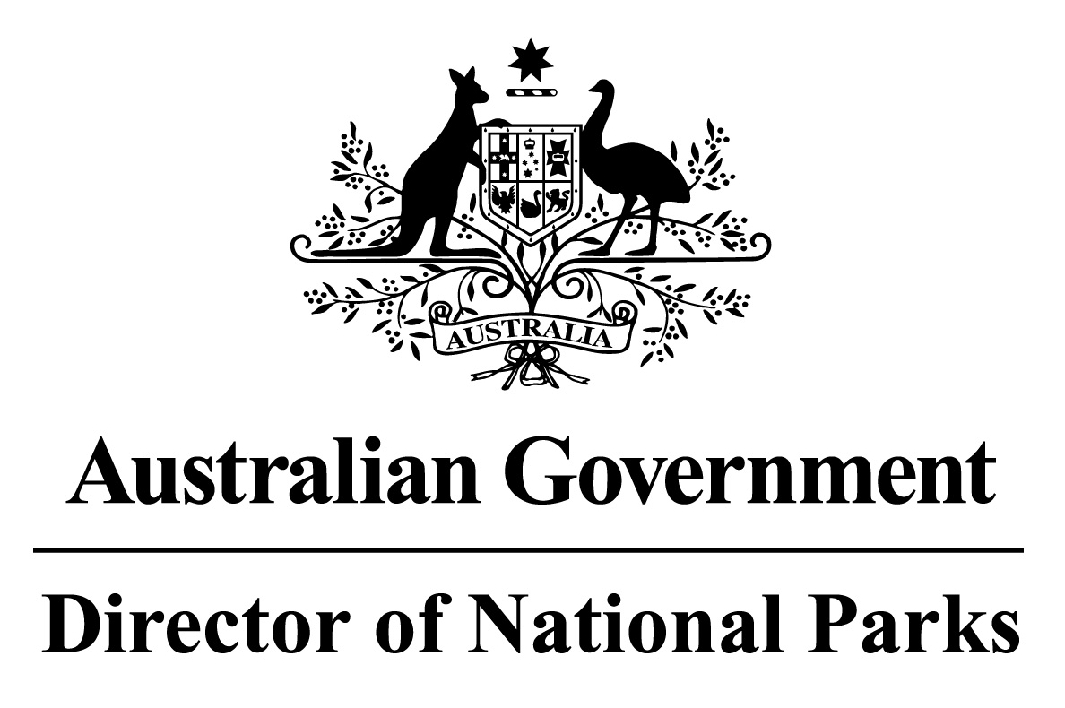

*Environment Protection and Biodiversity Conservation Regulations 2000*

Subregulation 12.56(2)

**DETERMINATION PROHIBITING ANCHORING OF COMMERCIAL SHIPPING VESSELS**

**NORTH NETWORK OF MARINE PARKS – PARKS AND PARK ZONES ASSIGNED TO IUCN CATEGORY II (NATIONAL PARK) OR IV (HABITAT PROTECTION)**

I, JASON MUNDY, Acting Director of National Parks, under subregulation 12.56(2) of the *Environment Protection and Biodiversity Conservation Regulations 2000,* HEREBY DETERMINE that each of:

1. Limmen Marine Park; and
2. each of the zones within Oceanic Shoals, Gulf of Carpentaria, and West Cape York Marine Parks that are assigned to IUCN category II (national park); and
3. each of the zones within Oceanic Shoals, Wessel, and West Cape York Marine Parks that are assigned to IUCN category IV (habitat protection),

being the areas shown in marine park maps in Schedule 2 and described in Schedule 4 to the *North Marine Parks Network Management Plan 2018*, as specified in the Schedule hereto, is an area of water where vessels engaged in commercial shipping cannot be anchored.

Note : This determination does not prevent anchoring in the areas described in the Schedule hereto due to circumstances of force majeure or distress or for the purposes of rendering assistance to persons, vessels or aircraft in danger or distress.

Dated this 27 th day of June 2018

SIGNED

Jason Mundy

**SCHEDULE**

**NORTH NETWORK OF MARINE PARKS - PARKS AND PARK ZONES ASSIGNED TO IUCN CATEGORY II (NATIONAL PARK) OR IV (HABITAT PROTECTION)**

List of relevant zone and clause numbers in Schedule 4 to the *North Marine Parks Network Management Plan 2018*:

|  |  |  |
| --- | --- | --- |
| **Marine Park** | **Zone Number/s** | **Clause describing the area boundary** |
| Oceanic Shoals Marine Park | 1, 2 | 2.3, 2.4 |
| Wessel Marine Park | 2 | 5.4 |
| Limmen Marine Park | Entire area of marine park | 6.1 |
| Gulf of Carpentaria Marine Park | 1 | 7.3 |
| West Cape York Marine Park | 1, 2, 4 | 8.3, 8.4, 8.6 |