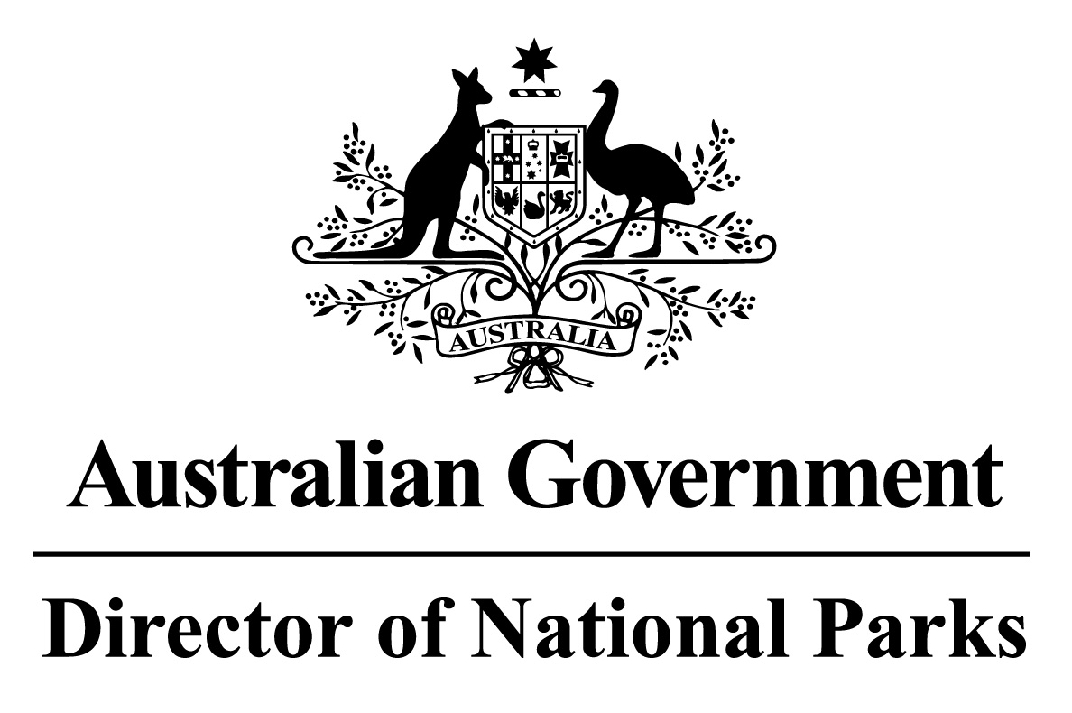

*Environment Protection and Biodiversity Conservation Regulations 2000*

Sub-regulation 12.34(3)

**DETERMINATION OF COMMERCIAL FISHING PRACTICES**

**CORAL SEA MARINE PARK**

I, JASON MUNDY, Acting Director of National Parks, under sub-regulation 12.34(3) of the *Environment Protection and Biodiversity Conservation Regulations 2000* HEREBY DETERMINE that in the Coral Sea Marine Park the following practices in commercial fishing are to be followed:

1. vessels (other than vessels engaged in cage towing) transiting a zone within the Marine Park that is assigned to IUCN category II (national park), as described in the Schedule hereto, must travel at a speed greater than 5 knots; and
2. fish may only be processed or transhipped in zones in which use of a gear type or fishing method for the taking of that fish is authorised by the *Coral Sea Marine Park Management Plan 2018* or the Class Approval issued by the Director of National Parks for commercial fishing in the Marine Park; and
3. vessels transiting or stopping and anchoring in zones in which fishing, or use of fishing gear on board the vessel, is not authorised by the *Coral Sea Marine Park Management Plan 2018* or the Class Approval issued by the Director of National Parks for commercial fishing in the Marine Park, must have the fishing gear stowed and secured at all times.

Note: Paragraphs (b) and (c) do not apply to commercial fishing practices conducted in accordance with an authorisation issued by the Director of National Parks.

In this determination:

**stowed and secured** means all fishing apparatus, including nets and lines, are rendered inoperative, including that the apparatus is inboard the vessel, and otherwise completely out of the water; and

**transiting** means the continuous and expeditious passage of a vessel through an area whereby the vessel does not stop for any reason other than in response to an emergency or to render assistance to persons, aircraft or vessels in danger or distress.

Dated this 27 th day of June 2018

SIGNED

Jason Mundy

**SCHEDULE**

**CORAL SEA MARINE PARK IUCN II ZONES**

The areas shown in maps in Schedule 2 and described in Schedule 4 to the *Coral Sea Marine Park Management Plan 2018*, as specified below:

|  |  |  |
| --- | --- | --- |
| **Marine Park** | **Zone Number** | **Clause describing the area boundary** |
| Coral Sea Marine Park | 2 | 1.4 |
|  | 3 | 1.5 |
|  | 5 | 1.7 |
|  | 11 | 1.13 |
|  | 12 | 1.14 |
|  | 13 | 1.15 |
|  | 14 | 1.16 |
|  | 16 | 1.18 |
|  | 19 | 1.21 |
|  | 25 | 1.27 |
|  | 27 | 1.29 |