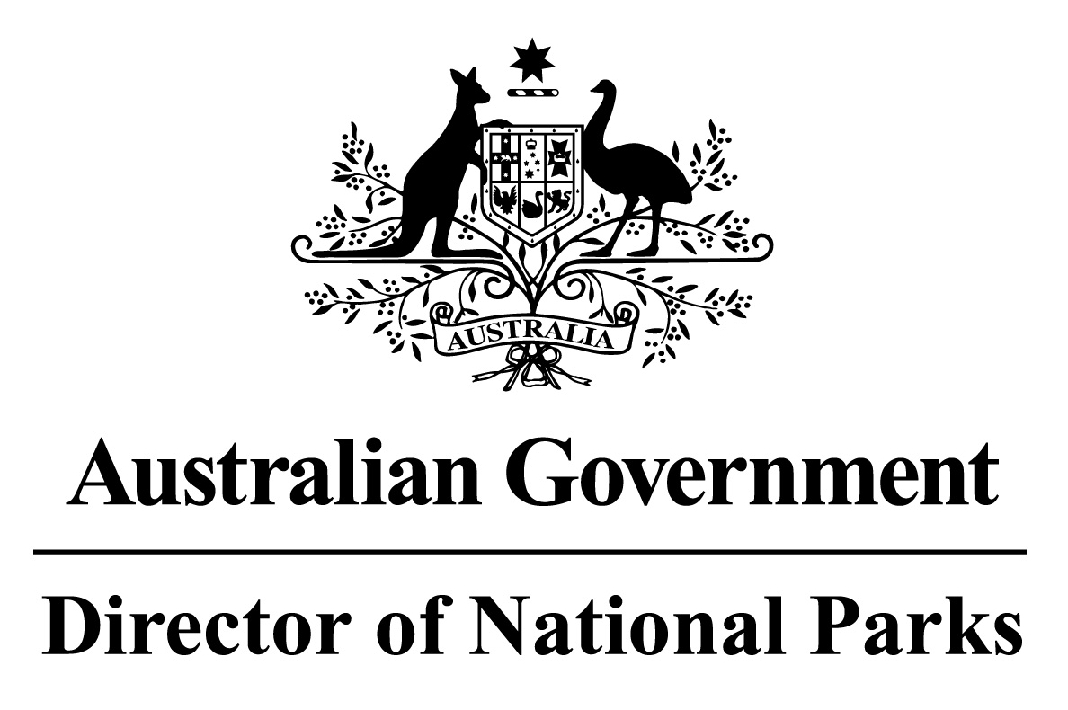

*Environment Protection and Biodiversity Conservation Regulations 2000*

Subregulation 12.56(2)

**DETERMINATION PROHIBITING ANCHORING OF COMMERCIAL SHIPPING VESSELS**

**TEMPERATE EAST NETWORK OF MARINE PARKS – PARKS AND PARK ZONES ASSIGNED TO IUCN CATEGORY II (NATIONAL PARK) OR IV (HABITAT PROTECTION AND RECREATIONAL USE)**

I, JASON MUNDY, Acting Director of National Parks, under subregulation 12.56(2) of the *Environment Protection and Biodiversity Conservation Regulations 2000,* HEREBY DETERMINE that each of:

1. Cod Grounds Marine Park;
2. the zones within Norfolk, Lord Howe, Central Eastern, and Solitary Islands Marine Parks that are assigned to IUCN category II (national park);
3. the zones within Gifford, Norfolk, Lord Howe, Central Eastern, Hunter, and Jervis Marine Parks that are assigned to IUCN category IV (habitat protection); and
4. the zone within Lord Howe Marine Park that is assigned to IUCN category IV (recreational use),

being the areas shown in marine park maps in Schedule 2 and described in Schedule 4 to the *Temperate East Marine Parks Network Management Plan 2018,* as specified in the Schedule hereto, is an area of water where vessels engaged in commercial shipping cannot be anchored.

Note : This determination does not prevent anchoring in the areas described in the Schedule hereto due to circumstances of force majeure or distress or for the purposes of rendering assistance to persons, vessels or aircraft in danger or distress.

Dated this 27 th day of June 2018

SIGNED

Jason Mundy

**SCHEDULE**

**TEMPERATE EAST NETWORK OF MARINE PARKS— PARKS AND ZONES ASSIGNED TO IUCN CATEGORY II (NATIONAL PARK) OR IV (HABITAT PROTECTION AND RECREATIONAL USE)**

List of relevant zone and clause numbers in Schedule 4 to the *Temperate East Marine Parks Network Management Plan 2018*:

|  |  |  |
| --- | --- | --- |
| **Marine Park** | **Zone Number/s** | **Clause describing the area boundary** |
| Gifford Marine Park | Entire area of marine park | 1.1 |
| Norfolk Marine Park | 1, 2 | 2.3, 2.4 |
| Lord Howe Marine Park | 2, 3, 4, 5, 6, 7 | 3.4, 3.5, 3.6, 3.7, 3.8, 3.9 |
| Central Eastern Marine Park | 1, 3 | 4.3, 4.5 |
| Solitary Islands Marine Park | 2 | 5.4 |
| Cod Grounds Marine Park | Entire area of marine park | 6.1 |
| Hunter Marine Park | 2 | 7.4 |
| Jervis Marine Park | 2 | 8.4 |