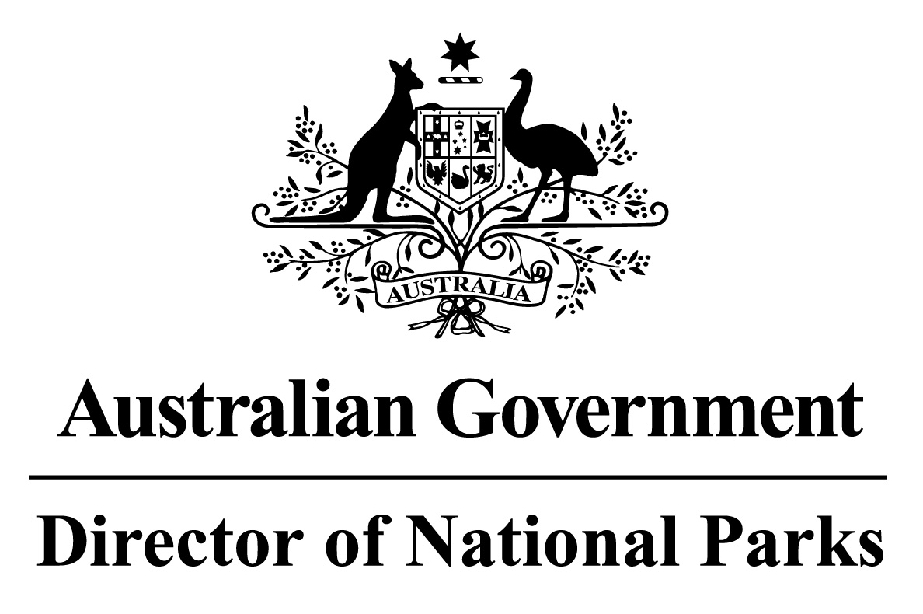

*Environment Protection and Biodiversity Conservation Regulations 2000*

Subregulation 12.14B(1)

**DETERMINATION OF AREAS FOR THE DISPOSAL OF INDUSTRIAL WASTE - VESSELS**

**NORTH-WEST NETWORK OF MARINE PARKS  
– PARKS AND PARK ZONES ASSIGNED TO IUCN CATEGORY IV AND VI**

I, JASON MUNDY, Acting Director of National Parks, under subregulation 12.14B(1) of the *Environment Protection and Biodiversity Conservation Regulations 2000,* HEREBY DETERMINE that the area of each Marine Park, or zone within a Marine Park, comprised in the North-west Network of Marine Parks and that is assigned to the IUCN Category IV or VI, being the areas shown in marine park maps in Schedule 2 and described in Schedule 4 to the *Temperate East Marine Parks Network Management Plan 2018*, as specified in the Schedule hereto, is an area that may be used for the disposal of industrial waste that is a vessel provided that disposal is in accordance with a permit issued under the *Environment Protection (Sea Dumping) Act 1981*.

Dated this 27 th day of June 2018

SIGNED

Jason Mundy

**SCHEDULE**

**NORTH-WEST NETWORK OF MARINE PARKS - PARK AND PARK ZONE VESSEL DISPOSAL AREAS**

List of relevant zone and clause numbers in Schedule 4 to the *North-west Marine Parks Network Management Plan 2018*:

|  |  |  |
| --- | --- | --- |
| **Marine Park** | **Zone Number/s** | **Clause describing the area boundary** |
| Shark Bay Marine Park | Entire area of marine park | 1.1 |
| Carnarvon Canyon Marine Park | Entire area of marine park | 2.1 |
| Ningaloo Marine Park | 1, 3 | 3.3, 3.5 |
| Gascoyne Marine Park | 2, 3, 4 | 4.4, 4.5, 4.6, |
| Montebello Marine Park | Entire area of marine park | 5.1 |
| Dampier Marine Park | 2, 3 | 6.4, 6.5 |
| Eighty Mile Beach Marine Park | Entire area of marine park | 7.1 |
| Roebuck Marine Park | Entire area of marine park | 8.1 |
| Argo-Rowley Terrace Marine Park | 2, 3, 4 | 10.4, 10.5, 10.6 |
| Kimberley Marine Park | 1, 3, 4 | 11.3, 11.5, 11.6 |
| Ashmore Reef Marine Park | 2 | 12.4 |