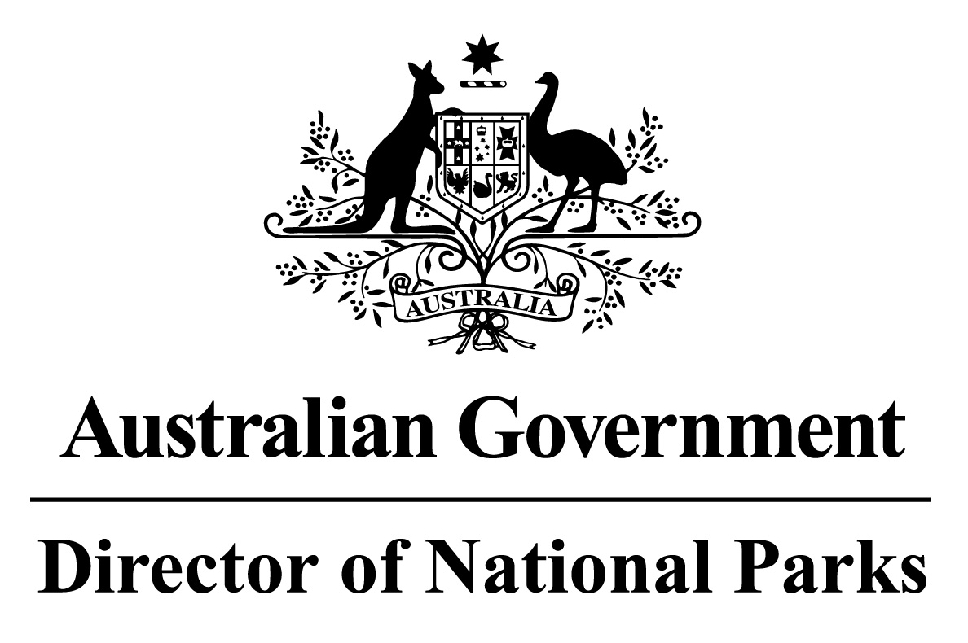

*Environment Protection and Biodiversity Conservation Regulations 2000*

Subregulation 12.32(3)

**DETERMINATION OF BURIAL AREAS**

**SOUTH-WEST NETWORK OF MARINE PARKS  
– PARKS AND PARK ZONES EXCLUDING SPECIAL PURPOSE ZONE (TRAWL)**

I, ANDREW READ, Acting Assistant Secretary, Marine Protected Areas Branch, Parks Australia Division, Department of Environment and Energy, delegate of the power of the Director of National Parks, under subregulation 12.32(3) of the *Environment Protection and Biodiversity Conservation Regulations 2000,* HEREBY DETERMINE that the area of each Marine Park comprised in the South-west Network of Marine Parks, excluding the area of the Special Purpose Zone Trawl in Western Eyre Marine Park, being the areas shown in marine park maps in Schedule 2 and described in Schedule 4 to the *South-west Marine Parks Network Management Plan* 2018, as specified in the Schedule hereto, is a burial area.

Note: Sea burials are subject to the *Environment Protection (Sea Dumping) Act 1981* and must be conducted in accordance with a permit under that Act.

Dated this 17 th day of July 2018

SIGNED

Andrew Read

**SCHEDULE**

**SOUTH-WEST NETWORK OF MARINE PARKS - PARK AND PARK ZONE BURIAL AREAS**

List of relevant zone and clause numbers in Schedule 4 to the *South-west Marine Parks Network Management Plan 2018*:

|  |  |  |
| --- | --- | --- |
| **Marine Park** | **Zone Number/s** | **Clause describing the area boundary** |
| Southern Kangaroo Island | Entire area of marine park | 1.1 |
| Western Kangaroo Island Marine Park | Entire area of marine park | 2.1 |
| Western Eyre Marine Park | 1, 3, 4, 5, 6 | 3.3, 3.5, 3.6, 3.7, 3.8 |
| Murat Marine Park | Entire area of marine park | 4.1 |
| Great Australian Bight Marine Park | Entire area of marine park | 5.1 |
| Twilight Marine Park | Entire area of marine park | 6.1 |
| Eastern Recherche Marine Park | Entire area of marine park | 7.1 |
| South-west Corner Marine Park | Entire area of marine park | 8.1 |
| Bremer Marine Park | Entire area of marine park | 9.3 |
| Geographe Marine Park | Entire area of marine park | 10.1 |
| Perth Canyon Marine Park | Entire area of marine park | 11.1 |
| Two Rocks Marine Park | Entire area of marine park | 12.1 |
| Jurien Marine Park | Entire area of marine park | 13.1 |
| Abrolhos Marine Park | Entire area of marine park | 14.1 |