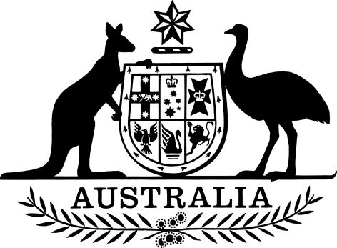

National Redress Scheme for Institutional Child Sexual Abuse Amendment (2018 Measures No. 2) Declaration 2018
I, Paul Fletcher, Minister for Families and Social Services, make the following declaration.
Dated 7 October 2018
Paul Fletcher
Minister for Families and Social Services

Contents
1 Name 1
2 Commencement 1
3 Authority 1
4 Schedules 1
Schedule 1—Amendments 2
National Redress Scheme for Institutional Child Sexual Abuse Declaration 2018 2

1 Name
This instrument is the National Redress Scheme for Institutional Child Sexual Abuse Amendment (2018 Measures No. 2) Declaration 2018.

2 Commencement
(1) Each provision of this instrument specified in column 1 of the table commences, or is taken to have commenced, in accordance with column 2 of the table. Any other statement in column 2 has effect according to its terms.

Commencement information
Column 1 | Column 2 | Column 3
Provisions | Commencement | Date/Details
1. The whole of this instrument | The day after this instrument is registered.
Note: This table relates only to the provisions of this instrument as originally made. It will not be amended to deal with any later amendments of this instrument.
(2) Any information in column 3 of the table is not part of this instrument. Information may be inserted in this column, or information in it may be edited, in any published version of this instrument.

3 Authority
This instrument is made under the National Redress Scheme for Institutional Child Sexual Abuse Act 2018.

4 Schedules
Each instrument that is specified in a Schedule to this instrument is amended or repealed as set out in the applicable items in the Schedule concerned, and any other item in a Schedule to this instrument has effect according to its terms.

Schedule 1—Amendments

National Redress Scheme for Institutional Child Sexual Abuse Declaration 2018
1 After paragraph 9(ep)
Repeal paragraph 9(ew), substitute:

(ew) United Protestant Association of NSW Limited;
(ex) The Salvation Army (Victoria) Property Trust, established as a body corporate by the Salvation Army (Victoria) Property Trust Act 1930 (Vic);
(ey) The Salvation Army (Northern Territory) Property Trust, established as a body corporate by the Salvation Army (Northern Territory) Property Trust Act (NT);
(ez) The Salvation Army (Tasmania) Property Trust, established as a body corporate by the Salvation Army (Tasmania) Property Trust Act 1930 (Tas);
(fa) The Salvation Army (Western Australia) Property Trust, established as a body corporate by the Salvation Army (Western Australia) Property Trust Act 1931 (WA);
(fb) The Salvation Army (Queensland) Property Trust, established as a body corporate by the Salvation Army (Queensland) Property Trust Act 1930 (Qld);
(fc) The Salvation Army (New South Wales) Property Trust, established as a body corporate by the Salvation Army (New South Wales) Property Trust Act 1929 (NSW);
(fd) The Salvation Army (South Australia) Property Trust, established as a body corporate by the Salvation Army (South Australia) Property Trust Act 1931 (SA).
3 Section 15 (table)
Following item 1 add:

2 | All Salvation Army Property Trust institutions as at Part 2, paragraphs 9(ex) -(fd) | The Salvation Army (Australia) Redress Limited

