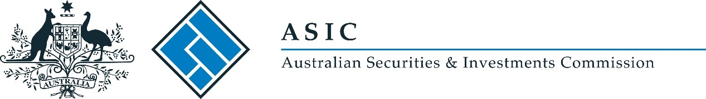
ASIC Market Integrity Rules (NSXA Market) Repeal Instrument 2018/1157
I, Calissa Aldridge, delegate of the Australian Securities and Investments Commission, make the following legislative instrument.

Date 7 January 2019

Calissa Aldridge

Contents
Part 1—Preliminary 3
1 Name of legislative instrument 3
2 Commencement 3
3 Authority 3
4 Schedule 3
Schedule 1—Repeal 4
ASIC Market Integrity Rules (NSXA Market) 2010 4

Part 1—Preliminary

1 Name of legislative instrument
This is the ASIC Market Integrity Rules (NSXA Market) Repeal Instrument 2018/1157.

2 Commencement
This instrument commences on the day this instrument is registered on the Federal Register of Legislation.
Note: The register may be accessed at www.legislation.gov.au.

3 Authority
This instrument is made under subsection 798G(1) of the Corporations Act 2001.

4 Schedule
Each instrument that is specified in Schedule 1 to this instrument is repealed as set out in the applicable items in the Schedule.

Schedule 1—Repeal

ASIC Market Integrity Rules (NSXA Market) 2010
1 The whole of the instrument
Repeal the instrument.

