

Control of Naval Waters (Henderson and Osborne) Proclamation 2019

I, General the Honourable Sir Peter Cosgrove AK MC (Ret’d), Governor‑General of the Commonwealth of Australia, acting with the advice of the Federal Executive Council, make the following Proclamation.

Signed and Sealed with the

Great Seal of Australia on

7 February 2019

Peter Cosgrove

Governor‑General

By His Excellency’s Command

Christopher Pyne

Minister for Defence

Contents

1 Name 1

2 Commencement 1

3 Authority 1

4 Definitions 1

5 Declaration of naval waters—Henderson 1

6 Declaration of naval waters—Osborne 3

1 Name

This instrument is the *Control of Naval Waters (Henderson and Osborne) Proclamation 2019*.

2 Commencement

(1) Each provision of this instrument specified in column 1 of the table commences, or is taken to have commenced, in accordance with column 2 of the table. Any other statement in column 2 has effect according to its terms.

| Commencement information | | |
| --- | --- | --- |
| Column 1 | Column 2 | Column 3 |
| Provisions | Commencement | Date/Details |
| 1. The whole of this instrument | The day after this instrument is registered. | 9 February 2019 |

Note: This table relates only to the provisions of this instrument as originally made. It will not be amended to deal with any later amendments of this instrument.

(2) Any information in column 3 of the table is not part of this instrument. Information may be inserted in this column, or information in it may be edited, in any published version of this instrument.

3 Authority

This instrument is made under section 3B of the *Control of Naval Waters Act 1918.*

4 Definitions

In this instrument:

***Act*** means the *Control of Naval Waters Act 1918*.

***Mean Higher High Water*** has the same meaning as in the Australian Hydrographic Office Tidal Glossary, as existing at the time this instrument commences.

Note: In 2019, the text of the Australian Hydrographic Office Tidal Glossary could be viewed on the Australian Hydrographic Office’s website (http://www.hydro.gov.au).

5 Declaration of naval waters—Henderson

It is declared that the waters specified in column 2 of the following table, and further explained in the map titled “Henderson Australian Marine Complex”, that are within the distance specified in paragraph 3B(1)(a) of the Act from the installation, being the shipbuilding facilities at Australian Marine Complex Henderson, Western Australia, are naval waters for the purposes of the Act.

| Item | Column 1  Installation | Column 2  Waters  Referenced to the World Geodetic System (WGS 84) For the purpose of this description the term high water line (HWL) means the Mean Higher High Water |
| --- | --- | --- |
| 1 | Australian Marine Complex shipbuilding facilities at Henderson, Western Australia | All those waters within an area commencing at a point on the HWL nearest to Point 1.  Point 1—32°09′02.52″S, 115°45′41.76″E  Point 2—32°09′03.90″S, 115°45′36.60″E  Then generally south along the HWL to a point on the HWL nearest to Point 3.  Point 3—32°09′43.02″S, 115°45′37.38″E  Point 4—32°10′05.95″S, 115°45′45.52″E  Then to a point on the HWL nearest to Point 5.  Point 5—32°10′01.61″S, 115°46′02.42″E  Then generally north along the HWL to a point on the HWL nearest to Point 1. |

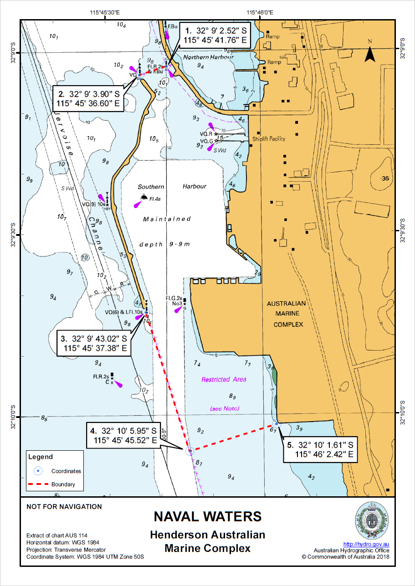

6 Declaration of naval waters—Osborne

It is declared that the waters specified in column 2 of the following table, and further explained in the map titled “Osborne Techport Common User Facility”, that are within the distance specified in paragraph 3B(1)(a) of the Act from the installation, being the Techport Common User Facility shipbuilding facilities at Osborne, South Australia, are naval waters for the purposes of the Act.

| Item | Column 1  Installation | Column 2  Waters  Referenced to the World Geodetic System (WGS 84) For the purpose of this description the term high water line (HWL) means the Mean Higher High Water |
| --- | --- | --- |
| 1 | Techport Common User Facility shipbuilding facilities at Osborne, South Australia | All those waters within an area commencing at a point on the HWL nearest to Point 1.  Point 1—34°46′52.08″S, 138°30′47.81″E  Point 2—34°46′52.96″S, 138°30′53.18″E  Point 3—34°47′29.23″S, 138°30′44.39″E  Then to a point on the HWL nearest to Point 4.  Point 4—34°47′28.14″S, 138°30′38.48″E  Then generally north along the HWL to a point on the HWL nearest to Point 1. |

