

**Food Standards (Application A1161 –** **Potassium polyaspartate as a Food Additive) Variation**

The Board of Food Standards Australia New Zealand gives notice of the making of this variation under section 92 of the *Food Standards Australia New Zealand Act 1991*. The variation commences on the date specified in clause 3 of the variation.

Dated 20 February 2019

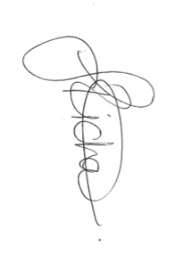

Joanna Richards

Standards Management Officer

Delegate of the Board of Food Standards Australia New Zealand

**Note:**

This variation will be published in the Commonwealth of Australia Gazette No. FSC 125 on 27 February 2019. This means that this date is the gazettal date for the purposes of the above notice.

**1 Name**

This instrument is the *Food Standards (Application A1161 – Potassium polyaspartate as a Food Additive) Variation*.

**2 Variation to Standards in the *Australia New Zealand Food Standards Code***

The Schedule varies standards in the *Australia New Zealand Food Standards Code*.

**3 Commencement**

The variation commences on the date of gazettal.

**Schedule**

**[1] Standard 4.5.1** is varied by

[1.1] inserting in the table to clause 3, in alphabetical order

|  |
| --- |
| Potassium polyaspartate |

[1.2] omitting paragraph 5(5)(h), substituting

(h) 200 mg/L of added dimethyl dicarbonate; and

(i) 100 mg/L of potassium polyaspartate.

**[2] Schedule 8** is varied by

[2.1] inserting in the table to section S8—2 entitled ‘Food additive names—alphabetical listing’, in alphabetical order

|  |  |
| --- | --- |
| Potassium polyaspartate | 456 |

[2.2] inserting in the table to section S8—2 entitled ‘Food additive names—numerical listing’, in numerical order

|  |  |
| --- | --- |
| 456 | Potassium polyaspartate |

**[3] Schedule 15** is varied by inserting in item 14.2.2 of the table to section S15—5, in numerical order

|  |  |  |  |
| --- | --- | --- | --- |
| 456 | Potassium polyaspartate | 100 |  |