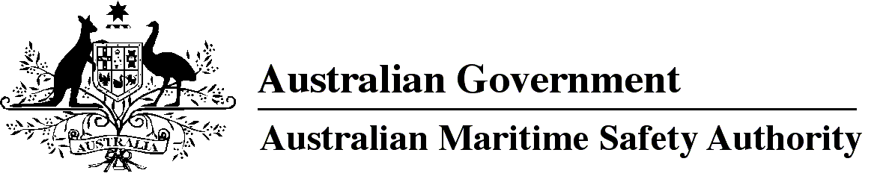

Australian Maritime Safety Authority Fees Amendment Determination 2019

I, Michael Kinley, Chief Executive Officer of the Australian Maritime Safety Authority, make this determination under subsection 47(1) of the *Australian Maritime Safety Authority Act 1990*.

21 March 2019

Michael Kinley  
Chief Executive Officer

1 Name of Determination

This Determination is *Australian Maritime Safety Authority Fees Amendment Determination 2019*.

2 Commencement

This Determination commences on 1 April 2019.

3 Amendment of *Australian Maritime Safety Authority Fees Determination 2015*

Schedule 1 amends *Australian Maritime Safety Authority Fees Determination 2015*.

Schedule 1 Amendment

[1] Schedule 1, after table item 12.1

insert

|  |  |  |
| --- | --- | --- |
| 12.2 | Any service for which AMSA bears a direct expense | the amount of the expense |

**Note**

1. All legislative instruments and compilations of legislative instruments are registered on the Federal Register of Legislation under the *Legislation Act 2003.* See https://www.legislation.gov.au.