Greenhouse and Energy Minimum Standards (Air Conditioners up to 65kW) Determination 2019
I, Angus Taylor, Minister for Energy, make the following determination.
Dated 25 March 2019

Angus Taylor
Minister for Energy

Contents
Part 1—Preliminary 2
1 Name 2
2 Commencement, revocation and replacement 2
3 Authority 2
4 Definitions—standards referred to in this Determination 2
5 Definitions—other expressions used in this Determination 4
6 Meaning of fixed, two-stage, multi-stage and variable capacity 11
7 Temperature conditions—H1, H2, H3 and T1 12
8 Total cooling capacity and related terms 12
9 Heating capacity and related terms 13
10 Meaning of rated and tested 14
11 Applicable definitions and applicable versions of standards and documents incorporated into standards 15
12 Families of models 15
13 Product category 16
14 Registrations affected by this Determination 16
Part 2—Products covered by Determination 17
15 Purpose of Part 17
16 Classes of products that are covered by this Determination 17
17 Classes of products that are not covered by this Determination 17
Part 3—GEMS level requirements 19
Division 1—Preliminary 19
18 Purpose of Part 19
19 Meaning of relevant MEPS level 19
20 Meaning of ACOP, AEER, COP and EER 19
Division 2—GEMS level requirements (MEPS levels) 20
21 GEMS level requirements (MEPS levels) for product classes 2, 3 and 4 20
22 GEMS level requirements (MEPS levels) for other product classes—products without variable capacity 20
23 GEMS level requirements (MEPS levels) for other product classes—products with variable capacity 21
24 Testing requirements 22
Part 4—GEMS labelling requirements 23
Division 1—Preliminary 23
25 Purpose of Part 23
26 Interpretation 23
Division 2—Requirements relating to energy labels 23
Subdivision 1—When energy labels are and are not required or permitted 23
27 Prohibition on energy labels 23
28 When energy labels are required or permitted 24
29 Manner of communication of energy rating labels 24
Subdivision 2—Calculation of amounts for energy rating label and energy rating icon 25
30 Calculating Cooling Season Total Energy Consumption and Heating Season Total Energy Consumption 25
31 Calculating the star rating 26
Division 3—Other GEMS labelling requirements 27
32 Application of Division 27
33 Meaning of SEER rating 27
34 Advertising material—references to SEER ratings 27
Division 4—Testing requirements 28
35 Testing requirements 28
Division 5—Labelling requirements if this Determination is revoked 28
36 Impact of replacement determination 28
Division 6—Transitional GEMS labelling requirements 28
37 Purpose of Division 28
38 Transitional GEMS labelling requirements—product classes other than product classes 3 or 4 28
Part 5—Other requirements 30
39 Purpose of Part 30
40 Product performance—average true power factor 30
41 Amounts to be determined before applying for registration 30
42 Testing requirements 31
Schedule 1—Product classes and minimum energy performance standards 32
Schedule 2—Testing requirements 34
1 Conducting tests 34
2 General 34
3 Test simulation software 34
4 Use of calorimeter and air enthalpy test methods 36
5 Use of default test values in AS/NZS 3823.4.1:2014 37
6 Rating variable capacity products as fixed capacity products 38
7 Degradation coefficient of AS/NZS 3823.4 38
8 Seasonal rating tests 38
9 Noise (sound power) testing 39
10 Specific requirements for multi-split outdoor units 39
11 Alternative test methods for VRF type multi-split outdoor units and products > 30kW 40
12 Specific requirements for unitary double duct air conditioners 41
13 Specific requirements for portable unitary single duct unit air conditioners 42
14 Specific requirements for water-to-air air conditioners 42
15 Specific requirements for single-split outdoor units 42
16 Specific requirements for testing for average true power factor 43
Schedule 3—Format of energy rating label 44
1 Interpretation 44
2 Meaning of certain details in the diagrams 44
3 Default elements of the energy rating label 44
4 Content of elements b and c (cooling capacity strip and heating capacity strip) 45
5 Content of element d (star rating statement) 48
6 Content of elements e, f and g (hot, average and cold area Cooling Season Total Energy Consumption and Heating Season Total Energy Consumption figures) 48
7 Content of elements h, i and j (hot, average and cold area star ratings) 49
8 Content of element k (noise statement) 50
9 Content of element m (model details) 51
10 Colours and fonts for the energy rating label 52
11 Object requirements for the energy rating label—diagram 55
12 Physical layout requirements for the label 56
Schedule 4—Format of energy rating icon 59
1 Interpretation 59
2 Meaning of certain details in the diagrams 59
3 Elements of the energy rating icon 59
4 Colours for the energy rating icon 59
5 Fonts for the energy rating icon 60
6 Size of the energy rating icon 60
7 Content of energy rating icon 60
Schedule 5—Star ratings 62
1 Star ratings 62
Schedule 6—Commercial-based temperature bins 63
1 Commercial-based temperature bins 63
2 Values of t₀ and t₁₀₀ 66

COPYRIGHT

© 2019 Commonwealth of Australia

This Determination includes material from Australian Standards and/or Australian/New Zealand Standards, which are copyright Standards Australia Ltd. Apart from uses permitted under the Copyright Act 1968, Standards Australia Ltd material may not be reproduced without permission or licence.

With the exception of the Commonwealth Coat of Arms, any trade marks owned by the Commonwealth (including the energy rating labels and the energy rating icons) and any material the subject of third party intellectual property rights, this Determination is licensed under the Creative Commons Attribution-Non-Commercial-ShareAlike 4.0 International Licence. To view a copy of this licence, visit https://creativecommons.org/licenses/by-nc-sa/4.0/.

You are free to copy and communicate this Determination (apart from the excluded material indicated above) so long as you do so for non-commercial purposes, attribute the Commonwealth of Australia, and license any derivative works under the same licence as the original (indicating any modifications), in accordance with CC BY-NC-SA. For clarity, you are permitted to use this Determination in the above manner to comply with your obligations under it.

Complete Australian/New Zealand Standards are available for purchase from Standards Australia Ltd. Requests and inquiries concerning other reproduction and rights pertaining to standards should be directed to Standards Australia Ltd via the contact details set out at https://www.standards.org.au/contact.

Part 1—Preliminary

1 Name
This instrument is the Greenhouse and Energy Minimum Standards (Air Conditioners up to 65kW) Determination 2019.

2 Commencement, revocation and replacement
This Determination:
(a) commences and comes into force on 1 April 2020; and
(b) revokes the Greenhouse and Energy Minimum Standards (Air Conditioners and Heat Pumps) Determination 2013; and
(c) replaces that Determination.
Note: The form of this section reflects the requirements of sections 34 and 35 of the Greenhouse and Energy Minimum Standards Act 2012, which deal with how a GEMS determination enters into force and how it replaces an earlier one. Subsection 35(2) of the Greenhouse and Energy Minimum Standards Act 2012 provides that, when a GEMS determination is revoked and replaced, the revoked determination ceases to be in force immediately before the replacement determination comes into force.

3 Authority
This Determination is made under sections 23 and 35 of the Greenhouse and Energy Minimum Standards Act 2012.

4 Definitions—standards referred to in this Determination
Note: Subsection 11(2) provides that the applicable version of each standard referred to in this section is the version that existed at the date this Determination was made.
In this Determination:
AHRI 1230:2010 means Air-Conditioning, Heating, & Refrigeration Institute Standard 1230 Performance Rating of Variable Refrigerant Flow (VRF) Multi-Split Air-Conditioning and Heat Pump Equipment.
Note 1: AHRI 1230:2010 is available from www.ahrinet.org.
Note 2: AHRI 1230:2010 includes all amendments and changes through Addendum 2, June 2014.
AS/NZS 3823.1.1:2012 means Australian/New Zealand Standard 3823.1.1:2012 Performance of electrical appliances – air conditioners and heat pumps – Part 1.1: Non-ducted air conditioners and heat pumps – Testing and rating for performance (ISO 5151:2010, MOD).
Note: AS/NZS 3823.1.1:2012 is available from Standards Australia Limited.
AS/NZS 3823.1.2:2012 means Australian/New Zealand Standard 3823.1.2:2012 Performance of electrical appliances – air conditioners and heat pumps – Part 1.2: Ducted air conditioners and air-to-air heat pumps—Testing and rating for performance (ISO 13253:2011, MOD).
Note: AS/NZS 3823.1.2:2012 is available from Standards Australia Limited.
AS/NZS 3823.1.3:2005 means Australian/New Zealand Standard 3823.1.3:2005 Performance of electrical appliances – air conditioners and heat pumps. Part 1.3: Water-source heat pumps—Water-to-air and brine-to-air heat pumps—Testing and rating of performance (ISO 13256-1, Ed. 01 (1998) MOD).
Note 1: AS/NZS 3823.1.3:2005 is available from Standards Australia Limited.
Note 2: AS/NZS 3823.1.3:2005 includes all amendments up to and including AS/NZS 3823.1.3:2005/Amdt 1 made on 22 September 2011.
AS/NZS 3823.1.4:2012 means Australian/New Zealand Standard 3823.1.4:2012 Performance of electrical appliances – Air conditioners and heat pumps. Part 1.4: Multiple split-system air conditioners and air-to-air heat pumps–Testing and rating for performance (ISO 15042:2011, MOD).
Note: AS/NZS 3823.1.4:2012 is available from Standards Australia Limited.
AS/NZS 3823.1.5:2015 means Australian/New Zealand Standard 3823.1.5:2015 Performance of electrical appliances – Air conditioners and heat pumps. Part 1.5: Non-ducted portable air-cooled air conditioners and air-to-air heat pumps having a single exhaust duct – Testing and rating for performance.
Note: AS/NZS 3823.1.5:2015 is available from Standards Australia Limited.
AS/NZS 3823.4.1:2014 means Australian/New Zealand Standard 3823.4.1:2014 Performance of electrical appliances – Air conditioners and heat pumps. Part 4.1: Air-cooled air conditioners and air-to-air heat pumps–Testing and calculating methods for seasonal performance factors – Cooling seasonal performance factor (ISO 16358-1:2013, (MOD)).
Note 1: AS/NZS 3823.4.1:2014 is available from Standards Australia Limited.
Note 2: AS/NZS 3823.4.1:2014 includes all amendments up to and including AS/NZS 3823.4.1:2014/Amdt 1 made on 8 May 2017.
AS/NZS 3823.4.2:2014 means Australian/New Zealand Standard 3823.4.2:2014 Performance of electrical appliances – Air conditioners and heat pumps. Part 4.2: Air-cooled air conditioners and air-to-air heat pumps–Testing and calculating methods for seasonal performance factors – Heating seasonal performance factor (ISO 16358-2:2013, (MOD)).
Note 1: AS/NZS 3823.4.2:2014 is available from Standards Australia Limited.
Note 2: AS/NZS 3823.4.2:2014 includes all amendments up to and including AS/NZS 3823.4.2:2014/Amdt 1 made on 8 May 2017.
EN 12102:2013 means European Standard 12102:2013 Air conditioners, liquid chilling packages, heat pumps and dehumidifiers with electrically driven compressors for space heating and cooling. Measurement of airborne noise. Determination of the sound power level.
Note: EN 12102:2013 is available from the European Committee for Standardization.
EN 12102-1:2017 means European Standard 12102-1:2017 Air conditioners, liquid chilling packages, heat pumps, process chillers and dehumidifiers with electrically driven compressors - Determination of the sound power level - Part 1: Air conditioners, liquid chilling packages, heat pumps for space heating and cooling, dehumidifiers and process chillers.
Note: EN 12102-1:2017 is available from the European Committee for Standardization.
EN 14511:2018 means European Standard 14511:2018 Air conditioners, liquid chilling packages and heat pumps for space heating and cooling and process chillers, with electrically driven compressors.
Note: EN 14511:2018 is available from the European Committee for Standardization.
ISO 5151:2017 means International Organization for Standardization Standard 5151:2017 Non-ducted air conditioners and heat pumps - Testing and rating for performance.
Note: ISO 5151:2017 is available from the International Organization for Standardization.
ISO 13253:2017 means International Organization for Standardization Standard 13253:2017 Ducted air conditioners and air-to-air heat pumps - Testing and rating for performance.
Note: ISO 13253:2017 is available from the International Organization for Standardization.
ISO 15042:2017 means International Organization for Standardization Standard 15042:2017 Multiple split-system air-conditioners and air-to-air heat pumps - Testing and rating for performance.
Note: ISO 15042:2017 is available from the International Organization for Standardization.

5 Definitions—other expressions used in this Determination
In this Determination:
Act means the Greenhouse and Energy Minimum Standards Act 2012.
air conditioner means a device that:
(a) is capable of cooling, heating, or both cooling and heating, a conditioned space using a vapour compression cycle driven by an electric compressor; and
(b) contains one or more condensers, one or more evaporators, and one or more fans; and
(c) is designed for cooling, heating, or both cooling and heating, of a conditioned space primarily for human comfort;
whether or not it has additional functions such as dehumidification, air purification, ventilation, heat recovery, sanitary water heating, and supplementary air heating by means of electric resistance heating.
Note: An air conditioner in heating mode is also referred to as a heat pump.
air-to-air: an air conditioner is air-to-air if it uses:
(a) when in cooling mode—air as the heat sink; and
(b) when in heating mode—air as the heat source.
Annual Coefficient of Performance or ACOP—see subsection 20(1).
Annual Energy Efficiency Ratio or AEER—see subsection 20(1).
Australian Standard means a standard that is published by Standards Australia Limited denoted by the letters “AS” and identifying numbers and letters.
Australian/New Zealand Standard means a standard that is jointly published by Standards Australia Limited and Standards New Zealand, is applicable in both countries and denoted by the letters “AS/NZS” and identifying numbers and letters.
average true power factor—see subsection 40(3).
capacity means:
(a) total cooling capacity; or
(b) heating capacity.
ceiling cassette means a type of indoor unit for a non-ducted single-split system whose chassis is installed within the ceiling space. The fascia/panel/grille assembly includes an air inlet and multiple outlets and is the only component visible from within the conditioned space.
circumvention device—see subsection 2(5) of Schedule 2.
close control air conditioner—see subsection 17(2).
Coefficient of Performance or COP—see subsection 20(1).
commercial SEER rating—see section 33.
conditioned space means an enclosed space, room or zone to which conditioned air is provided.
Cooling Season Total Energy Consumption means the amount of energy a product will use over a cooling season for a particular climate zone, as calculated in accordance with subsection 30(1) or subsection 30(4).
Note: A particular product, other than one in product class 3 or 4, will have 6 values for the Cooling Season Total Energy Consumption, a value for each temperature zone (hot, average and cold) relating to residential use of the product, and a value for each temperature zone relating to commercial use of the product.
A product in product class 3 or 4 will have only 3 values for the Cooling Season Total Energy Consumption, one for each temperature zone relating to residential use of the product.
Cooling Seasonal Energy Consumption or CSEC—see subsection 30(1).
dehumidifier—see subsection 17(2).
ducted: an air conditioner is ducted if it is designed primarily to provide ducted delivery of conditioned air to a conditioned space.
Note: An air conditioner will not necessarily be “ducted” solely because it has ducts connected to it. For example, an air conditioner will not be “ducted” if the air conditioner only has ducts drawing outside air into the air conditioner or expelling air to the outside, such as in the case of a unitary double duct air conditioner (that is, a portable unitary double duct air conditioner or a wall mounted unitary double duct air conditioner) or a unitary single duct air conditioner (that is, a portable unitary single duct air conditioner or a wall mounted unitary single duct air conditioner).
duration of a supplementary water tank means the period the tank can provide water before needing to be refilled.
Note: For a portable unitary double duct air conditioner (product class 2), the duration of the tank is worked out in accordance with subsection 12(5) of Schedule 2. For a portable unitary single duct air conditioner (product class 4), the duration of the tank is worked out in accordance with Appendix B of AS/NZS 3823.1.5:2015.
Energy Efficiency Ratio or EER—see subsection 20(1).
energy label—see section 26.
energy rating label—see section 26.
evaporatively-cooled condenser means a heat exchanger that condenses refrigerant vapour by rejecting heat to a water and air mixture causing the water to evaporate and increase the enthalpy of air.
Note 1: For the purposes of this Determination, evaporatively-cooled condensers may be found in portable unitary single duct air conditioners or portable unitary double duct air conditioners.
Note 2: Such condensers are fed by a supplementary water tank.
Note 3: This is the same meaning as clause 3.8 of AS/NZS 3823.1.5:2015.
extra-low temperature heating capacity test—see subsection 9(2).
fixed capacity—see section 6.
fixed head: a multi-split system is of fixed head type if:
(a) it has a single outdoor unit that has a dedicated set of refrigeration ports for each individual indoor unit; and
(b) the maximum number of indoor units that can be connected is limited by the number of dedicated ports on the outdoor unit.
GEMS retail premises—see section 26.
ground-loop air conditioner—see subsection 17(2).
ground-water air conditioner—see subsection 17(2).
H1—see section 7.
H2—see section 7.
H3—see section 7.
heating capacity—see subsection 9(1).
heating extended-load operation has the same meaning as in clause 3.13 of AS/NZS 3823.4.2:2014.
Heating Season Total Energy Consumption means the amount of energy a product will use over a heating season for a particular climate zone, as calculated in accordance with subsection 30(2) or subsection 30(4).
Note: A particular product, other than one in product class 3 or 4, will have 6 values for the Heating Season Total Energy Consumption, a value for each temperature zone (hot, average and cold) relating to residential use of the product, and a value for each temperature zone relating to commercial use of the product.
A product in product class 3 or 4 will have only 3 values for the Heating Season Total Energy Consumption, one for each temperature zone, relating to residential use of the product.
Heating Seasonal Energy Consumption or HSEC—see subsection 30(2).
Heating Seasonal Performance Factor or HSPF means the ratio of the total annual amount of heat, including make-up heat, that the equipment can add to the conditioned space when operated for heating in active mode to the total annual amount of energy consumed by the equipment during the same period, as calculated by the method set out in clause 6.1 of AS/NZS 3823.4.2:2014.
Note: Each product, other than a product in product class 3 or 4, will have 6 values for the HSPF, a value for each temperature zone (hot, average and cold) relating to residential use of the product, and a value for each temperature zone relating to commercial use of the product.
An HSPF is not calculated for products in product classes 3 and 4 (wall mounted unitary single duct air conditioners and portable unitary single duct air conditioners).
liquid-chilling package—see subsection 17(2).
low temperature cooling capacity test—see subsection 8(2).
low temperature heating capacity test—see subsection 9(2).
low temperature heating extended-load capacity—see subsection 9(1).
low temperature heating full capacity—see subsection 9(1).
MEPS means Minimum Energy Performance Standards.
multi-split outdoor unit means the outdoor unit of a multi-split system, that:
(a) contains the compressor, outdoor heat exchanger, fans, and refrigeration ports; and
(b) does not contain the indoor heat exchanger; and
(c) is designed to be connected to two or more individually controlled indoor units.
multi-split system: an air-to-air air conditioner is a multi-split system if:
(a) it has separate indoor and outdoor units that are connected with refrigerant piping; and
(b) it has two or more indoor units, each of which can be individually controlled.
Note: A multi-split system can be of fixed head type or variable refrigerant flow (VRF) type.
multi-stage capacity—see section 6.
noise means the sound power level (dB(A)) of a product as determined under EN 12102:2013 or EN 12102-1:2017.
Note: See section 9 of Schedule 2 for an associated testing requirement.
non-ducted: an air conditioner is non-ducted if it is designed primarily to provide free delivery of conditioned air to a conditioned space.
Note 1: Spot coolers, dehumidifiers, unitary single duct air conditioners and unitary double duct air conditioners are defined separately.
Note 2: An air conditioner might still be “non-ducted” even if has one or more ducts drawing outside air into the air conditioner or expelling air to the outside, so long as it provides for free (that is, non-ducted) delivery of air to the conditioned space. For example, the following are “non-ducted”: unitary double duct air conditioners (that is, portable unitary double duct air conditioners and wall mounted unitary double duct air conditioners) and unitary single duct air conditioners (that is, portable unitary single duct air conditioners and wall mounted unitary single duct air conditioners).
portable: an air conditioner is portable if it:
(a) is designed to be portable; and
(b) is supplied and offered for supply for portable applications only; and
(c) has the following features:
(i) a casing that encloses the entire air conditioner, including the back;
(ii) castors, wheels or feet;
(iii) flexible ductwork that is:
(A) either supplied with the air conditioner or available as additional accessories, for adapting to various portable installation situations; and
(B) designed to temporarily fit, via specialised attachments, to a partially opened window or door;
(iv) a length of power cord with a mains plug; and
(d) does not have any of the following:
(i) permanent wall or window mounting brackets, either on the air conditioner, in the packaging, or as a separately supplied accessory;
(ii) available instructions that demonstrate how to fix the air conditioner (other than the ductwork) to a wall or window;
(iii) other accessories, such as pipes and flanges, designed to allow permanent wall or window mounting.
portable unitary double duct air conditioner means a unitary double duct air conditioner that is portable.
Note 1: As a portable unitary double duct air conditioner provides for the free delivery of conditioned air to the conditioned space, it is a “non-ducted air conditioner”.
Note 2: A product that is a portable unitary double duct air conditioner will be treated as such for the purposes of this Determination, whether or not it can also operate as a spot cooler or a portable unitary single duct product.
portable unitary single duct air conditioner means a unitary single duct air conditioner that is portable.
Note 1: As a portable unitary single duct air conditioner provides for the free delivery of conditioned air to the conditioned space, it is a “non-ducted air conditioner”.
Note 2: A product that is a portable unitary single duct air conditioner will be treated as such for the purposes of this Determination, whether or not it can also operate as a spot cooler.
product class—see section 16.
rated—see section 10.
relevant MEPS level—see section 19.
Note: MEPS is short for minimum energy performance standards.
residential SEER rating—see section 33.
SEER rating—see section 33.
single-phase: a product is single-phase if all components that require an external power supply require only single-phase power.
single-split outdoor unit means the outdoor unit of a single-split system, that:
(a) contains the compressor, outdoor heat exchanger, fans, and refrigeration ports; and
(b) does not contain the indoor heat exchanger; and
(c) is not designed to be connected to two or more individually controlled indoor units; and
(d) is supplied or offered for supply as a separate outdoor unit of a single-split system, rather than as part of a complete single-split system.
single-split system: an air-to-air air conditioner is a single-split system if:
(a) it has separate indoor and outdoor units that are connected with refrigerant piping; and
(b) if it has two or more indoor units—the units cannot be individually controlled.
Note 1: The indoor unit of a single-split system usually lies within the conditioned space, and may be installed or portable. The indoor unit in some configurations feeds into a duct system. The indoor units of some single-split ducted systems might not have a fan and instead be designed to operate with an existing system (for example, with a gas heater).
Note 2: A single-split system might have two or three indoor units that are controlled by a single controller, in which case it is known as a twin or triple split system. Twin or triple split systems are tested to AS/NZS 3823.1.1:2012.
solar-boosted air conditioner—see subsection 2(5) of Schedule 2.
split system means:
(a) a multi-split system; or
(b) a single-split system.
spot cooler—see subsection 17(2).
standard means an Australian Standard, an Australian/New Zealand Standard, a CIE Standard, an IEC Standard or any other equivalent document.
standard cooling capacity test—see subsection 8(2).
standard cooling full capacity—see subsection 8(1).
standard cooling part-load capacity—see subsection 8(1).
standard heating capacity test—see subsection 9(2).
standard heating full capacity—see subsection 9(1).
standard heating part-load capacity—see subsection 9(1).
supplementary water tank means a tank designed as an integral part of the unit to contain external supplementary water which is fed to the evaporatively-cooled condenser.
Note 1: For the purposes of this Determination, supplementary water tanks may be found in portable unitary single duct air conditioners or portable unitary double duct air conditioners.
Note 2: This is the same meaning as clause 3.31 of AS/NZS 3823.1.5:2015.
T1—see section 7.
tested—see section 10.
test simulation software—see subsection 3(7) of Schedule 2.
three-phase: a product is three-phase if at least one component requires an external three-phase power supply.
Note: Where a system has more than one power supply (e.g., a split system), the whole system is considered to be three-phase where at least one of the external power supply systems is three-phase.
total cooling capacity—see subsection 8(1).
Total Cooling Seasonal Performance Factor or TCSPF means the ratio of the total annual amount of heat that the equipment can remove from the conditioned space to the total annual amount of energy consumed by the equipment, including the active and inactive energy consumption as calculated by the method set out in Annex B of AS/NZS 3823.4.1:2014.
Note: Each product, other than a product in product class 3 or 4, will have 6 values for the TCSPF, a value for each temperature zone (hot, average and cold) relating to residential use of the product, and a value for each temperature zone relating to commercial use of the product.
A TCSPF is not calculated for products in product classes 3 and 4 (wall mounted unitary single duct air conditioners and portable unitary single duct air conditioners).
two-stage capacity—see section 6.
unitary: an air conditioner is unitary if the evaporator, condenser and associated refrigeration components (for example, the compressor) are contained within a single housing.
Note: Unitary air conditioners may be non-ducted (for example, window/wall units) or ducted (for example, packaged rooftop units).
unitary double duct air conditioner means a unitary, air-to-air air conditioner that:
(a) is designed to:
(i) be located wholly within the conditioned space; and
(ii) provide free delivery of conditioned air to the conditioned space; and
(b) draws air into the air conditioner from outside the conditioned space using one duct; and
(c) uses another duct to discharge that air back outside the conditioned space.
Note 1: As a unitary double duct air conditioner provides for the free delivery of conditioned air to the conditioned space, it is a “non-ducted air conditioner”.
Note 2: A unitary double duct air conditioner will, depending on its design features, either be a “portable unitary double duct air conditioner” or a “wall mounted unitary double duct air conditioner”.
Note 3: A product that is a unitary double duct air conditioner will be treated as such for the purposes of this Determination, whether or not it can also operate as a unitary single duct air conditioner.
unitary single duct air conditioner:
(a) means a unitary, air-to-air air conditioner that:
(i) is designed to:
(A) be located wholly within the conditioned space; and
(B) provide free delivery of air to the conditioned space; and
(ii) draws air into the air conditioner from the conditioned space; and
(iii) uses a duct to discharge that air outside the conditioned space, whether or not the duct is supplied with the air conditioner; but
(b) does not include such a product that is designed so that it can be configured as a unitary double duct air conditioner.
Note 1: As a unitary single duct air conditioner provides for the free delivery of conditioned air to the conditioned space, it is a “non-ducted air conditioner”.
Note 2: A unitary single duct air conditioner will, depending on its design features, either be a “portable unitary single duct air conditioner” or a “wall mounted unitary single duct air conditioner”.
variable capacity—see section 6.
variable refrigerant flow or VRF: a multi-split system is of variable refrigerant flow or VRF type if it has one or more outdoor units comprising a single refrigerant circuit, each of which has a set of refrigeration ports that services the network of indoor units through branch piping or distribution devices or both.
wall mounted unitary double duct air conditioner means a unitary double duct air conditioner that is not portable.
Note 1: As a wall mounted unitary double duct air conditioner is a unitary double duct air conditioner, it provides for the free delivery of conditioned air to the conditioned space, and so is a “non-ducted” air conditioner.
Note 2: A product that is able to be wall mounted as well as portable is considered to be wall mounted for the purposes of this Determination.
wall mounted unitary single duct air conditioner means a unitary single duct air conditioner that is not portable.
Note 1: As a wall mounted unitary single duct air conditioner is a unitary single duct air conditioner, it provides for the free delivery of conditioned air to the conditioned space, and so is a “non-ducted” air conditioner.
Note 2: A product that is able to be wall mounted as well as portable is considered to be wall mounted for the purposes of this Determination.
water-loop air conditioner means a water-to-air air conditioner that uses liquid circulating in a common piping loop functioning as a heat source or a heat sink.
Note 1: The temperature of the liquid loop is usually mechanically controlled within a temperature range of 15 °C to 40 °C.
Note 2: This is the same meaning as the term “water-loop heat pump application” in clause 3.1.1 of AS/NZS 3823.1.3:2005.
water-to-air: an air conditioner is water-to-air if it uses:
(a) when in cooling mode—water or brine as the heat sink; and
(b) when in heating mode—water or brine as the heat source.
Note 1: Water-to-air air conditioners include the following three subtypes:
(a) water-loop air conditioners (covered by this Determination);
(b) ground-water air conditioners (not covered by this Determination);
(c) ground-loop air conditioners (not covered by this Determination).
Note 2: Several other words and expressions used in this Determination have the meaning given by section 5 of the Act. For example:
● category A product;
● covered by;
● family of models;
● GEMS;
● GEMS business premises;
● GEMS labelling requirements;
● GEMS level requirements;
● model;
● premises;
● product classes.

6 Meaning of fixed, two-stage, multi-stage and variable capacity
In this Determination, the following apply:
(a) a product is of fixed capacity if it is unable to change its capacity;
(b) a product is of two-stage capacity if it can vary its capacity by two steps;
(c) a product is of multi-stage capacity if it can vary its capacity by three or four steps;
(d) a product is of variable capacity if it can vary its capacity by five or more steps.
Note: For paragraphs (c) and (d), these are the same meanings as in clauses 3.9 and 3.10 respectively of AS/NZS 3823.4.1:2014.

7 Temperature conditions—H1, H2, H3 and T1
In this Determination:
H1 means the following temperature conditions:
(a) 20 ˚C dry-bulb and 15 ˚C wet-bulb inside;
(b) 7 ˚C dry-bulb and 6 ˚C wet-bulb outside.
H2 means the following temperature conditions:
(a) 20 ˚C dry-bulb and 15 ˚C wet-bulb inside;
(b) 2 ˚C dry-bulb and 1 ˚C wet-bulb outside.
H3 means the following temperature conditions:
(a) 20 ˚C dry-bulb and 15 ˚C wet-bulb inside;
(b) -7 ˚C dry-bulb and -8 ˚C wet-bulb outside.
T1 means the following temperature conditions:
(a) 27 °C dry-bulb and 19 °C wet-bulb inside;
(b) 35 °C dry-bulb and 24 °C wet-bulb outside.

8 Total cooling capacity and related terms
Meaning of total cooling capacity and related definitions
(1) In this Determination:
standard cooling full capacity, in relation to an air conditioner, means:
(a) the air conditioner’s total cooling capacity when tested in accordance with the standard cooling capacity test at full load; or
(b) a rated value based on that amount.
standard cooling part-load capacity, in relation to an air conditioner, means:
(a) the air conditioner’s total cooling capacity when tested in accordance with the standard cooling capacity test at a particular part-load point; or
(b) a rated value based on that amount.
total cooling capacity of an air conditioner means the amount of sensible and latent heat that the air conditioner can remove from the conditioned space at particular temperature conditions and at a particular load in a defined interval of time.
Note: This value may be tested or rated.
Tests for total cooling capacity
(2) In this Determination:
low temperature cooling capacity test, in relation to an air conditioner, means the test for the air conditioner’s total cooling capacity in accordance with the relevant test standard at:
(a) the outdoor dry bulb temperature of 29˚C, as defined in Table 1 of AS/NZS 3823.4.1:2014; and
(b) a particular load.
standard cooling capacity test, in relation to a product, means the test for the product’s total cooling capacity in accordance with the relevant test standard at:
(a) T1 temperature conditions; and
(b) a particular load.
Meaning of relevant test standard
(3) For this section, the following are relevant test standards:
(a) for a water-to-air air conditioner—clause 6.1 of AS/NZS 3823.1.3:2005;
(b) for a unitary single duct air conditioner—clause 5.1 of AS/NZS 3823.1.5:2015;
(c) for a non-ducted air-to-air air conditioner (other than one covered by paragraph (b))—clause 5.1 of AS/NZS 3823.1.1:2012;
(d) for a ducted air-to-air air conditioner—clause 6.1 of AS/NZS 3823.1.2:2012;
(e) for a multi-split system—clause 6.1 of AS/NZS 3823.1.4:2012;
(f) if applicable—a standard referred to in section 11 of Schedule 2.

9 Heating capacity and related terms
Meaning of heating capacity and related definitions
(1) In this Determination:
heating capacity of an air conditioner means the amount of heat that the air conditioner can deliver to the conditioned space at particular temperature conditions and at a particular load in a defined interval of time.
Note: The value may be tested or rated.
low temperature heating extended-load capacity, in relation to an air conditioner, means:
(a) the air conditioner’s heating capacity when tested using the low temperature heating capacity test at heating extended-load operation; or
(b) a rated value based on that amount.
low temperature heating full capacity, in relation to an air conditioner, means:
(a) the air conditioner’s heating capacity when tested in accordance with the low temperature heating capacity test at full load; or
(b) a rated value based on that amount.
standard heating full capacity, in relation to an air conditioner, means:
(a) the air conditioner’s heating capacity when tested using the standard heating capacity test at full load; or
(b) a rated value based on that amount.
standard heating part-load capacity, in relation to an air conditioner, means:
(a) the air conditioner’s heating capacity when tested using the standard heating capacity test at a specified part-load point; or
(b) a rated value based on that amount.
Other definitions
(2) In this Determination:
extra-low temperature heating capacity test, in relation to a product, means the test for the product’s heating capacity in accordance with the relevant test standard at:
(a) H3 temperature conditions; and
(b) a particular load.
low temperature heating capacity test, in relation to a product, means the test for the product’s heating capacity in accordance with the relevant test standard at:
(a) H2 temperature conditions; and
(b) a particular load.
standard heating capacity test, in relation to a product, means the test for the product’s heating capacity in accordance with the relevant test standard at:
(a) H1 temperature conditions; and
(b) a particular load.
Meaning of relevant test standard
(3) For this section, the following are relevant test standards:
(a) for a water-to-air air conditioner—clause 6.1 of AS/NZS 3823.1.3:2005;
(b) for a unitary single duct air conditioner—clause 6.1 of AS/NZS 3823.1.5:2015;
(c) for a non-ducted air-to-air air conditioner (other than one covered by paragraph (b))—clause 6.1 of AS/NZS 3823.1.1:2012;
(d) for a ducted air-to-air air conditioner—clause 7.1 of AS/NZS 3823.1.2:2012;
(e) for a multi-split system—clause 7.1 of AS/NZS 3823.1.4:2012;
(f) if applicable—a standard referred to in section 11 of Schedule 2.

10 Meaning of rated and tested
In this Determination:
rated: a rated value or amount is one that is claimed by the manufacturer and that:
(a) is based on a tested value or amount; and
(b) in the case of a product’s capacity—satisfies the following:
$$\text{rated capacity ≤ }\frac{\text{tested capacity}}{0.95}$$
(c) in the case of a product’s power input—satisfies the following:
$$\text{rated power input ≥ }\frac{\text{tested power input}}{1.05}$$
(d) in the case of any other parameter—is calculated on the basis of rated capacities or power inputs that satisfy paragraph (b) or (c), as appropriate.
tested: a tested value or amount is one that is:
(a) determined in accordance with a physical or simulation test conducted in accordance with this Determination; or
(b) calculated on the basis of values or amounts that have been determined in accordance with paragraph (a).
Note: Under this Determination, the following values are tested and may be rated:
• the total cooling capacity or the heating capacity;
• the product’s power input.
The following values are tested, but are not rated:
• the amount P_{ia} referred to in subsection 20(2);
• noise (sound) levels;
• average true power factor;
• the duration of a supplementary water tank of a portable unitary double duct air conditioner or a portable unitary single duct air conditioner.

11 Applicable definitions and applicable versions of standards and documents incorporated into standards
Applicable definitions of terms or phrases
(1) If there is inconsistency in the definitions of words or expressions, words or expressions will be interpreted in the following order of priority to the extent of any inconsistency:
(a) the Act;
(b) this Determination;
(c) a standard referred to in this Determination, or another standard referred to in such a standard.
Applicable version of documents incorporated into standards
(2) For the purposes of this Determination the applicable version of any:
(a) standard; or
(b) other document that:
(i) is referred to in a standard under the heading “Referenced Documents” or under an equivalent heading; and
(ii) must be applied to give effect to this Determination or a standard referred to in this Determination;
is the version of the standard or other document that existed at the date this Determination was made.
Note: For example clause 5.1 of AS/NZS 3823.4.1:2014 requires that the accuracy of all test instrumentation used for tests are those defined in AS/NZS 3823.1.1:2012, AS/NZS 3823.1.2:2012 and AS/NZS 3823.1.4:2012. The applicable versions of AS/NZS 3823.1.1:2012, AS/NZS 3823.1.2:2012 and AS/NZS 3823.1.4:2012 are the versions that existed at the date this Determination was made.

12 Families of models
(1) For section 28 of the Act, for a particular product class covered by this Determination, two or more models are in the same family of models if:
(a) they are members of a family that has been declared to the GEMS Regulator; and
(b) the requirements of this section are satisfied in relation to the models and the family.
(2) For subsection (1), the models must:
(a) be in the same product class; and
(b) have the same energy performance characteristics relevant to complying with Part 3 and Part 5, including, but not limited to:
(i) electrical phase; and
(ii) average true power factor; and
(iii) rated power inputs; and
(iv) rated capacities; and
(c) have the same physical characteristics that are relevant to complying with Part 3, Part 4 and Part 5; and
(d) be included on a single test report which was prepared prior to the application for registration for the model being made under section 41 of the Act.
(3) For subsection (1), a family must not contain more than 10 models.

13 Product category
For section 29 of the Act, the products covered by this Determination are category A products.

14 Registrations affected by this Determination
For section 36 of the Act, this Determination does not affect the registration of any model registered against the Greenhouse and Energy Minimum Standards (Air Conditioners and Heat Pumps) Determination 2013.
Note: If a model’s registration is not affected, the model is taken to be registered against this Determination. See section 36 of the Act.

Part 2—Products covered by Determination

15 Purpose of Part
For subsections 23(1) and (2) of the Act, this Part specifies:
(a) one or more classes of products that are covered by this Determination; and
(b) one or more classes of products that are not covered by this Determination.

16 Classes of products that are covered by this Determination
A numbered product class set out in Schedule 1 is a class of products covered by this Determination.
Note 1: The product classes are numbered 1 to 23.
Note 2: The products covered by this Determination are single-phase and three-phase:
• air conditioners; and
• multi-split outdoor units (whether or not supplied or offered for supply as part of a multi-split system); and
• single-split outdoor units;
that have a rated standard cooling full capacity, or for heating only products, a rated standard heating full capacity, of 65kW or less.
Air conditioners that have a rated standard cooling full capacity, or for heating only products, a rated standard heating full capacity, of greater than 65kW are expected to be covered by another GEMS determination.
Note 3: The products covered by this Determination are ones that are designed primarily for human comfort. However, this Determination covers such products irrespective of the context in which they are used. For example, this Determination applies to such products designed primarily for human comfort even if they are used in a close control context.

17 Classes of products that are not covered by this Determination
(1) This Determination does not cover the following:
(a) close control air conditioners;
(b) liquid-chilling packages;
(c) evaporative coolers or any other cooling systems that are not of the vapour compression type;
(d) ground-water air conditioners or ground-loop air conditioners;
(e) spot coolers;
(f) dehumidifiers;
(g) air conditioners powered by mains electricity specifically designed and sold only for installation in end-use mobile applications, such as caravans, mobile homes, camper vans, boats and rail cars;
(h) air conditioners powered by mains electricity specifically designed and sold only for installation in specialised high temperature industrial applications, such as crane cabins used over blast furnaces;
(i) air conditioners that do not condition air sourced from within the conditioned space, but instead condition air sourced from outside the conditioned space, and deliver that air to the conditioned space.
Note 1: Regarding paragraphs (a) and (b), some products excluded from the application of this Determination are subject to the application of other GEMS determinations.
Note 2: Regarding paragraph (c), air conditioners of the vapour compression type that have an enhancement or option to assist the operating energy efficiency (for example, solar-boosted air conditioners) are not excluded from this Determination.
Note 3: Regarding paragraph (d), water-loop air conditioners are included in the application of this Determination.
Note 4: Regarding paragraph (g), units for end-use mobile applications listed at paragraph (g) are air conditioners that have been designed to cater for the expected vibrations, repetitive bumping and shock and other rough use conditions of the intended mobile application, and have design specifications and test evidence of complying with Australian/New Zealand Standard or IEC Standard requirements under such conditions.
Note 5: Regarding paragraph (g), units installed in portable buildings are included in the application of this Determination.
(2) In this section:
close control air conditioner means an air conditioner designed for high sensible heat ratio applications that is capable of maintaining close control of both temperature and humidity.
dehumidifier means an encased assembly designed to remove moisture from its surrounding atmosphere using either an electrically operated refrigeration system or a desiccant type of material. It also includes a means to circulate air and a drain arrangement for any or all of collecting, storing and disposing of the condensate.
Note: This is the same meaning as in clause 3.4 of AS/NZS 3823.1.5:2015.
ground-loop air conditioner means a brine-to-air air conditioner that uses a brine solution circulating through a subsurface piping loop as a heat source or a heat sink.
Note 1: The heat exchange loop may be placed in horizontal trenches or vertical bores, or be submerged in a body of surface water.
Note 2: The temperature of the brine is related to climatic conditions and may vary from -5 °C to 40 °C.
Note 3: This is the same meaning as the term “ground-loop heat pump application” in clause 3.1.3 of AS/NZS 3823.1.3:2005.
ground-water air conditioner means a water-to-air air conditioner that uses water pumped from a well, lake or stream as a heat source or a heat sink.
Note: This is the same meaning as the term “ground-water heat pump application” in clause 3.1.2 of AS/NZS 3823.1.3:2005.
liquid-chilling package means a factory-made and prefabricated assembly (not necessarily shipped as one package) of one or more compressors, condensers and evaporators, with interconnections and accessories, designed for the purpose of cooling water, and is a machine specifically designed to make use of a vapour compression refrigeration cycle to remove heat from water and reject the heat to a cooling medium, usually air or water.
spot cooler:
(a) means a unitary air conditioner, which is usually portable, that lies wholly within a conditioned space, draws air for both the evaporator and condenser from the conditioned space, and expels both of these back into the conditioned space; but
(b) does not include a product that can be configured as:
(i) a portable unitary double duct air conditioner; or
(ii) a portable unitary single duct air conditioner.
Note: This is the same meaning as in clause 3.29 of AS/NZS 3823.1.5:2015.

Part 3—GEMS level requirements

Division 1—Preliminary

18 Purpose of Part
For paragraph 24(1)(a) of the Act, this Part specifies GEMS level requirements in accordance with section 25 of the Act for the product classes covered by this Determination.

19 Meaning of relevant MEPS level
In this Part:
relevant MEPS level, for a product in a particular product class, means the amount specified for the product class in Schedule 1.
Note: MEPS is short for minimum energy performance standards.

20 Meaning of ACOP, AEER, COP and EER
(1) In this Determination:
Annual Coefficient of Performance or ACOP means the measure of the energy efficiency of the heating function of air conditioners and incorporates Weighted Average Inactive Power Consumption (P_{ia}).
Annual Energy Efficiency Ratio or AEER means the measure of the energy efficiency of the cooling function of air conditioners and incorporates Weighted Average Inactive Power Consumption (P_{ia}).
Coefficient of Performance or COP means a ratio of the standard heating full capacity to the power input to the product (watts/watts).
Energy Efficiency Ratio or EER means the ratio of the standard cooling full capacity to the power input to the product (watts/watts).
Calculation of ACOP and AEER
(2) For this Determination, a product’s ACOP and AEER are calculated in accordance with the following formula:
$$ACOP \text{or} AEER=\frac{\text{capacity}×2000}{\left(\text{power input}×2000\right)+\left(P_{ia}×6.76\right)}$$
where:
capacity is:
(a) in relation to the product’s ACOP—the product’s standard heating full capacity or standard heating part-load capacity, as appropriate, in kW; and
(b) in relation to the product’s AEER—the product’s standard cooling full capacity or standard cooling part-load capacity, as appropriate, in kW.
power input is the product’s power input, in kW, when determining the relevant capacity.
P_{ia} is the Weighted Average Inactive Power Consumption, in watts, as defined in Annex B of AS/NZS 3823.4.1:2014 and AS/NZS 3823.4.2:2014.
Note 1: P_{ia} represents a single, weighted, average, inactive power consumption figure that applies equally to both cooling and heating cycles. It can be measured/calculated once using Annex B of either AS/NZS 3823.4.1:2014 or AS/NZS 3823.4.2:2014. The product of the amount P_{ia} and the number of hours of inactive mode, H_{ia}, as given by AS/NZS 3823.4.1:2014 or AS/NZS 3823.4.2:2014, is equal to the annual inactive energy consumption C_{IAE}, as used in subsections 30(1) and (2).
Note 2: The number 2000 represents the assumed hours of operation per year in cooling or heating mode.
Note 3: The number 6.76 is a factor that converts power (watts) to energy (kWh) for 6760 (that is, 8760 – 2000) hours per year.

Division 2—GEMS level requirements (MEPS levels)

21 GEMS level requirements (MEPS levels) for product classes 2, 3 and 4
Note: For a reverse cycle air conditioner, the product must meet the requirements of this section for both heating and cooling.
Application of section
(1) This section applies to a product in product class 2, 3 or 4.
Cooling requirement
(2) If the product is capable of cooling, the product’s rated and tested EER must be greater than or equal to the relevant MEPS level.
Heating requirement
(3) If the product is capable of heating, the product’s rated and tested COP must be greater than or equal to the relevant MEPS level.
Note: For products in product classes 2 and 4 with a supplementary water tank designed to provide additional water to an evaporatively-cooled condenser, the EER and COP may be tested using this feature, provided that the duration of the tank is 4 hours or more. See sections 12 and 13 of Schedule 2.

22 GEMS level requirements (MEPS levels) for other product classes—products without variable capacity
Note: For a reverse cycle air conditioner, the product must meet the requirements of this section for both heating and cooling.
Application of section
(1) This section applies to a product that:
(a) is in product class 1 or 5 to 23; and
(b) is not of variable capacity.
Cooling requirement
(2) If the product is capable of cooling, the product’s rated and tested AEER at full load must be greater than or equal to the relevant MEPS level.
Heating requirement
(3) If the product is capable of heating, the product’s rated and tested ACOP at full load must be greater than or equal to the relevant MEPS level.

23 GEMS level requirements (MEPS levels) for other product classes—products with variable capacity
Note: For a reverse cycle air conditioner, the product must meet the requirements of this section for both heating and cooling.
Application of section
(1) This section applies to a product that:
(a) is in product class 1 or 5 to 23; and
(b) is of variable capacity.
Cooling requirement
(2) If the product is capable of cooling, then either:
(a) the product’s rated and tested AEER at full load must be greater than or equal to the relevant MEPS level; or
(b) both of the following must be satisfied:
(i) the product’s rated and tested AEER at full load must be greater than or equal to 95 per cent of the relevant MEPS level;
(ii) when operating at a part-load point nominated by the manufacturer—either:
(A) for a part-load point between 83.3 per cent and 100 per cent of full load—the tested AEER at that part-load point must be greater than or equal to the relevant MEPS level; or
(B) for a part-load point between 50 per cent and 83.3 per cent of full load—the tested AEER at that part-load point must be greater than or equal to the amount AEER_{part-load} as calculated in accordance with subsection (4).
Heating requirement
(3) If the product is capable of heating, then either:
(a) the product’s rated and tested ACOP at full load must be greater than or equal to the relevant MEPS level; or
(b) both of the following must be satisfied:
(i) the product’s rated and tested ACOP at full load must be greater than or equal to 95 per cent of the relevant MEPS level;
(ii) when operating at a part-load point nominated by the manufacturer—either:
(A) for a part-load point between 83.3 per cent and 100 per cent of full load—the tested ACOP at that part-load point must be greater than or equal to the relevant MEPS level; or
(B) for a part-load point between 50 per cent and 83.3 per cent of full load—the tested ACOP at that part-load point must be greater than or equal to the amount ACOP_{part-load} as calculated in accordance with subsection (4).
(4) For this section, the amounts AEER_{part-load} and ACOP_{part-load}, at a particular part-load point, are calculated in accordance with the following formula:
$${AEER}_{partload} \text{or} {ACOP}_{partload}=\left[1.25-0.3×\frac{{\text{capacity}}_{partload}}{{\text{capacity}}_{fullload}}\right]×MEPS$$
where:
capacity_{part-load} is:
(a) in relation to the product’s AEER_{part-load}—the product’s standard cooling part-load capacity, in kW, at that part-load point; and
(b) in relation to the product’s ACOP_{part-load}—the product’s standard heating part-load capacity, in kW, at that part-load point.
capacity_{full-load} is:
(a) in relation to the product’s AEER_{part-load}—the product’s standard cooling full capacity, in kW; and
(b) in relation to the product’s ACOP_{part-load}—the product’s standard heating full capacity, in kW.
MEPS is the relevant MEPS level.

24 Testing requirements
For paragraph 25(b) of the Act, testing requirements for the purposes of this Part are set out in Schedule 2.

Part 4—GEMS labelling requirements

Division 1—Preliminary

25 Purpose of Part
For paragraph 24(1)(b) of the Act, this Part specifies GEMS labelling requirements in accordance with section 26 of the Act for the product classes covered by this Determination.

26 Interpretation
In this Determination:
energy label, in relation to a product, means a label that is, or purports to be, designed to assist consumers to compare the energy efficiency and energy consumption of products covered by this Determination.
energy rating icon means an energy label whose content and format complies with the requirements of Schedule 4.
energy rating label means an energy label whose content and format complies with the requirements of Schedule 3.
GEMS retail premises means any premises:
(a) that are open to the public on a regular basis; and
(b) that are used for, or in connection with, the supply of one or more GEMS products; and
(c) at which products that are covered by this Determination are displayed for the purposes of retail supply or offers of retail supply.
Note: Such a premises will be a GEMS business premises within the meaning of section 5 of the Act, and in particular, will satisfy paragraph (a) of the definition of that term.
non-residential product means a product in any of product classes 1 to 12, that:
(a) is designed for non-residential applications; and
(b) is not on display for sale through retail outlets; and
(c) is not promoted in any catalogue or advertising material that could be interpreted as implying that it is suitable for some residential applications.

Division 2—Requirements relating to energy labels
Note: This Division applies only in relation to retail supplies and offers of retail supply, and does not regulate wholesale supplies or offers of wholesale supply.

Subdivision 1—When energy labels are and are not required or permitted

27 Prohibition on energy labels
Subject to section 28 and Division 3, an energy label must not be provided with, displayed with, or otherwise communicated in connection with, a product covered by this Determination in the course of the retail supply, or offer of retail supply, of the product.

28 When energy labels are required or permitted
Products covered by this section
(1) This section covers a product:
(a) that is in any of product classes 1 to 12; and
(b) that has a rated standard cooling full capacity or, for a heating-only product, a rated standard heating full capacity, of < 30kW.
(2) However, this section does not cover such a product if test simulation software was used in place of any physical test.
When energy rating labels are required
(3) An energy rating label must be communicated in connection with the retail supply, or offer of retail supply, of a product that:
(a) is covered by this section; and
(b) is:
(i) single-phase; and
(ii) non-ducted; and
(iii) supplied, or offered for supply, at a GEMS retail premises; and
(c) is not a single-split system that has a ceiling cassette as the indoor unit.
Note: See section 29.
When energy rating labels are permitted
(4) An energy rating label may, but need not, be communicated in connection with the retail supply, or offer of retail supply, of any other product that is covered by this section.
Note: See section 29.
When energy rating icons are permitted
(5) An energy rating icon may, but need not, be used in an online or print advertisement for a product covered by this section.

29 Manner of communication of energy rating labels
(1) If an energy rating label is communicated under section 28, it must:
(a) adhere to, be printed on, or be part of; or
(b) be included in;
the packaging of each unit of the product.
Example: A single-split system for which the indoor and outdoor units are in separate packages could have:
• an energy rating label that is printed on the package of the outdoor unit; and
• no energy rating label that adheres to, is printed on, is part of, or is included in, the package of the indoor units.
(2) If an energy rating label is communicated under section 28, and one or more units or packages of the product, or one or more units of another product that looks like or is otherwise represented as being the product, are displayed at a GEMS retail premises:
(a) at least one energy rating label must be clearly visible in relation to the display; and
(b) if all units on display are packaged—an energy rating label must adhere to, be printed on, or be part of, the outside of each package; and
(c) if one or more units are not packaged:
(i) for each unpackaged unit—an energy rating label must:
(A) adhere to, be printed on, or be part of, the unit; or
(B) be attached, in the form of a double-sided swing tag or a non-rotating single-sided swing tag, to the unit; and
(ii) for each packaged unit (if any)—the energy rating label may, but need not, adhere to, be printed on, be part of, the unit’s package.
(3) For subsection (2), if a display relating to the product includes a model of the product, a non-functioning display unit, or another item that represents a unit of the product, paragraph (2)(c) applies as if it were an unpackaged unit.

Subdivision 2—Calculation of amounts for energy rating label and energy rating icon

30 Calculating Cooling Season Total Energy Consumption and Heating Season Total Energy Consumption
Products other than unitary single duct air conditioners
(1) For this Determination, for a product other than a unitary single duct air conditioner, the Cooling Season Total Energy Consumption is the amount TEC_{CS} as calculated in accordance with the following formula:
$${TEC}_{CS}=C_{\text{CSE}}+0.6×C_{\text{IAE}}$$
where:
C_{CSE} is the Cooling Seasonal Energy Consumption (CSEC), as calculated in accordance with clause 6 of AS/NZS 3823.4.1:2014 and based on rated inputs.
Note: The Cooling Seasonal Energy Consumption or CSEC is the total annual amount of energy consumed by the equipment when it is operated for cooling in active mode.
C_{IAE} is the Annual Inactive Energy Consumption, as calculated in accordance with Annex B of AS/NZS 3823.4.1:2014 and based on rated inputs.
Note 1: The annual inactive energy consumption C_{IAE} is equal to the product of the weighted average inactive power consumption P_{ia} (see subsection 20(2)) and the number of hours of inactive mode, H_{ia}, as given by AS/NZS 3823.4.1:2014.
Note 2: The factor 0.6 represents 60 per cent of the C_{IAE}, which is attributed to the cooling cycle.
(2) For this Determination, for a product other than a unitary single duct air conditioner, the Heating Season Total Energy Consumption is the amount TEC_{HS} as calculated in accordance with the following formula:
$${TEC}_{HS}=C_{\text{HSE}}+0.4×C_{\text{IAE}}$$
where:
C_{HSE} is the Heating Seasonal Energy Consumption (HSEC), as calculated in accordance with clause 6 of AS/NZS 3823.4.2:2014 and based on rated inputs.
Note: The Heating Seasonal Energy Consumption or HSEC is the total annual amount of energy consumed by the equipment, including make-up heat, when it is operated for heating in active mode.
C_{IAE} is the Annual Inactive Energy Consumption, as calculated in accordance with Annex B of AS/NZS 3823.4.2:2014 and based on rated inputs.
Note 1: The annual inactive energy consumption C_{IAE} is equal to the product of the weighted average inactive power consumption P_{ia} (see subsection 20(2)) and the number of hours of inactive mode, H_{ia}, as given by AS/NZS 3823.4.2:2014.
Note 2: The factor 0.4 represents 40 per cent of the C_{IAE}, which is attributed to the heating cycle.
Temperature bins for energy rating label calculations
(3) For calculating the Cooling Season Total Energy Consumption and Heating Season Total Energy Consumption using subsections (1) and (2) for the purposes of section 6 of Schedule 3, calculations must be based on the residential temperature bins of clause 6.3 of AS/NZS 3823.4.1:2014 and AS/NZS 3823.4.2:2014.
Note: AS/NZS 3823.4.1:2014 has 3 cooling temperature bins, for the hot, average and cold zones. AS/NZS 3823.4.2:2014 has 3 heating temperature bins, for the hot, average and cold zones.
Unitary single duct air conditioners
(4) For section 6 of Schedule 3, for a unitary single duct air conditioner within product classes 3 or 4, the Cooling Season Total Energy Consumption and (if applicable) Heating Season Total Energy Consumption must be calculated for each climate zone by multiplying the rated power input specified by subsection (5) or subsection (6) by the hours of operation set out in the following table:
Zone | Cooling hours | Heating hours
Hot | 2247 | 277
Average | 840 | 1291
Cold | 545 | 2660
(5) A wall mounted unitary single duct air conditioner in product class 3 must use the rated power input derived from the standard cooling capacity test at full load.
(6) A portable unitary single duct air conditioner in product class 4 must use the rated power input derived from:
(a) if the duration of the supplementary water tank is 4 hours or longer—the standard cooling full capacity test using the supplementary water tank in accordance with the additional requirements of Appendix B of AS/NZS 3823.1.5:2015; and
(b) otherwise—the standard cooling capacity test at full load.

31 Calculating the star rating
Products other than unitary single duct air conditioners
(1) For section 7 of Schedule 3 and section 7 of Schedule 4, for a product other than a unitary single duct air conditioner:
(a) the cooling star rating is based on the Total Cooling Seasonal Performance Factor (TCSPF or F_{TCSP}) calculated in accordance with Annex B of AS/NZS 3823.4.1:2014 and derived from the use of rated values; and
(b) the heating star rating is based on the Heating Seasonal Performance Factor (HSPF, or F_{HSP}) calculated in accordance with clause 6.1 of AS/NZS 3823.4.2:2014 and derived from the use of rated values.
(2) For subsection (1), calculations must be based on the residential temperature bins of clause 6.3 of AS/NZS 3823.4.1:2014 and AS/NZS 3823.4.2:2014.
Note: AS/NZS 3823.4.1:2014 has 3 cooling temperature bins, for the hot, average and cold zones. AS/NZS 3823.4.2:2014 has 3 heating temperature bins, for the hot, average and cold zones.
(3) The TCSPF and HSPF correspond to a star rating as per Schedule 5.
Unitary single duct air conditioners
(4) For section 7 of Schedule 3 and section 7 of Schedule 4, unitary single duct air conditioners within product class 3 or 4 must always display a star rating of zero for cooling and heating (if applicable) in all climate zones on the energy rating label or the energy rating icon, as appropriate.

Division 3—Other GEMS labelling requirements

32 Application of Division
This Division does not apply to:
(a) unitary single duct air conditioners (product classes 3 and 4); or
(b) water-to-air air conditioners (product classes 22 and 23).

33 Meaning of SEER rating
In this Determination:
commercial SEER rating means a SEER rating calculated:
(a) using the commercial-based temperature bins set out in section 1 of Schedule 6; and
(b) according to subclause 6.2 of AS/NZS 3823.4.1:2014 and AS/NZS 3823.4.2:2014, using the t₀ and t₁₀₀ values set out in section 2 of Schedule 6 for the purposes of Formula 2.
residential SEER rating means a SEER rating calculated in accordance with Division 2 of this Part.
SEER rating (short for Seasonal Energy Efficiency Ratio rating) means any of the following:
(a) the Total Cooling Seasonal Performance Factor (TCSPF);
(b) the Heating Seasonal Performance Factor (HSPF);
(c) the Cooling Season Total Energy Consumption;
(d) the Heating Season Total Energy Consumption.
Note: For each SEER rating, there will be 6 values, one for each temperature zone (hot, average and cold) relating to residential use of the product, and one value for each temperature zone relating to commercial use of the product.

34 Advertising material—references to SEER ratings
(1) Sales literature that is provided at the time a product is supplied, or offered for supply, may include either or both of the following:
(a) a commercial SEER rating;
(b) a residential SEER rating.
(2) If a SEER rating is included, the sales literature must indicate:
(a) whether the SEER rating is a commercial SEER rating or a residential SEER rating; and
(b) the temperature zone or zones (hot, average or cold) to which the SEER rating applies.
(3) If a star rating is included, the sales literature must indicate the temperature zone or zones (hot, average or cold) to which the star rating applies.

Division 4—Testing requirements

35 Testing requirements
For paragraph 26(1)(c) of the Act, testing requirements for the purposes of this Part are set out in Schedule 2.

Division 5—Labelling requirements if this Determination is revoked

36 Impact of replacement determination
A GEMS labelling requirement of this Determination (the revoked requirement) is taken to be complied with if:
(a) this Determination is revoked in accordance with paragraph 35(1)(a) of the Act; and
(b) another GEMS determination (the replacement determination) is made in accordance with paragraph 35(1)(b) of the Act; and
(c) a transitional GEMS labelling requirement (the replacement requirement) of the replacement determination provides that, if the replacement requirement is complied with, the revoked requirement is taken to be complied with.

Division 6—Transitional GEMS labelling requirements

37 Purpose of Division
The requirements of this Division are made for the purpose mentioned in paragraph 26(2)(c) of the Act.
Note: The purpose mentioned in paragraph 26(2)(c) of the Act is providing a transition to regulation of products in the product class under a GEMS determination (including because the products were not previously covered by a GEMS determination or because the GEMS determination is a replacement determination). Under the Act, a requirement of a GEMS determination that is expressed to be made for this purpose is a “transitional GEMS labelling requirement”.

38 Transitional GEMS labelling requirements—product classes other than product classes 3 or 4
Note: This section does not apply to unitary single duct air conditioners (product classes 3 or 4).
(1) This section applies to a product other than one in product classes 3 or 4 if:
(a) the model of the product was registered (whether under this Determination or the revoked Determination) before 1 April 2020; and
(b) the product is supplied or offered for supply while the registration is in force.
Note 1: 1 April 2020 is the date this Determination came into force. See section 2.
Note 2: For paragraph (b), see Division 5 of Part 5 of the Act for when a registration is in force.
(2) This section applies irrespective of whether:
(a) the supply or offer for supply is before or after 1 April 2020; or
(b) the product was imported into, or the product’s last process of manufacture is performed in, Australia before or after 1 April 2020.
(3) The product must comply with the GEMS labelling requirements of either:
(a) this Determination; or
(b) the revoked Determination.
(4) In this section:
revoked Determination means the Greenhouse and Energy Minimum Standards (Air Conditioners and Heat Pumps) Determination 2013.

Part 5—Other requirements

39 Purpose of Part
For subsection 24(2) of the Act, this Part specifies other requirements in accordance with section 27 of the Act for product classes covered by this Determination.

40 Product performance—average true power factor
(1) The specified product performance requirements in relation to tested average true power factor are as follows:
(a) air conditioners with a rated power input of less than or equal to 850W must have:
(i) a tested input that does not exceed 1000VA; and
(ii) a tested average true power factor greater than or equal to 0.5;
(b) air conditioners with a rated power input of greater than 850W and a rated capacity of less than or equal to 15kW must have a tested average true power factor greater than or equal to 0.85;
(c) air conditioners with a rated capacity of greater than 15kW and less than or equal to 20kW must have a tested average true power factor greater than or equal to:
$$0.85-\left(\frac{\text{rated capacity (kW)}-15}{100}\right)$$
(d) air conditioners with a rated capacity of greater than 20kW must have a tested average true power factor greater than or equal to 0.80.
(2) In this section:
rated capacity means:
(a) rated standard cooling full capacity; or
(b) for a heating-only product—rated standard heating full capacity.
(3) In this section:
average true power factor means the average ratio over a given time of the tested kilowatt hours (kWh) divided by the tested kilo volt ampere hours (kVAh).
Note: It is not the average of regular instantaneous power factor measurements.

41 Amounts to be determined before applying for registration
The:
(a) Total Cooling Seasonal Performance Factor; and
(b) Heating Seasonal Performance Factor; and
(c) noise (sound power);
must be determined before an application to register a model of a product is made under the Act.
Note: For products that have an energy rating label, these amounts appear on the label. For products that do not have an energy rating label, these amounts would be provided at the time of applying for registration, and would appear on the GEMS Register.

42 Testing requirements
For paragraph 27(1)(e) of the Act, testing requirements for the purposes of this Part are set out in Schedule 2.

Schedule 1—Product classes and minimum energy performance standards

Note: See section 16 and sections 21, 22 and 23.

(1) For section 16 of this Determination, a numbered product class identified in the following table consists of products that:
(a) are the kind of product indicated; and
(b) have the characteristics indicated; and
(c) have a value of R in the indicated range; and
(d) are not excluded by section 17 of this Determination.
(2) For this Schedule, R is:
(a) the rated standard cooling full capacity; or
(b) for heating-only products—the rated standard heating full capacity.
(3) For the purposes of determining the relevant product class, the amount R must be rounded to the nearest 0.1kW.
Note: In the case of reverse cycle products, the relevant Minimum Energy Performance Standards (MEPS) for heating and cooling are both based on the product’s rated standard cooling full capacity (even if the product’s rated standard heating full capacity is different from its standard cooling full capacity).
Kind of product | Product class | Characteristics | Value of R |  |  | MEPS value
Air-to-air unitary air conditioners | 1 | Wall mounted unitary double duct air conditioners |  | R | ≤ 65kW | 3.10
 | 2 | Portable unitary double duct air conditioners |  | R | ≤ 65kW | 2.50
 | 3 | Wall mounted unitary single duct air conditioners |  | R | ≤ 65kW | 3.10
 | 4 | Portable unitary single duct air conditioners |  | R | ≤ 65kW | 2.50
 | 5 | Ducted or non-ducted, excluding product classes 1 to 4 |  | R | < 10kW | 3.10
 | 6 | Ducted or non-ducted, excluding product classes 1 to 4 | 10kW ≤ | R | ≤ 39kW | 3.10
 | 7 | Ducted or non-ducted, excluding product classes 1 to 4 | 39kW < | R | ≤ 65kW | 2.90
Air-to-air single-split systems | 8 | Non-ducted |  | R | < 4kW | 3.66
 | 9 | Non-ducted | 4kW ≤ | R | < 10kW | 3.22
 | 10 | Ducted |  | R | < 10kW | 3.10
 | 11 | Ducted or non-ducted | 10kW ≤ | R | ≤ 39kW | 3.10
 | 12 | Ducted or non-ducted | 39kW < | R | ≤ 65kW | 2.90
Air-to-air single-split outdoor units  (not supplied or offered for supply as part of a single-split system) | 13 | Supplied or offered for supply to create a non-ducted system |  | R | < 4kW | 3.66
 | 14 | Supplied or offered for supply to create a non-ducted system | 4kW ≤ | R | < 10kW | 3.22
 | 15 | Supplied or offered for supply to create a ducted system |  | R | < 10kW | 3.10
 | 16 | Whether supplied or offered for supply to create a ducted or a non-ducted system | 10kW ≤ | R | ≤ 39kW | 3.10
 | 17 | Whether supplied or offered for supply to create a ducted or a non-ducted system | 39kW < | R | ≤ 65kW | 2.90
Air-to-air multi-split outdoor units  (whether or not supplied or offered for supply as part of a multi-split system) | 18 |  |  | R | < 4kW | 3.66
 | 19 |  | 4kW ≤ | R | < 10kW | 3.22
 | 20 |  | 10kW ≤ | R | < 39kW | 3.10
 | 21 |  | 39kW ≤ | R | ≤ 65kW | 2.90
Water-to-air air conditioners | 22 |  |  | R | < 39kW | 3.50
 | 23 |  | 39kW ≤ | R | ≤ 65kW | 3.20

Schedule 2—Testing requirements

Note: See sections 24, 35 and 42.

1 Conducting tests
This Schedule sets out requirements for conducting tests in relation to Part 3, Part 4 and Part 5 of this Determination.

2 General
Application of section
(1) This section applies to all tests conducted for the purposes of Part 3, Part 4 and Part 5 of this Determination.
Rounding and significant figures
(2) Unless otherwise stated, numbers must be rounded and recorded to five significant figures.
Use of circumvention devices
(3) Circumvention devices must not be used.
Solar-boosted air conditioners
(4) Solar-boosted air conditioners must be tested with any solar input minimised or disconnected, as far as possible.
Definitions
(5) In this section:
circumvention device means any control, control device, software, component or part that alters the operating characteristics during any test procedure, resulting in measurements that are unrepresentative of the appliance’s true characteristics that may occur during normal use under comparable conditions.
Note 1: Generally, circumvention devices save energy during an energy test, but not during normal use.
Note 2: An example of a circumvention device would be a mechanism that de-activates a crankcase heater or other energy-consuming devices during the test.
Note 3: Locking instructions, or software or hardware that sets the compressor output, fan speeds and other settings for a rated test, are not considered circumvention devices.
solar-boosted air conditioner means an air conditioner that has provision for the input of energy from a solar source and can be configured to operate with little or no solar input.

3 Test simulation software
Application of section
(1) This section applies to all tests conducted for the purposes of Part 3 and Part 5 of this Determination.
Restriction on use of test simulation software
(2) Test simulation software must not be used other than in accordance with this section.
(3) Test simulation software must not be used for a product in product class 3, 4, 22 or 23.
(4) Test simulation software must not be used:
(a) to test noise (sound power); or
(b) to test average true power factor; or
(c) to conduct the tests referred to in subsections 8(3) and (4) of this Schedule at H2 or H3 temperature conditions.
Note 1: For noise (sound power), see section 9 of this Schedule.
Note 2: For average true power factor, see section 40 of this Determination and section 16 of this Schedule.
Note 3: The tests referred to in subsections 8(3) and (4) of this Schedule are used when determining SEER ratings, and in particular, when determining:
• the Heating Seasonal Performance Factor (HSPF), and hence the star rating (see section 31 of, and Schedule 5 to, this Determination); and
• the Heating Season Total Energy Consumption (see section 30 of, and section 6 of Schedule 3 to, this Determination).
As a result, simulation software cannot be used on its own in order to determine these SEER ratings.
Use of test simulation software—product classes other than 3, 4, 22 and 23
(5) The GEMS Regulator may authorise, in writing, a particular test simulation software package for a product or products that:
(a) are in product classes other than 3, 4, 22 or 23; and
(b) are of a particular type;
if satisfied that the software package has an accuracy equivalent to the relevant physical test standard for products that are in those product classes and of that type.
Note 1: Evidence of accuracy to this level may include (but is not limited to) a full physical test report and a full simulation test report on the same product.
Note 2: The GEMS Regulator may require separate evidence of the accuracy of the software package for each product class/type combination for which the supplier wishes to use it.
(6) Test simulation software that has been so authorised may be used for:
(a) products:
(i) that have a rated standard cooling full capacity or, for heating-only products, a rated standard heating full capacity, of ≥ 30kW; and
(ii) that are of the same type as the product for which the software has been authorised; and
(iii) that are in the product classes specified in the authorisation; or
(b) products:
(i) that have a rated standard cooling full capacity or, for heating-only products, a rated standard heating full capacity, of < 30kW; and
(ii) that are of the same type as the product for which the software has been authorised; and
(iii) that are in the product classes specified in the authorisation, but that are not in product class 1 or 2; and
(iv) for which the sales of the model of the products have been or will be less than 10 units in the financial year in which registration occurred, and each subsequent financial year.
Note: The GEMS Regulator may request evidence of sales volumes to demonstrate compliance with subparagraph (6)(b)(iv), under section 56 of the Act.
Definitions
(7) In this section
relevant physical test standard means:
(a) for non-ducted air conditioners—AS/NZS 3823.1.1:2012; and
(b) for ducted air conditioners—AS/NZS 3823.1.2:2012; and
(c) for multi-split systems—AS/NZS 3823.1.4:2012.
test simulation software means a computer-based software package that uses simplified measurements and other data to estimate relevant product performance without the need for a full, physical test.
type: the following are the types of products:
(a) ducted split systems;
(b) non-ducted split systems;
(c) multi-split systems;
(d) ducted unitary systems;
(e) non-ducted unitary systems.

4 Use of calorimeter and air enthalpy test methods
(1) This section applies in relation to all tests undertaken for the purposes of Part 3 and Part 4 (other than sound testing) of this Determination.
(2) This section does not apply in relation to a simulation test that was conducted in accordance with section 3 of this Schedule.
(3) For a test of a kind indicated in the following table that is conducted in relation to a product indicated in the corresponding row of the table, the test method, or any of the test methods, indicated in the corresponding row of the table must be used.
Note: These tests are outlined in AS/NZS 3823.1.1:2012, AS/NZS 3823.1.2:2012 and AS/NZS 3823.1.4:2012.

 | Tests | Products | Indoor enthalpy test method | Calorimeter room test method | Shortened calorimeter room test spanning 3 complete defrost cycles
1 | the following tests for the purposes of Part 4:  (a) low temperature heating capacity test (H2); and  (b) extra-low temperature heating capacity test (H3) | all products (whether single-phase or three-phase) other than products in product class 3 or 4 | × | × | ×
2 | any test not covered by item 1 | (a) products in product class 3 or 4 (whether single-phase or three-phase); |  | ×
 |  | (b) single-phase, non-ducted products in product class 1, 2, 5, 6 or 7, other than such products that are registered on the basis that a label will not be displayed at the time of supply or offer of supply; |  | ×
 |  | (c) single-phase, non-ducted products in product class 8, 9, 11 or 12, other than such products:  (i) with a ceiling cassette as the indoor unit; or  (ii) that are registered on the basis that a label will not be displayed at the time of supply or offer of supply |  | ×
 |  | (d) any product not covered by paragraph (a), (b) or (c) | × | ×

5 Use of default test values in AS/NZS 3823.4.1:2014
For Part 4 of this Determination, fixed capacity products may elect to use the default values of Table 1 of AS/NZS 3823.4.1:2014 for the low temperature cooling capacity test, rather than perform a physical test at these conditions.
Note: These defaults are based on tested values from the standard cooling full capacity test. The standard cooling full capacity is multiplied by 1.077 and the power input is multiplied by 0.914.

6 Rating variable capacity products as fixed capacity products
For Part 4 of this Determination, variable capacity, two-stage capacity, and multi-stage capacity units may elect to be tested and rated as a fixed capacity product for the purposes of testing to Table 1 of AS/NZS 3823.4.1:2014 and/or AS/NZS 3823.4.2:2014.
Note 1: A low temperature cooling capacity test may be performed using the locking instructions for the standard cooling full capacity test. Alternatively, the default values may be used as per section 5 of this Schedule.
Note 2: A low temperature heating capacity test at full capacity may be performed using the locking instructions for the standard heating full capacity test.

7 Degradation coefficient of AS/NZS 3823.4
For Part 4 of this Determination, the value for the Degradation Coefficient (C_{D}) of Table 1 in both AS/NZS 3823.4.1:2014 and AS/NZS 3823.4.2:2014 may not be changed from the default value of 0.25.

8 Seasonal rating tests
(1) This section applies:
(a) to a product in a product class other than 3, 4, 22 and 23; and
(b) in relation to tests relating to a SEER rating that are conducted for Part 4 of this Determination.
Note: This section applies to product classes other than those covering water-to-air air conditioners and unitary single duct air conditioners.
(2) Subject to sections 5 to 7 of this Schedule, an air conditioner that has a cooling capability must be tested to the required cooling test points identified in Table 1 in AS/NZS 3823.4.1:2014, as per its product type.
(3) Subject to sections 6 and 7 of this Schedule, an air conditioner that has:
(a) a heating capability; and
(b) for an air conditioner that also has a cooling capability—a rated standard cooling full capacity of < 30kW; and
(c) for a heating-only product—a rated standard heating full capacity of < 30kW;
must be tested to the required heating test points identified in Table 1 in AS/NZS 3823.4.2:2014, as per its product type.
Note 1: The heating test points correspond to temperature conditions H1, H2 and H3.
Note 2: See paragraph 3(4)(c) of this Schedule for when tests referred to in subsection (3) cannot be done using test simulation software.
(4) Subject to sections 6 and 7 of this Schedule, an air conditioner that has:
(a) a heating capability; and
(b) for an air conditioner that also has a cooling capability—a rated standard cooling full capacity of ≥ 30kW; and
(c) for a heating-only product—a rated standard heating full capacity of ≥ 30kW;
must either:
(d) be tested to the required heating test points identified in Table 1 in AS/NZS 3823.4.2:2014, as per its product type; or
(e) be tested and rated as per the standard heating full capacity test.
Note 1: The heating test points correspond to temperature conditions H1, H2 and H3.
Note 2: See paragraph 3(4)(c) of this Schedule for when tests referred to in subsection (4) cannot be done using test simulation software.
(5) In the case of subsection (2), subsection (3) or paragraph (4)(d), any of the optional tests may also be performed.
Note: Testing at H3 is optional under AS/NZS 3823.4.2:2014.
(6) In this section:
product type means fixed capacity, two-stage capacity, variable or variable capacity.

9 Noise (sound power) testing
(1) For section 8 of Schedule 3 to this Determination, sound power tests must be conducted according to either EN 12102:2013 or EN 12102-1:2017.
(2) Tests must be conducted using the installation and operating conditions of:
(a) the standard cooling full capacity test; or
(b) for heating only products—the standard heating full capacity test.

10 Specific requirements for multi-split outdoor units
Note: For multi-split outdoor units, the relevant product classes are 18 to 21, “Air to air multi-split outdoor units (whether or not supplied or offered for supply as part of a multi-split system)”.
Each of these product classes covers only the multi-split outdoor unit itself; the unit may be supplied or offered for supply in relation to any appropriate system of outdoor and indoor units (including a system with a single indoor unit).
(1) This section applies in relation to all tests undertaken for the purposes of Part 3 and Part 5 of this Determination.
(2) The test results for a multi-split outdoor unit are based on a multi-split system. The outdoor unit model is to be tested using a representative combination of indoor units. The representative combination of indoor units must:
(a) consist of units that are readily available for possible check-testing purposes; and
(b) for a VRF type unit—not be less than the manufacturer’s specified minimum number of indoor units; and
(c) for a fixed head product—consist of a dedicated indoor unit for each refrigeration port on the outdoor unit; and
(d) be one for which the ratio of:
(i) the sum of the manufacturer’s nominated rated capacities for the indoor units; and
(ii) the manufacturer’s nominated rated capacity for the outdoor unit;
is equal to 1, or is as close as possible to 1 within the range of the manufacturer’s specified connectable indoor units; and
(e) be the same for all heating and cooling tests; and
(f) be configured with a remote control for each indoor unit (unless the controls are integral to the indoor unit).
(3) The documentation of the test must also specify:
(a) the make and model number of each indoor unit; and
(b) the rated capacity for each indoor unit when used in the representative combination; and
(c) the configuration and test setup. Complete setup instructions, including but not limited to piping lengths and layouts, capacity fixing methods, refrigerant charge and system specifications must be included. This may take the form of a printout from the manufacturer’s sales selection software.
Note: A representative indoor unit that is used for the purposes of this section might be the indoor unit of a single-split system which has an energy rating label pursuant to section 28 of this Determination. In such a case, the rated capacity for the purposes of subparagraph (2)(d)(i) and paragraph (3)(b) of this section might differ from the rated capacity as indicated on the single-split system’s energy rating label. This is because the rated capacity of an indoor unit can vary depending on the outdoor unit with which it is combined.

11 Alternative test methods for VRF type multi-split outdoor units and products > 30kW
(1) This section applies in relation to all tests undertaken for the purposes of Part 3 and Part 5 of this Determination.
(2) This section applies to:
(a) variable refrigerant flow (VRF) type multi-split outdoor units; and
(b) products that:
(i) are in a product class other than 3, 4, 22 or 23; and
(ii) have a rated standard cooling full capacity or, for heating-only products, a rated standard heating full capacity, of more than 30kW.
(3) Subject to this section and section 4 of this Schedule, tests for the purposes of Part 3 and Part 5 of this Determination may be undertaken according to the methods set out in the following:
(a) EN 14511:2018;
(b) a standard based on ISO 5151:2017 (non-ducted air conditioners, any VRF multi-split and fixed head multi-split outdoor unit greater than 30kW rated standard cooling full capacity or, for heating-only products, rated standard heating full capacity);
(c) a standard based on ISO 13253:2017 (ducted air conditioners);
(d) a standard based on ISO 15042:2017 (multi-split outdoor units);
(e) AHRI 1230:2010.
(4) Subject to this section, information set out in any of the following certificates may be relied on for the purposes of Part 3 and Part 5 of this Determination without further testing being conducted:
(a) an AHRI certificate, being a certified test certificate from the Air-Conditioning, Heating, and Refrigeration Institute;
Note: Further information on AHRI certification could, in 2019, be found at www.ahrinet.org.
(b) a Eurovent certificate, being a certified test certificate from the European Association of Air Handling and Refrigerating Equipment Manufacturers.
Note: Further information on Eurovent certification could, in 2019, be found at www.eurovent-certification.com.
(5) A standard or certificate mentioned in this section may be relied on only in relation to testing at:
(a) an electrical supply voltage of 230V single-phase or 400V three-phase; and
(b) a frequency of 50Hz; and
(c) the H1, H2, H3 or T1 temperature conditions.

12 Specific requirements for unitary double duct air conditioners
(1) This section applies in relation to all tests undertaken for the purposes of Part 3, Part 4 and Part 5 of this Determination.
Specific requirements for wall mounted unitary double duct air conditioners
(2) Wall mounted unitary double duct air conditioners must use the test procedures of AS/NZS 3823.1.1:2012. They must be installed on the wall of the test chamber as per the manufacturer’s installation instructions.
Specific requirements for portable unitary double duct air conditioners
(3) Portable unitary double duct air conditioners must use the general test procedures of AS/NZS 3823.1.1:2012. However, both the exhaust and inlet ducts must be installed as per Appendices A2.1 to A2.5 of AS/NZS 3823.1.5:2015.
(4) Portable unitary double duct air conditioners that contain a condensate container must not have a test interrupted by a full condensate container triggering a cut-off switch. If necessary, condensate containers must be modified to drain away excess condensate into a larger container in the test chamber before the volume that activates the cut-off switch is reached.
Note 1: Some portable unitary double duct air conditioners may have an in-built hose to facilitate the draining of condensate.
Note 2: Some portable unitary double duct air conditioners are designed to collect condensate and evaporate it on the condenser. This process should be allowed to occur during testing.
Note 3: The testing requirements of this subsection mirror the requirements for unitary single duct air conditioners as detailed in AS/NZS 3823.1.5:2015.
(5) For a portable unitary double duct air conditioner that contains a supplementary water tank:
(a) the duration of the tank must be determined during the standard cooling full capacity test; and
(b) in determining this period:
(i) the test setup and test conditions must be as per AS/NZS 3823.1.1:2012; but
(ii) the duration must be determined as per Appendix B of AS/NZS 3823.1.5:2015; and
(c) if the duration of the tank is ≥ 4 hours:
(i) all tests may be performed using this feature as per the manufacturer’s instructions; and
(ii) if tests are performed using the tank—any water added to the tank must be 27°C ± 1°C; and
(iii) if the product can operate both with and without the tank—the standard cooling full capacity must be determined both with and without the tank being used; and
(d) if the duration of the tank is < 4 hours—the tank must not be used when determining whether the product meets the GEMS level requirement of section 21 of this Determination.
Note 1: If the duration of the tank is less than 4 hours, and the portable unitary double duct air conditioner cannot operate without the tank, the product will not comply with the requirements of this Determination.
Note 2: Some portable unitary double duct air conditioners are fitted with a supplementary water evaporation feature designed to provide additional water for the evaporatively-cooled condenser and/or compressor. They generally require the user to fill the water tank and manually select an operational mode via the unit’s control panel or remote control that turns this function on. This operational mode may override other thermostat and fan settings and is designed to achieve higher cooling capacities and greater energy efficiency while this feature is active. When these units deactivate their supplementary water evaporation feature (for instance, when insufficient water is detected in the supplementary water tank), they may automatically revert to cooling without the aid of the supplementary water evaporation feature, or they may automatically switch off.
Note 3: This provision is not applicable to wall mounted unitary double duct air conditioners within product class 1.
Note 4: The testing requirements of this subsection mirror the requirements for unitary single duct air conditioners as detailed in AS/NZS 3823.1.5:2015.
Note 5: AS/NZS 3823.4.1:2014 and AS/NZS 3823.4.2:2014 use the test procedures of AS/NZS 3823.1.1:2012 for unitary double duct air conditioners.

13 Specific requirements for portable unitary single duct unit air conditioners
(1) This section applies in relation to all tests undertaken for the purposes of Part 3, Part 4 and Part 5 of this Determination.
(2) For a portable unitary single duct air conditioner (product class 4) that contains a supplementary water tank:
(a) if the duration of the tank is ≥ 4 hours:
(i) all tests may be performed using this feature as per the manufacturer’s instructions; and
(ii) if the product can operate both with and without the tank—the standard cooling full capacity must be determined both with and without the tank being used; and
(b) if the duration of the tank is < 4 hours—the tank must not be used when determining whether the product meets the GEMS level requirement of section 21 of this Determination.
Note: For a portable unitary single duct air conditioner, the duration of the tank is worked out in accordance with Appendix B of AS/NZS 3823.1.5:2015.

14 Specific requirements for water-to-air air conditioners
(1) This section applies for the purposes of Part 3 of this Determination.
(2) Water-to-air air conditioners (product classes 22 and 23) must be tested to the cooling and (if applicable) heating capacity tests of AS/NZS 3823.1.3:2005.
Note: While the determination of seasonal performance to AS/NZS 3823.4.1:2014 and AS/NZS 3823.4.2:2014 are prohibited for water-to-air air conditioners, variable capacity products may be tested for part load performance as per the provisions of subsections 23(2) and (3) of this Determination. Part load testing is defined in AS/NZS 3823.1.3:2005.

15 Specific requirements for single-split outdoor units
(1) This section applies in relation to all tests undertaken for the purposes of Part 3 and Part 5 of this Determination.
(2) A single-split outdoor unit must be tested using a representative indoor unit. The representative indoor unit must:
(a) be of the same type of indoor air distribution as the outdoor unit is being supplied or offered to be supplied for (i.e. ducted or non-ducted); and
(b) be specified by make and model number and be readily available for possible check-testing purposes; and
(c) be the same for all cooling and heating tests; and
(d) be configured with a remote control, unless the controls are integral to the indoor unit.

16 Specific requirements for testing for average true power factor
(1) This section applies in relation to tests undertaken for the purposes of Part 5 of this Determination.
(2) The average true power factor must be determined over a period of not less than 5 minutes of operation.
(3) The calculation of the average true power factor value must be based on the results of the standard cooling capacity test, the standard heating capacity test, or both, as applicable, at full load. The values must not be calculated through simulation testing.

Schedule 3—Format of energy rating label

1 Interpretation
In this Schedule:
diagram 1—see subsection 3(3) of this Schedule.
diagram 2—see subsection 4(7) of this Schedule.
diagram 3—see subsection 4(8) of this Schedule.
diagram 4—see subsection 4(9) of this Schedule.
diagram 5—see subsection 4(10) of this Schedule.
diagram 6, 7 and 8—see subsection 7(7) of this Schedule.
diagram 9—see subsection 8(8) of this Schedule.
diagram 10—see subsection 8(8) of this Schedule.
diagram 11—see subsection 8(8) of this Schedule.
diagram 12—see subsection 8(8) of this Schedule.
diagram 13—see subsection 8(8) of this Schedule.
diagram 14—see subsection 10(4) of this Schedule.
diagram 15—see subsection 10(5) of this Schedule.
diagram 16—see subsection 10(6) of this Schedule.
diagram 17—see subsection 10(7) of this Schedule.
diagram 18—see subsection 11(2) of this Schedule.
diagram 19—see subsection 12(2) of this Schedule.
diagram 20—see subsection 12(3) of this Schedule.
diagram 21—see subsection 12(4) of this Schedule.
diagram 22—see subsection 12(5) of this Schedule.
element—see subsection 3(2) of this Schedule.

2 Meaning of certain details in the diagrams
In a diagram in this Schedule, numbers, model details and star ratings are illustrative only; the actual numbers, model details and star ratings for the energy rating label for a particular product must be those specified in this Schedule.

3 Default elements of the energy rating label
(1) Unless this Schedule provides otherwise:
(a) the energy rating label for a product must include each element mentioned in subsection (2); and
(b) the elements must contain the objects and text shown in diagram 1; and
(c) the elements, and the objects and text within them, must be arranged as shown in diagram 1.
(2) For this Schedule, the elements of an energy rating label for a product are the following, as identified by letter in diagram 1:
(a) the heading strip (element a);
(b) the cooling capacity strip (element b);
(c) the heating capacity strip (element c);
(d) the star rating statement (element d);
(e) the hot, average and cold area Cooling Season Total Energy Consumption and Heating Season Total Energy Consumption figures (elements e, f and g);
(f) the hot, average and cold area star ratings (elements h, i and j);
(g) the noise statement (element k);
(h) the climate zone map (element l);
(i) the model details (element m).
(3) Diagram 1:
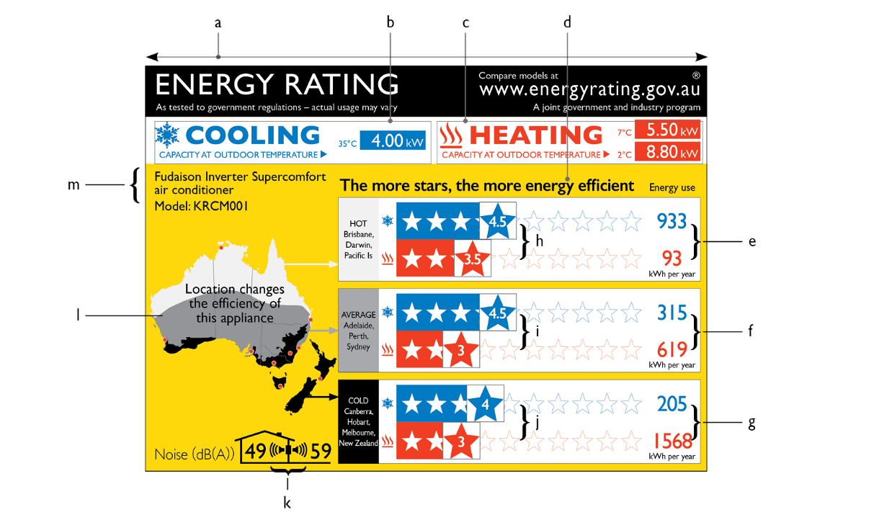

4 Content of elements b and c (cooling capacity strip and heating capacity strip)
Heating only and cooling only products
(1) Despite any other provision in this Schedule:
(a) for a cooling only product, the heating capacity strip must be left blank, as shown in diagram 2; and
(b) for a heating only product, the cooling capacity strip must be left blank, as shown in diagram 3.
Products that are capable of cooling
(2) Subject to subsections (3) and (4), for a product that is capable of cooling, the cooling capacity strip must:
(a) state the product’s rated standard cooling full capacity; and
(b) have the wording, and be in the arrangement, shown in element b of diagram 1.
(3) For a product in product class 2 or 4 that:
(a) has a supplementary tank with a duration of 4 hours or more; and
(b) can operate with or without it;
the cooling capacity strip must instead:
(c) state the rated standard cooling full capacity both with and without the supplementary water tank in use; and
(d) have the wording, and be in the arrangement, shown in:
(i) for a product in product class 2—element b of diagram 2; and
(ii) for a product in product class 4—element b of diagram 5.
(4) For a product in product class 4 that:
(a) has no supplementary water tank; or
(b) has a supplementary tank with a duration of 4 hours or more and cannot operate without it;
the cooling capacity strip must instead:
(c) state the product’s rated standard cooling full capacity; and
(d) have the wording, and be in the arrangement, shown in element b of diagram 4.
Products that are capable of heating
(5) For a product that is capable of heating, the heating capacity strip must state:
(a) the product’s rated standard heating full capacity; and
(b) for a product other than one in product class 3 or 4—either:
(i) if the product is capable of heating extended-load operation—the product’s rated low temperature heating extended-load capacity; or
(ii) otherwise—the product’s rated low temperature heating full capacity.
(6) The heating capacity strip must have the wording, and be in the arrangement, shown in:
(a) for a product in product class 3 or 4—element c of diagram 4; and
(b) otherwise—element c of diagram 1.
(7) Diagram 2:
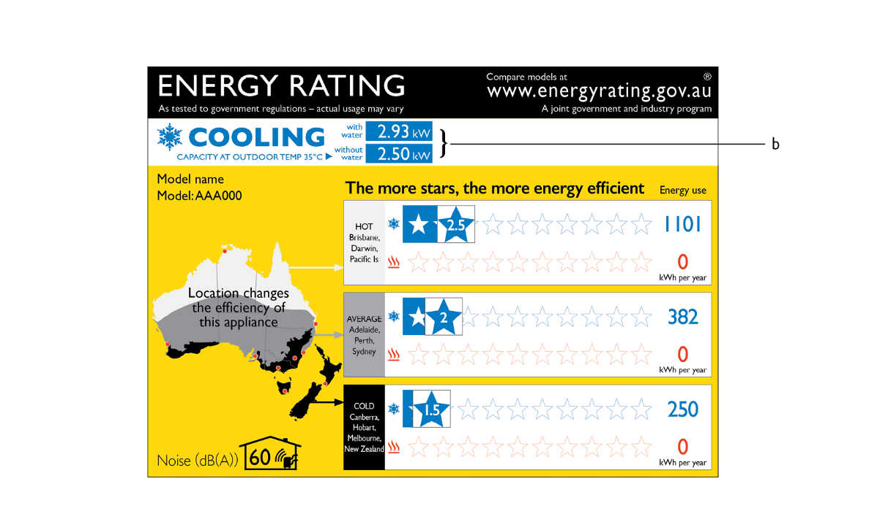
(8) Diagram 3:
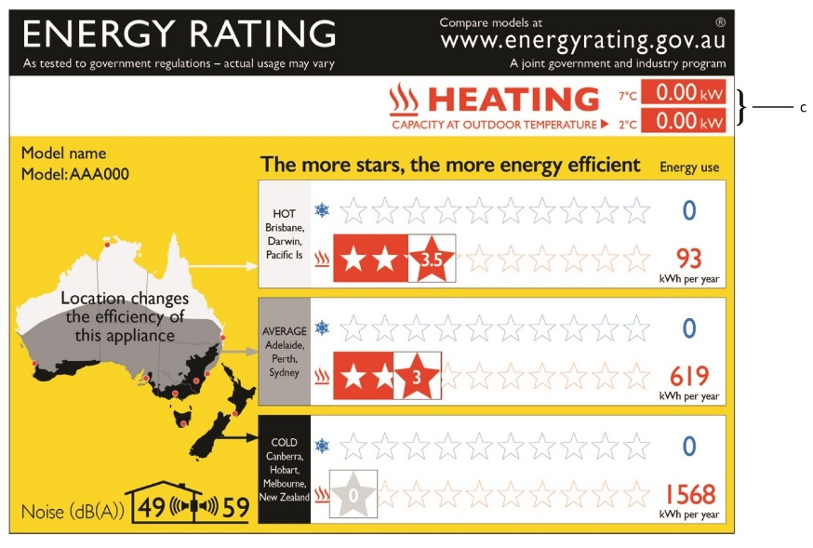
(9) Diagram 4:
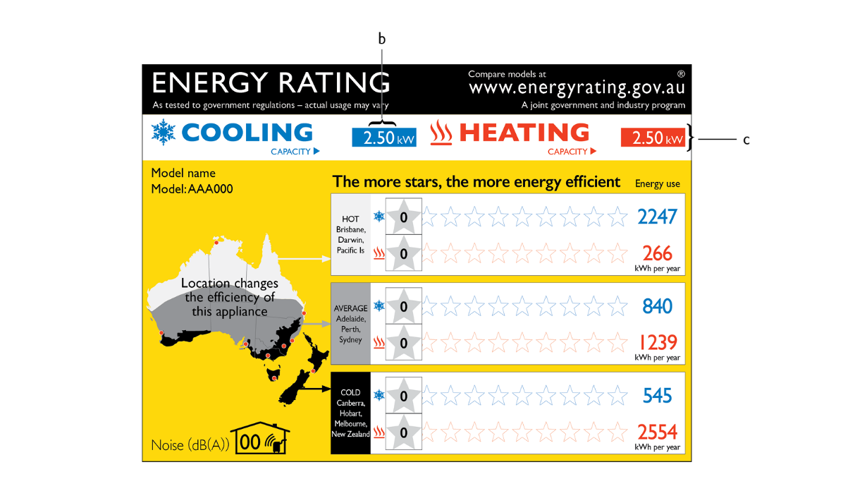

(10) Diagram 5:
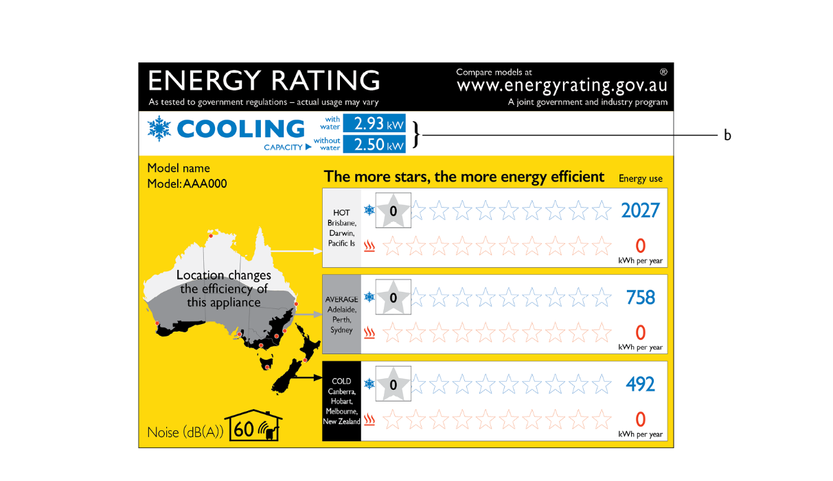

5 Content of element d (star rating statement)
The text of the star rating statement must be set out as shown in element d of diagram 1.

6 Content of elements e, f and g (hot, average and cold area Cooling Season Total Energy Consumption and Heating Season Total Energy Consumption figures)
Elements e, f and g must set out the product’s:
(a) Cooling Season Total Energy Consumption; and
(b) Heating Season Total Energy Consumption;
for each temperature zone, calculated on the basis of the residential temperature bins.
Note: For a product other than one in product class 3 or 4, the Cooling Season Total Energy Consumption and Heating Season Total Energy Consumption figures are calculated in accordance with subsection 30(1) and (2) of this Determination respectively.
For a product in product class 3 or 4, these figures are calculated in accordance with subsection 30(4) of this Determination.

7 Content of elements h, i and j (hot, average and cold area star ratings)
(1) The hot, average and cold area star ratings for the product in accordance with section 31 of this Determination must be set out as shown in elements h, i and j of diagram 1, with any modifications or variations required by this section.
(2) For each relevant heating and cooling function, a star rating must be shown in numerals in a star, positioned as detailed below. There must be a set of such ratings for each geographical region. A product that does not provide either a cooling or heating service must not place a rating star on the star band for that service.
(3) The cooling function star rating (the rating star) must be shown in a blue star within a square box with black outline. A rating of 0 must be shown in a grey star (see for example diagrams 3 and 4). A rating of 0.5 must be shown in a star whose left half is blue and right half grey.
(4) The heating function rating star must be shown as a red star within a square box with black outline. A rating of 0 must be shown in a grey star (see for example diagram 4). A rating of 0.5 must be shown in a star whose left half is red and right half grey (see for example diagrams 7 and 15).
(5) The rating star must be vertically centred on the centre of the relevant star in the star band. For example, if the rating is “4 stars” then the rating star aligns with the fourth star in the band; this obscures the fourth star, and some of the third. Rating stars from 0 to 1 are placed in the same location; the centre of the rating star must sit on the centre of the first star in the star band. For a rating involving a half star, the rating star must bisect the gap between the stars that bracket the value.
(6) The coloured band for the star rating must extend to the edge of the rating star box.
(7) The following diagrams (diagrams 6, 7 and 8) show the appropriate star bands for different types of products, and their dimensions:
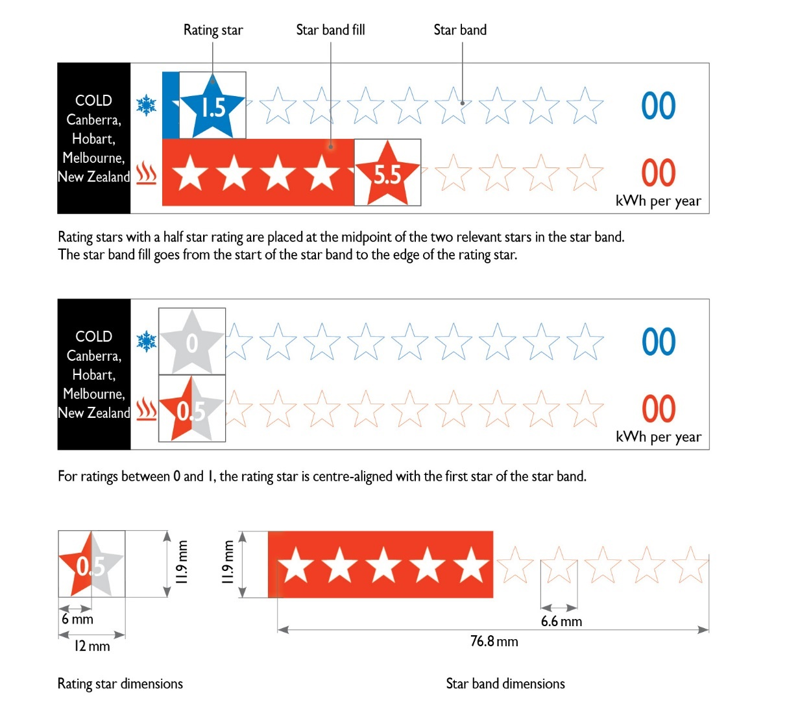

8 Content of element k (noise statement)
(1) The tested noise level in decibels in accordance with section 9 of Schedule 2 to this Determination must be set out as shown in element k of diagram 1, and diagram 9, with any modifications or variations required by this section.
(2) For the following product types, the relevant noise (sound power) types are as follows:
 | Product type | Noise type
1 | Non-ducted single-split systems  Non-ducted unitary air conditioners (other than those of a kind mentioned in item 3) | indoor and outdoor noise levels
2 | Ducted units (including ducted split systems and ducted unitary air conditioners) | outdoor noise level only
3 | Unitary double duct air conditioners  Unitary single duct air conditioners | indoor noise level only
(3) For non-ducted, single-split systems with two or three indoor units, indoor sound power is required for a single indoor unit only.
(4) For a product in product classes 5, 6, 8, 9 or 11, excluding ducted products, the indoor decibel rating must be shown inside the house symbol and the outdoor decibel rating must be shown outside the house symbol, as shown in diagram 10.
(5) For a product in product class 5, 6, 10 or 11, excluding non-ducted products, only the outdoor decibel rating must be shown outside the house symbol together with the fixed ducted air conditioner symbol, as shown in diagram 11.
(6) For a product in product class 1 or 2, only the indoor decibel rating must be shown together with the double duct symbol, as shown in diagram 12.
(7) For a product in product class 3 or 4, only the indoor decibel rating must be shown together with the single duct symbol, as shown in diagram 13.
(8) The following diagrams show the appropriate decibel rating icons for different types of products, and their dimensions:
(a) diagram 9:
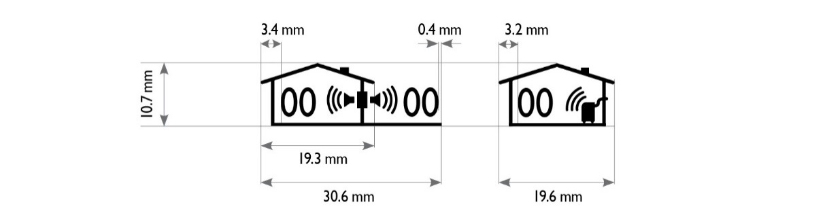
(b) diagram 10:
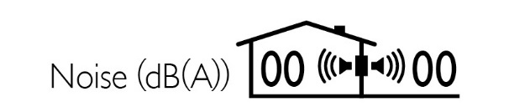
®
(c) diagram 11:
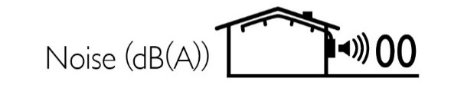
(d) diagram 12:
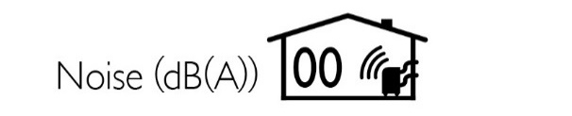
(e) diagram 13:
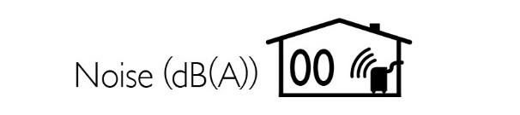

9 Content of element m (model details)
(1) The brand and model of the product must be set out as shown in element m of diagram 1. The text must:
(a) be complete and concise; and
(b) not exceed a width of 58 mm; and
(c) not exceed a height of 17 mm (or 4 lines of text); and
(d) be left aligned in the area allowed.
(2) For a single-split system, the model details must consist of:
(a) if there is a model number for the system as a whole—that number; and
(b) otherwise—the model numbers of the individual units, using the format “outdoor unit model number/indoor unit model number”.
(3) A family name may be used in place of an individual model name/number for a family registration. Wildcard characters may be used in the family name, but may not represent more than one character.

10 Colours and fonts for the energy rating label
(1) The energy rating label must be printed on a white background using the following colours in the elements as shown in diagram 14:
Colour | For a printed label
Yellow | Pantone 116
Blue | Pantone 300
Red | Pantone Warm red
Light grey | Pantone Black 5%
Dark grey | Pantone Black 40%
Black | Pantone Black
(2) The entire label must be in only one font, which may be any one of the following:
(a) Gill Sans (preferred);
(b) Humanist 521;
(c) Hammersmith.
(3) The text in an energy rating label must be of the font size and colour shown in diagrams 14 to 17. All type weights regular unless otherwise specified.
(4) Diagram 14 (default requirements):
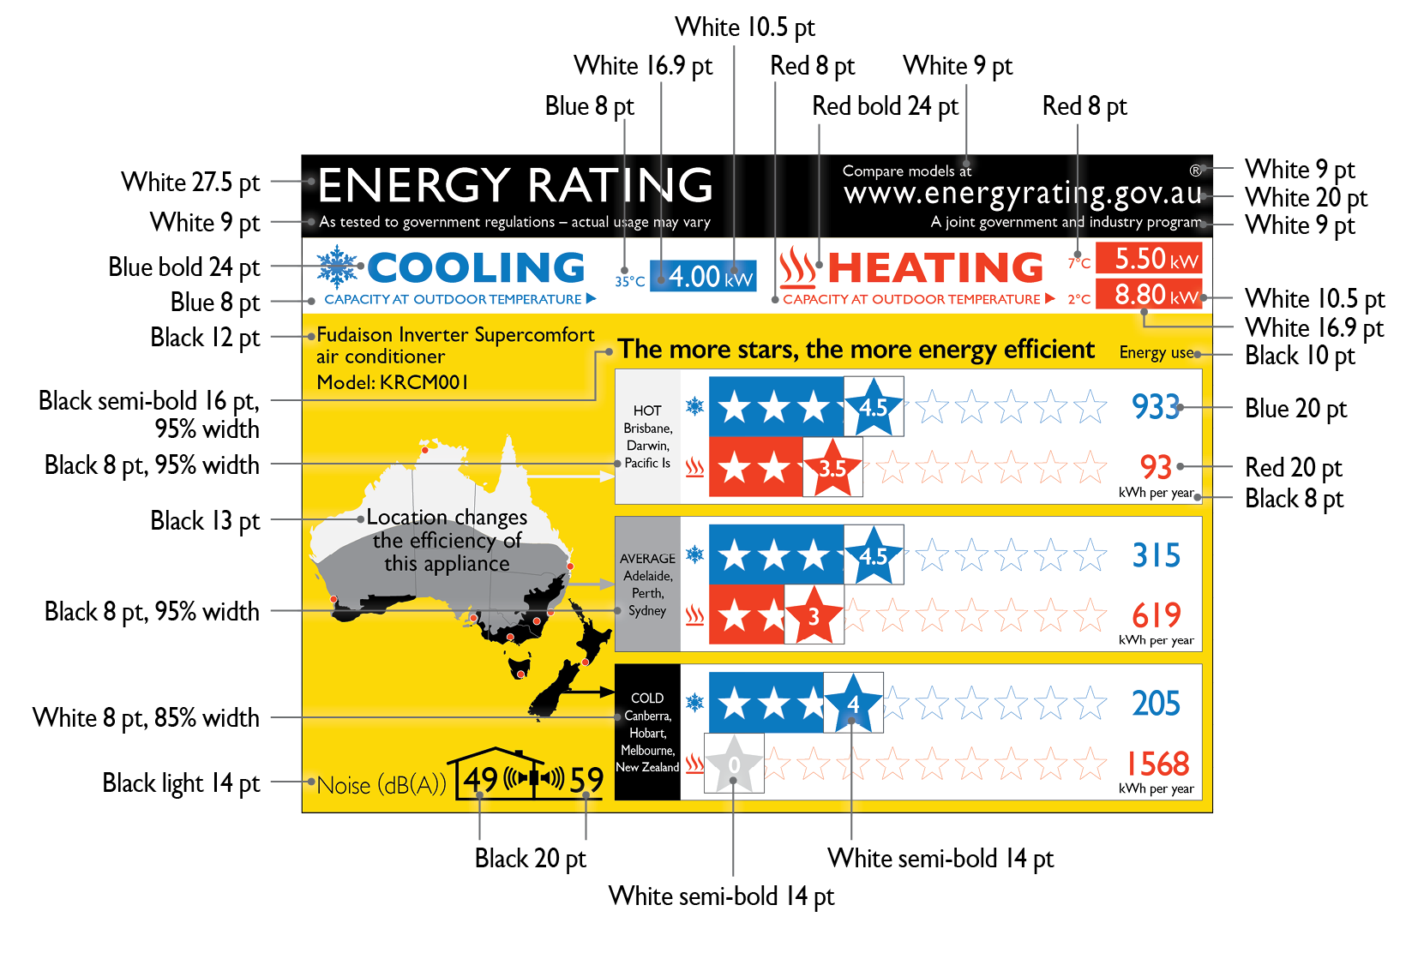
(5) Diagram 15 (requirements for cooling capacity strip given by diagram 2):
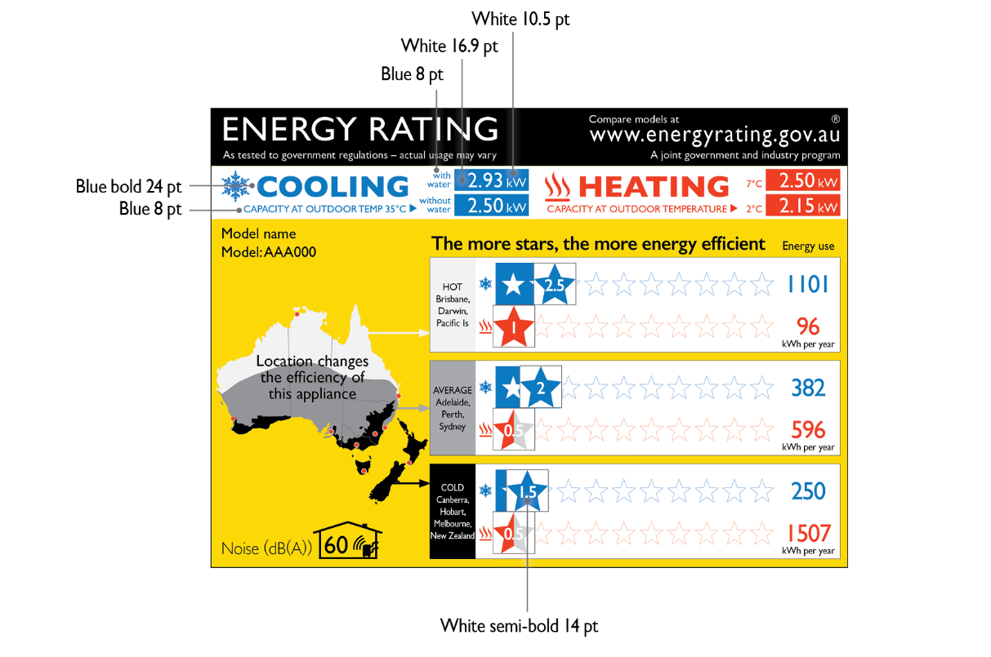
(6) Diagram 16 (requirements for heating and cooling capacity strips given by diagram 4):
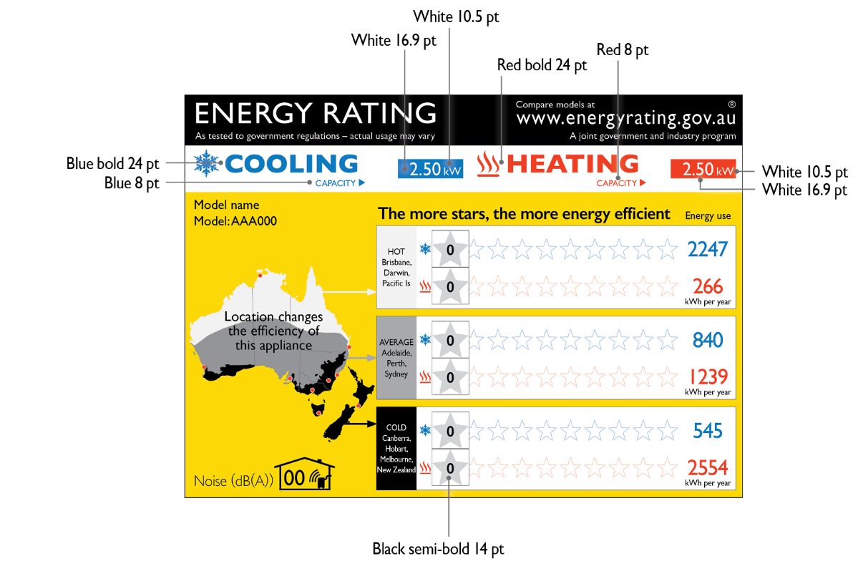
(7) Diagram 17 (requirements for cooling capacity strip given by diagram 5):
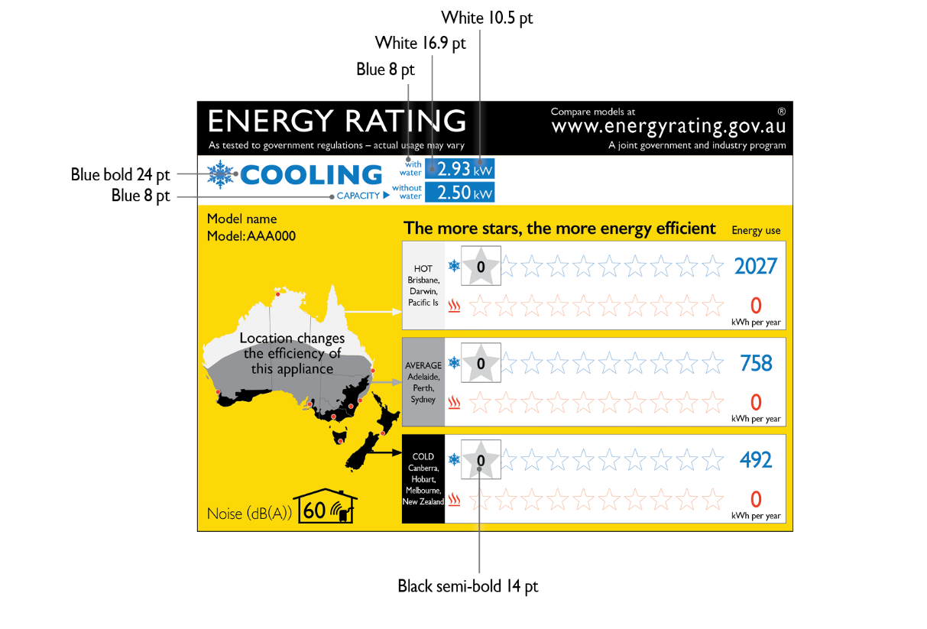

11 Object requirements for the energy rating label—diagram
(1) The objects in an energy rating label must be as shown in diagram 18.
(2) Diagram 18 (default requirements):
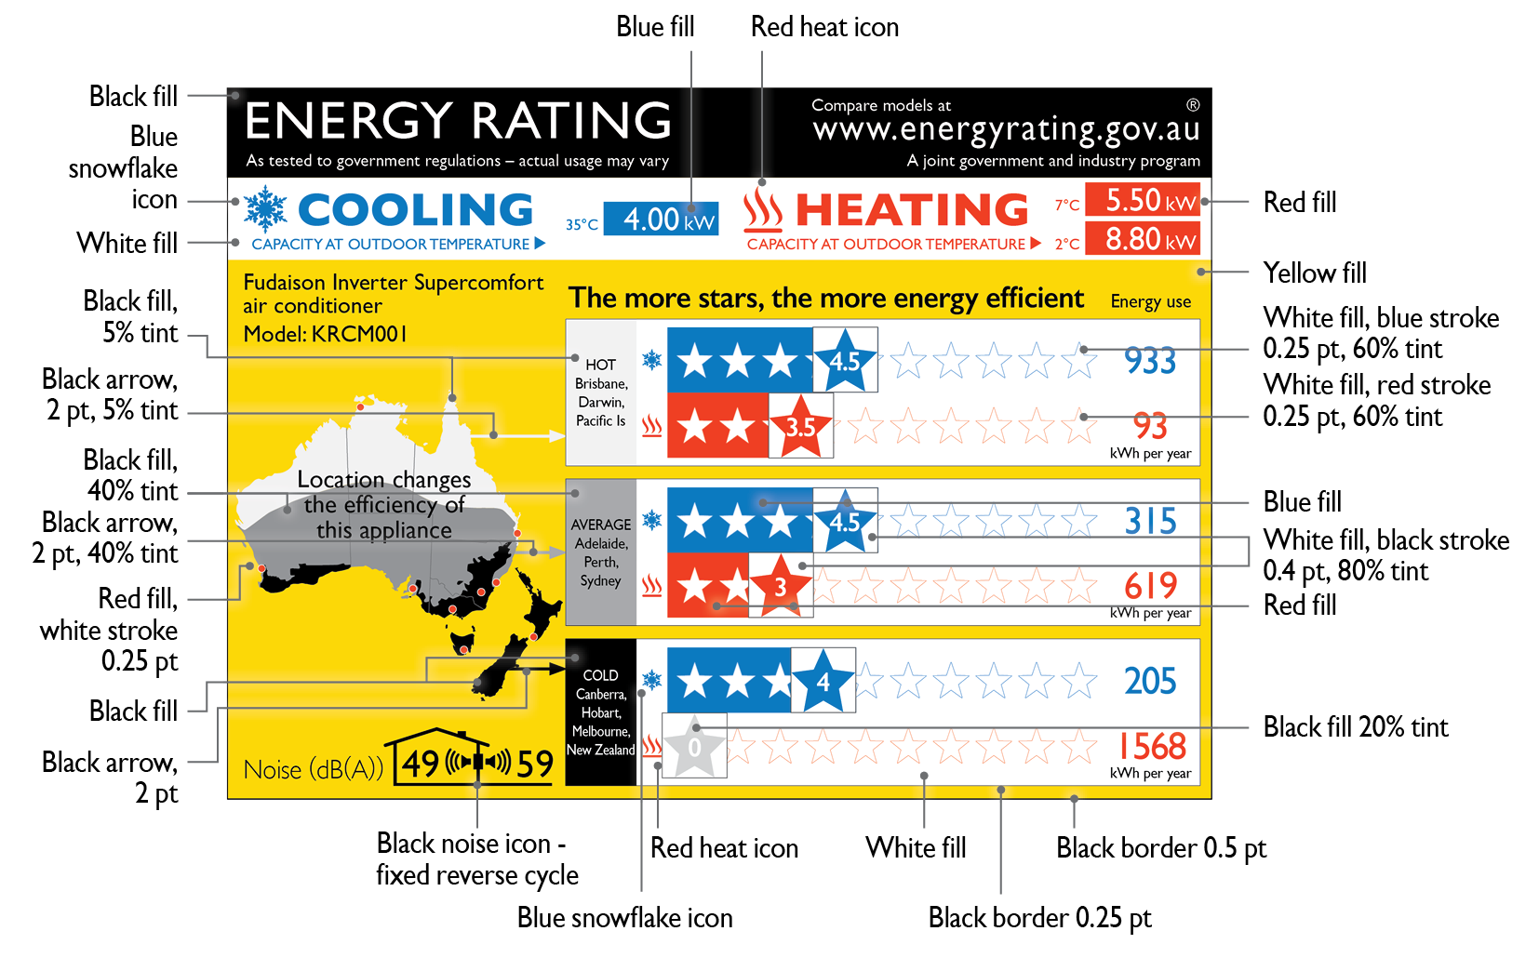

12 Physical layout requirements for the label
(1) The objects and elements in an energy rating label must be laid out as shown in diagrams 19 to 22.
(2) Diagram 19 (default requirements):
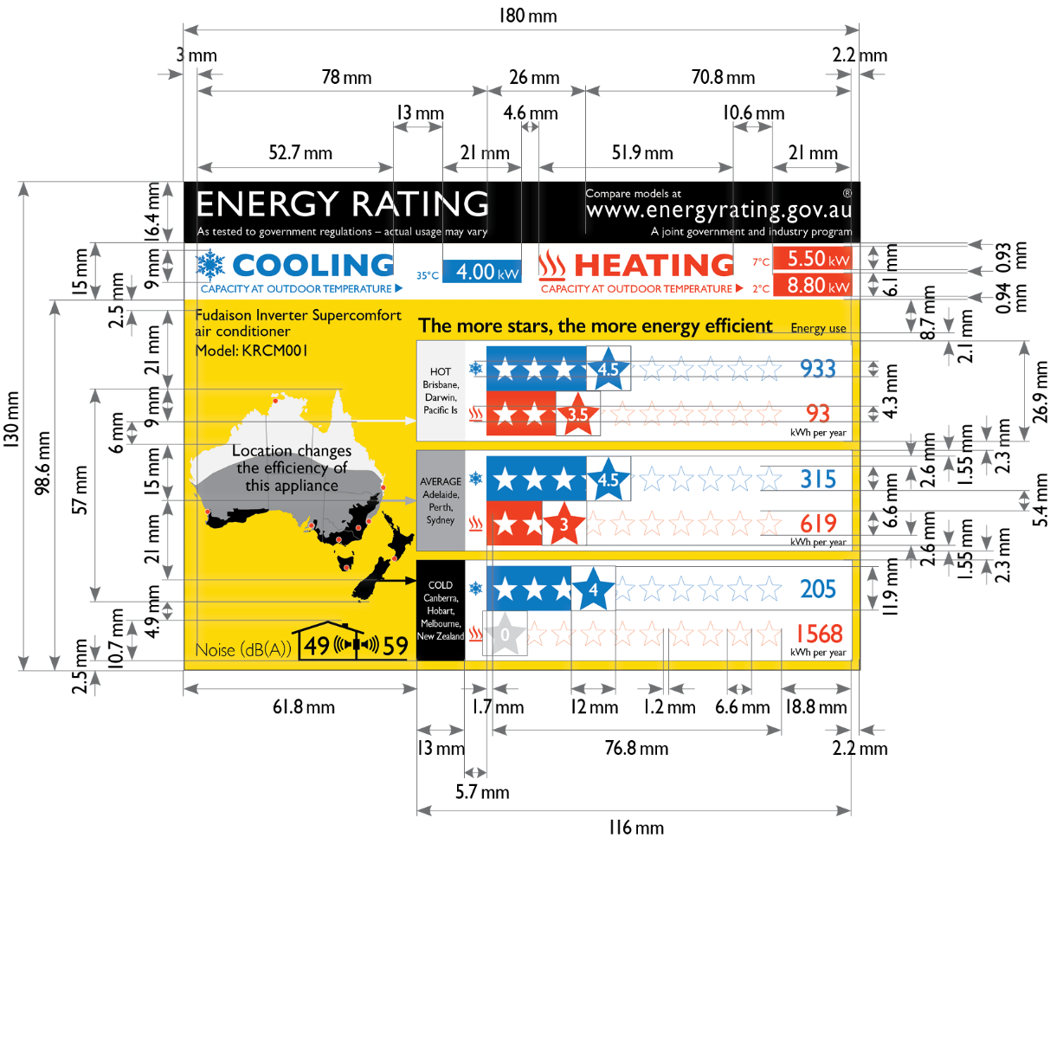

(3) Diagram 20 (requirements for cooling capacity strip given by diagram 2):
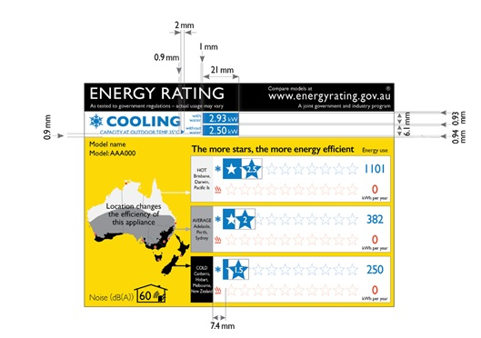
(4) Diagram 21 (requirements for heating and cooling capacity strips given by diagram 4):
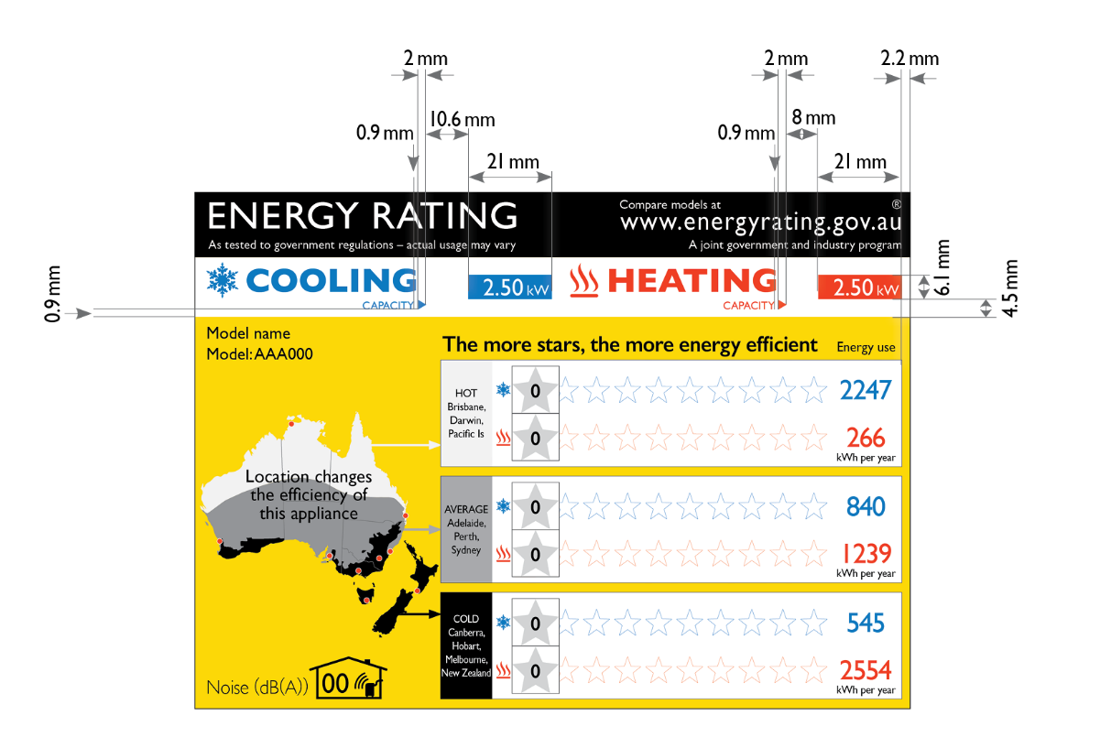
(5) Diagram 22 (requirements for cooling capacity strip given by diagram 5):
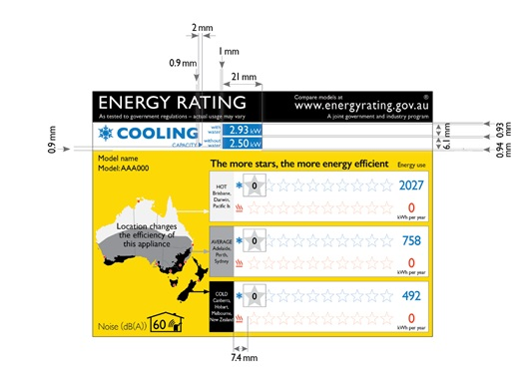

Schedule 4—Format of energy rating icon

1 Interpretation
In this Schedule:
Diagram 1—see subsection 3(2) of this Schedule.
Diagram 2—see subsection 7(4) of this Schedule.
Diagram 3—see subsection 7(5) of this Schedule.

2 Meaning of certain details in the diagrams
In a diagram in this Schedule, numbers are illustrative only; the actual numbers for the energy rating icon for a particular product must be those specified in this Schedule.

3 Elements of the energy rating icon
(1) Subject to section 7, an energy rating icon must be in substantially the format shown in diagram 1.
(2) Diagram 1:
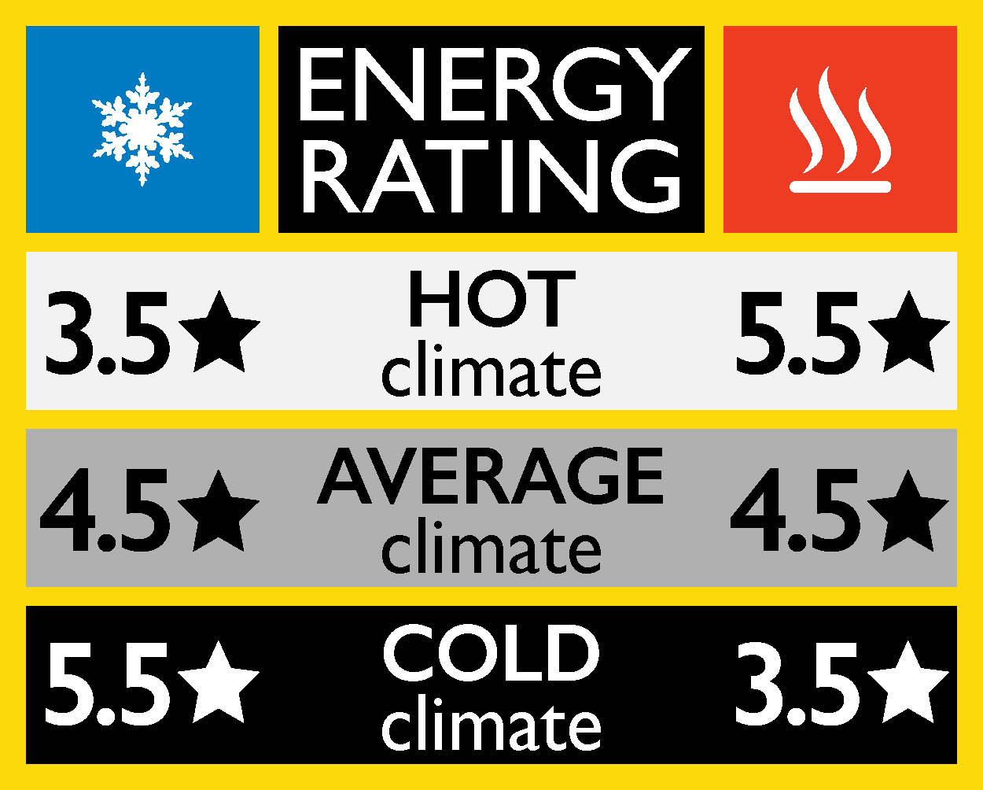
™

4 Colours for the energy rating icon
The energy rating icon must use the colours in the elements in accordance with the following table:
Colour | For a printed label—the following Pantone colours | For a label that appears in digital media—the following RGB colours, or equivalent colours
Yellow | Pantone 116 | 252 - 217 - 11
Blue | Pantone 300 | 0 - 122 - 195
Red | Pantone Warm red | 238 - 59 - 36
Light grey | Pantone Black 5% | 242 - 242 - 242
Dark grey | Pantone Black 40% | 177 - 179 - 179
Black | Pantone Black | 0 - 0 - 0
Note: The Pantone colours are illustrated in the energy rating labels that are reproduced in Schedule 3. The RGB colours are illustrated in the energy rating icons that are reproduced in this Schedule.

5 Fonts for the energy rating icon
(1) The entire icon must be in only one font, which may be any one of the following:
(a) Gill Sans (preferred);
(b) Humanist 521;
(c) Hammersmith.
(2) The text in an energy rating icon must have the following weights and cases:
Element | Weight | Case
“ENERGY RATING” | regular | capital
Star ratings | semibold | –
“HOT”, “AVERAGE” and “COLD” | semibold | capital
“climate” | regular | lower case

6 Size of the energy rating icon
(1) Subject to this section, an energy rating icon may be of any size.
(2) The dimensions of the icon, and of the text in the icon, must be proportional to the dimensions of the icon as illustrated in section 3.

7 Content of energy rating icon
(1) Subject to this section, an energy rating icon must list the cooling star ratings and heating star ratings for each of the climate zones, as illustrated in section 3.
(2) If the product is heating-only, a dash must be included in the area where the cooling star rating would otherwise go (see diagram 2).
(3) If the product is cooling-only, a dash must be included in the area where the heating star rating would otherwise go (see diagram 3).
(4) Diagram 2:
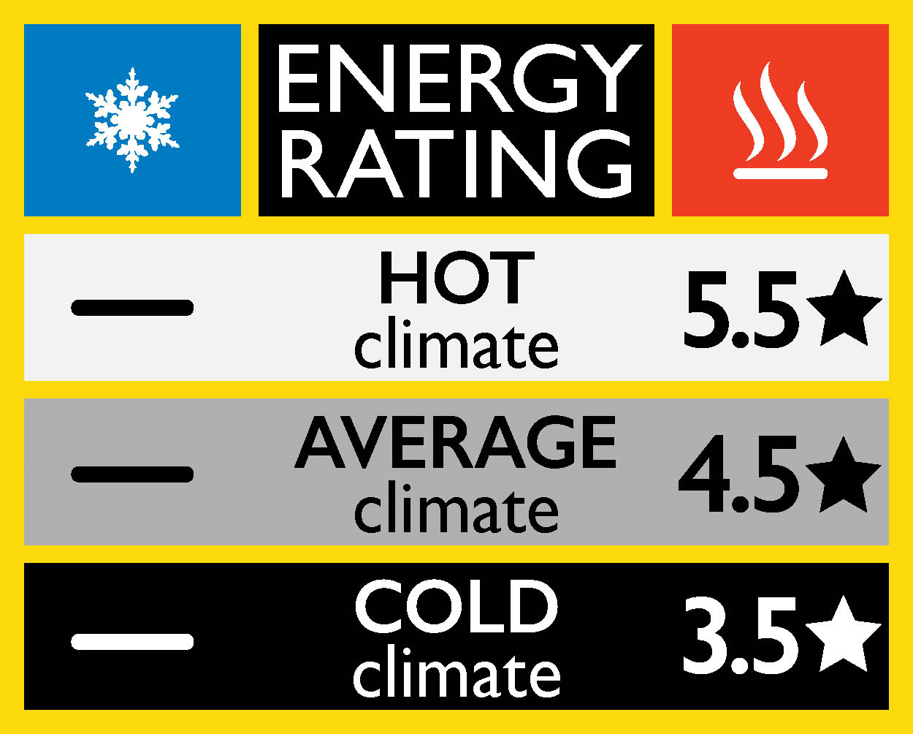
™

(5) Diagram 3:
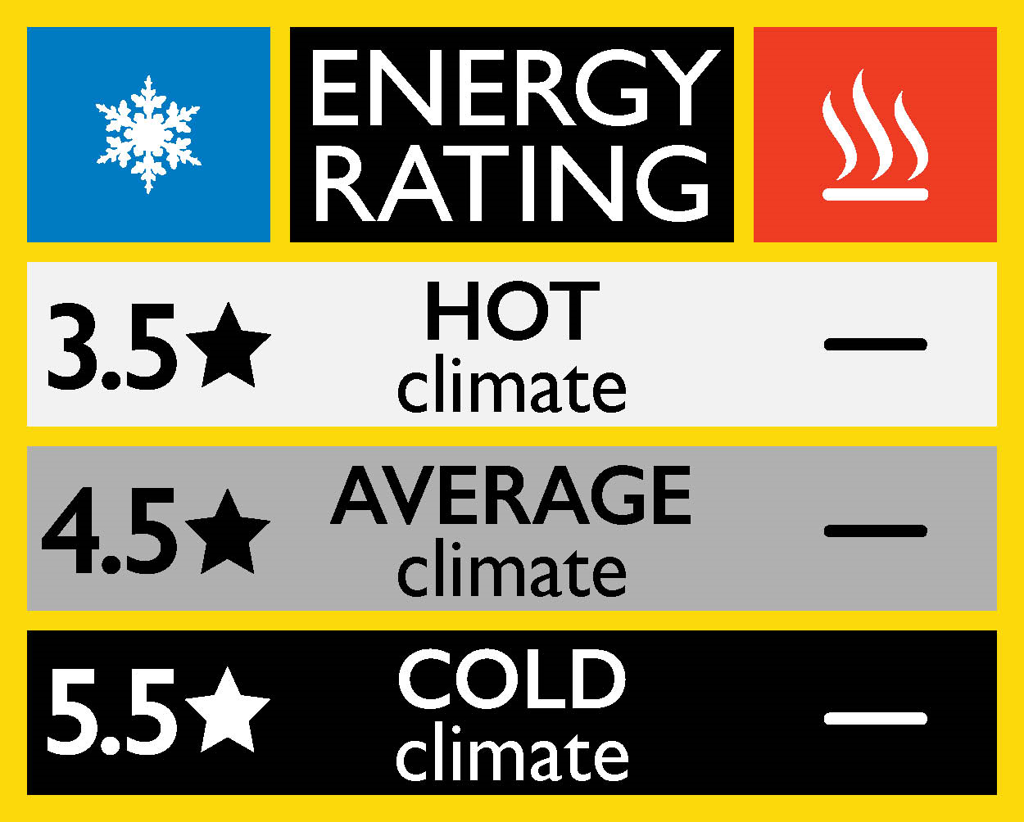
™

Schedule 5—Star ratings

1 Star ratings
For subsection 31(3) of this Determination, the correspondence between the TCSPF and HSPF and the star ratings is given by the following table:
TCSPF or HSPF value |  |  | Star rating
 | TCSPF / HSPF | < 2 | 0
2 ≤ | TCSPF / HSPF | < 2.5 | 0.5
2.5 ≤ | TCSPF / HSPF | < 3 | 1
3 ≤ | TCSPF / HSPF | < 3.5 | 1.5
3.5 ≤ | TCSPF / HSPF | < 4 | 2
4 ≤ | TCSPF / HSPF | < 4.5 | 2.5
4.5 ≤ | TCSPF / HSPF | < 5 | 3
5 ≤ | TCSPF / HSPF | < 5.5 | 3.5
5.5 ≤ | TCSPF / HSPF | < 6 | 4
6 ≤ | TCSPF / HSPF | < 6.5 | 4.5
6.5 ≤ | TCSPF / HSPF | < 7 | 5
7 ≤ | TCSPF / HSPF | < 7.5 | 5.5
7.5 ≤ | TCSPF / HSPF | < 8 | 6
8 ≤ | TCSPF / HSPF | < 8.5 | 6.5
8.5 ≤ | TCSPF / HSPF | < 9 | 7
9 ≤ | TCSPF / HSPF | < 9.5 | 7.5
9.5 ≤ | TCSPF / HSPF | < 10 | 8
10 ≤ | TCSPF / HSPF | < 10.5 | 8.5
10.5 ≤ | TCSPF / HSPF | < 11 | 9
11 ≤ | TCSPF / HSPF | < 11.5 | 9.5
11.5 ≤ | TCSPF / HSPF |  | 10

Schedule 6—Commercial-based temperature bins

1 Commercial-based temperature bins
For paragraph (a) of the definition of “commercial SEER rating” in section 33 of this Determination, the commercial-based temperature bins are set out in the following tables:
Commercial cooling outdoor temperature distribution bins
Outdoor temperature tj °C | Hot/humid zone hrs | Mixed zone hrs | Cold zone hrs
15 | 0 | 0 | 181
16 | 0 | 0 | 183
17 | 0 | 0 | 170
18 | 100 | 229 | 177
19 | 117 | 238 | 175
20 | 141 | 251 | 185
21 | 185 | 225 | 165
22 | 235 | 242 | 143
23 | 256 | 208 | 118
24 | 282 | 185 | 112
25 | 290 | 178 | 82
26 | 306 | 129 | 72
27 | 304 | 125 | 69
28 | 265 | 89 | 45
29 | 271 | 70 | 66
30 | 219 | 39 | 40
31 | 137 | 52 | 45
32 | 101 | 39 | 32
33 | 85 | 21 | 22
34 | 57 | 21 | 11
35 | 30 | 18 | 6
36 | 17 | 17 | 5
37 | 13 | 14 | 0
38 | 4 | 14 | 0
39 | 0 | 2 | 0
40 | 0 | 3 | 0
41 | 0 | 2 | 0
Totals | 3415 | 2411 | 2104

Commercial heating outdoor temperature distribution bins
Outdoor temperature tj °C | Hot/humid zone hrs | Mixed zone hrs | Cold zone hrs
-7 | 0 | 0 | 0
-6 | 0 | 0 | 2
-5 | 0 | 0 | 4
-4 | 0 | 1 | 4
-3 | 0 | 0 | 8
-2 | 0 | 1 | 11
-1 | 0 | 2 | 17
0 | 0 | 6 | 14
1 | 0 | 6 | 17
2 | 0 | 9 | 28
3 | 0 | 18 | 29
4 | 0 | 16 | 38
5 | 3 | 15 | 48
6 | 4 | 23 | 62
7 | 7 | 29 | 122
8 | 14 | 33 | 127
9 | 15 | 48 | 176
10 | 18 | 52 | 163
11 | 15 | 77 | 222
12 | 28 | 87 | 197
13 | 27 | 126 | 184
14 | 30 | 170 | 0
15 | 38 | 210 | 0
16 | 62 | 221 | 0
17 | 0 | 0 | 0
Totals | 261 | 1150 | 1473

2 Values of t₀ and t₁₀₀
For paragraph (b) of the definition of “commercial SEER rating” in section 33 of this determination, the values of t₀ and t₁₀₀ are given by the following table:
AS/NZS 3823.4 zone | Standard | t₀ (°C) | t₁₀₀ (°C)
Hot/humid | AS/NZS 3823.4.1:2014 | 17 | 33
Hot/humid | AS/NZS 3823.4.2:2014 | 17 | 0
Mixed | AS/NZS 3823.4.1:2014 | 17 | 35
Mixed | AS/NZS 3823.4.2:2014 | 17 | 0
Cold | AS/NZS 3823.4.1:2014 | 14 | 35
Cold | AS/NZS 3823.4.2:2014 | 14 | 0

