

**Food Standards (Application A1149 – Addition of Steviol Glycosides in Fruit Drinks) Variation**

The Board of Food Standards Australia New Zealand gives notice of the making of this variation under section 92 of the *Food Standards Australia New Zealand Act 1991*. The variation commences on the date specified in clause 3 of this variation.

Dated 30 May 2019

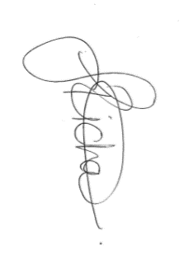

Standards Management Officer

Delegate of the Board of Food Standards Australia New Zealand

**Note:**

This variation will be published in the Commonwealth of Australia Gazette No. FSC 126 on 6 June 2019. This means that this date is the gazettal date for the purposes of the above notice.

1 Name

This instrument is the *Food Standards (Application A1149 – Addition of Steviol Glycosides in Fruit Drinks) Variation*.

2 Variation to a standard in the *Australia New Zealand Food Standards Code*

The Schedule varies a Standard in the *Australia New Zealand Food Standards Code*.

3 Commencement

The variation commences on the date of gazettal.

**Schedule**

**[1] Schedule 15** is varied by inserting in item 14.1.2.2.1 of the table to subsection S15—5, after the entry for ‘Dioctyl sodium sulphosuccinate’

|  |  |  |  |
| --- | --- | --- | --- |
| 960 | Steviol glycosides | 200 |  |