Commonwealth Coat of Arms

Family Law (Superannuation) (Interest Rate for Adjustment Period) Determination 2019

I, Guy Francis Thorburn, Australian Government Actuary, make the following determination under regulation 45D of the *Family Law (Superannuation) Regulations 2001*.

Dated: 1 June 2019

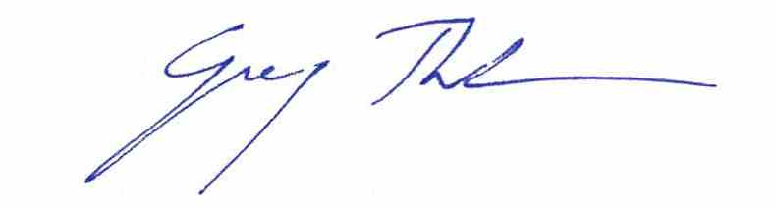

Guy Francis Thorburn

Australian Government Actuary

Contents

1 Name of determination 1

2 Commencement 1

3 Authority 1

4 Definition 1

5 Adjustment period—financial year 1

6 Adjustment period—less than 12 months within financial year 1

7 Adjustment period—12 months not within financial year 1

8 Adjustment period—less than 12 months not within financial year 2

1 Name of determination

This determination is the *Family Law (Superannuation) (Interest Rate for Adjustment Period) Determination 2019*.

2 Commencement

This determination commences on 1 July 2019.

3 Authority

This determination is made under regulation 45D of the *Family Law (Superannuation) Regulations 2001*.

4 Definition

In this determination:

***regulations*** means the *Family Law (Superannuation) Regulations 2001*.

5 Adjustment period—financial year

For subregulation 45D(3) of the regulations, the interest rate for the adjustment period, being the financial year beginning on 1 July 2019, is 0.048.

6 Adjustment period—less than 12 months within financial year

(1) This section applies to an adjustment period of less than 12 months that begins and ends in the financial year beginning on 1 July 2019.

(2) For subregulation 45D(4) of the regulations, the method for working out the interest rate for the adjustment period is by using the formula:

${\text{1.0}\text{48}}^{\frac{\text{d}}{\text{365}}} \text{-} \text{1}$

where:

***d*** is the number of days in the adjustment period.

7 Adjustment period—12 months not within financial year

(1) This section applies to an adjustment period of 12 months that begins in the financial year beginning on 1 July 2018 and ends in the financial year beginning on 1 July 2019.

(2) For subregulation 45D(6) of the regulations, the method for working out the interest rate for the adjustment period is by using the formula:

where:

***d1*** is the number of days in the adjustment period in the financial year beginning on 1 July 2018.

***d2*** is the number of days in the adjustment period in the financial year beginning on 1 July 2019.

8 Adjustment period—less than 12 months not within financial year

(1) This section applies to an adjustment period of less than 12 months that begins in the financial year beginning on 1 July 2018 and ends in the financial year beginning on 1 July 2019.

(2) For subregulation 45D(6) of the regulations, the method for working out the interest rate for the adjustment period is by using the formula:

where:

***d1*** is the number of days in the adjustment period in the financial year beginning on 1 July 2018.

***d2*** is the number of days in the adjustment period in the financial year beginning on 1 July 2019.