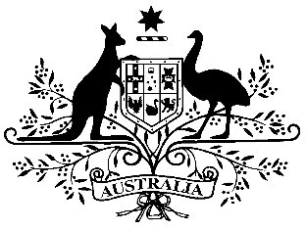

**PB 52 of 2019**

**National Health (Remote Area Aboriginal Health Services Program) Special Arrangement Amendment Instrument 2019 (No. 1)**

*National Health Act 1953*

___________________________________________________________________________

I, BEN SLADIC, Assistant Secretary, Pharmacy Branch,   
Department of Health, delegate of the Minister for Health, make this Amendment Instrument  
under subsections 100(1) and 100(2) of the *National Health Act 1953.*

Dated 14 June 2019

**BEN SLADIC**

Assistant Secretary

Pharmacy Branch

Technology Assessment and Access Division

Department of Health

___________________________________________________________________________

1 Name of Instrument

1. This Instrument is the *National Health (Remote Area Aboriginal Health Services Program) Special Arrangement Amendment Instrument 2019 (No. 1)*.
2. This Instrument may also be cited as PB 52 of 2019.

2 Commencement

This Instrument commences on 1 July 2019.

3 Amendment to PB 107 of 2017

Schedule 1 amends the *National Health (Remote Area Aboriginal Health Services Program) Special Arrangement* (PB 107 of 2017).

Schedule 1 Amendment

1. Amount of payments (15) Paragraph (c)

omit:

$3.04

substitute:

$3.08

1. Amount of payments (15) Paragraph (d)

omit:

$4.77

substitute:

$4.84