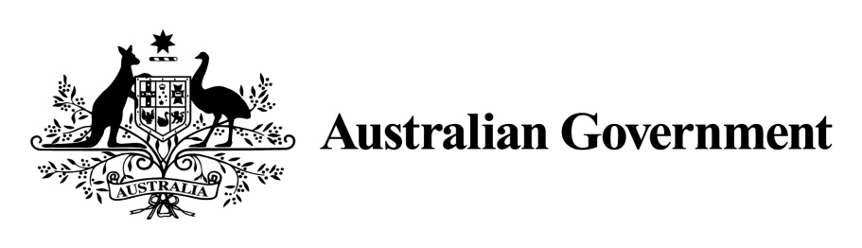

1. ***National Land Transport Act 2014***
2. **VARIATION OF THE ROADS TO RECOVERY LIST 2019**
3. **Instrument No. 2019/3**
4. **I, OLIVER HOLM,** General Manager, South East Infrastructure Investment, Department of Infrastructure, Transport, Cities and Regional Development,under Sections 88(2) and (3) of the *National Land Transport Act 2014* (the Act), vary the *Roads to Recovery List 2019* which was made by the Minister on 31 October 2018, and amended by Instrument No. 2019/2 made on 1 July 2019 as follows:
5. **Name of variation**
6. This variation instrument is the Roads to Recovery List 2019 Variation Instrument No. 2019/3.
7. **Variation**
8. (a) In Schedule 1 of the List:

Omit the amount specified in Column 2 of Schedule 1 for the funding recipient ‘Armidale Regional Council’ and replace the omitted amount with $7,148,503.

Omit the amount specified in Column 2 of Schedule 1 for the funding recipient ‘Inverell Shire Council’ and replace the omitted amount with $7,010,275.

1. (b) In Schedule 2 of the List:

Omit the amount specified in the List for Western Australia in Column 2 of Schedule 2 and replace the omitted amount with the amount $25,588,063.

1. **Commencement**
2. This instrument commences on 31 July 2019.
3. Dated: 29 July 2019
4. OLIVER HOLM

General Manager

1. South East Infrastructure Investment
2. Infrastructure Investment Division

Department of Infrastructure, Transport, Cities and Regional Development

**Schedule 1 to Instrument 2019/3**

|  |  |  |
| --- | --- | --- |
| **Item** | **Column 1 - Funding recipients** | **Column 2 – Funding amounts** |
| 2 | Armidale Regional Council | $7,148,503 |
| 59 | Inverell Shire Council | $7,010,275 |

**Schedule 2 to Instrument 2019/3**

|  |  |  |
| --- | --- | --- |
| **Item** | **Column 1 – States and areas of States** | **Column 2 – Funding amounts** |
| 1 | Western Australia | $25,588,063 |