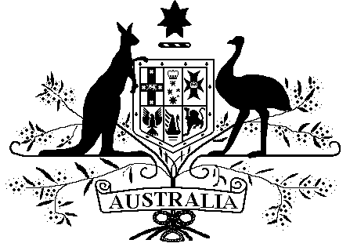

Repatriation Commission

Veterans’ Entitlements (Partner Service Pension — Retention of Eligibility) Determination 2019

Instrument 2019 No. R24

The Repatriation Commission, under subsection 38 (2AD) of the Veterans’ Entitlements Act 1986, makes the following instrument.

Dated this 5th of September 2019

The Seal of the  Repatriation Commission  was affixed hereto in the  presence of: | SEAL

…Elizabeth Cosson… |  | …………D Spinks……………
ELIZABETH COSSON |  | DONALD SPINKS
AM CSC |  | AM
PRESIDENT |  | COMMISSIONER

1 Name
This instrument is the Veterans’ Entitlements (Partner Service Pension — Retention of Eligibility) Determination 2019.

2 Commencement
This instrument commences, or is taken to have commenced, on 20 September 2019.

3 Authority
This instrument is made under subsection 38(2AD) of the Veterans’ Entitlements Act 1986.

4 Purpose
The purpose of this instrument is to set out the circumstances in which the married or non-married former partner of a veteran retains eligibility for a partner service pension, despite being separated from the veteran for more than 12 months.

5 Definitions
In this instrument:
Act means the Veterans’ Entitlements Act 1986.
former partner of a veteran means a person to whom paragraph 38(1AA)(a), (b) or (c) of the Act applies.
Note: In accordance with paragraph 46(1)(b) of the Acts Interpretation Act 1901, expressions used in this instrument have the same meaning as in the Act, for example:
• Commission —subsection 5Q (1) of the Act.
• Military Rehabilitation and Compensation Commission —subsection 5Q (1) of the Act.
• partner service pension —paragraph (c) of the definition of ‘service pension’ in subsection 5Q (1) of the Act.
• veteran —subsection 5C (1) of the Act.

6 Specified circumstances
(1) Subsections (2) and (3) specify circumstances for subsection 38(2AD) of the Act.
(2) On the first day on which the former partner of a veteran does not reside in the same residence as the veteran (the first separate residence day), the veteran has a psychological or other mental health incapacity caused by any of the following:
(a) a war-caused injury or war-caused disease for which the Commission has determined that the veteran is entitled to be granted a pension;
(b) a defence-caused injury or defence-caused disease for which the Commission has determined that the veteran, as a member of the Forces or member of a Peacekeeping Force, is entitled to be granted a pension;
(c) a service injury or service disease, within the meaning given by the Military Rehabilitation and Compensation Act 2004, for which the Military Rehabilitation and Compensation Commission has determined to accept liability;
(d) a disease or disorder, mentioned in subsection 85 (2) of the Act, for which the veteran is eligible for treatment under the Act;
(e) a condition to which a determination under paragraph 88A (1) (a) of the Act applies.
(3) The Commission is satisfied that, before the first separate residence day, the domestic environment shared by the former partner of the veteran with the veteran was, because of the veteran’s behaviour, unsafe or abusive for the former partner or any child of the former partner.

7 Repeal
The Veterans’ Entitlements (Partner Service Pension — Retention of Eligibility for Non-illness Separated Spouse) Determination R25/2009 is repealed.

8 Transitional provision
- This section applies to the non-illness separated spouse of a veteran if, immediately before the commencement of this instrument, the Veterans’ Entitlements (Partner Service Pension — Retention of Eligibility for Non-illness Separated Spouse) Determination R25/2009 applied to the spouse.
- On and after the commencement of this instrument, the Veterans’ Entitlements (Partner Service Pension — Retention of Eligibility for Non-illness Separated Spouse) Determination R25/2009 continues to apply to the non-illness separated spouse of the veteran as if it had not been repealed.

