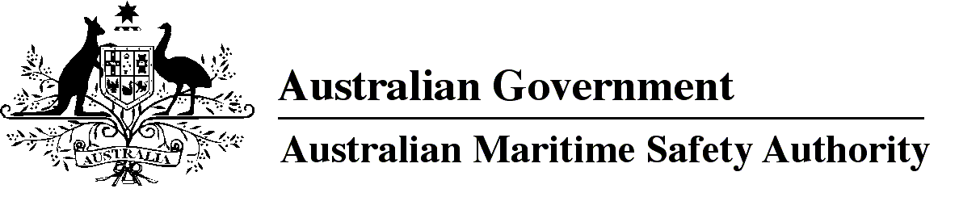

AMSA MO 2019/3

Marine Orders Amendment (Marine Order 31 — consequential changes) Order 2019

I, Brad Groves, Acting Chief Executive Officer of the Australian Maritime Safety Authority, make this Marine Order under subsection 342(1) of the *Navigation Act 2012*.

9 October 2019

Brad Groves  
Acting Chief Executive Officer

1 Name of Marine Order

This Marine Order is *Marine Orders Amendment (Marine Order 31 — consequential changes) Order 2019*.

2 Commencement

This Marine Order commences immediately after the commencement of *Marine Order 31 (SOLAS and non-SOLAS certification) 2019*.

3 Amendment of Marine Orders

Each Marine Order mentioned in Schedule 1 to this Marine Order is amended in accordance with the Schedule.

Schedule 1 Amendments

Division 1 *Marine Order 16 (Load Lines) 2014*

[1] Paragraph 25(5)(a)

omit

*Marine Order 31 (Ships surveys and certification) 2006*

insert

*Marine Order 31 (SOLAS and non-SOLAS certification) 2019*

Division 2 *Marine Order 43 (Cargo and cargo handling — livestock) 2018*

[2] Section 4, definition of *classification society*

substitute

***classification society*** has the same meaning as in *Marine Order 31 (SOLAS and non-SOLAS certification) 2019.*

Division 3 *Marine Order 52 (Yachts and training vessels) 2016*

[3] Section 4, definition of *non-SOLAS certificate*

substitute

***non-SOLAS certificate*** has the same meaning as in *Marine Order 31 (SOLAS and non-SOLAS certification) 2019.*

[4] Section 10, note 3

omit

*Marine Order 31 (Vessel surveys and certification) 2015*

insert

*Marine Order 31 (SOLAS and non-SOLAS certification) 2019*

[5] Subparagraph 20(1)(b)(i)

omit

*Marine Order 31 (Vessel surveys and certification) 2015*

insert

*Marine Order 31 (SOLAS and non-SOLAS certification) 2019*

[6] Subsection 27(1), note

substitute

*Note*   See *Marine Order 31 (SOLAS and non-SOLAS certification)* *2019* for certification requirements of regulated Australian vessels and foreign vessels. Foreign vessels that are not required to be issued a certificate in accordance with Regulation 12 of Chapter I of SOLAS must have at least 1 certificate or other documentary evidence issued by or on behalf of the country in which it is registered that attests to the vessel's seaworthiness.

[7] Paragraph 29(a)

omit

*Marine Order 31 (Vessel surveys and certification) 2015*

insert

*Marine Order 31 (SOLAS and non-SOLAS certification) 2019*

Division 4 *Marine Order 57 (Helicopter operations) 2016*

[8] Section 7, note 2

omit

*Marine Order 31 (Vessel surveys and certification) 2015*

insert

*Marine Order 31 (SOLAS and non-SOLAS certification) 2019*

Division 5 *Marine Orders 58 (Safe management of vessels) 2015*

[9] Subsection 6(1), note

omit

*Marine Order 31 (Vessel surveys and certification) 2015*

insert

*Marine Order 31 (SOLAS and non-SOLAS certification) 2019*

**Note**

1. All legislative instruments and compilations of legislative instruments are registered on the Federal Register of Legislation under the *Legislation Act 2003.* See https://www.legislation.gov.au.