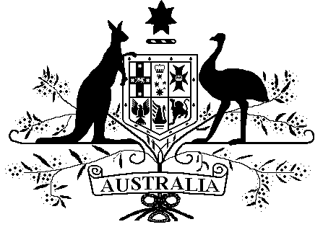

*Veterans’ Entitlements Act 1986*

**Veterans’ Entitlements (Exempt Lump Sum –****Compensation Payments by the Commonwealth on Behalf of the ADF for Historical Child Sexual Abuse Claims) Determination 2019**

Instrument 2019 No. R45

I, EDEL KAIROUZ, delegate of the Repatriation Commission, make the following determination under paragraph 5H(12)(c) of the *Veterans’ Entitlements Act 1986*.

Dated this 15th day of October 2019

…..E Kairouz….

**EDEL KAIROUZ**

**1 Name**

This determination is the *Veterans’ Entitlements (Exempt Lump Sum – Compensation Payments by the Commonwealth on Behalf of the ADF for Historical Child Sexual Abuse Claims) Determination 2019.*

**2 Commencement**

This determination is taken to have commenced on 1 July 2018.

**3 Authority**

This determination is made under paragraph 5H(12)(c) of the *Veterans’ Entitlements Act 1986*.

**4 Definitions**

In this determination:

***“income support supplement”*** means the payment called the income support supplement payable under Part IIIA of the *Veterans’ Entitlements Act 1986*.

**“*compensation* *payment on behalf of the ADF*”** means a payment of compensation made by the Commonwealth on behalf of the ADF as the consequence of a claim for compensation for historical child sexual abuse as a member of the ADF.

***“service pension”*** has the same meaning as it has in subsection 5Q(1) of the *Veterans’ Entitlements Act 1986*.

***“veteran payment”*** means the payment called the veteran payment payable under an instrument made under section 45SB of the *Veterans’ Entitlements Act 1986*.

**5 Exempt lump sum**

If:

1. a person or a person’s partner receives a *compensation payment on behalf of the ADF*; and
2. the person is eligible for, or in receipt of:
3. an *income support supplement*; or
4. a *service pension*; or
5. a *veteran payment*;

then, the amount of the *compensation payment on behalf of the ADF* received by the person or the person’s partner is an exempt lump sum.