

AMSA MO 2019/6

Marine Order 63 (Vessel reporting systems) 2019

I, Michael Kinley, Chief Executive Officer of the Australian Maritime Safety Authority, make this Marine Order under subsection 342(1) of the *Navigation Act 2012*.

7 November 2019

**Michael Kinley**  
Chief Executive Officer

Division 1 Preliminary 3

1 Name of Marine Order 3

1A Commencement 3

1B Repeal of *Marine Order 63 (Vessel reporting systems) 2015* 3

2 Purpose 3

3 Power 3

4 Definitions 3

5 Geographic positions 4

6 Application 4

Division 2 Reporting requirements and other matters 5

7 Reporting requirements — MASTREP area 5

8 Reporting requirements — REEFREP area 5

9 Prescribed area 5

Schedule 1 MASTREP area 6

Schedule 2 REEFREP area 7

Schedule 3 Reports for vessels — MASTREP area 8

Schedule 4 Reports for vessels — REEFREP area 9

Division 1 Preliminary

1 Name of Marine Order

This Marine Order is *Marine Order 63 (Vessel reporting systems) 2019*.

1A Commencement

This Marine Order commences on 1 January 2020.

1B Repeal of *Marine Order 63 (Vessel reporting systems) 2015*

*Marine Order 63 (Vessel reporting systems) 2015* is repealed.

2 Purpose

(1) This Marine Order gives effect to:

(a) Chapter 5 of the Annex to the SAR Convention; and

(b) Regulation 11 of Chapter V of SOLAS.

(2) This Marine Order establishes a system for the reporting of the movement of vessels in:

(a) the MASTREP area; and

(b) the REEFREP area.

3 Power

(1) The following provisions of the Navigation Act provide for this Marine Order to be made:

(a) section 221 which provides that the regulations may provide for reporting requirements for foreign vessels that are in, entering or leaving a prescribed area, and for regulated Australian vessels in any area;

(b) paragraph 340(1)(a) which provides that the regulations may give effect to SOLAS;

(c) subsection 341(1) which provides that the regulations may provide for the imposition of penalties for a contravention of the regulations.

(2) Subsection 339(1) of the Navigation Act provides for regulations to be made prescribing matters required or permitted to be prescribed, or that are necessary or convenient to be prescribed, for carrying out or giving effect to the Act.

(3) Subsection 342(1) of the Navigation Act provides that AMSA may make a Marine Order about anything that must or may be made by the regulations.

4 Definitions

(1) In this Marine Order:

***AIS***means the automatic identification system required by paragraph 19.2.4 of Chapter V of SOLAS to be fitted on a vessel.

***chemical tanker*** has the same meaning as in Regulation 1 of Chapter 1 of Annex II of MARPOL.

***GISIS*** means the IMO’s Global Integrated Shipping Information System.

***INF Code*** has the same meaning as in Regulation 14 of Chapter VII of SOLAS.

***JRCC Australia*** means AMSA’s Joint Rescue Coordination Centre responsible for coordinating search and rescue across the Australian search and rescue region.

***length of tow*** means the distance between the stern of a towing vessel and the after end of the towed vessel.

***MASTREP area*** means the area, for which JRCC Australia is responsible, described in IMO GISIS module *Radiocommunications and Search and Rescue*, as amended from time to time.

*Note*   The MASTREP area is also described in the Admiralty List of Radio Signals.

***oil tanker*** has the same meaning as in Regulation 1 of Chapter 1 of Annex 1 of MARPOL.

***recognised mobile satellite service*** means any service which operates through a satellite system that is for use in the Global Maritime Distress and Safety System (GMDSS) and recognised by the IMO.

***REEFREP area*** means the area for the mandatory ship reporting system mentioned in IMO Resolution MSC.52(66), as amended from time to time.

***REEFVTS*** means the service, authorised under *Marine Order 64 (Vessel traffic services) 2013*, known as the Great Barrier Reef and Torres Strait Vessel Traffic Service.

***SAR Convention*** means the *International Convention on Maritime Search and Rescue*, *1979*, as in force from time to time.

***UTC*** means coordinated universal time.

*Note 1*   Some terms used in this Marine Order are defined in *Marine Order 1 (Administration) 2013*, including:

* IMO
* MARPOL
* SOLAS.

*Note 2*   Other terms used in this Marine Order are defined in the Navigation Act, including:

* length overall
* domestic commercial vessel
* foreign vessel
* regulated Australian vessel
* vessel.

*Note 3*Information on obtaining copies of any IMO Resolution, IMO document or other document that is mentioned in this Marine Order is available from the AMSA website Marine Orders link at http://www.amsa.gov.au.

(2) A visual representation of the MASTREP area is set out in Schedule 1.

(3) A visual representation of the REEFREP area is set out in Schedule 2.

5 Geographic positions

The position of a meridian of longitude or a parallel of latitude is by reference to the World Geodetic System 1984 (WGS84).

6 Application

(1) This Marine Order applies to the following vessels in the MASTREP area:

(a) a regulated Australian vessel;

(b) a foreign vessel from its arrival at its first port in Australia until its departure from its final port in Australia.

*Note*The MASTREP system helps AMSA to carry out its search and rescue functions. For this reason, domestic commercial vessels fitted with Global Maritime Distress and Safety System (GMDSS) and AIS are also encouraged to participate in it whenever they are in the MASTREP area, even when it is not mandatory for them to do so.

(2) This Marine Order applies to the following kinds of vessel that are in, or in the process of entering, the REEFREP area:

(a) a vessel that is 50 metres or longer in length overall;

(b) an oil tanker;

(c) a chemical tanker;

(d)a vessel carrying at least 200 m3 of oil, whether the oil is cargo or for use by the vessel;

(e)a vessel to which the INF Code applies;

(f) a vessel engaged in towing or pushing if:

(i)it or the vessel being towed or pushed is a vessel mentioned in paragraph (a), (b), (c), (d) or (e); or

(ii) the length of tow is 150 metres or longer.

Division 2 Reporting requirements and other matters

7 Reporting requirements — MASTREP area

(1) For a vessel in the MASTREP area — the master of the vessel must ensure that reports are transmitted in accordance with Schedule 3.

Penalty: 50 penalty units

(2) An offence against subsection (1) is a strict liability offence.

(3) A person is liable to a civil penalty if the person contravenes subsection (1).

Civil penalty: 50 penalty units.

*Note*The publication *MASTREP and Australian Mandatory Reporting Guide* is available at the AMSA website: http://www.amsa.gov.au.

8 Reporting requirements — REEFREP area

(1) For a vessel that is in, or in the process of entering, the REEFREP area — the master of the vessel must ensure that reports are made to REEFVTS in accordance with Schedule 4.

Penalty: 50 penalty units

(2) An offence against subsection (1) is a strict liability offence.

(3) A person is liable to a civil penalty if the person contravenes subsection (1).

Civil penalty: 50 penalty units.

9 Prescribed area

For the definition of prescribed area in subsection 221(3) of the Navigation Act:

(a) the MASTREP area is prescribed; and

(b) the REEFREP area is prescribed.

Schedule 1 MASTREP area

(subsection 4(2))

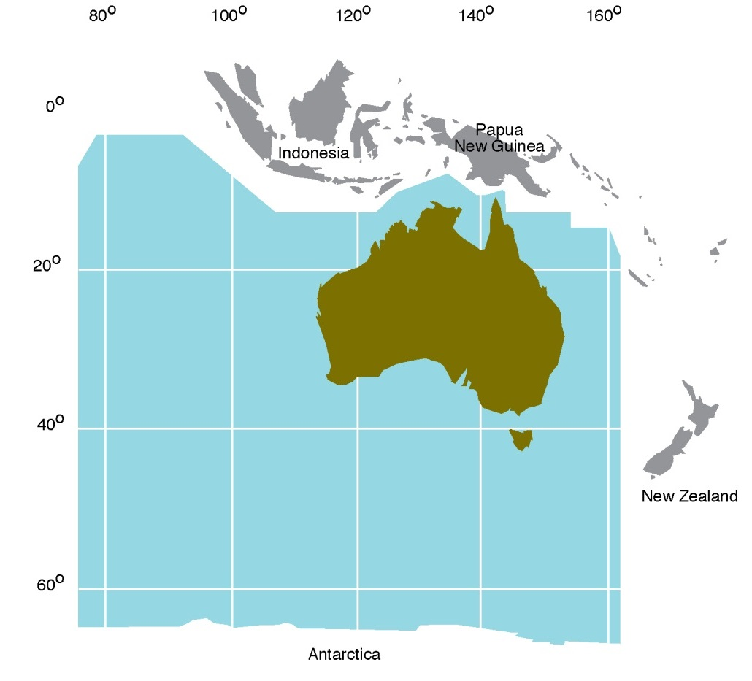

Schedule 2 REEFREP area

(subsection 4(3))

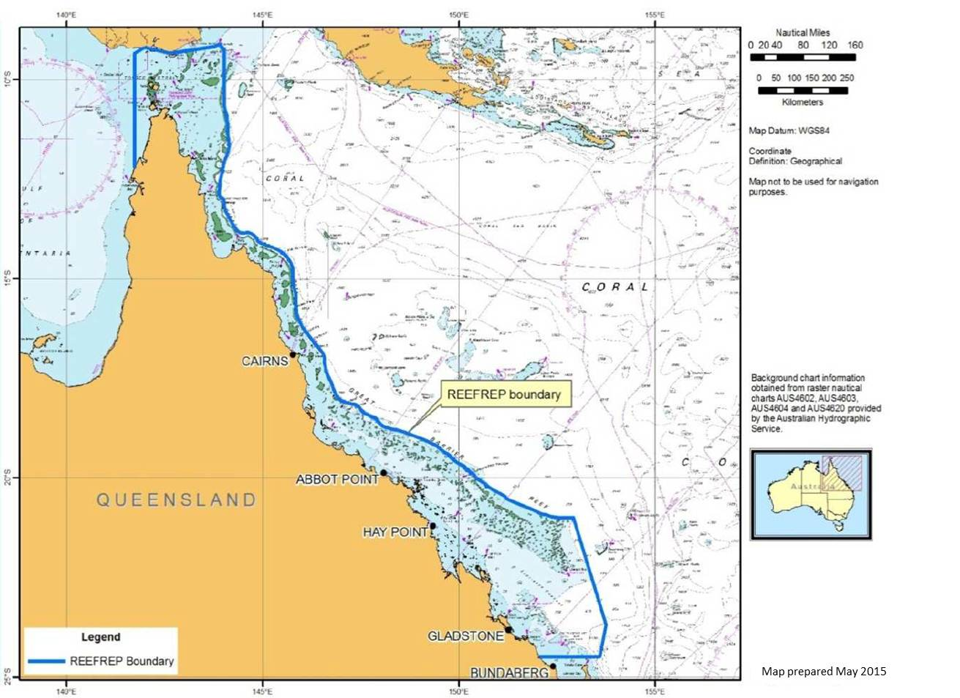

Schedule 3 Reports for vessels — MASTREP area

(subsection 7(1))

Position report

1 Information to be included in position report

A position report must include the following information about the vessel:

(a) identity;

(b) type;

(c) position;

(d) course;

(e) speed;

(f) navigational status.

*Note*Regulation 19.2.4 of Chapter V of SOLAS requires AIS to provide this information.

2 Position report to be transmitted by AIS

(1) A position report must be transmitted by AIS.

(2) The AIS must be operated in accordance with Regulation 19.2.4.7 of Chapter V of SOLAS.

*Note*Regulation 19.2.4.7 of Chapter V of SOLAS provides that AIS must be operated taking into account guidelines adopted by the IMO. Relevant guidelines are the *Revised guidelines for the onboard operational use of shipborne automatic identification systems (AIS)*,adopted by IMO Resolution A.1106(29), as amended from time to time.

(3) However, if the AIS malfunctions or the master of the vessel switches off the AIS for any safety or security reason, the position report must:

(a) be given manually by:

(i) VHF Radiotelephone on VHF channels in accordance with the vessel’s position and as mentioned in the table to subclause 6(1) of Schedule 4; or

(ii) any other means of communication requested by JRCC Australia; and

(b) be given hourly or as required by JRCC Australia; and

(c) include the following information:

(i) vessel name, call sign and IMO number;

(ii) date and time (in UTC);

(iii) current position (latitude and longitude);

(iv) speed (vessel’s anticipated average speed in knots and tenths of a knot).

Schedule 4 Reports for vessels — REEFREP area

(section 8)

1 Entry Report

(1) An Entry Report must be made at least 1 hour before a vessel:

(a) enters the REEFREP area; or

(b) departs from a port in the REEFREP area.

(2) The following information must be given in the Entry Report:

(a) vessel name, call sign and IMO number;

(b) date and time (in UTC);

(c) current position (latitude and longitude);

(d) date and estimated time (in UTC) of vessel’s entry to the REEFREP area;

(e) the last port visited, the next port to be visited and the route being used;

(f) speed (vessel’s anticipated average speed in knots and tenths of a knot);

(g) draught fore and aft (in metres and decimals of metres);

(h) position (latitude and longitude) of anticipated exit from the REEFREP area;

(i) if the vessel is fitted with recognized mobile satellite service equipment — the primary satellite equipment mobile number, manufacturer and model;

(j) vessel's satellite phone number;

(k)cargo information including normal name of the cargo and whether cargo is classified as hazardous;

(l) any of the matters required to be reported in accordance with clause 4;

(m)vessel details including vessel type, length (metres) and gross tonnage.

(3) For paragraph (2)(e):

(a) a standard route plan must be nominated; and

(b) any planned deviation from the standard route must be identified.

*Note*Standard route plans are set out in the REEFVTS User Guide available at the Maritime Safety Queensland website: http://www.msq.qld.gov.au/Shipping. Standard route plans have been developed to enable vessels to communicate their intended route through the REEFREP area.

2 Route Deviation Report

(1) If there is a deviation from the route mentioned in the Entry Report, a Route Deviation Report must be made to REEFVTS within 15 minutes after the deviation takes place.

*Note*The Route Deviation Report should be made before the deviation occurs, if possible.

(2) The Route Deviation Report must contain the following information:

(a) vessel name, call sign and IMO number;

(b) date and time (in UTC);

(c) next port to be visited and route being used;

(d) draught fore and aft (in metres and decimals of metres).

(3) For paragraph 221(2)(e) of the Navigation Act, a deviation occurs if a vessel uses a leg that is different to a leg of the route stated in the Entry Report.

3 Position Reports

(1) If a vessel is transiting the REEFREP area, Position Reports must be given to REEFVTS.

(2) Position Reports must be given using AIS in accordance with Regulation 19.2.4.7 of Chapter V of SOLAS.

*Note*Regulation 19.2.4.7 of Chapter V of SOLAS provides that AIS must be operated taking into account guidelines adopted by the IMO. Relevant guidelines are mentioned in Schedule 3.

(3) The following information must be given in the Position Report:

(a) vessel name, call sign and IMO number;

(b) vessel type;

(c) current position (latitude and longitude);

(d) course;

(e) speed (vessel’s anticipated average speed in knots and tenths of a knot);

(f) navigational status.

(4) However, if the AIS malfunctions or the master of the vessel switches off the AIS for any safety or security reason, the position report must:

(a) be given manually by:

(i) VHF Radiotelephone on VHF channels in accordance with the vessel’s position and as mentioned in the table to subclause 6(1); or

(ii) any other means of communication requested by REEFVTS; and

(b) be given hourly or as required by REEFVTS; and

(c) include the following information:

(i) vessel name, call sign and IMO number;

(ii) date and time (in UTC);

(iii) current position (latitude and longitude);

(iv) speed (vessel’s anticipated average speed in knots and tenths of a knot).

*Note*See subparagraph 4(2)(d)(ii) for defect reporting requirements if AIS malfunctions.

4 Defect Report

(1) A Defect Report that includes the information mentioned in subclause (2) must be given to REEFVTS if a vessel in the REEFREP area:

(a) suffers damage, failure or breakdown affecting the safety of the vessel; or

(b) deviates because of damage, failure or breakdown; or

(c) is required, under the Navigation Act or the *Protection of the Sea (Prevention of Pollution from Ships) Act 1983*, to report:

(i) safety related information; or

(ii) an incident involving dangerous goods, harmful substances or marine pollutants.

(2) The information is the following:

(a) vessel name, call sign and IMO number;

(b) current position (latitude and longitude) and date and time (in UTC);

(c) speed (vessel’s anticipated average speed until next report, in knots and tenths of a knot);

(d) description and details of any damage, failure or breakdown suffered, including:

(i) collision, grounding, fire, explosion, structural failure, flooding or cargo shifting; and

(ii) failure or breakdown of steering gear, propulsion plant, electrical generating system or essential shipborne navigational aids;

(e) details, using recognised IMO reporting formats, of:

(i) safety messages including on matters such as navigational safety, abnormal weather or unserviceable aids to navigation; and

(ii) incident reports involving dangerous goods, harmful substances or marine pollutants.

5 Final Report

(1) A Final Report must be given to REEFVTS when a vessel is:

(a) exiting the REEFREP area; and

(b) arriving at a port in the REEFREP area.

(2) The Final Report must include the following information:

(a) name, call sign and IMO number of vessel;

(b) the position (latitude and longitude) and date and time (in UTC) of vessel’s exit from the REEFREP area;

(c) if arriving at a port in the REEFREP area — the position (latitude and longitude) and date and time (in UTC) of arrival at the port.

6 Reporting method

In this Schedule:

(1) A report mentioned in this Schedule must be made by one of the following methods:

(a) **AIS**;

(b) **recognised mobile satellite service**;

(c) **VHF Radiotelephone**— on VHF channels in accordance with the vessel’s position and as mentioned in the following table:

| Latitude from: | Latitude to: | VHF Channel |
| --- | --- | --- |
| 9° 00´ S | 13° 30´ S | 14 |
| 13° 30´ S | 18° 00´ S | 11 |
| 18° 00´ S | 20° 00´ S | 14 |
| 20° 00´ S | 22° 00´ S | 11 |
| 22° 00´ S | 24° 30´ S | 14 |

(d) on telephone number +61 1300 721 293;

(e) on fax number +61 7 4721 0633;

(f) by email: reefvts@vtm.qld.gov.au.

*Note for paragraph (b)*   Messages sent by Inmarsat-C may use special access code (SAC) 861 through POR LES (212). This service is free of charge.

*Note for paragraph (c)*REEFVTS is operational 24 hours a day.

(2) However, subclause (1) does not apply to Position Reports.

(3) The language to be used for reporting is English, using the IMO *Standard Marine Communications Phrases*.

(4) If failure of a vessel’s equipment prevents reporting, an entry must be made:

(a) for radio equipment — in the vessel’s radio log book; and

(b) for other equipment — in the vessel’s official logbook.

Note

1. All legislative instruments and compilations of legislative instruments are registered on the Federal Register of Legislation under the *Legislation Act 2003.* See https://www.legislation.gov.au.