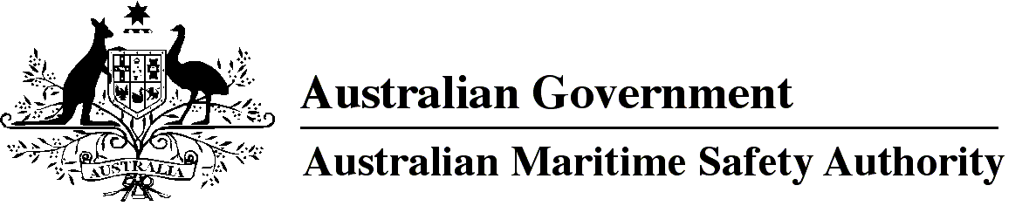

AMSA MO 2019/9

Marine Order 21 (Safety and emergency arrangements) Amendment Order 2019

I, Allan Schwartz, Acting Chief Executive Officer of the Australian Maritime Safety Authority, make this Marine Order under subsection 342(1) of the *Navigation Act 2012*.

19 November 2019

Allan Schwartz  
Acting Chief Executive Officer

1 Name of Marine Order

This Marine Order is *Marine Order 21 (Safety and emergency arrangements) Amendment Order 2019*.

2 Commencement

This Marine Order commences on 1 January 2020.

3 Amendment of *Marine Order 21 (Safety and emergency arrangements) 2016*

Schedule 1 amends *Marine Order 21 (Safety and emergency arrangements) 2016*.

Schedule 1 Amendment

[1] Subparagraph 2(b)(i)

omit

Regulation 21

insert

Regulations 19-1 and 21

[2] Subsection 19(5)

substitute

(5) The master of a vessel must ensure that the emergency drill and damage control drill procedures mentioned in Schedule 1 are carried out in accordance with Regulation 19-1 of Chapter II-I and Regulations 19 and 30 of Chapter III of SOLAS.

Note   MSC.1/Circ. 1446/Rev.2 recommends for passenger ships that practice musters are conducted before departure at each port of embarkation.

[3] Paragraph 23(2)(a)

substitute

(a) assign to seafarers emergency duties, including damage control duties; and

[4] Schedule 1, clause 6

omit

A damage control drill

insert

(1) A damage control drill for a vessel

[5] Schedule 1, after clause 6

insert

(2) However, the master of a passenger vessel must, in addition to meeting the requirements of subclause (1):

(a) conduct a damage control drill at least every 3 months; and

(b) vary the damage control drill scenarios for different damage conditions; and

(c) ensure that any seafarer with damage control drill responsibilities:

(i) participates in each drill; and

(ii) is familiar with their duties before a voyage begins; and

(iii) is familiar with the vessel’s damage control system; and

(iv) is instructed in damage survey.

(3) The following are also required for each damage control drill on a passenger vessel:

(a) any seafarer with damage control drill responsibilities must report to the seafarer’s muster station and prepare for duties mentioned in the muster list;

(b) any bilge pump must be operated and its alarm and automatic starting system checked;

(c) any communication link to shore based support must be tested;

(d) stability assessments must be conducted for the simulated damage conditions by using:

(i) damage control information; and

(ii) if fitted — an on board damage stability computer; and

(iii) if the vessel has a communication link to shore based support — the activated link at least once a year;

(e) any seafarer with damage control drill responsibilities must demonstrate the ability to:

(i) operate watertight doors and closures; and

(ii) if fitted — use the flooding detection system and the cross-flooding and equalisation systems.

**Note**

1. All legislative instruments and compilations of legislative instruments are registered on the Federal Register of Legislation under the *Legislation Act 2003.* See https://www.legislation.gov.au.