

**Food Standards (Application A1161 –** **Potassium polyaspartate as a Food Additive) Variation**

The Board of Food Standards Australia New Zealand gives notice of the making of this variation under section 92 of the *Food Standards Australia New Zealand Act 1991*. The variation commences on the date specified in clause 3 of the variation.

Dated 28 November 2019

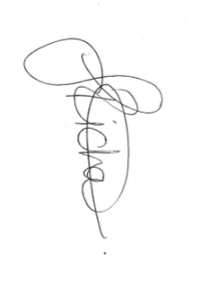

Joanna Richards

Standards Management Officer

Delegate of the Board of Food Standards Australia New Zealand

**Note:**

This variation will be published in the Commonwealth of Australia Gazette No. FSC 129 on 5 December 2019. This means that this date is the gazettal date for the purposes of the above notice.

**1 Name**

This instrument is the *Food Standards (Application A1161 – Potassium polyaspartate as a Food Additive) Variation*.

**2 Variation to Standards in the *Australia New Zealand Food Standards Code***

The Schedule varies standards in the *Australia New Zealand Food Standards Code*.

**3 Commencement**

The variation commences on the date of gazettal.

**Schedule**

**[1] Standard 4.5.1** is varied by

[1.1] inserting in the table to clause 3, in alphabetical order

|  |
| --- |
| Potassium polyaspartate |

[1.2] omitting paragraph 5(5)(h), substituting

(h) 200 mg/L of added dimethyl dicarbonate; and

(i) 100 mg/L of potassium polyaspartate.

**[2] Schedule 8** is varied by

[2.1] inserting in the table to section S8—2 entitled ‘Food additive names—alphabetical listing’, in alphabetical order

|  |  |
| --- | --- |
| Potassium polyaspartate | 456 |

[2.2] inserting in the table to section S8—2 entitled ‘Food additive names—numerical listing’, in numerical order

|  |  |
| --- | --- |
| 456 | Potassium polyaspartate |

**[3] Schedule 15** is varied by inserting in item 14.2.2 of the table to section S15—5, in numerical order

|  |  |  |  |
| --- | --- | --- | --- |
| 456 | Potassium polyaspartate | 100 |  |