

**Food Standards (Application A1166 – Reduction in minimum alcohol for Tequila) Variation**

The Board of Food Standards Australia New Zealand gives notice of the making of this variation under section 92 of the *Food Standards Australia New Zealand Act 1991*. The variation commences on the date specified in clause 3 of this variation.

Dated 28 November 2019

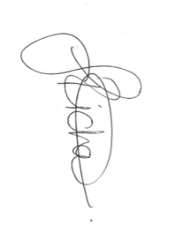

Joanna Richards

Standards Management Officer

Delegate of the Board of Food Standards Australia New Zealand

**Note:**

This variation will be published in the Commonwealth of Australia Gazette No. FSC 129 on 5 December 2019. This means that this date is the gazettal date for the purposes of clause 3 of the variation.

## 

**1 Name**

This instrument is the *Food Standards (Application A1166 – Reduction in minimum alcohol for Tequila) Variation*.

**2 Variation to a standard in the *Australia New Zealand Food Standards Code***

The Schedule varies a Standard in the *Australia New Zealand Food Standards Code*.

**3 Commencement**

The variation commences on the date of gazettal.

**Schedule**

**[1] Standard 2.7.5** is varied by omitting subsection 2.7.5—3(3), and inserting

(3) A food that is sold as a spirit must:

(a) be a spirit, and;

(b) contain no less than:

(i) in the case of tequila—35% alcohol by volume; and

(ii) otherwise—37% alcohol by volume.