

**Food Standards (Application A1173 – Minimum protein in follow-on formula) Variation**

The Board of Food Standards Australia New Zealand gives notice of the making of this variation under section 92 of the *Food Standards Australia New Zealand Act 1991*. The variation commences on the date specified in clause 3 of this variation.

Dated 28 November 2019

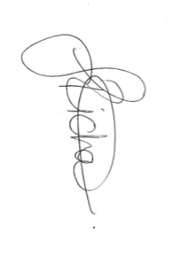

Joanna Richards

Standards Management Officer

Delegate of the Board of Food Standards Australia New Zealand

**Note:**

This variation will be published in the Commonwealth of Australia Gazette No. FSC 129 on 5 December 2019. This means that this date is the gazettal date for the purposes of clause 3 of the variation.

1 Name

This instrument is the *Food Standards (Application A1173 – Minimum protein in follow-on formula) Variation.*

2 Variation to a standard in the *Australia New Zealand Food Standards Code*

The Schedule varies a Standard in the *Australia New Zealand Food Standards Code*.

3 Commencement

The variation commences on the date of gazettal.

**Schedule**

**[1] Standard 2.9.1** is varied by

[1.1] omitting paragraph 2.9.1—9(2)(b), substituting

(b) the following protein content:

(i) for a milk-based follow-on formula—a protein content of no less than 0.38 g/100 kJ and no more than 1.3 g/100 kJ; and

(ii) for all other follow-on formulas—a protein content of no less than 0.45 g/100 kJ and no more than 1.3 g/100 kJ;

[1.2]      inserting after subsection 2.9.1—9(2)

***Note***   Section 2.9.1—15 sets the protein content for infant formula and follow-on formula that are for special dietary use based on a *protein substitute.