

**Food Standards (Proposal P1054 – Pure and highly concentrated caffeine products) Variation**

The Board of Food Standards Australia New Zealand gives public notice of the approval of this variation under section 97 of the *Food Standards Australia New Zealand Act 1991*. The variation commences on the date specified in clause 3 of this variation.

Dated 11 December 2019

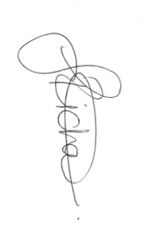

Standards Management Officer

Delegate of the Board of Food Standards Australia New Zealand

**Note:**

Public notice of the approval of the variation will be given in the *Food Standards Australia New Zealand Notification Circular* Number 105-19 published and issued on 12 December 2019. This means that this date is the date of public notice for the purposes of clause 3 of the variation.

**1 Name**

This instrument is the *Food Standards (Proposal P1054 – Pure and highly caffeinated products) Variation*.

**2 Variation to a standard in the *Australia New Zealand Food Standards Code***

The Schedule varies a Standard in the *Australia New Zealand Food Standards Code*.

**3 Commencement**

The variation commences on the date of public notice of the approval of the variation.

**4 Transitional arrangements**

Section 1.1.1–9 of the *Australia New Zealand Food Standards Code* does not apply to the variations made by this instrument.

**Schedule**

**[1] Standard 1.1.1** is varied by omitting paragraph 1.1.1—10(5)(f), substituting

(f) if the food is for retail sale—raw apricot kernels;

(g) if the food is for retail sale—a food in which caffeine is present at a concentration of:

(i) 5% or greater—if the food is a solid or semi-solid food; and

(ii) 1% or greater—if the food is a liquid food.