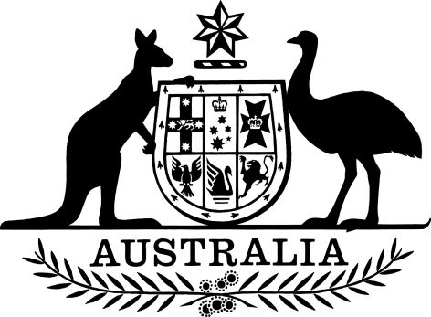

Commonwealth of Australia

Tertiary Education Quality and Standards Agency Act 2011

Notice of Revocation of Ministerial Direction No. 2 of 2013

I, Dan Tehan, Minister for Education, pursuant to subsection 155(1) of the Tertiary Education Quality and Standards Agency Act 2011 and subsection 33(3) of the Acts Interpretation Act 1901, revoke Ministerial Direction No. 2 of 2013 made on 22 October 2013 (F2013L01824).

This revocation takes effect the day after it is registered on the Federal Register of Legislation.

Dated: 12 December 2019

______________________________
DAN TEHAN
Minister for Education

