**INTERGOVERNMENTAL AGREEMENT  
CRIMES AT SEA**

This Agreement is made on **29 November 2019**

Between

The Commonwealth of Australia

The State of New South Wales

The State of Victoria

The State of Queensland

The State of Western Australia

The State of South Australia

The State of Tasmania

The Northern Territory

**GIVEN THAT**

1. the Commonwealth and the States have agreed to a cooperative scheme to apply the criminal law of the States extraterritorially in the areas adjacent to the coast of Australia; and
2. the cooperative scheme is given the force of law by the following laws:
   1. *Crimes at Sea Act 2000* (Commonwealth);
   2. *Crimes at Sea Act 1998* (New South Wales);
   3. *Crimes at Sea Act 1999* (Victoria);
   4. *Crimes at Sea Act 2001* (Queensland);
   5. *Crimes at Sea Act 2000* (Western Australia);
   6. *Crimes at Sea Act 1998* (South Australia);
   7. *Crimes at Sea Act 1999* (Tasmania);
   8. *Crimes at Sea Act 2000* (Northern Territory); and
3. clause 5 of the cooperative scheme authorises the making of an intergovernmental agreement providing for the division of responsibility for administering and enforcing the law relating to crimes at sea.

**THE COMMONWEALTH AND THE STATES AGREE AS FOLLOWS**

1. **Definitions**

In this Agreement:

***adjacent area***means an area where the law of a State is applied by Commonwealth law.

***adjacent state,***in relation to an adjacent area, means the State whose laws are applied to that area by Commonwealth law.

***applied laws,***in relation to a State, means the substantive and procedural laws applied to the State by clauses 2 and 3 of the cooperative scheme.

***arrival State*** means the participating State in which an Australian ship next arrives, with the alleged offender on board, after an offence has been committed on or from that ship within the adjacent area of another participating State.

***Australian ship*** has the meaning given by clause 1 of the cooperative scheme.

***authority*** has the meaning given in clause 3 of the cooperative scheme.

***Commonwealth*** means the Commonwealth of Australia.

***cooperative scheme*** means the legislative and administrative scheme for applying and enforcing criminal law in the areas adjacent to the coast of Australia, set out in Schedule 1 to the *Crimes at Sea Act 2000* (Commonwealth).

***participating State*** means a State that is party to the cooperative scheme and this Agreement.

***State*** has the meaning given by clause 1 of the cooperative scheme.

1. **Duty etc of an authority of an adjacent State**

An authority (other than a court) of a State that has a power, duty or function (other than a power, duty or function involving the exercise of judicial power) under a provision of the criminal law of that State that is also an applied law, has a corresponding power, duty or function under the applied law.

1. **International obligations to be observed**

In exercising or performing powers, duties and functions under the cooperative scheme, the parties and their agencies must act so as to avoid any breach by Australia of its international obligations, in particular under the United Nations Convention on the Law of the Sea, having regard especially to the responsibilities of Australia with respect to ships of the Australian flag, and to the rights of other countries in the maritime areas to which the arrangements in this Agreement apply.

1. **Application of primary responsibility**
2. In respect of an alleged offence in an adjacent area, the adjacent State has primary responsibility for taking investigation and prosecution action under its applied laws in any of the following circumstances:
   1. the conduct occurs on, from or in relation to, a fixed or floating platform or other installation in that area;
   2. the conduct occurs on or from an Australian ship and the next place of entry to Australia is, or is intended to be at the time the conduct occurs, within that State;
   3. the alleged offender is an Australian citizen whose next place of entry to Australia is, or is intended to be at the time the conduct occurs, within that State.
3. However:
   1. the arrival State has primary responsibility for taking investigation and prosecution action if the conduct occurs on or from an Australian ship and the next place of entry to Australia is within that State; and
   2. the Commonwealth has primary responsibility for taking investigation and prosecution action in respect of any alleged offence on or from an Australian Defence Force ship when it is outside the limits of a State.
4. **Investigatory etc decision to conform to standard**

A decision of an authority of the State (or the Commonwealth) having primary responsibility under clause 4 whether to investigate, or further investigate, or prosecute or seek extradition, must be taken in the same manner and subject to the same considerations and policies as apply to decisions in relation to other similar alleged offences against the laws of that State or the Commonwealth.

1. **Undertaking to consult**
2. Where more than one party may take investigation or prosecution action in relation to the same alleged offence, the parties concerned must consult at the request of any of them on how the matter should be dealt with.
3. If, following consultation, it appears that one of those parties may more conveniently take action to investigate or prosecute the alleged offence, it should do so.
4. **Undertaking to assist other parties**

Bearing in mind the possible difficulties for any single party of taking action at sea in relation to an alleged offence:

1. any other party must, on request, give whatever assistance it considers practicable to the party with primary responsibility in relation to the alleged offence; and
2. the Commonwealth must, on a request for assistance being made to the Attorney‑General of the Commonwealth by the Attorney‑General of the State with primary responsibility in relation to the alleged offence, use its best endeavours to secure that assistance from any relevant Commonwealth department, body or agency (including the Australian Defence Force, the Australian Border Force and the Australian Federal Police), and any such assistance may include:
   1. the gathering of evidence; or
   2. the provision of investigating personnel; or
   3. the provision of transport, communication facilities or information.
3. **Date of effect**
4. This Agreement commences at the start of the day after the instrument is registered.
5. **Agreement supersedes previous Agreement**
6. This Agreement supersedes the Intergovernmental Agreement – Crimes at Sea (Commonwealth of Australia Gazette, GN 49, 12 December 2001 at 3596 to 3600).

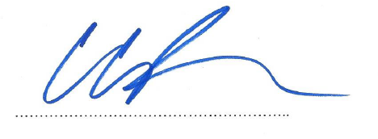

SIGNED by the Honourable Attorney‑General of the Commonwealth of Australia

in the presence of:



SIGNED by the Honourable Attorney‑General of the State of New South Wales,

in the presence of:

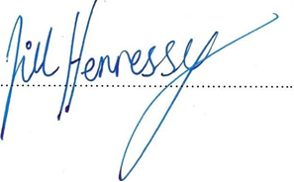

SIGNED by the Honourable Attorney‑General of the State of Victoria,

in the presence of:

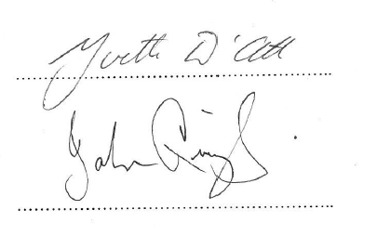SIGNED by the Honourable Attorney‑General of the State of Queensland,

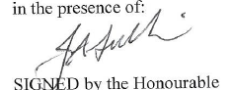in the presence of:

SIGNED by the Honourable Attorney‑General of the State of Western Australia,

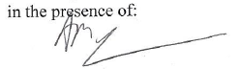in the presence of:

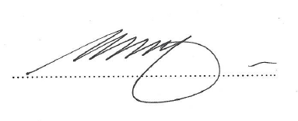

SIGNED by the Honourable Attorney General of the State of South Australia,

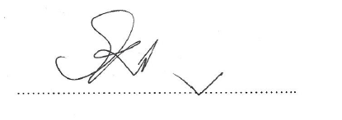in the presence of:

SIGNED by the Honourable Attorney General of the State of Tasmania,

in the presence of:

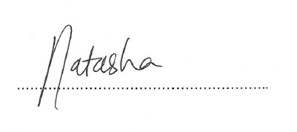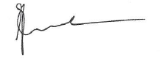  
  
SIGNED by the Honourable Attorney General of the Northern Territory,  
in the presence of: