

Future Drought Fund (Drought Resilience Funding Plan 2020 to 2024) Determination 2020

I, DAVID LITTLEPROUD, Minister for Agriculture, Drought and Emergency Management, make the following determination.

Dated 10th February 2020

David Littleproud

Minister for Agriculture, Drought and Emergency Management.

1 Name

This instrument is the *Future Drought Fund (Drought Resilience Funding Plan 2020 to 2024) Determination 2020*.

2 Commencement and repeal

This instrument commences on the day after it is registered.

Note: Subsection 31(4) of the *Future Drought Fund Act 2019* provides that the Drought Resilience Funding Plan comes into force at the start of the day after registration under the *Legislation Act 2003*. The Plan is repealed at the end of the 4‑year period that begins when the Plan comes into force, unless it is repealed earlier.

3 Authority

This instrument is made under section 31 of the *Future Drought Fund Act 2019* (***the Act***).

4 Schedules

The plan in Schedule 1 is the Drought Resilience Funding Plan determined under section 31 of the Act, for ensuring that a coherent and consistent approach is adopted in:

1. making arrangements or grants under section 21 of the Act; and
2. entering into agreements under section 22 of the Act.

Schedule 1—Drought Resilience Funding Plan for 2020 to 2024

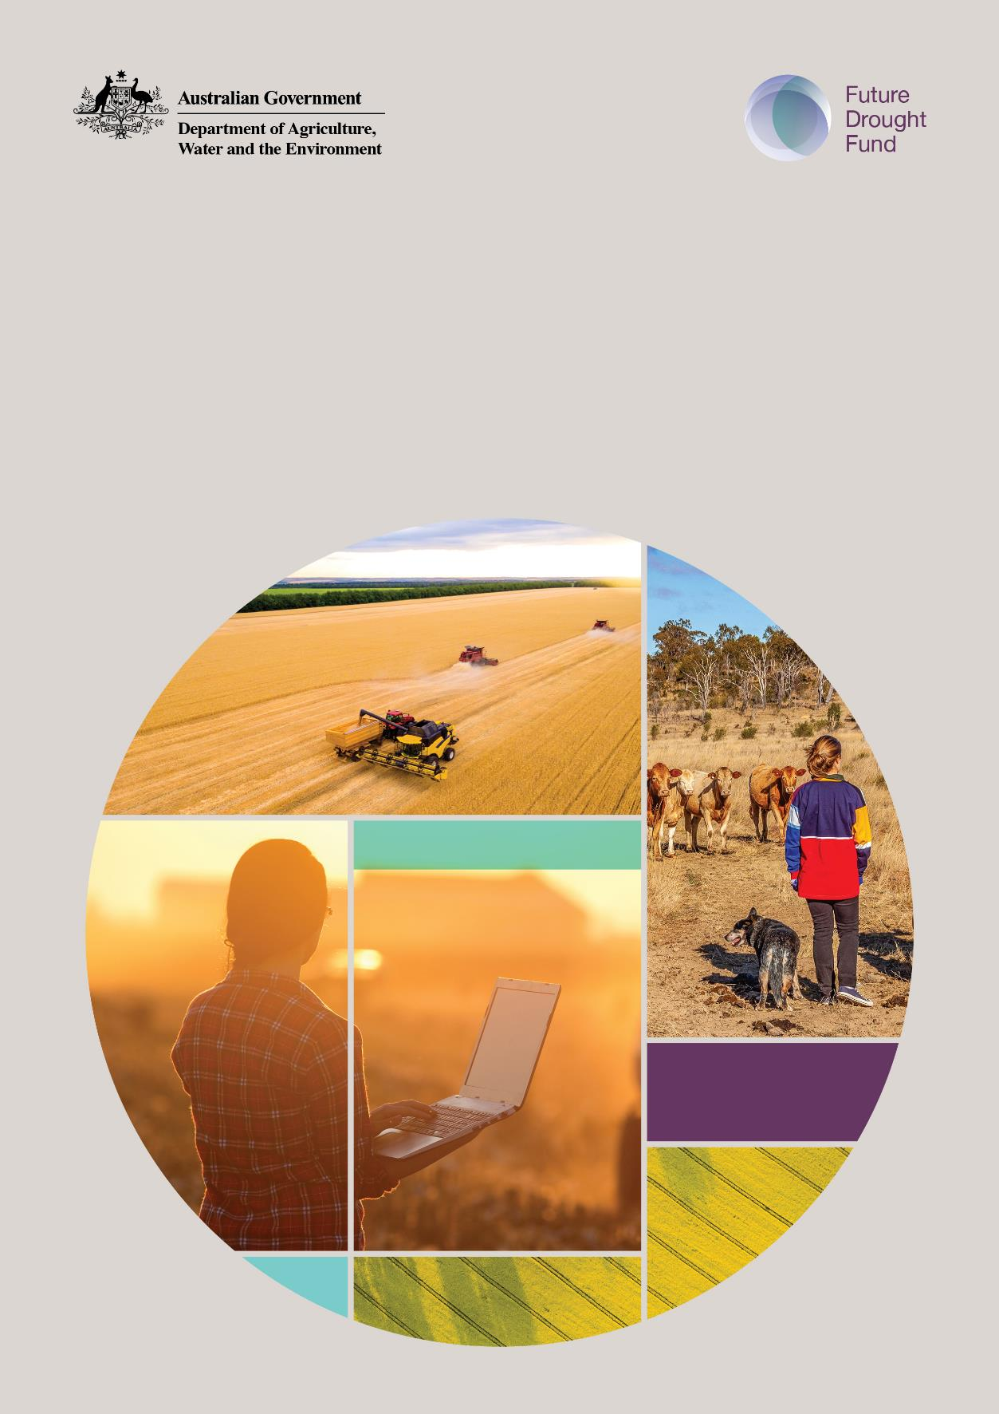

**Drought Resilience Funding Plan 2020 to 2024**

Contents

Funding principles 4

Vision 5

Aim 5

Strategic priorities 5

Objectives 5

Strategic priorities in detail 6

**Drought Resilience Funding Plan**

The Drought Resilience Funding Plan (the Plan) sets out an approach for making arrangements or grants in relation to drought resilience, or entering into agreements in relation to such grants.

For the purposes of the Future Drought Fund (the Fund), 'drought resilience' means the ability to adapt, reorganise or transform in response to changing temperature, increasing variability and scarcity of rainfall and changed seasonality of rainfall, for improved economic, environmental and social wellbeing.

The Plan serves as a framework for all expenditure from the Agriculture Future Drought Resilience Special Account. Before the Minister for Drought allocates funding, the minister must first:

* seek advice from the Fund’s Consultative Committee (the committee) on the design of programs to ensure they comply with the Plan
* seek independent technical expert advice from the Regional Investment Corporation Board—and other expert advice if necessary—on the making of individual grants or arrangements.

As stated in the *Future Drought Fund Act 2019*, the purpose of the Fund is to **enhance the public good by building drought resilience**. This means the benefits generated by the funding must be able to be accessed and/or shared by many (public benefits), rather than be captured solely by individual businesses or industries solely for private commercial gain (private benefits). It also means the benefits achievable from the funding should outweigh the costs. Wherever projects could deliver both public and private benefits, the Fund should seek to leverage private or industry co‑contributions.

For infrastructure and other capital investment or on-ground works, 'public good' is taken to mean that the project would not otherwise be able to recover costs—for example, utility pricing—and should deliver significant spill-over benefits for society and the economy, well beyond those derived by private beneficiaries. This is similar to health and education where public funds deliver spill-over benefits. This approach is consistent with the quantum of funding available ($100 million per year) and the range of other drought resilience measures to be supported by the Fund in addition to infrastructure.

**Funding principles**

These funding principles apply:

* in relation to any arrangements and grants made to a person or body under section 21 of the *Future Drought Fund Act 2019*; and
* where such arrangements and grants relate to a program of further arrangements and grants to be made by the person or body for the purposes set out in that section, in relation to those further arrangements and grants.

The arrangements and grants will:

1. be consistent with the Vision, Aim, Strategic Priorities and Objectives outlined in this Plan
2. ensure only projects and activities that enhance the public good by building drought resilience are funded. Projects and activities must deliver significant benefits that can be accessed or shared by many (rather than be captured solely by individual businesses or industries solely for commercial gain)
3. not provide in-drought assistance
4. not duplicate or replace existing Commonwealth, state, territory or local government funding programs, and will aim to improve the coordination or integration of existing Commonwealth Government policies, frameworks and programs where they meet the Fund’s purpose
5. be delivered in accordance with Commonwealth guidelines where applicable including the Commonwealth Grants Rules and Guidelines 2017, the Commonwealth Procurement Rules 2019 and the *Federal Financial Relations Act 2009*
6. consider the incremental, transitional and transformational opportunities needed to strengthen drought resilience and encourage innovative proposals
7. support a range of activities or projects at a mixture of levels, such as the farm, regional or national level
8. deliver programs through a user-based lens and, where possible, a community-led, co‑design, and/or end-user approach
9. ensure eligibility for programs is streamlined and, where possible, minimise the burden of regulation on businesses, community organisations and individuals
10. recognise the diversity of people, businesses and landscapes involved in agricultural production, including Indigenous landholders
11. where appropriate, use or collaborate with existing community networks, Indigenous organisations and communities, natural resource management organisations, industry and farmer groups
12. use a structured and, where appropriate, contestable process to identify the best value and highest quality ideas, talent and projects
13. as far as practicable, require co-investment to maximise program outcomes
14. consider proposals favourably that have enduring outcomes and avoid creating barriers to change or adaptation
15. consider potential qualitative and quantitative outcomes and expected public benefits as part of the assessment process for all programs and projects—not necessarily in monetary terms—and articulate why the funding is needed to achieve these benefits
16. ensure there are no ongoing operational or maintenance dependencies from the Fund when considering proposals for new or existing infrastructure
17. ensure that all new knowledge is shared and freely made available in the public domain.

**Vision**

The Fund's vision is an innovative and profitable farming sector, a sustainable natural environment and adaptable rural, regional and remote communities—all with increased resilience to the impacts of drought and climate change.

**Aim**

The Fund aims to enhance the public good by building drought resilience in Australia's agricultural sector, the agricultural landscape, and communities.

**Strategic priorities**

The Fund has three inter-connected strategic priorities:

* economic resilience for an innovative and profitable agricultural sector
* environmental resilience for sustainable and improved functioning of farming landscapes
* social resilience for resourceful and adaptable communities.

**Objectives**

The Fund’s three objectives to achieve the strategic priorities will enhance the public good by building drought resilience through programs that will:

* grow the self-reliance and performance (productivity and profitability) of the agricultural sector
* improve the natural capital of agricultural landscapes for better environmental outcomes
* strengthen the wellbeing and social capital of rural, regional and remote communities.

**Strategic priorities in detail**

Strengthening the economic, environmental and social resilience for future droughts will assist producers and communities to become more productive, competitive and sustainable. Attention to all three strategic priorities is needed to deliver a holistic approach to building drought resilience.

The three strategic priorities will guide the design of the Fund's programs and do not imply an equal allocation of funding across the three areas. Funding allocation will be determined through the Fund's program design, based on this Plan, and the quality of applications received. As far as practicable, the design of each of the Fund's programs will seek to address all three strategic priorities.

**Strategic priority: Economic resilience for an innovative and profitable agricultural sector**

**Objective**

* Enhance the public good by building drought resilience to grow the self-reliance and performance (productivity and profitability) of the agricultural sector.

The Fund will improve information, planning, evaluation, management capacity and incentives that deliver on this objective at all levels—from farm and community to regional and industry. The Fund will catalyse an enterprising and innovative culture for adaptability and transformative change.

**Actions**

Knowledge, innovation and extension

* Support the collection, management, public accessibility and application of data and information to improve farm and agri-business decision-making, risk assessment and management.
* Support the development of systems and collaborations that enable better analysis and practical application of data and information, including thresholds, trends and projected changes to agri‑climatic zones.
* Support the development and availability of an innovative drought resilience research, development, extension and adoption strategy—including a stocktake and evaluation of drought resilience research and extension—in a process that will involve end users to maximise the relevance and adoption of outcomes.
* Encourage the leveraging of investment, including through public and private partnerships and other potential investors, to address gaps and investment opportunities in research, innovation and extension.
* Identify and review innovative solutions developed overseas for drought resilience, with a view to adapting them to suit Australia’s agricultural sector.
* Encourage the generation of ideas, information sharing and the adoption of regionally and industry relevant research, development and extension through collaborations with public and private sector extension organisations and networks.
* Support improved weather information over a range of timeframes and levels regarding drought risk, such as early warning systems, seasonal forecasts, future climate projections and impacts for agriculture.
* Support demand driven research including cross-sectoral, development, extension and adoption to expand technologies available to primary producers and agribusiness to respond to risks such as drought—both within their current industries and activities and to enable switches to new enterprises.

Collaboration and building capability

* Increase primary producers' understanding of their farm business drought resilience level
  + including through sharing information—for example, on climate data, soil health, water use efficiency, maintenance of groundcover, capturing carbon and the efficient use of inputs—and/or
  + by encouraging voluntary farm resilience assessments where appropriate.
* Support improved strategic management capacity of farm business managers through the use of innovative tools, improved drought risk business planning, education and training, and improved knowledge of—and access to—market and private sector services.
* Encourage primary producers to adopt innovative approaches and technology, including on and off‑farm diversification options or new farming practices, farming systems and markets (e.g. emerging carbon markets).
* Promote approaches that overcome barriers to developing innovative infrastructure or creating new lines of business.

**Why is this strategic priority needed?**

Preparing for drought is a critical part of managing the commercial risks associated with agriculture. Preparation involves more than purely adopting appropriate production strategies. It should also entail business management planning and sound decision-making. Forward planning, setting performance targets and monitoring progress has been associated with improved farm innovation and financial performance, particularly the ability to withstand variation in income and profits over time. This includes consecutive years with low or negative profits, which may occur due to poor seasonal conditions and commodity prices.

Research, development, extension and adoption is crucial for building drought resilience. When focused on farming and community needs, these activities can guide technological advances and support good decision-making and risk management, helping producers to adjust.

As noted by Ernst & Young in their 2019 *Agricultural Innovation* report, innovation culture in Australia is generally considered risk averse and there is a need to encourage and support a culture of entrepreneurship, appetite for risk and transformational innovation. Structured management practices are a key driver of enterprise performance. However, in a recent study by the University of Technology Sydney and the Department of Industry, Innovation and Science, agriculture, forestry and fishing was found to be the lowest performing industry when assessed on overall management capabilities in Australia (66% below the top-performing sector). In digital management capability, agriculture was again the lowest performing sector by an even larger margin.

**How is this strategic priority best addressed?**

The Fund can help build, inform and embed sound farm business planning, risk management and innovation to help the agriculture sector respond to the challenges of the future including climate change and more frequent droughts. Economic resilience has strong public benefits in terms of reduced requirements for government in-drought support, the financial means to invest in natural resource management, more robust regional communities and improved health, education and recreational services.

Good decision-making and business planning are the most important tools for proactively managing farm risk and helping to build economic resilience. Sustainable drought-resilient primary producers understand and undertake business planning and use risk management tools available to them to design an overall risk management strategy that is appropriate for their business. Strong financial literacy and business acumen—such as understanding the trade-off between risk and return and how specific risk management products work—are key elements. Development of detailed drought plans for farm businesses helps identify and implement strategies to enhance future drought preparedness, response and resilience.

Primary producers are in the best position to assess the climate and other risks they face and adopt risk management strategies or undertake transformational change, based on their individual circumstances. But to do so, they need an innovative framework with accessible research, development and information that can be tailored, adapted and applied to on-farm practice. This includes maximising the collection and use of data to improve decision-making, reduce risk and support transformational change where necessary.

Enabling primary producers to make informed decisions and improve their capability to adapt quickly so they are equipped to reduce the impacts of future droughts on their business' viability is essential. Collaboration and building capacity are an important part of developing drought risk‑management strategies and could include upskilling to adopt innovative approaches to business planning, property management and diversification options.

**Strategic priority: Environmental resilience for sustainable and improved functioning of farming landscapes**

**Objective**

* Enhance the public good by building drought resilience to improve the natural capital of agricultural landscapes for better environmental outcomes.

The Fund will support improved information, planning, management capacity and incentives that deliver on this objective at all agricultural landscape levels—from farm and community level through to regional and agri-industry groups and organisations. The Fund will support the improvement of the natural resource base for long-term productivity, landscape health and sustainability credentials. This will improve the agricultural sector's access to economic diversification options related to natural resource management, including through emerging markets and alignment with existing or future sustainability frameworks.

**Actions**

Knowledge, innovation and extension

* Improve information and management capacity for farming practices and systems that support improved functioning of agricultural landscapes.
* Facilitate primary producers’ increased knowledge of market and private sector services to improve natural resource management and enable access to emerging markets.
* Support the collection, management, public accessibility and application of data and information to improve natural resource management.
* Support the development of systems and collaborations that enable better analysis and practical application of data, including for farm natural resource management practices.
* Involve end users to co-design local natural resource management research development, extension and adoption. This will help to develop tailored outcomes and the adoption of the research.
* Support incentives for practice change that will build or redesign landscapes for improved functioning.
* Support primary producers to adopt strategies for improving soil health, land cover, water and biodiversity

Collaboration and building capability

* Encourage improved natural resource management capability through planning and training on financial, drought and risk management
* Support on-ground projects that enhance the resilience of natural capital in agricultural landscapes—including adoption of new or existing technology and practices.
* Incentivise local and regional organisation’s capabilities by trialling and adopting new natural resource management practices and technology through collaboration.
* Support landholders to undertake voluntary environmental resilience assessments or other measures to better understand their environmental resilience level

Natural capital and commercial opportunities

* Promote the development and adoption of new or existing commercial opportunities and technologies that support improvement of natural resource condition and resilience.
* Support the creation and uptake of commercial opportunities for investment into sustainable landscapes, and encourage increased private sector’s involvement in environmental management.

**Why is this strategic priority needed?**

Management of natural resources is an important contributor to drought resilience of farms and farm businesses and the long-term sustainability and productivity of Australia's agricultural landscapes. While natural resource management practices and programs are generally designed to have environmental and sustainable agriculture outcomes, there are also farm productivity and profitability benefits created by the protection and enhancement of the natural resource base and associated ecological services. This strengthens the capacity of primary producers and of farming systems to withstand and recover from drought conditions.

Stronger farm performance and resilience to climate shocks can be achieved through improved natural capital such as healthy soils, increased biodiversity, improved water quality, efficient water use and groundcover. This would also reduce the negative physical impacts of drought, such as soil moisture loss, weed spread, groundcover depletion, soil degradation, biodiversity loss and degraded ecosystem service. Beyond the physical aspects, primary producers' and land managers' engagement in activities to improve natural resource management practices has been linked with social connections, confidence in land management, improved health and wellbeing. Higher levels of well-managed natural resources contribute to wellbeing for individuals and the wider community—especially during drought—with positive impacts on economic and social resilience.

**How is this strategic priority best addressed?**

Natural resource management activities are highly diverse and sustainable and ideal practices will vary with geography and production management aims. While some may appear to directly influence economic and/or social resilience to drought, others may have no effect. Determining which activities have greatest potential impact on the drought resilience of farming systems and communities will be a key issue for the Fund's program design.

Building environmental resilience requires support for improvement of the natural resource base for long-term productivity, landscape health and sustainable products. This support could include improving information and management capacity, and exploring options for natural resource management‑related economic diversification (such as emerging carbon markets).

**Strategic priority: Social resilience for resourceful and adaptable communities**

**Objective**

* Enhance the public good by building drought resilience to strengthen the wellbeing and social capital of rural, regional and remote communities.

The Fund will support this objective by empowering communities to develop the skills and adopt innovative approaches to drought resilience, including community and regional planning, and supporting the use of existing and new networks to improve community wellbeing.

**Actions**

Information and planning

* Support data and information collection, coordination and supply to improve community and regional planning to build drought resilience.
* Empower communities to identify the impacts of drought and develop regional drought resilience and management plans
* Assist communities to develop and implement innovative activities that build drought resilience

Collaboration and building capability

* Facilitate increased community understanding of their drought resilience, including through training and information sharing—for example, case studies, inventory or support packages and making information readily accessible.
* Encourage communities with a high level of drought resilience to share learnings with other communities.
* Support community activities and initiatives that foster ongoing social networking, support, engagement and wellbeing.
* Encourage the development of local leaders, including youth, to enhance wellbeing and drive initiatives that build drought resilience.
* Support initiatives that strengthen and build leadership in communities to help build drought resilience, including exploring entrepreneurial opportunities.

Community facilities and infrastructure

* Support communities to implement small-scale enduring infrastructure projects to build drought resilience and enhance wellbeing—such as water efficient or recycling infrastructure for sporting and recreational facilities, upgrades to public gardens, tourist attractions and other community facilities.

**Why is this strategic priority needed?**

Drought can create difficulties in maintaining the social fabric or social capital of rural and regional Australia, which may threaten the viability of some rural communities. Despite sometimes sharing similar challenges, Australia's rural and regional communities differ greatly—social-economically, climatically, geographically, economically and in their proximity to large regional centres.

Social capital is built on social networks of trust, mutual support and understanding. When people are part of social networks, they are more involved in community life. Community and economic diversity is an important factor in increasing resilience. Drought can reduce people's ability to work together for the benefit of the whole community. For example, when people experience stressors impacting on their individual or family circumstances, they may have reduced capacity to engage in social and business networks. This may also reduce their capacity to empathise with their peers and learn innovative ways to manage through drought. It also reduces capacity to engage in community projects, sporting activities or voluntary work, all of which can help keep rural communities vibrant, prosperous and contribute to ongoing resilience against various shocks.

**How is this strategic priority best addressed?**

Building social resilience to encourage resourceful and adaptable communities could be achieved by providing support to help maintain and improve the wellbeing and social fabric of rural and regional communities—particularly through a community-led approach. Communities could be supported to undertake planning, projects and activities that will build their social resilience. Developing local leaders, including youth leaders, will help to drive initiatives to build resilience. Broadening the social networking and support to other communities to share learnings and success stories would also be of benefit.