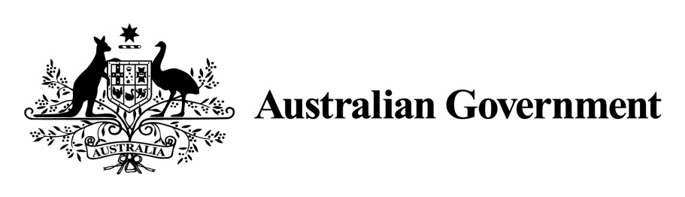

1. ***National Land Transport Act 2014***
2. **VARIATION OF THE ROADS TO RECOVERY LIST 2019**
3. **Instrument No. 2020/1**
4. **I, ROBYN LEGG,** General Manager, NSW, Assurance, Subprograms and SA (NASSA), Department of Infrastructure, Transport, Regional Development and Communications,under Sections 88(2) and (3) of the *National Land Transport Act 2014* (the Act), vary the *Roads to Recovery List 2019* which was made by the Minister on 31 October 2018, and amended by Instrument No. 2019/2 made on 1 July 2019, 2019/3 made on 29 July 2019, Instrument No. 2019/4 made on 27 September 2019, and Instrument No. 2019/5 made on 23 November 2019 as follows:
5. **Name of variation**
6. This variation instrument is the Roads to Recovery List 2019 Variation Instrument No. 2020/1.
7. **Variation**
8. (a) In Schedule 1 of the List, in the part relating to New South Wales:

omit the name specified in Column 1 of Schedule 1 for the funding recipient name ‘Nambucca Shire Council’ and replace the omitted name with ‘Nambucca Valley Council’.

1. (b) In Schedule 1 of the List, in the part relating to South Australia:

omit the name specified in Column 1 of Schedule 1 for the funding recipient name ‘District Council of Barunga West’ and replace the omitted name with ‘Barunga West Council’.

1. (c) In Schedule 1 of the List, in the part relating to South Australia:

omit the name specified in Column 1 of Schedule 1 for the funding recipient name ‘Nipapanha Community Incorporated’ and replace the omitted name with ‘Nipapanha Community Aboriginal Corporation’.

1. (d) In Schedule 1 of the List, in the part relating to Unincorporated Areas and Indian Ocean Territories:

omit the name specified in Column 1 of Schedule 1 for the funding recipient name ‘Roads and Maritime Services’ and replace the omitted name with ‘Transport for New South Wales’.

1. (e) In Schedule 1 of the List, in the part relating to Western Australia:

omit the amount specified in Column 2 of Schedule 1 to the List for each applicable person or body named in Column 1 of the schedule to this instrument and replace the omitted amount with the amount specified for that person or body in Column 2 of the schedule to this instrument.

1. (f) Schedule 2 of the List, in the part relating to Western Australia:

omit the amount specified in Column 2 of Schedule 2, and replace the omitted amount with the word ‘Nil’.

1. **Commencement**
2. This instrument commences on the day after registration.
3. Dated: 12 February 2020
4. Robyn Legg

General Manager

1. NSW, Assurance, Subprograms and SA
2. Infrastructure Investment Division
3. Department of Infrastructure, Transport, Regional Development and Communications

**Schedule to Instrument 2020/1**

1. **Schedule 1**

|  |  |  |
| --- | --- | --- |
| **Item** | **Column 1 - Funding recipients** | **Column 2 – Funding amounts** |
| **New South Wales** | | |
| 82 | Nambucca Valley Council | $3,844,327 |
| **Western Australia** | | |
| 324 | Shire of Derby-West Kimberley | $3,958,545 |
| 330 | Shire of East Pilbara | $8,208,410 |
| 339 | Shire of Halls Creek | $3,370,004 |
| 345 | City of Kalgoorlie-Boulder | $5,594,043 |
| 376 | Shire of Narrogin | $2,145,593 |
| 378 | Shire of Ngaanyatjarraku | $3,975,596 |
| 387 | Town of Port Hedland | $2,744,555 |
| 389 | Shire of Ravensthorpe | $3,521,012 |
| 402 | Shire of Upper Gascoyne | $3,270,284 |
| 407 | Shire of Wandering | $1,002,527 |
| 418 | Shire of Wyndham-East Kimberley | $3,834,802 |
| **South Australia** | | |
| 428 | Barunga West Council | $1,182,138 |
| 465 | Nipapanha Community Aboriginal Corporation | $101,043 |
| **Unincorporated Areas and Indian Ocean Territories** | | |
| 551 | Transport for New South Wales | $5,818,613 |

**Schedule 2**

|  |  |  |
| --- | --- | --- |
| **Item** | **Column 1 – States and areas of States** | **Column 2 – Funding amounts** |
| 1 | Western Australia | Nil |