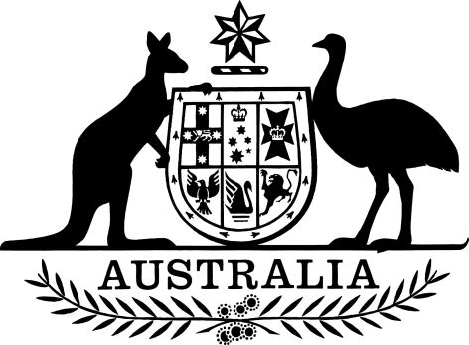

Coronavirus Economic Response Package (Deferral of Sunsetting – Financial Management and Accountability Determination 2010/02) Determination 2020
I, MATHIAS HUBERT PAUL CORMANN, Minister for Finance, make the following determination.
Dated 26 / 03 / 2020
MATHIAS HUBERT PAUL CORMANN
Minister for Finance

Contents
1 Name
2 Commencement 1
3 Authority 1
4 Definitions 1
5 Deferral of original sunset day 2

1 Name
This instrument is the Coronavirus Economic Response Package (Deferral of Sunsetting – Financial Management and Accountability Determination 2010/02) Determination 2020.

2 Commencement
(1) Each provision of this instrument specified in column 1 of the table commences, or is taken to have commenced, in accordance with column 2 of the table. Any other statement in column 2 has effect according to its terms.

Column 1 | Column 2 | Column 3
Provisions | Commencement | Date/Details
The whole of this instrument | The day after this instrument is registered.
(2) Any information in column 3 of the table is not part of this instrument. Information may be inserted in this column, or information in it may be edited, in any version of this instrument published on the Federal Register of Legislation.

3 Authority
This instrument is made under subitem 1(2) of Schedule 16 to the Coronavirus Economic Response Package Omnibus Act 2020.

4 Definitions
In this instrument:
current SOETM instrument means the Financial Management and Accountability Determination 2010/02 – Services for Other Entities and Trust Moneys – Department of the Environment, Water, Heritage and the Arts Special Account Establishment 2010.
Note: SOETM is short for Services for Other Entities and Trust Moneys.
new SOETM instrument means the PGPA Act Determination (Environment SOETM Special Account 2020).

5 Deferral of original sunset day
For the purposes of subitem 1(2) of Schedule 16 to the Coronavirus Economic Response Package Omnibus Act 2020:
- the current SOETM instrument continues to operate until the earlier of the following days (the later sunset day):
- 1 October 2020;
(ii) the day the new SOETM instrument commences in accordance with paragraph 79(5)(a) of the Public Governance, Performance and Accountability Act 2013; and
- the current SOETM instrument ceases to operate on the later sunset day.

