**EXPLANATORY STATEMENT**

*Telecommunications Act 1997*

***Telecommunications (Low-Impact Facilities) (Temporary Facilities) Amendment Determination 2020***

Issued by the Authority of the Minister for Communications, Cyber Safety and the Arts

**Authority**

The Minister for Communications, Cyber Safety and the Arts (the Minister) has made the *Telecommunications (Low-impact Facilities) (Temporary Facilities) Amendment Determination 2020* (the Determination) under subclause 6(3) of Schedule 3 of the *Telecommunications Act 1997* (the Act).

Subclause 6(3) of Schedule 3 of the Act allows the Minister to determine, by legislative instrument, that specified facilities[1] are low-impact facilities for the purpose of that clause. This specification power includes the power to determine particular classes of facilities to be low-impact facilities.

Subsection 33(3) of the *Acts Interpretation Act 1901* provides that where an Act confers a power to make an instrument of a legislative character, the power shall be construed as including a power exercisable in the like manner and subject to the like conditions to repeal, rescind, revoke, amend, or vary any such instrument. The Determination amends the *Telecommunications (Low-impact Facilities) Determination 2018* (LIFD).

**Purpose and operation of the instrument**

Telecommunications services play an important and expanding role in how people, business and government goes about daily life.  Telecommunications carriers have certain specific legal powers under the Act to let them undertake inspections and to install and maintain facilities. It also provides carriers with immunity from a range of state and territory laws when carrying out those activities, such as laws relating to land use, planning, design, construction, siting, tenancy, environmental assessments and protection. These powers and immunities are set out in Schedule 3 of the Act and primarily relate to low-impact facilities which are specified in the LIFD.

The powers and immunities framework is critical to the efficient construction and maintenance of telecommunications networks.  It minimises the regulatory burden on carriers so they can quickly and cost-effectively meet the community’s need for access to affordable, fast and reliable telecommunications services in a nationally consistent way.

The LIFD describes the types of facilities specified as low-impact that can be installed under the powers and immunities framework. The Determination amends the LIFD to:

* allow temporary towers and temporary facilities to be specified as low-impact facilities and installed under certain conditions;
* allow for a radiocommunications facility under Item 8, Part 1 of the Schedule to the LIFD to have more than one antenna; and
* corrects a minor drafting inaccuracy in the definition of ‘original facility’.

The Determination is a legislative instrument for the purposes of the *Legislation Act 2003.*

**Temporary Towers and Temporary Facilities**

The installation of towers, masts and poles are usually subject to state and territory planning laws. However, Schedule 2 to the *Telecommunications Legislation Amendment Act 2019* (TLAA) amended the Act to enable the Minister to prescribe temporary towers as low-impact facilities when used to:

* provide additional capacity during one or more events (such as a cultural, festival or sporting event);
* provide additional capacity during a high-demand holiday period;
* minimise service disruption during the maintenance or replacement of an existing facility; or
* provide services to an emergency services organisation so that it can respond to or manage an emergency or natural disaster.

One of the key characteristics of temporary facilities is that they are designed to be transportable, meaning the facility can be moved to different locations to provide a carriage service for the purposes outlined in the TLAA. In many cases, a temporary tower will be one item of a number of other items of equipment specified in the LIFD and used in the deployment of a temporary facility.

The provisions have been designed to implement the long-standing policy that telecommunications carriers will often deploy several items of equipment, specified as low-impact facilities in the Schedule to the LIFD, at a location for the same or different purpose. For example, the installation of a new telecommunications facility on an existing tower or location may include, but is not limited to, the following equipment:

* a radiocommunications facility – Item 8, Part 1 of Schedule to the LIFD;
* a cabinet – Item 2, Part 3 of Schedule to the LIFD;
* solar panel – Item 7, Part 3 of Schedule to the LIFD; and
* ancillary equipment – clause 3.1(4) of the LIFD.

Each of these low-impact facilities would be specifically itemised in the notification required to be issued to the landowner and occupier prior to installation in accordance with notification requirements set out in the *Telecommunications Code of Practice 2018* (the Code of Practice). This allows carriers to tailor the infrastructure they deploy for their own unique network requirements.

The specification of temporary facilities in the LIFD, after the implementation of the changes set out in the Determination, explicitly provides for this principle and makes it clear that a telecommunications carrier may install a low-impact facility either separately or in conjunction with one or more other low-impact facilities for the same or different purpose. Not only does this approach allow for variations and advancements in the types of equipment able to be deployed, but also provides certainty for landowners and occupiers about what equipment may be installed on their land.

There are currently four common types of temporary facilities used by carriers in Australia. These types of temporary facilities are commonly known as a Cell on Wheels, Satellite on Wheels, Mobile Exchange on Wheels, and Node on Wheels.

The diagrams below demonstrate examples of items from the Schedule to the LIFD, current and proposed by this Determination, which may be used in the deployment of temporary towers and temporary facilities.

Cell on Wheels

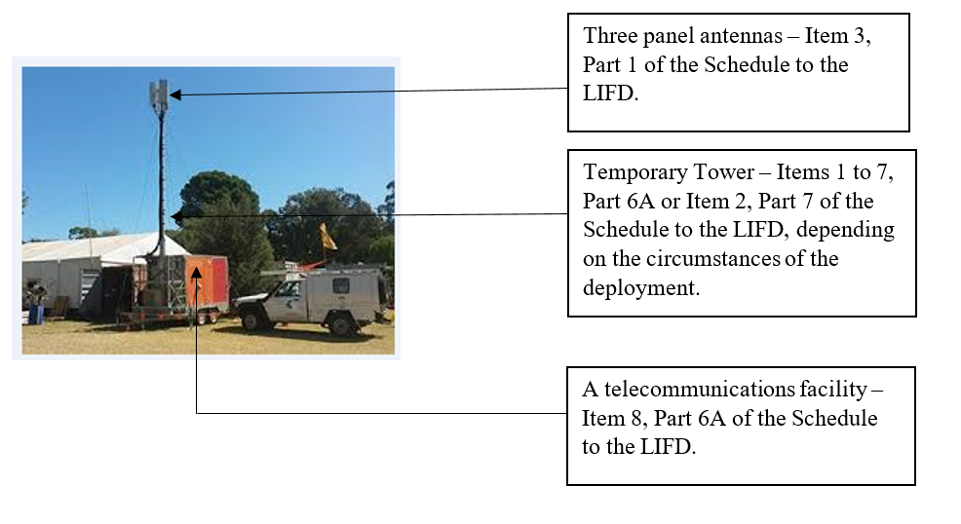

Satellite on Wheels

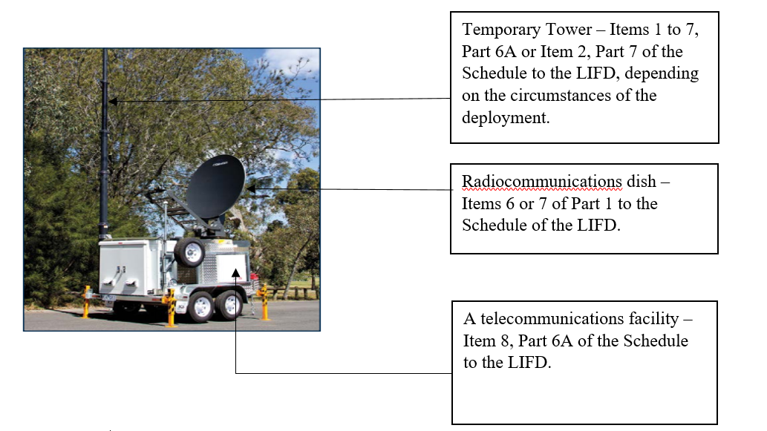

Mobile Exchange on Wheels

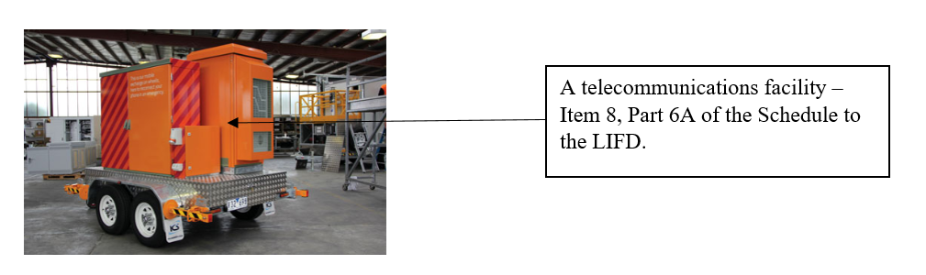

Network on Wheels

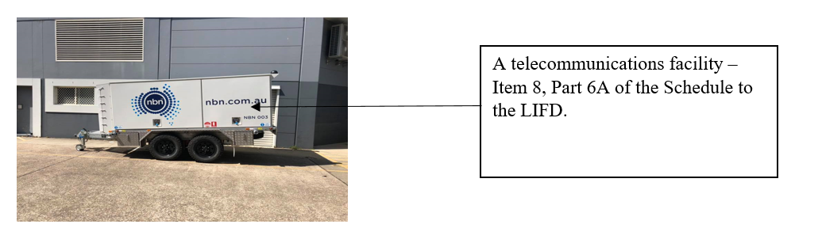

Within the specification of the new temporary facilities are criteria for the deployment of temporary towers and temporary facilities, such as the dimensions of the equipment and locations where temporary towers and temporary facilities could be installed, were consulted on in late 2019 and are included in the Determination. Further information about these conditions is provided in **Attachment A.**

Notification, Objection and Conditions

Safeguards for landowners and occupiers, including notification and objection procedures, continue to apply to temporary tower and temporary facility deployments in the same way as they otherwise would for any other type of low-impact facility. The Actand the Code of Practice set out obligations on carriers to notify landholders and land occupiers of their intention to install telecommunications infrastructure on land and the timing of such notifications. For the installation of a temporary tower, a notice should be sent at least 10 business days before the carrier begins to engage in the activity.

The Act and the Code of Practice detail obligations on carriers to advise landholders of their right to object, the grounds for objection (for example, the use of the land or the location of the facility on the land), the right to have a decision reviewed by the Telecommunications Industry Ombudsman (TIO) and timeframes for lodging objections.

These notification and objection arrangements provide mechanisms by which affected landowners can raise concerns with carriers about proposed installations and seek an acceptable outcome. However, it is reasonable to expect that carriers should engage with landowners or occupiers to confirm the details of proposed deployments, such as the location of the temporary facility at the site or venue, as early as possible without relying on the landowner or occupier exercising their right to object.

The Code also sets out conditions about how carriers undertake activities under Schedule 3 of the Act and it is expected that these conditions will apply to the design and placement of temporary facilities, including temporary towers. Some of these conditions require carriers to take all reasonable steps to cause as little detriment, inconvenience or damage as practicable, to act in accordance with good engineering practice, to protect the safety of persons and property, to interfere as little as practicable with the operations of a public utility, public roads and paths, the movement of traffic and the use of the land, and to protect the environment.

**Radiocommunications Facilities**

The Determination makes a minor amendment to Item 8, Part 1 of the Schedule to the LIFD to make clear that the specified facility within that class can include a radiocommunications facility with one or more than one antenna.

**Correction to Drafting**

The Determination makes a minor change to the definition of ‘original facility’ to refer to the Schedule to the LIFD. Previously, the definition of ‘original facility’ in the LIFD incorrectly referred to Schedule 3 of the Act.

An explanation of each provision of the instrument is set out in the notes at **Attachment A**.

**Consultation**

Amendments to allow temporary towers and temporary facilities have been the subject of consultation since 2017. The initial proposal to allow for such facilities was made in the then Department of Communications and the Arts 2017 Consultation Paper titled ‘*Possible amendments to telecommunications carrier powers and immunities’*. A total of 81 submissions were received in response to the consultation paper.

To allow temporary towers to be deployed as a low-impact facility, an amendment to the Act was required. The amendment to the Act was implemented through the TLAA. The TLAA was subject to an inquiry by the Senate Environment and Communications Legislation Committee. During the inquiry process eight submissions were received.

In November 2019, an exposure draft of the amending instrument was released as part of a four week consultation process. Nine submissions were received in total. An exposure draft of the amending instrument was released for public consultation via the Department of Infrastructure, Transport, Regional Development and Communication’s (the Department) website. The Department also notified peak bodies representing carriers, utilities, local government and commercial building owners of the consultation process, as these bodies are most likely to deploy telecommunications infrastructure or have such infrastructure installed on their land.

Some stakeholders suggested that minor drafting changes be made to improve clarity and readability. These changes were made and include:

* relocating all new items that can be deployed on a temporary basis (except for emergencies) to the new Part 6A of the Schedule to the LIFD; and
* amending Item 8, Part 6A of the Schedule to the LIFD to specifically provide that a temporary facility could be installed separately or in conjunction with one or more other low-impact facilities specified in the Schedule to the LIFD.

Some stakeholders also raised amending the Determination to allow temporary towers and temporary facilities to be deployed in areas of environmental significance. Further consultation with affected parties, including state, territory and local government bodies, would be required to sensitively implement such a proposal. As such, the suggestion was not adopted at this time.

**Regulatory impact assessment**

The Office of Best Practice Regulation (OBPR) was consulted in relation to the amendments. OBPR have advised that a Regulatory Impact Statement is not required, as the reforms were originally considered when the TLAA was introduced to Parliament (OBPR ref: 20695).

**Statement of compatibility with human rights**

A statement of compatibility with human rights for the purposes of Part 3 of the *Human Rights (Parliamentary Scrutiny) Act 2011* is set out in **Attachment B.**

**Attachment A**

**Notes to the *Telecommunications (Low-impact Facilities) (Temporary Facilities) Amendment Determination 2020***

**Section 1 Name**

This section provides for the instrument to be cited as the *Telecommunications (Low-impact Facilities) Amendment (Temporary Facilities) Determination 2020.*

**Section 2 Commencement**

This section provides for the instrument to commence at the start of the day after it is registered on the Federal Register of Legislation.

The Federal Register of Legislation may be accessed at <https://www.legislation.gov.au>.

**Section 3 Authority**

Section 3 provides that the source of authority for making of the Determination is subclause 6(3) of Schedule 3 of the *Telecommunications Act 1997* (the Act) and subsection 33(3) of the *Acts Interpretation Act 1901.*

**Section 4 Amendments**

Schedule 1 to the Determination outlines the amendments made to the *Telecommunications (Low-impact Facilities) Determination 2018*.

**Schedule 1 – Amendments**

**Item 1 Section 1.4 (Background to determination)**

This item makes a minor technical correction to the table at section 1.4 of the LIFD, namely substituting references of the word ‘subsections’ with ‘subclauses’.

**Item 2 Section 1.4 (Background to determination, third paragraph)**

This item inserts a new note into section 1.4 of the LIFD, to specify that temporary towers cannot be considered low-impact facilities unless certain conditions are satisfied.

**Item 3 Section 1.5 (Before “In this Determination”)**

This item inserts a subclause number immediately before “In this Determination” to signify that it is one of multiple subclauses within that section. This change is consequential to Item 6, which inserts an extra subsection into section 1.5.

**Item 4 Section 1.5**

This item inserts additional terms and their definitions used in the Determination. It provides for definitions of ‘high-demand holiday period’, ‘public land’ and ‘maintenance’.

The terms ‘high-demand holiday period’ and ‘public land’ are defined to have the same meaning as in clause 2 of Schedule 3 of the Act.

Under clause 2 of Schedule 3 of the Act, a high-demand holiday period is intended to mean a school holiday period, or in the case of a public holiday, the weekend either immediately before or after that public holiday in any State or Territory. A high-demand holiday period would not be limited to the official holidays in the State or Territory in which the facility is to be installed.

For example, Carrier A may install a temporary tower as a low-impact facility (specified in Item 7 of Part 6A of the Schedule to the LIFD) at a ski resort located in New South Wales. Carrier A could deploy the temporary tower during the New South Wales school holidays. If the Victorian school holiday commenced at the end of the New South Wales holiday period, then the temporary tower could remain until the end of the Victorian school holiday period.

The term ‘maintenance’ is intended to have the same meaning as provided for in clause 7 of Schedule 3 of the Act for the purposes of new Items 1-4 and Item 8 of Part 6A to the Schedule of the LIFD.

Under clause 2 of Schedule 3 to the Act, the term ‘public land’ means land that is the property of the Commonwealth, a State or Territory, a local government body, or an authority of a Commonwealth, a State or Territory which is a public place (which is defined in clause 2 of Schedule 3 to the Act as a place to which members of the public have ready access).

**Item 5 Section 1.5, definition of original facility**

This item corrects a drafting inaccuracy by removing a reference to “of Schedule 3 of the Act” from the definition of original facility and inserting the words “of the Schedule to this Determination”.

**Item 6 At the end of section 1.5**

This item adds new subsections to section 1.5. New subsection 1.5(2) provides that for the purposes of Items 1-7 of Part 6A of the Schedule to the LIFD, the height of the temporary tower is to be ascertained in accordance with subclause 6(5C) of Schedule 3 to the Act. That subclause provides for the height of a tower or facility to be the distance between the top of the tower or facility and ground level.

**Item 7 Schedule (at paragraph (a) of Item 8 of Part 1 – Radio facilities)**

Carriers often deploy radiocommunications facilities consisting of one or more antennas and a cabinet, which is usually deployed on a utility pole but can also be deployed on the ground.

Item 8, Part 1 of the Schedule to the LIFD allows for a radiocommunications facility to consist of a separate antenna and a cabinet that does not exceed 1 cubic metre in volume. This item inserts ‘one or more’ and ‘each antenna is’ into paragraph (a) of Item 8 of Part 1 to clarify that a radiocommunications facility may be deployed with multiple antennas.

While references in the LIFD to a radiocommunications facility in the singular form also include the plural form (in reliance on section 23 of the *Acts Interpretation Act 1901*), this item has been inserted to ensure that there is no ambiguity as to whether carriers can deploy radiocommunications facilities with more than one antenna.

**Item 8 After Part 6 – Payphones (inserts new Part 6A)**

This item inserts a new part into the Schedule to the LIFD and eight accompanying items.

Items 1-7, Part 6A – Temporary Towers

Items 1-7 of new Part 6A set out the features of the new class of temporary towers that can be deployed as low-impact facilities. A temporary tower can only be installed for any of the following purposes:

* minimise service disruption during the maintenance or replacement of an existing facility; or
* provide additional capacity during one or more events (such as a cultural, festival or sporting event); or
* provide additional capacity during a high-demand holiday period.

In circumstances where a facility is being maintained or replaced (original facility), the original facility does not have to be low-impact for a temporary tower to be deployed. For example, a carrier could deploy a temporary tower to supply a carriage service whilst the original facility (i.e a permanent tower of 40 metres in height and installed under State or Territory planning laws) is being replaced.

*Height of temporary towers*

The height of temporary towers under Items 1-7 cannot exceed 30 metres in height, except if the temporary tower is deployed in a rural area for maintenance or replacement purposes. In such circumstances, the provisions provide for the height of the temporary tower to be up to the height of the existing tower.

In accordance with clause 6(5C) of Schedule 3 to the Act, the height of the temporary tower must be measured from ground level to the top of the tower.

*Placement of temporary towers*

Items 1-7 provide a cascading list of criteria for the location of the temporary towers (other than towers installed to provide additional capacity in a high-demand holiday period). They can only be installed:

* on the land on which the other facility is located; or in the case of an event the land on which the venue is located;
* where installation on the original land is not possible, the tower is to be installed on public land, or
* where installation on public land is not possible, the tower is to be installed in the vicinity of the original facility or where the event is being held. The term ‘vicinity’ is not defined and is intended to have its ordinary meaning.

In the case of temporary towers deployed to provide additional capacity in a high-demand holiday period. In these circumstances, the temporary tower must only be installed on public land.

These new types of low-impact facilities will be subject to clause 3 of the LIFD and cannot be installed in certain areas, such as an area of environmental significance.

Item 8, Part 6A – Temporary Facilities

Item 8 provides a new class of temporary facilities that may be low-impact facilities.

This new class of temporary facility covers those facilities that are designed to be transportable from place to place. This is intended to capture the temporary characteristic of these types of facilities as they could be deployed as standalone pieces of equipment or set up on a trailer or other similar means.

Item 8 also sets out the maximum dimensions of a temporary facility in terms of its length and height once fully deployed. These dimensions strike a balance between providing effective and efficient telecommunications services to the public, but are considered to be of low visual impact and unlikely to cause significant disruption to the community during installation or operation.

Under this new class of temporary facilities, there are restrictions on the purposes for which they can be deployed. Namely, they must only be deployed for one of the following reasons:

* to minimise disruption to the supply of a carriage service that might result from the maintenance or replacement of another facility; or
* to provide additional capacity to supply carriage services to person who are attending one or more events at a venue and the intervals between those events are not longer than 28 days; or
* to provide additional capacity to supply carriage services to persons who are physically present in a particular area during a high-demand holiday period.

In circumstances where a facility is being maintained or replaced (original facility), the original facility does not have to be low-impact for a temporary facility to be deployed. For example, a carrier could deploy a temporary facility to supply a carriage service whilst the original facility (a permanent tower) is being replaced.

*Placement of temporary facilities*

Item 8 provides a cascading list of criteria for where a carrier can install a temporary facility. For example, the temporary facility must be installed:

* on the land on which the other facility is located; or in the case of an event the land on which the venue is located;
* where installation on the original land is not possible, the tower is to be installed on public land, or
* where installation on public land is not possible, the tower is to be installed in the vicinity of the original facility or where the event is being held. The term ‘vicinity’ is not defined in the LIFD and is intended to have its ordinary meaning.

Installation of one or more low-impact facilities

Item 8 explicitly provides that a temporary facility can be installed either separately or in conjunction with one or more other low-impact facilities. This allows for a temporary facility to be used by itself (for example, in the circumstances where a Mobile Exchange on Wheels is required). Alternatively, it also allows for a temporary facility to be deployed in conjunction with other low-impact facilities, such as a temporary tower, to create a Cell on Wheels.

Some temporary facilities may include other low-impact facilities, such as antennas or satellite dishes. Provided they meet the criteria set out in the existing items in the Schedule to the LIFD, these items of equipment may also be used in conjunction with a temporary facility.

By operation of clause 3.1(4)(a)(i) of the LIFD, a facility that is ancillary to a facility covered by an item in the Schedule to the LIFD will also be a low-impact facility where it is necessary for the operation or proper functioning of the low-impact facility.

Ancillary equipment for the purposes of ensuring the proper functioning of a temporary tower or temporary facility installation may include, but is not limited to, equipment such as generators, laptops and cabling.

Aerial cables to be deployed on a temporary basis could be installed as a low-impact facility (ancillary equipment type) under clause 3.1(4) of the LIFD when installed to provide power to a temporary facility because, in that context, the facility would be characterised as being necessary for the operation or proper functioning of the temporary facility. However, in recognition of the rule in subclause 6(4) of Schedule 3 to the Act, the maximum external cross section of overhead cabling installed as an ‘ancillary low-impact facility’ cannot currently exceed 48mm in diameter (the diameter of 48mm is specified in Regulation 11.2 of the Telecommunications Regulations 2001).

**Item 11 Schedule (after item 1 of Part 7 – Emergency facilities)**

This amendment provides for a new class of emergency facilities, being a temporary tower, that may be a low-impact facility. Under new Item 2 of Part 7 of the Schedule to the LIFD, a temporary tower can be deployed in all areas as a low-impact facility provided that it supplies carriage services to one or more Emergency Service Organisations (ESOs) so that the ESO can deal with an emergency or natural disaster.

There are no height or placement restrictions for the temporary facilities specified under new item 2 of Part 7 of the Schedule to the LIFD. This is consistent with the current approach in relation to facilities covered by item 1 of Part 7 that are installed in emergency or natural disaster situations

**Attachment B**

## Statement of Compatibility with Human Rights

*Prepared in accordance with Part 3 of the Human Rights (Parliamentary Scrutiny) Act 2011*

**Telecommunications (Low-impact Facilities) (Temporary Facilities) Amendment Determination 2019**

The *Telecommunications (Low-impact Facilities) (Temporary Facilities) Amendment Determination 2019* (the Determination) is compatible with the human rights and freedoms recognised or declared in the international instruments listed in section 3 of the *Human Rights (Parliamentary Scrutiny) Act 2011*.

### Overview of the Determination

Part 1 of Schedule 3 of the *Telecommunications Act 1997* (the Act) provides authority for telecommunications carriers to inspect, install low-impact facilities and maintain facilities without seeking state, territory or local government planning approval or landowner consent. The *Telecommunications (Low-impact Facilities) Determination 2018* (LIFD) contains a list of low-impact telecommunications facilities that can be installed under the carrier powers and immunities set out in Schedule 3 of the Act.

The purpose of the Determinationis to add several new facilities to the list of low-impact facilities. These items are in relation to the installation of temporary towers and transportable above-ground facilities that are installed in certain situations. For example, temporary towers and facilities may be deployed to minimise service disruption where maintenance or replacement of facilities needs to occur, or to provide additional capacity to the supply of carriage services due to an event or events, a high-demand holiday period, and emergency situations. The Determination also makes one minor technical amendment to the definition of ‘original facility’, and a clarification change in respect of the radiocommunications class of low-impact facilities.

The Determination itself is technical and operational in nature and does not invoke any of the human rights or freedoms recognised or declared in the treaties listed in section 3 of the *Human Rights (Parliamentary Scrutiny) Act 2011.*

No human rights issues were raised during the consultation undertaken in developing the draft Determination.

### Human rights implications

The Determination does not engage any of the applicable rights or freedoms.

### Conclusion

The Determination is compatible with human rights as it does not raise any human rights issues.

1. A reference to ‘facility’ includes infrastructure or equipment provided for in the *Telecommunications (Low-Impact Facilities) Determination 2018.*