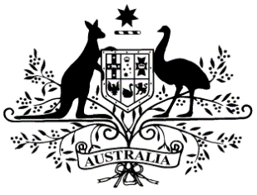

**PB 43 of 2020**

**National Health (Commonwealth Price and Conditions for Commonwealth Payments for Supply of Pharmaceutical Benefits) Amendment Determination 2020 (No. 3)**

*National Health Act 1953*

___________________________________________________________________________

I, THEA DANIEL, Assistant Secretary, Pricing and PBS Policy Branch, Technology Assessment and Access Division, Department of Health, delegate of the Minister for Health, make this Instrument under paragraph 98C(1) of the *National Health Act 1953*.

Dated 29th May 2020

**THEA DANIEL**

Assistant Secretary

Pricing and PBS Policy Branch

Technology Assessment and Access Division

Department of Health

___________________________________________________________________________

1. **Name of Instrument**
2. This Instrument is the *National Health (Commonwealth Price and Conditions for Commonwealth Payments for Supply of Pharmaceutical Benefits) Amendment Determination 2020 (No. 3)*.
3. This Instrument may also be cited as PB 43 of 2020.
4. **Commencement**

This Instrument commences on 1 June 2020.

1. **Amendments to *National Health (Commonwealth Price and Conditions for Commonwealth Payments for Supply of Pharmaceutical Benefits) Determination 2019***

Schedule 1 amends the *National Health (Commonwealth Price and Conditions for Commonwealth Payments for Supply of Pharmaceutical Benefits) Determination 2019*.

**Schedule 1 Amendments**

1. Schedule 4, after entry for Macrogol 3350 in the form Sachets containing powder for oral solution 13.125 g with electrolytes, 30

insert:

|  |  |
| --- | --- |
| Mepolizumab | Injection 100 mg in 1 mL single dose pre-filled pen |