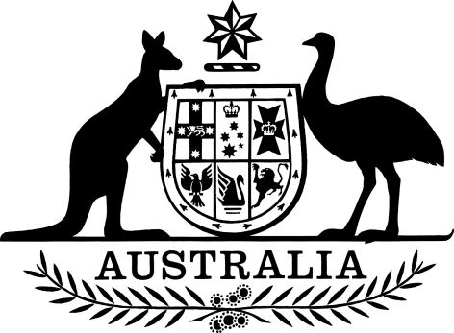

PGPA Act Determination (Recovery of Compensation for Health Care and Other Services Special Account Amendment 2020)
I, MATHIAS HUBERT PAUL CORMANN, Minister for Finance, make the following determination.
Dated 9 June 2020
MATHIAS HUBERT PAUL CORMANN
Minister for Finance

Contents
Part 1—Establishment 1
1 Name 1
2 Commencement 1
3 Authority 1
4 Definitions 1
Part 2— Amendment of the special account determination 2
5 Amendment of the special account determination 2

Part 1—Establishment

1 Name
This instrument is the PGPA Act Determination (Recovery of Compensation for Health Care and Other Services Special Account Amendment 2020).

2 Commencement
(1) Each provision of this instrument specified in column 1 of the table commences, or is taken to have commenced, in accordance with column 2 of the table. Any other statement in column 2 has effect according to its terms.

Column 1 | Column 2 | Column 3
Provisions | Commencement | Date/Details
The whole of this instrument | The later of 30 June 2020 or the day mentioned in paragraph 79(5)(a) of the Act.
(2) Any information in column 3 of the table is not part of this instrument. Information may be inserted in this column, or information in it may be edited, in any version of this instrument published on the Federal Register of Legislation.

3 Authority
This instrument is made under subsection 78(3) of the Act.

4 Definitions
In this instrument:
Act means the Public Governance, Performance and Accountability Act 2013.
special account determination means the PGPA Act (Recovery of Compensation for Health Care and Other Services Special Account 2015- Establishment) Determination 2015/06.

Part 2— Amendment of the special account determination

5 Amendment of the special account determination
For the purposes of subsection 78(3) of the Act, the special account determination is varied as follows:
Section 6 is repealed and replaced with:
6 Accountable authority
For paragraph 78(1)(d) of the PGPA Act, the accountable authority responsible for the special account is the Chief Executive Officer of Services Australia.

