

**Food Standards (Application A1184 – Glucoamylase from GM *Aspergillus niger* (donor *Trametes cingulata*)) Variation**

The Board of Food Standards Australia New Zealand gives notice of the making of this variation under section 92 of the *Food Standards Australia New Zealand Act 1991*. The variation commences on the date specified in clause 3 of this variation.

Dated 28 August 2020

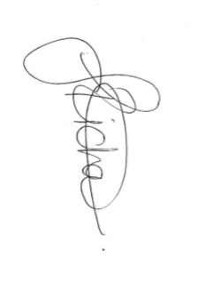

Joanna Richards

Delegate of the Board of Food Standards Australia New Zealand

**Note:**

This variation will be published in the Commonwealth of Australia Gazette No. FSC 136 on 3 September 2020. This means that this date is the gazettal date for the purposes of clause 3 of the variation.

1 Name

This instrument is the *Food Standards (Application A1184 – Glucoamylase from GM* Aspergillus niger *(donor* Trametes cingulata*)) Variation*.

2 Variation to a standard in the Australia New Zealand Food Standards Code

The Schedule varies a Standard in the Australia New Zealand Food Standards Code.

3 Commencement

The variation commences on the date of gazettal.

**Schedule**

**[1] Schedule 18** is varied by inserting in the table to subsection S18—9(3), in alphabetical order

|  |  |  |
| --- | --- | --- |
| Glucoamylase (EC 3.2.1.3) sourced from *Aspergillus niger* containing the glucoamylase gene from *Trametes cingulata* | For use in starch processing and the production of potable alcohol | GMP |