

Food Standards (Application A1185 – Alpha-amylase from GM Aspergillus niger as a processing aid (enzyme)) Variation

The Board of Food Standards Australia New Zealand gives notice of the making of this variation under section 92 of the Food Standards Australia New Zealand Act 1991. The variation commences on the date specified in clause 3 of this variation.

Dated 28 August 2020
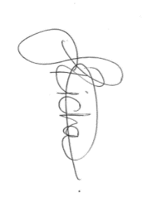

Joanna Richards
Standards Management Officer
Delegate of the Board of Food Standards Australia New Zealand

Note:

This variation will be published in the Commonwealth of Australia Gazette No. FSC 136 on 3 September 2020. This means that this date is the gazettal date for the purposes of clause 3 of the variation.

1 Name
This instrument is the Food Standards (Application A1185 – Alpha-amylase from GM Aspergillus niger as a processing aid (enzyme)) Variation.
2 Variation to a standard in the Australia New Zealand Food Standards Code
The Schedule varies a Standard in the Australia New Zealand Food Standards Code.
3 Commencement
The variation commences on the date of gazettal.
Schedule
[1] Schedule 18 is varied by inserting in the table to subsection S18—9(3), in alphabetical order

α-Amylase (EC 3.2.1.1) sourced from Aspergillus niger containing the α-Amylase gene from Rhizomucor pusillus | For use in starch processing and the production of potable alcohol | GMP

