Australian Film, Television and Radio School Act 1973

DETERMINATION OF DEGREES, DIPLOMAS AND CERTIFICATES
No. 2020/2

I, Russel Howcroft, on behalf of the Australian Film, Television and Radio School, make a determination under section 6A of the Australian Film, Television and Radio School Act 1973 (the Act) specifying the following degrees, diplomas and certificates for the purposes of paragraph 5(1)(g) of the Act.

Master of Arts Screen: Business
Graduate Diploma Screen: Business

This Determination comes into effect on the day after it is registered with the Federal Register of Legislative Instruments.

Dated: 11 September 2020

Signed:

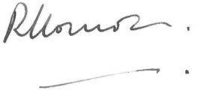

Russel Howcroft
Chair of Council
Australian Film, Television and Radio School

