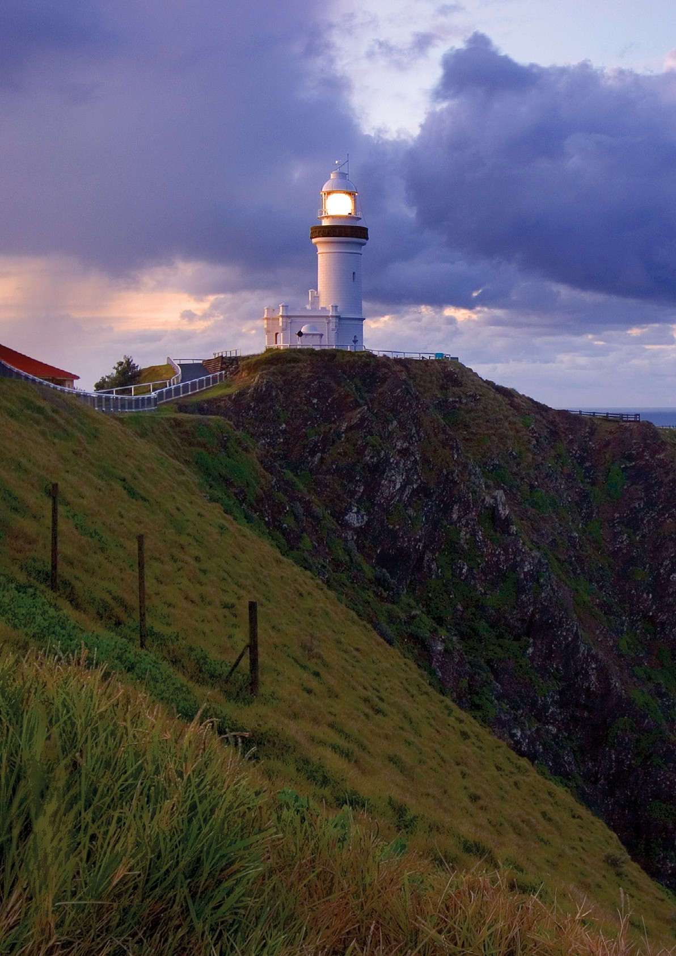

Cape Byron Lighthouse

Heritage Management Plan

2020

The Australian Maritime Safety Authority, acting pursuant to Schedule 7A of the Environment Protection and Biodiversity Conservation Regulations (2000), makes this heritage management plan in relation to parts of the Cape Byron Lighthouse within its ownership or control.



this 4th day of September 2020

Mick Kinley

Chief Executive Officer

**Copyright**

The Australian Maritime Safety Authority encourages the dissemination and exchange of information provided in this publication.

Except as otherwise specified, all material presented in this publication is provided under Creative Commons Attribution 4.0 International licence.

This excludes:

* the Commonwealth Coat of Arms
* this department’s logo
* content supplied by third parties.

The Creative Commons Attribution 4.0 International Licence is a standard form licence agreement that allows you to copy, distribute, transmit and adapt this publication provided that you attribute the work.

The details of the version 4.0 of the licence are available on the Creative Commons website, as is the full legal code for that licence.

**Acknowledgements**

The Australian Maritime Safety Authority acknowledges that the Lighthouse is in the traditional Country of the Bundjalung people.

For additional information or any inquiries about this heritage management plan, contact the Australian Maritime Safety Authority, Manager Asset Capability, PO Box 10790, Adelaide Street, Brisbane QLD 4000

Phone: (02) 6279 5000 (switchboard) Email: [Heritage@amsa.gov.au](mailto:Heritage@amsa.gov.au) Website: [www.amsa.gov.au](http://www.amsa.gov.au/)

**Attribution**

AMSA’s preference is that you attribute this publication (and any material sourced from it) using the following wording:

Source: Australian Maritime Safety Authority *Cape Byron Lighthouse Heritage Management Plan – 2020*

**Front cover image**

© Copyright Garry Searle

**More information**

For enquiries regarding copyright including requests to use material in a way that is beyond the scope of the terms of use that apply to it, please contact us through our website: [www.amsa.gov.au](http://www.amsa.gov.au/)





Cape Byron Lighthouse

Heritage Management Plan

2020

# Contents

Executive summary 3

1. Introduction 4
   1. Background and purpose 4
   2. Heritage management plan objectives 4
   3. Methodology 5
   4. Status 5
   5. Authorship 5
   6. Acknowledgements 5
   7. Language 6
   8. Previous reports 6
   9. Sources of information and images 6
2. Cape Byron Lightstation site 7
   1. Location 7
   2. Setting and landscape 8
   3. Lease and ownership 9
   4. Access 9
   5. Listings 9
3. History 13
   1. General history of lighthouses in Australia 13
   2. The Commonwealth lighthouse service 15
   3. New South Wales lighthouse management 16
   4. Cape Byron: a history 16
   5. Planning a lighthouse 17
   6. Lighthouse keepers 21
   7. Chronology of major events 22
   8. Changes and conservation over time 23
   9. Summary of current and former uses 24
   10. Summary of past and present community

associations 25

* 1. Unresolved questions or historical conflicts 26
  2. Recommendations for further research 26

1. Fabric 27
   1. Fabric register 27
   2. Related object and associated AMSA artefact 53
   3. Comparative analysis 53
2. Heritage significance 55
   1. Commonwealth heritage list – Cape Byron Lightstation 55
   2. NSW State heritage register – Cape Byron Lightstation 57
   3. Condition and integrity of the

Commonwealth heritage values 62

* 1. Gain or loss of heritage values 62

1. Opportunities and constraints 63
   1. Implications arising from significance 63
   2. Framework – sensitivity to change 64
   3. Statutory and legislative requirements 66
   4. Operational requirements and occupier needs 70
   5. Proposals for change 71
   6. Potential pressures 72
   7. Process for decision-making 72
2. Conservation management policies 74
3. Policy implementation schedule 80
4. Appendices 81

Appendix 1. Glossary of heritage conservation terms

Appendix 2. Glossary of historic lighthouse terms

relevant to Cape Byron Lighthouse 84

Appendix 3. Current Cape Byron light details 86

Appendix 4. Opening of the Cape Byron Lightstation (1901) and transcription 88

Appendix 5. Table Demonstrating Compliance with

the EPBC Regulation (2000) 90

Reference List 92

Website URLs 94

List of figures

|  |  |
| --- | --- |
| Figure 1 | Cover photo of Cape Byron Lighthouse (Garry Searle) |
| Figure 2 | Planning process applied for heritage management (Australia ICOMOS, 1999) |
| Figure 3 | Location of Byron Bay (NSW) |
| Figure 4 | Location of Cape Byron Lighthouse (NSW) |
| Figure 5 | View of Cape Byron Lighthouse and surrounding cliffs (2015) |
| Figure 6 | View of Tallow Beach from Cape Byron Lighthouse tower (2009) |
| Figure 7 | Lease plan detailing land parcels under AMSA control (AMSG, 2015) |
| Figure 8 | AMSA Map of Lease – Cape Byron Lighthouse (2017) |
| Figure 9 | Cape Byron Lightstation NSW State Heritage Register Plan 3210 (NSW State Heritage Council, 2019) |
| Figure 10 | Early technology used in lighthouses |
| Figure 11 | Incandescent oil vapour lamp by Chance Brothers |
| Figure 12 | Dioptric lens on display at Narooma |
| Figure 13 | Dalén’s system – sunvalve, mixer, flasher and cylinder |
| Figure 14 | James Barnet (n.d.) |
| Figure 15 | Blueprint design for Cape Byron Lighthouse tower and attached pavilions (c.1899) |
| Figure 16 | 1. Ministerial party at official opening of the Cape Byron Lighthouse (1901) 2. View of Cape Byron Lighthouse (1901) |
| Figure 17 | Design plan of Cape Byron’s lens and lantern room (1982) |
| Figure 18 | 1. Cape Byron Lighthouse (lit 1901), 2. Point Perpendicular Lighthouse (lit 1899), 3. Norah Head Lighthouse (lit 1903). |
| Figure 19 | Cape Byron elevation blueprint (1899) |
| Figure 20 | Point Perpendicular elevation blueprint (1897) |
| Figure 21 | Document detailing the opening of the Cape Byron light and signatures (1901) |

# Executive summary

The Cape Byron Lightstation was placed on the Commonwealth Heritage List in 2004 for its contribution to the establishment of marine Aids

to Navigation (AtoN) along the New South Wales coast, the rarity of its Henry-Lepaute optic, it’s aesthetic characteristics, unique technical features, and immense social value.

The Cape Byron Lightstation was placed on the NSW State Heritage Register in 2019 for its historical, associative, aesthetic and social significance, its research potential, rarity and

representativeness. The site is also of high cultural significance to the Bundjalung of Byron Bay Arakwal People who are the native title holders.

Situated 1.6 kilometres from Byron Bay town centre, the lightstation is located on the most easterly point of the Australian mainland. Built in 1901, the Cape Byron Lighthouse was one of the last lightstations

to make up the ‘highway of lights’ illuminating the New South Wales coastline. Its concrete block construction was designed by Charles Harding who modelled the lighthouse after the work of former colonial architect James Barnet. Apart from the tower and attached pavilion rooms, the lightstation also encompasses a flag locker, flagpole, the Cape Byron pillar, and two cottages. As a working aid

to navigation, the lighthouse tower remains the property of the Australian Maritime Safety Authority (AMSA).

Although the lighthouse remains fitted with its original lens assembly, it now runs on an automated mechanism as part of our network of AtoN. The equipment is serviced by AMSA’s maintenance contractor who visits at least once per year.

Our officers visit on an ad hoc basis for auditing,

project and community liaison purposes.

The larger part of the lightstation which includes the two cottages lies outside of our lease and is managed by the New South Wales National Parks and Wildlife Service (NPWS). The lightstation is open to visitors all year round.

This heritage management plan is concerned mainly with the lighthouse, but also addresses the management of the surrounding precinct and land. The plan is intended to guide our decisions and actions. We have prepared this plan to integrate the heritage values of the lightstation in accordance with the *Environment Protection and Biodiversity Conservation Act 1999*, and the Environment Protection and Biodiversity Conservation Regulations 2000.

Being well built and generally well maintained, the lighthouse precinct is in relatively good, stable

condition. The policies and management guidelines set out in this heritage management plan strive to ensure that the Commonwealth heritage values

of the Cape Byron Lightstation are recognised, maintained, and preserved for future generations.

# Introduction

### Background and purpose

AMSA is the Commonwealth agency responsible for AtoNs. Our network includes the Cape Byron Lighthouse (NSW) built by the Department of Public Works in 1901.

*The Environment Protection & Biodiversity Conservation Act* 1999 (*EPBC Act*) requires us to prepare management plans that satisfy the

obligations included in Schedule 7A and 7B of the EPBC Regulations 2000. The principal features of this management plan are:

* a description of the place, its heritage values, their condition and the method used to assess its significance
* an administrative management framework
* a description of any proposals for change
* an array of conservation policies that protect and manage the place
* an implementation plan
* the ways the policies will be monitored and how the management plan will be reviewed.

We have commissioned this heritage management plan to guide the future conservation of the place.

This plan provides the framework and basis for the conservation and best practice management of the Cape Byron Lighthouse in recognition of its

heritage values. The policies in this plan indicate the objectives for identification, protection, conservation and presentation of the commonwealth heritage values of the place. Figure 2. shows the basic planning process applied.

### Heritage management plan objectives

The objectives of this heritage management plan are to:

* protect, conserve and manage the Commonwealth heritage values of the Cape Byron Lightstation.
* interpret and promote the Commonwealth heritage values of the Cape Byron Lightstation.
* manage use of the lightstation
* use best practice standards, including ongoing technical and community input, and apply

best available knowledge and expertise when

**Understand significance**

**Understand management obligations and constraints**

**Develop policy**

**Manage in accordance with policy**

Figure 2. Planning process applied for heritage management (*Australia ICOMOS, 1999*)

considering actions likely to have a substantial impact on Commonwealth heritage values.

In undertaking these objectives, this plan aims to:

* Provide for the protection and conservation of the heritage values of the place while minimising any impacts on the environment by applying

the relevant environmental management requirements in a manner consistent with Commonwealth heritage management principles.

* Take into account the significance of the region as a cultural landscape occupied by Aboriginal people over many thousands of years.
* Recognise that the site has been occupied by

lease holders since the early 20th century.

* Encourage site use that is compatible with the historical fabric, infrastructure and general environment.
* Record and document maintenance works, and changes to the fabric in the Cape Byron Lighthouse fabric register.

The organisational planning cycle and associated budgeting process is used to confirm requirements, allocate funding, and manage delivery of maintenance activities. Detailed planning for the aids to navigation network is managed through our internal planning processes.

An interactive map showing many of AMSA’s heritage sites, including Cape Byron, can be found online at AMSA Heritage Lighthouses Interactive Mapa.

### Methodology

The methods used in the preparation of this plan are consistent with the recommendations of The Burra Charter. The plan addresses:

* The history of the site based on information sourced from archival research, expert knowledge, and documentary resources.
* The description of the site based on information sourced from site inspection reports, and fabric registers.
* The Commonwealth heritage criterions satisfied by Cape Byron as set out by the Environment Protection and Biodiversity Conservation Regulations 2000 (EPBC Regulations).

The EPBC Regulation Section 7A (h) (i-xiii)

was used to develop the necessary policies for management of the Cape Byron Lightstation, and the Department of Environment and Energy advised on best practice management approaches.

The draft management plan was advertised in accordance with the EPBC Regulations and the comments received were incorporated into the final document. A developed draft was then submitted to the Minister through the Department of Sustainability, Environment, Water, Population and Communities and in that process the Minister’s delegate sought advice from the Australian Heritage Council.

No updates or amendments have been made in this version of the plan. Future updates and amendments will be listed here.

### Status

This plan has been adopted by AMSA in accordance with Schedule 7A (Management plans for Commonwealth Heritage places) and Schedule 7B (Commonwealth Heritage management principles) of the EPBC Regulations (2000) to guide the management of the place and for inclusion in the Federal Register of Legislative Instruments.

### Authorship

This plan has been prepared by AMSA. At the initial time of publication, AMSG is the contract maintenance provider for the Commonwealth Government’s AtoN network including Cape Byron Lighthouse.

### Acknowledgements

AMSA acknowledges the professional assistance of

conservation architect, Peter Marquis-Kyle.

### Language

For clarity and consistency, some words in this plan such as restoration, reconstruction, and preservation, are used with the meanings defined in the Burra Charter 1. See Appendix 1, Glossary of heritage conservation terms.

Also see Appendix 2, Glossary of lighthouse terminology relevant to Cape Byron Lighthouse which sets out the technical terminology used in this plan.

### Previous reports

A Supplementary Information report on Cape Byron by Graham Brooks and Associates Pty Ltd was produced for NSW NPWS in November 2001.b

A Conservation Management Plan was prepared in 2008 by Donald Ellsmore Pty Ltd (and contributors) for Freeman Ellsmore, Conservation Architects and Planners for the NSW Department of Lands and Water Conservation.c

### Sources of information and images

This plan has used a number of sources of information. This includes the National Archives of Australia (NAA), the National Library of Australia (NLA), as well as the heritage collection of AMSA.

Photos with no credit are solely owned by AMSA.

Website URLs are found in Appendix 5. and are referenced via superscript letters in main text. Example: Cape Byron Reportx

* + 1. Australia ICOMOS Burra Charter, (2013)

# Cape Byron Lightstation site

### Location

The Cape Byron Lighthouse is located on Lighthouse Road, Cape Byron, NSW, 1.6 kilometres from Byron Bay town centre and 143 kilometres

south of Brisbane’s central business district. The Cape is considered the most easterly point of the Australian mainland.

Coordinates: 28° 38.3131’ S, 153° 38.1845’ E

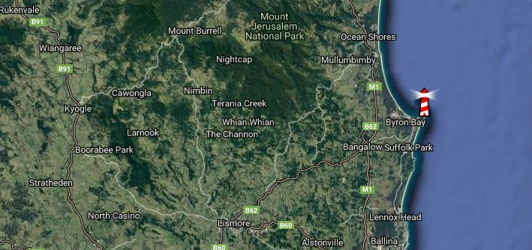

Figure 3. Location of Byron Bay (NSW)

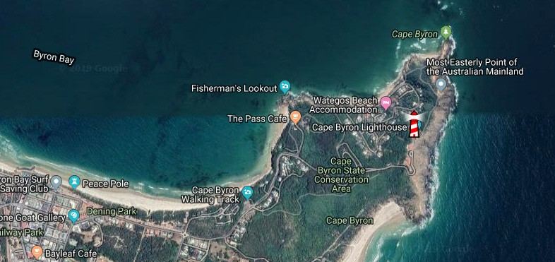

Figure 4. Location of Cape Byron Lighthouse (NSW)

### Setting and landscape

The lightstation is located on Cape Byron approximately 1.6 kilometres from Byron Bay’s town centre.

Situated atop a rocky cliff, the Cape Byron Lighthouse is surrounded by coastal beaches. The Cape is considered the most easterly point of the Australian mainland.

The thick vegetation found to its south-south-east is listed under the Cape Byron State Conservation Authority, which hosts the Cape Byron walking

track, a trail that loops around the Cape. This region

is registered as a protected area.

Due to its elevated position, views from the

lightstation are uninterrupted.

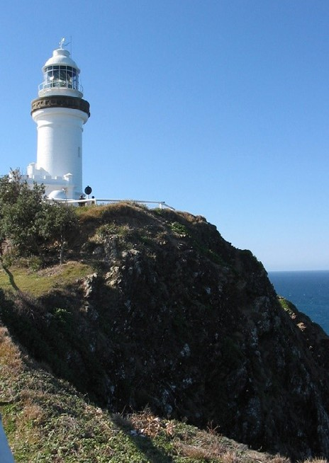

Figure 5. View of Cape Byron Lighthouse and surrounding cliffs (2005)

The Cape Byron Lighthouse precinct comprises of:

* a lighthouse tower and attached pavilion rooms
* a signal house/flag room
* a head lightkeeper’s quarters – currently a visitor

information centre

* an assistant lightkeeper’s quarters
* a signal mast
* a retaining wall
* steps
* a toilet block
* a walkway

AMSA is responsible for the lighthouse tower and surrounding paved area only.

#### Fauna and flora

The Byron Bay district is home to a number of native fauna species including flying foxes, koalas, and frogs.

A number of endangered ecological communities have been identified in the Arakwal National Park surrounding the Cape Byron Lightstation. The Graminoid Clay Heath, an endangered ecological community containing a large collective of native plants including, but not limited to, the fern-leaved banksia, hairy bushpea, kangaroo grass, and broad sword sedge.

The Themeda grasslands, another endangered ecological community, contains the following species:

* *Acacia sophorae*
* *Banksia integrifolia subsp. Integrifolia*
* *Commelina cyanea*
* *Glycine clandestina*
* *Glycine microphylla*
* *Hibbertia scandens*
* *Isolepis nodosa*
* *Kennedia rubicunda*
* *Lepidosperma spp.*
* *Leptospermum laevigatum*
* *Lomandra longifolia*
* *Monotoca elliptica*
* *Opercularia aspera*
* *Pimelea linifolia*
* *Poranthera microphylla*
* *Sporobolus virginicus*
* *Themeda australis*
* *Viola banksii*
* *Westringia fruticosa*

The endangered ecological community of the Littoral Rainforest has been identified within the Byron Bay region. The community is dominated by rainforest species but also includes *Angophora costata*, *Banksia integrifolia*, *Eucalyptus botryoides* and *Eucalyptus tereticornis* which are scattered throughout.

A restoration project is currently in place to assist in preserving the native landscape.

Information on fauna and flora camp management plans can be access from the Byron Shire Council: Native Animals and Plants webpage.d Furthermore, the Arakwal National Park plan of management

is available via the NSW Department of Planning,

Industry and Environment webpage.e

### Lease and ownership

The Cape Byron Lighthouse and surrounding land is owned by the New South Wales Government. AMSA lease the lighthouse and land from the NPWS.

The AMSA lease consists of two parcels with a

combined total of 639.8 metres-squared:

* Lot 1: 405.4 sq. m
* Lot 2: 234.4 sq. m

The current lease was signed on 8 October 1998 and terminates on 8 June 2022. The lease has an option to renew for a period of 25 years. The lease stipulates that AMSA must comply with any applicable management plan and state environmental laws.

Due to the popularity in tourism on the site, there was a tourist licence signed between the NSW Minister for Environment and AMSA on 1 July 1997 and terminates on 13 June 2022. There is an option to renew this licence for a further 25 years.

### Access

The precinct has an elevated position and there is only one vehicle access track, a well-maintained sealed road (Lighthouse Road). It terminates as a vehicle parking site at the base of Lot 2 (lighthouse block) between the assistant lighthouse keeper’s cottages and tourism facilities blocks. A restricted vehicle access road exists between the base of the lighthouse and this parking site however all visitors are required to complete the last 80 metres (approximately) by foot.

Walking access is available along the Cape Byron walking track (approximately a 3.7 kilometre loop) which includes the Cape Byron Lighthouse along its State Conservation Area route. These access points are located to the south and the north-north-east

of Lot 2. A concrete apron paving allows walking

access around the entire base of the lighthouse.

### Listings

|  |  |
| --- | --- |
| **Register**  Commonwealth Heritage List | **ID** |
| 105599f |
| NSW State Heritage List | 02023g |
| Register of the National Estate | 103599 |

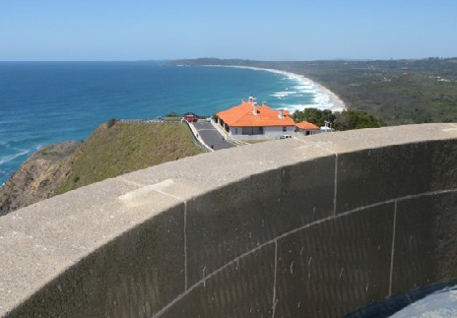

Figure 6. View of Tallow Beach from Cape Byron Lighthouse tower (2009)

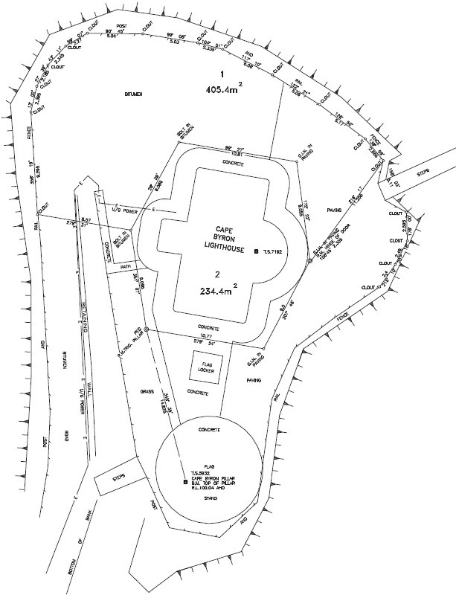

Figure 7. Lease Plan detailing land parcels under AMSA control (AMSG, 2015)

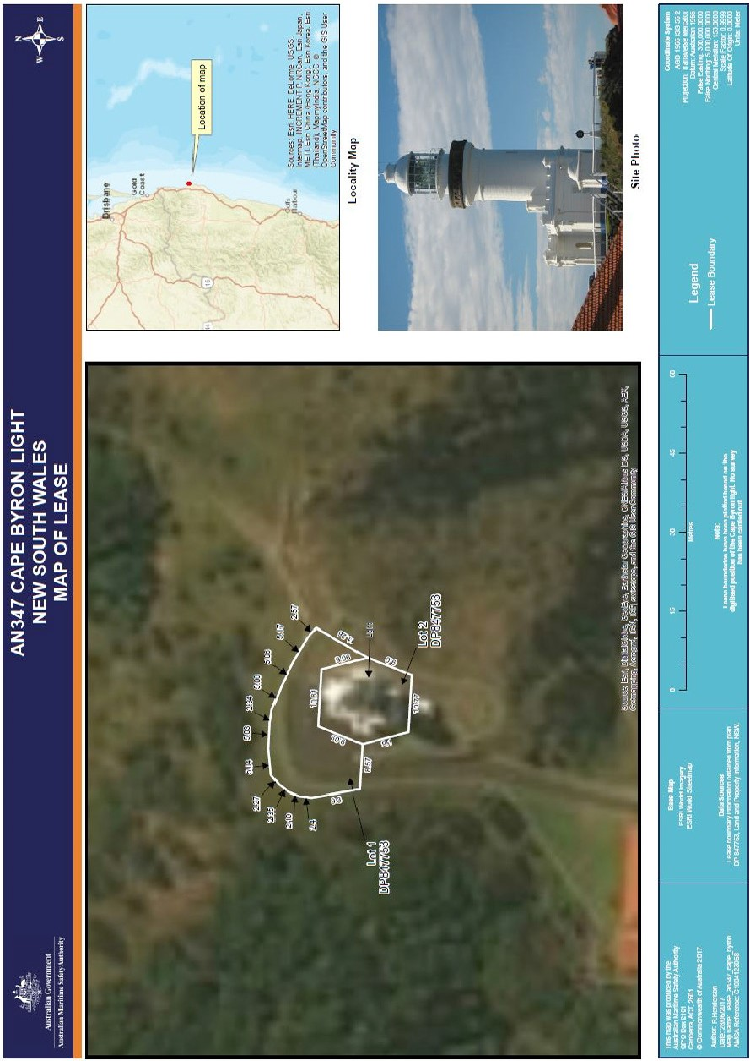

Figure 8. Cape Byron Lightstation NSW State Heritage Register Plan 3210 (NSW State Heritage Council, 2019)

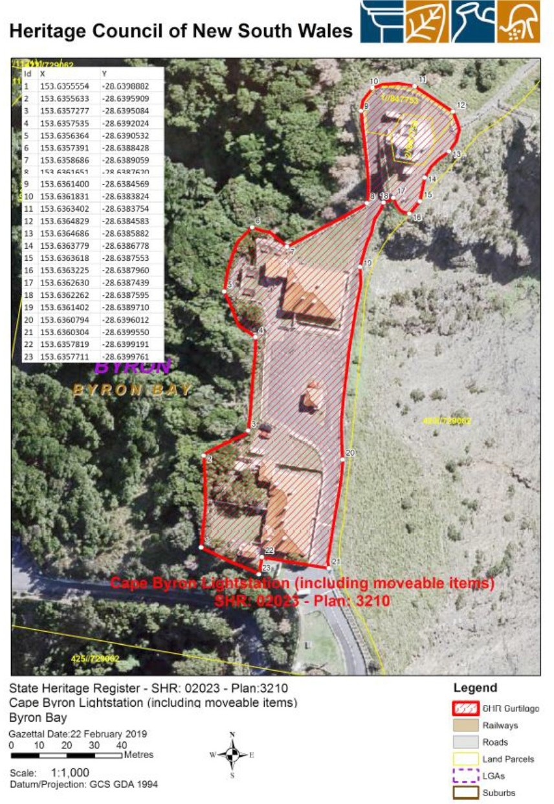

Figure 9. Cape Byron Lightstation NSW State Heritage Register Plan 3210 (NSW State Heritage Council, 2019)

# History

The following sections outline the history of lighthouses in Australia and Cape Byron Lighthouse. Some sections were provided by heritage architect, Peter Marquis-Kyle, and are referenced via footnote.

### General history of lighthouses in Australia

The first lighthouse to be constructed along Australian soil was Macquarie Lighthouse, located at the entrance to Port Jackson, NSW. First lit in 1818, the cost of the lighthouse was recovered through the introduction of a levy on shipping. This was instigated by Governor Lachlan Macquarie, who had ordered and named the light.

The following century oversaw the construction of hundreds of lighthouses around the country. Constructing and maintaining a lighthouse were costly ventures that often required the financial

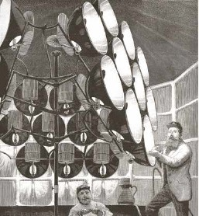

Figure 10. Early technology used in lighthouses 2

support of multiple colonies. However, they were deemed necessary aids in assisting the safety of mariners at sea. Lighthouses were firstly

managed by the colony they lay within, with each colony developing their own style of lighthouse and operational system. Following Federation in 1901, which saw the various colonies unite under one Commonwealth government, lighthouse management was transferred from State hands to the Commonwealth Lighthouse Service.

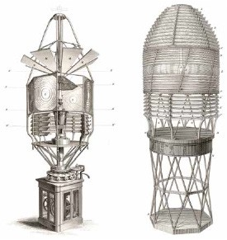

* + 1. Figure 10 – The Lantern room of the 1834 Belle Tout lighthouse, south west England. ‘The apparatus here employed is that of the “catoptric” system, in which a revolving frame has a number of large concave reflectors, with an Argand fountain lamp in each, fitted to each side of the frame. The shape and position of the reflectors are precisely calculated to throw the rays of light, in a combined flood of light, upon certain parts of the surface of the sea, and to prevent their being wasted in the sky.’ (Parts of a wood engraving and article published in the *Illustrated London News*, 5th January, 1884.); Figure [10] right – Early example of a rotating catadioptric apparatus, made for the 1844 lighthouse at Skerryvore, Western Scotland (Steel engraving from *Tomlinson’s Cyclopaedia of Useful Arts*, 1854)

#### Lamps and optics – an overview

Lighthouse technology has altered drastically over the centuries. 18th century lighthouses were lit using parabolic mirrors and oil lamps. Documentation

of early examples of parabolic mirrors in the United Kingdom, circa 1760, were documented as consisting of wood and lined with pieces of looking

glass or plates of tin. As described by Searle, “When light hits a shiny surface, it is reflected at an angle equal to that at which it hit. With a light source is placed in the focal point of a parabolic reflector,

the light rays are reflected parallel to one another,

producing a concentrated beam”3.

In 1822, Augustin Fresnel invented the dioptric glass lens. By crafting concentric annular rings with a convex lens, Fresnel had discovered a method

to reduce the amount of light absorbed by a lens. The Dioptric System was adopted quickly with Cordouran Lighthouse (France), fitted with the first dioptric lens in 1823. The majority of heritage-

listed lighthouses in Australia house dioptric lenses made by others such as Chance Brothers (United Kingdom), Henry-LePaute (France), Barbier, Bernard & Turenne (BBT, France) and Svenska Aktiebolaget Gasaccumulator (AGA of Sweden).

These lenses were made in a range of standard sizes, called orders—see Appendix 2. Glossary of lighthouse Terms relevant to Cape Byron Lighthouse.

Early Australian lighthouses were originally fuelled by whale oil and burned in Argand lamps, and multiple wicks were required in order to create a large flame that could be observed from sea. By the 1850s, whale oil had been replaced by colza oil, which was in turn replaced by kerosene, a mineral oil.

In 1900, incandescent burners were introduced. This saw the burning of fuel inside an incandescent mantle which produced a brighter light with less fuel within a smaller volume. Light keepers were required to maintain pressure to the burner by manually pumping a handle as can be seen in Figure 11.

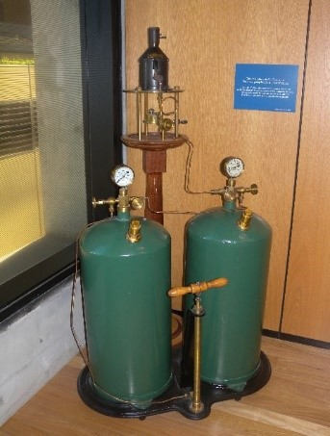

Figure 11. Incandescent oil vapour lamp by Chance Brothers

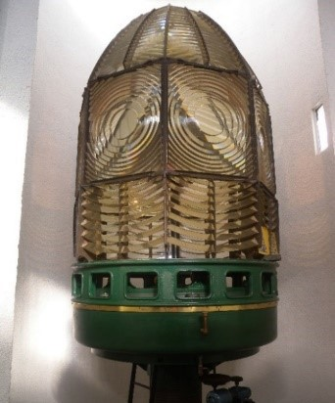

Figure 12. Dioptric lens on display at Narooma

* + 1. Searle. G, *First Order: Australia’s Highway of Lighthouses*, (2013). Page 34

In 1912, Gustaf Dalén, a Swedish engineer, was awarded the Nobel Prize in physics for a series of inventions relating to acetylene-powered navigation lights. Dalén’s system included the sun valve,

the mixer, the flasher, and the cylinder containing compressed acetylene. Due to their efficiency and reliability, Dalén’s inventions led to the gradual demanning of lighthouses. Acetylene was quickly adopted by the Commonwealth Lighthouse Service from 1915 onwards.

Large dioptric lenses, such as that shown in Figure 12, gradually decreased in popularity due to cost and the move towards unmanned automatic lighthouses. By the early 1900s, Australia had stopped ordering these lenses with the last installed at Eclipse Island in Western Australia in 1927.

Smaller Fresnel lenses continued to be produced and installed until the 1970s when plastic lanterns, still utilising Fresnel’s technology, were favoured instead. Acetylene remained in use until it was finally phased out in the 1990s.

In current day, Australian lighthouses are lit and extinguished automatically using mains power, diesel generators, and solar-voltaic systems.

### The Commonwealth lighthouse service

When the Australian colonies federated in 1901, it was decided that the new Commonwealth Government would be responsible for coastal

lighthouses. This included only the major lights used by vessels travelling from port to port, not the minor lights used for navigation within harbours and rivers. There was a delay before this new arrangement came into effect and the existing lights continued to be operated by the states.

Since 1915, various Commonwealth departments have managed lighthouses. AMSA, established under the *Australian Maritime Safety Authority Act 1990*, is now responsible for operating

Commonwealth lighthouses and other marine aids

to navigation, along with its other functions.

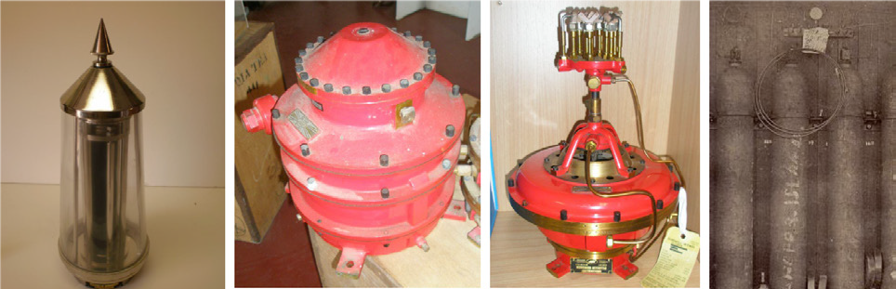

Figure 13. Dalén’s system – sunvalve, mixer, flasher and cylinder

* 1. **New South Wales lighthouse management**

The table below details the authorities of NSW

lighthouse management from 1915 to present.

## Cape Byron: a history

#### Indigenous presence

Prior to European occupation, the Bundjalung people (containing the subgroups of Arakwal and Galibal) claimed the coastal lands around Cape Byron (regarded by custodians as ‘Walgun’) as their tribal territories.

|  |  |
| --- | --- |
| **Time Period**  1915 – 1927 | **Administration** |
| Lighthouse Branch No. 3 District New South Wales, Victoria and Tasmania, Sydney headquarters. |
| 1927 – 1963 | Deputy Director of Lighthouses and Navigation, New South Wales. |
| 1963 – 1972 | Department of Shipping and Transport, Regional Controller, New South Wales. |
| 1972 – 1977 | Department of Transport [III], New South Wales Region / (from 1973) Surface Transport Group,  New South Wales region. |
| 1977 – 1982 | Department of Transport [III],  New South Wales region. |
| 1982 – 1983 | Department of Transport and Construction, regional office, New South Wales. |
| 1983 – 1987 | Department of Transport [IV], New South Wales regional office. |
| 1987 – 1990 | Department of Transport and Communications (Transport Group), New South Wales regional office. |
| 1991 – | Australian Maritime Safety Authority  (AMSA). |

The rich surrounding nature reserve was a key area for hunting and gathering, and also as a camping site 4. Various shell middens have been identified in the area with one site (4-5-0037, the pippi midden) regarded as the oldest dated foredune shell midden on the north coast of NSW with a date estimate of 1440+/- 70 BP.

Further consultation with traditional stakeholders will be undertaken to gain a greater understanding of Cape Byron’s history. This plan will be updated in future versions to reflect the accumulation of information.

#### Early European history

Captain Cook is believed to have been the first European to sight, record and name Cape Byron during his travels along what would become the New South Wales coast in mid-May 1770. Naming the Cape after fellow circumnavigator Vice-Admiral John Byron (1723–1786), it was also on this same day that Cook observed people walking along a beach believed to be just south of Byron 5.

The region appeared to forgo further European interaction until 1828 when the *Rainbow* docked in Byron and the ship’s master, William Johns, charted the bay. This remains the earliest known landing at Byron Bay 6.

* + 1. Boyd, W. E., et al, ‘The accumulation of charcoal within a midden at Cape Byron, northern New South Wales, during the last millennium’ *Australian Archaeology* (51) 2000, pg. 21; Pratten C., and R. Irving., Cape Byron Headland Reserve Heritage Study, (1991), pg. 10.
    2. Beaglehole, J.C., (ed.), The Journals of Captain James Cook on his Voyages of Discovery. I *The Voyage of the Endeavour 1768- 1771*, (Cambridge University Press), 1955; Brooks, G., and Associated Pty Ltd NPWS Lighthouses Conservation Management and Cultural Tourism Plan - Cape Byron Lighthouse: Supplementary Information, (2001) pg. 4.
    3. Stubbs, B.J., *History of the Cape Byron Lightstation Precinct*, Crown (2008) pg. 2.

|  |
| --- |
| On 25 June 1840, surveyor Robert Dixon travelled **Design**  through the Byron Bay region and recorded Designing the Cape Byron lightstation was a large interactions with a group of Indigenous hunters. feat as not only was a design required for a tower, Throughout the 1840s, Byron Bay became a critical but also for a surrounding precinct complete with point of access to shipping as cedar logs cut from living quarters for both chief and assistant lighthouse  the hinterland were dragged through the shallows keepers. Initial designs were produced by James  and onto cargo boats waiting in deeper water. Barnet, renowned architect who was frequently In 1881, a walking trip from Ballina to Brunswick engaged to design lightstations.  Heads took travellers through Byron Bay, and After his retirement as head colonial architect in 1890 European settlement in the area followed swiftly however, the official blueprints for the lightstation thereafter. By 1886, the first government sale of land precinct were completed by Charles Harding of the  in the area had occurred, and by the late 1880s, a Harbour and River Navigation Branch. The blueprints  jetty had been built 7. are believed to have been largely based on Barnet’s  earlier designs 10.  **3.5 Planning a lighthouse**  **Why Cape Byron?**  Owing to the importance of shipping and trade within the region, nautical traffic was relatively frequent with freight shipping increasingly common towards the  end of the 1860s. Figure 14. James Barnet (n.d)  In 1864, the freight ship *HMS Volunteer* was  wrecked on the Cape rocks which resulted in a **James Barnet (1827-1904)**  large loss of cargo. By 1896, five wrecks had been |
| recorded along Byron’s beaches and in 1897, funds Born 1827, Barnet studied drawing, design and totalling £18,000 were allocated to the erection of a architecture in London before he and his family lightstation on Cape Byron 8. migrated to Australia c.1854. Appointed clerk of  The site, which was cleared of vegetation by mid works for Sydney University, Barnet later joined 1898, was chosen due to its elevated position the Colonial Architect’s Office in 1860. By 1865, along the cape—approximately 113m above sea he was named colonial architect, a position he level (1901 data). Newspaper articles of the time held until his retirement in 1890. In that timeframe, announcing the lighthouse’s completion dictated that, Barnet was responsible for the architectural  as the most easterly point in Australia, the position design of numerous public works including called for the erection of a light, while the stretch of alledgedly 15 lighthouses. His design style, coast between the North Head of the Richmond and adopted from Francis Greenway’s Macquarie the light at Fingal Point, near the tweed, was another Light (1818), served as the quintessential NSW reason why it should be erected 9*.* style until the end of the 19th century. |

* + 1. Stubbs, B. J., *History of the Cape Byron Lightstation Precinct*, (2008) pg. 1.

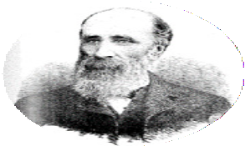

* + 1. Brooks, G and Associates Pty Ltd, *Cape Byron Lighthouse: Supplementary Information*, (2001) pg. 5.
    2. “A lighthouse for Cape Byron,” *The Northern Star*, Dec 1st, 1897, https://trove.nla.gov.au/newspaper/ article/71758856?searchTerm=Cape%20Byron%20lighthouse%20&searchLimits=dateFrom=1897-01-01|||dateTo=1901-12-31
    3. Brooks, G., and Associates Pty Ltd, *Cape Byron Lighthouse: Supplementary Information*, (2001), pg. 5.

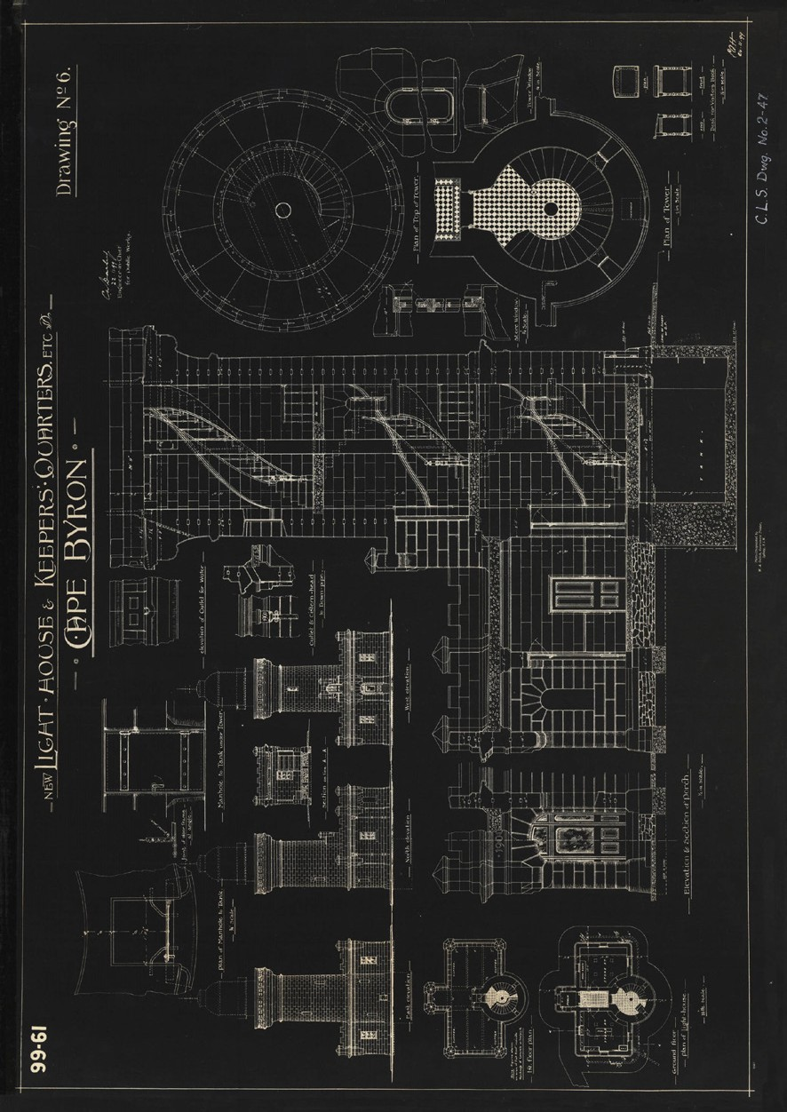

Figure 15. Blueprints for Cape Byron Lighthouse tower and attached pavilions (c.1899)

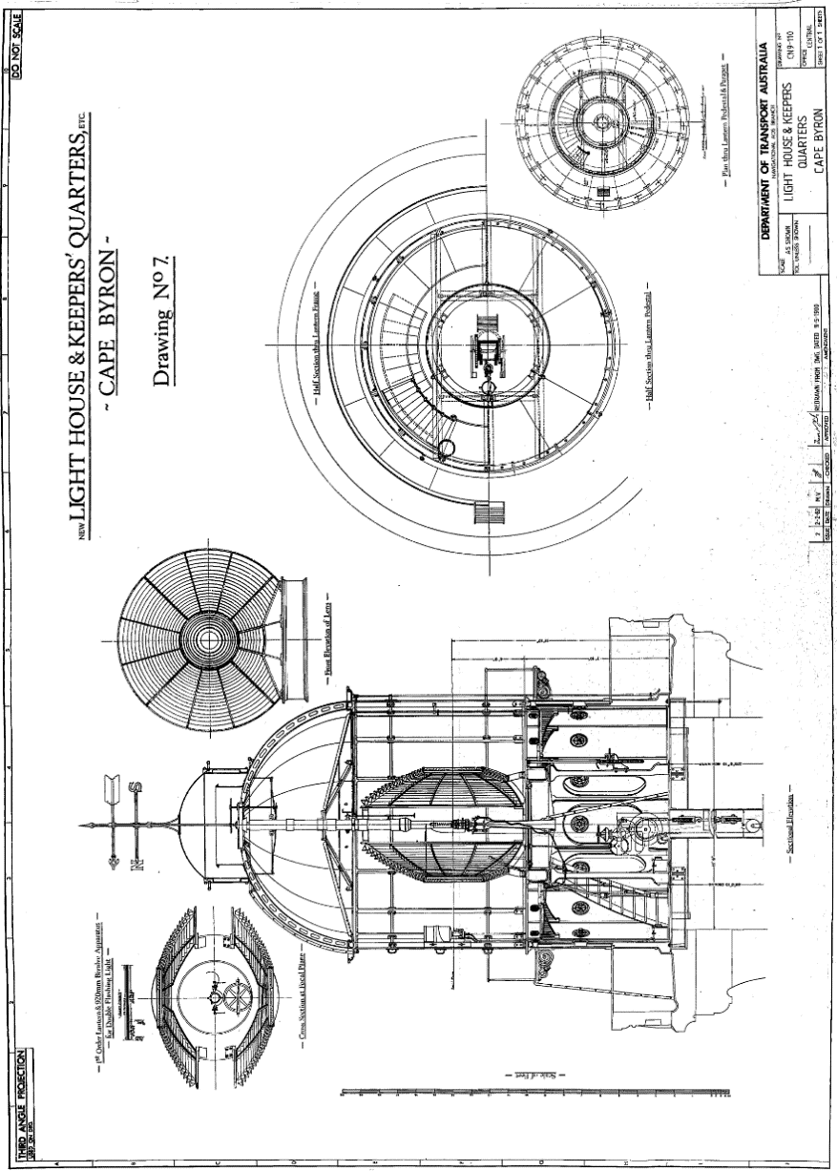

Figure 16. Design plan of Cape Byron’s lens and lantern room (1982)

#### Construction

Tenders for the construction of Cape Byron Lighthouse were called in March 1900 and Mitchell and King were successfully chosen as contractors for the project at a cost of £9970.

Construction started in July of 1900 where the area was levelled (undertaken by day labour) and plots were outlined for:

* the lighthouse tower
* workroom
* kerosene store room
* two lighthouse keeper’s cottages
* a signal station.

However, construction was reportedly delayed temporarily owing to the lack of a nearby water source 11. Once construction commenced, the main tower was built out of pre-cast concrete units placed in a cylindrical formation with the workroom and storeroom at its base. A mercury floatation mechanism was installed in the light tower (see Sub-section ‘Equipment when built’ below) which was designed by lighthouse engineer Mr. Douglass

and erected under the supervision of Mr. HC Cooper (engineer representative of WF Douglass Victoria Street Firm, London). The lighthouse keeper’s quarters were constructed from concrete and tiled roofs.

The lighthouse was connected telephonically to the Telegraph Office in Byron Bay by means of electric bells.

Construction was complete by 1901 and it was intended that the Lighthouse be officially opened by the Honourable John See, Premier of New South Wales on Saturday evening, 30 November.

However, due to inclement weather, the government steamer *Victoria* carrying the ministerial party was delayed and the Cape Byron Lighthouse was not officially opened until midday the following day on Sunday 1 December. The light was first lit that night.

#### Equipment when built

The completed lighthouse was regarded highly for

its modern fittings and composition.

As reported by The Northern Star (local newspaper) on 4 December 1901,

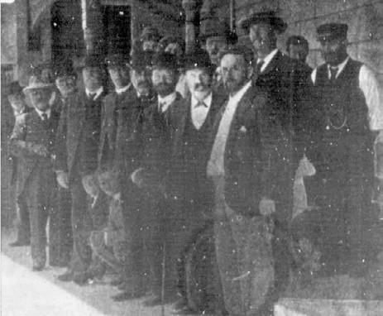 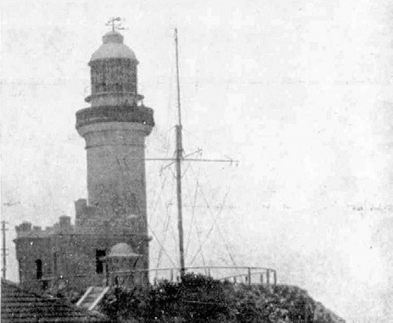

Figure 15. a) Ministerial Party at official opening (1901), b) view of Cape Byron lighthouse (1901)

* + 1. Stubbs, B. J., History of the Cape Byron Lightstation Precinct (2008), pg. 6.
    2. “The Cape Byron lighthouse,” The Northern Star, Dec 4th, 1901, https://trove.nla.gov.au/newspaper/ article/72080223?searchTerm=Byron%20Lighthouse%20construction%20%20%20%20%20%20%20%20%20%20%20%20 &searchLimits=exactPhrase|||anyWords|||notWords|||requestHandler|||dateFrom=1899-01-01|||dateTo=1901-12-31|||sortby

The light consists of a first-order lantern 12 feet internal diameter, and a first order revolving bi- valve double floating, “feu eclair” optical apparatus, manufactured by the Societie des Establiesement Henry Lepaute of Paris. The intensity of the flash is

145,000 standard English candles, and the apparatus rotates in a mercury bath at the rate of one complete revolution in 10 seconds 12.

The article also detailed the unique mercury float mechanism the lighthouse operated in conjunction with – the first of its kind in Australia:

The lamp takes six concentric wicks, the outer one five inches in diameter, and fed by kerosene oil…The occulting or revolving gear is worked by a clockwork arrangement, and winding up massive weights in

the centre of the tower. This gear, instead of working on rollers as with other revolving lights, is floated in a mass of 850 lbs of mercury and the weight of the machinery so floated is about four and half tons. A great deal of wear and tear and friction is avoided 13.

The equipment and mechanisms installed permitted rapid bursts of light from the tower which was reported as lasting one-fifth of a second, six times every minute.

### Lighthouse keepers

The Cape Byron Lighthouse was manned from its construction in 1901 right up until 1989, thirty years after the introduction of electricity to the lighthouse. Alongside the chief lighthouse keeper and their family, there were also assistant lighthouse keepers who lived with their families on the precinct in their own cottages. The first chief lighthouse keeper stationed at Cape Byron was William Warren and he was accompanied by two assistant light keepers, one being Mr Richard Sullivan. Both men had previously worked on the Solitary Island light. A comprehensive list of the names of those stationed as keepers at Cape Byron has been collated

and a copy is available within the Cape Byron Lighthouse museum. In addition to their lighting duties, the keepers were required to carry out minor maintenance duties on the precinct such as painting structures and managing the roads.

By 5 December 1959, the same year the lighthouse was converted from kerosene to electricity, the role of 2nd assistant keeper was made redundant. Thirty years later in 1989, the lighthouse was officially

de-manned. The cottages which had hosted the keepers were repurposed. The assistant lighthouse keeper’s residence was converted into a tourism destination with accommodation services. The chief lighthouse keeper’s quarters was converted into an office complete with meeting rooms, an interpretative centre and shop.

* + 1. “The Cape Byron lighthouse,” The Northern Star, Dec 4th, 1901, https://trove.nla.gov.au/newspaper/ article/72080223?searchTerm=Byron%20Lighthouse%20construction%20%20%20%20%20%20%20%20%20%20%20%20 &searchLimits=exactPhrase|||anyWords|||notWords|||requestHandler|||dateFrom=1899-01-01|||dateTo=1901-12-31|||sortby

1. “Struck by lightning: Cape Byron lighthouse,” The Telegraph, Nov 23rd, 1920, https://trove.nla.gov.au/newspaper/ article/179639297?searchTerm=byron%20lighthouse&searchLimits=exactPhrase|||anyWords|||notWords|||requestHandler|||dateFr om=1901-01-01|||dateTo=2011-12-31|||sortby
2. “Byron Bay lighthouse damaged,” Casino and Kyogle Courier and North Coast Advertiser, Feb 20th, 1929, https://trove.nla.gov.au/ newspaper/article/233837230?searchTerm=byron%20lighthouse&searchLimits=exactPhrase|||anyWords|||notWords|||requestHan dler|||dateFrom=1901-01-01|||dateTo=2011-12-31|||sortby
3. “Lighthouse reserve banned,” Tweed Daily, Sep 5th, 1939, https://trove.nla.gov.au/newspaper/ article/194657696?searchTerm=byron%20lighthouse&searchLimits=exactPhrase|||anyWords|||notWords|||requestHandler|||dateFr om=1901-01-01|||dateTo=2011-12-31|||sortby
4. “Weather station at lighthouse,” The Northern Star, Dec 1st, 1948, https://trove.nla.gov.au/newspaper/ article/99036744?searchTerm=byron%20lighthouse&searchLimits=exactPhrase|||anyWords|||notWords|||requestHandler|||dateFr om=1901-01-01|||dateTo=2011-12-31|||sortby

### Chronology of major events

The table below details the chronology of major events to have occurred at the Cape Byron Lighthouse.

|  |  |
| --- | --- |
| **Date**  1901 | **Event Details** |
| Construction of the Cape Byron Lighthouse completed.  Lightstation officially opened by Honourable John See, Premier of New South Wales |
| 1915 | Commonwealth takes control of state-owned lighthouses |
| 1920 | Lighthouse tower struck by lightning three times during electrical storm, extinguishing the light twice. The head keeper was struck by the second shock and badly stunned. Some damage was observed to the interior and woodwork of the lighthouse, to the wiring, and to the weathervane 14 |
| 1927 | 20 acres of adjoining land reserved for public recreation by lighthouse |
| 1929 | Lighthouse tower struck by lightning during electrical storm – suffered some damage to electrical  bells and telephonic communication devices inside the lighthouse 15 |
| 1939 | Lighthouse Reserve closed to all unauthorised persons indefinitely 16 |
| 1948 | Weather station installed at Cape Byron Lightstation 17 |
| 1959 | The second assistant keeper position discontinued |
| 1970s–1980s | Concrete retaining wall constructed onsite |
| 1980 | Cape Byron Lightstation added to Register of the National Estate |
| 1985 | First stage of Cape walking track opened |
| 1986 | Light extinguished manually for final time |
| 1987 | Second stage of Cape walking track opened |
| 1988 | Cape Byron Trust and Cape Byron Headland Reserve established |
| 1989 | Lighthouse officially de-manned |
| 1995 | Indigenous Land Use Agreement signed |
| 2004 | Cape Byron Lightstation added to Commonwealth Heritage List |
| 2014 | Local and international activists ‘occupy’ the Cape Byron Lighthouse in response to the G20 Summit held in the Queensland capital of Brisbane. Seeking to highlight concerns on climate change crisis, the lighthouse was allegedly chosen for it being “an iconic spot from which to broadcast our message” 18 |
| 2019 | Cape Byron Lightstation added to NSW State Heritage Register |

1. Prabhu, Harsha “Gee, 20 occupy lighthouse,” Echonetdaily, Nov 18th, 2014, [https://www.echo.net.au/2014/11/gee-20-occupy-](http://www.echo.net.au/2014/11/gee-20-occupy-)

lighthouse/

### Changes and conservation over time

Cape Byron Lighthouse has undergone minimal changes since its construction in 1901.

The small changes made were largely in relation to the light source and electrical systems rather than the structure itself.

#### The Brewis Report (1913)

Commander CRW Brewis, retired naval surveyor,

was commissioned in 1911 by the Commonwealth Government to report on the condition of existing lights and to recommend any additional ones.

Brewis visited every lighthouse in Australia between June and December 1912 and produced a series of reports published in their final form in March 1913. These reports were the basis for future decisions made in relation to the individual lighthouses.

Brewis’s recommendations for Cape Byron included increasing the power of the light from 145,000 candlepower (cp.) to 545,000 cp. by installing an incandescent mantle.

|  |
| --- |
| **Cape Byron Light 19** |
| 27 miles from Cook Island.  *Lat*. 28º 38’ S., *Long*. 153º 39’ E., *Chart No.* 1028. – Established 1901.  *Character– Main Light:* One white, dioptric, 145,000 c.p. Flashing, showing one flash of one-fifth of a second duration every five seconds. Illuminant, kerosene; six-wick burner.  Circular concrete tower, 60 feet, painted white. Height of focal plane, 371 feet.  *Subsidiary Light:* One red, dioptric, fixed. About 200 c.p. Exhibited from same tower as main light, at a height of 350 feet.  *Visibility – Main Light:* From seaward, in clear weather, for a distance of about 26 nautical miles.  *Subsidiary Light:* Only over Juan and Julia Rocks, for a distance of about 8 nautical miles.  *Optical Apparatus – Main Light:* Henri Lepaute, France, 1901. Two panels. Focal radius, 36 inches. Mercury float. One complete revolution every ten seconds.  *Subsidiary Light:* Chance Bros., 1889. Fixed lens, 15 inches diameter.  *Condition and State of Efficacy:* The tower, apparatus, quarters, and equipment are in good condition.  An incandescent installation is necessary to bring the light up to date. This will produce 545,000 c.p., and effect a  considerable economy in the consumption of oil.  Three light-keepers are stationed here.  *Communication:* By road with Byron Bay, distance 3 miles. Railway and steamer communication.  Connected by telephone with Byron Bay.  Mails daily. Government stores by coastal steamer once a year. Illuminating oil, provisions, &c., as required.  Electric Morse Lamp.  *Fogs:* Very few fogs are experienced in this locality.  *Soundings:* The soundings on the Chart are of a complete and suitable nature, and a vessel maintaining a depth of over 30 fathoms will pass at least 2 miles of Cape Byron and well clear of all dangers.  RECOMMENDED: The power of the light be increased from 145,000 c.p. to 545,000 c.p., and economy effected in the consumption of oil, by installing a 55 mm incandescent mantles. Illuminant, vaporized kerosene. |

1. Brewis, C.R.W., Lighting of the East Coast of Australia: Cape Moreton to Gabo Island (Including Coast of New South Wales), (1913). Page 12.

#### Alterations to the light

Major alterations made to the Cape Byron Light are listed below:

|  |  |
| --- | --- |
| **Date**  31 Jul 1905 | **Alteration** |
| Occulting mechanism removed –  light’s character altered. |
| 24 Mar 1914 | 6-wick burner removed, 55 mm IOV kerosene-powered light installed.  Intensity: 545,000 candlepower. |
| Aug 1922 | 3 x 55 mm incandescent kerosene  burner installed.  Intensity: 1,000,000 candlepower. |
| 28 Aug 1959 | Light converted from kerosene to electricity.  Intensity: 3,000,000 candlepower. |
| Prior to 1974 | 100V 2250W Tungsten halogen  globe installed.  Intensity: 2,200,000 candlepower. |
| 1985 | Direct-drive motor installed. |
| 10 Dec 1986 | Lighthouse fully automated. Chance Bros 185 millimetres drum lens (auxiliary) replaced by a Tideland ML-300 plastic lens (600 candlepower). |
| 1989 | Lighthouse de-manned. |
| 2015 | Light source changed to Sealite  Light-emitting diode (LED). |

#### Conservation works

Large refurbishments have been undertaken at the Cape Byron Lighthouse in recent years in an effort to take proactive measures to preserve the tower’s fabric and materials.

|  |  |
| --- | --- |
| **Date**  1990 | **Works Completed** |
| Refurbishments carried out by AMSA on pavilion roof (fitted with fibreglass). |
| 2015 | All interior lead-based paint coatings stripped from lighthouse tower.  Resealing of the:   * dome * internal floors * balcony * timber windows * tower base * murette and catwalk * glazing cage * guttering * internal steel work * tower external flat roof |
| 2019 | * Pavilion roof door replaced |

### Summary of current and former uses

From its construction in 1901, the Cape Byron Lighthouse has been utilised as a marine aid to navigation for mariners at sea. Its AtoN capabilities remains its primary utilisation.

The Cape Byron Lighthouse as a key tourism site developed over recent decades following the de- manning of the light. This provided the opportunity to transform the original assistant keeper’s cottage into a visitor information centre, and to commence guided tours inside the lighthouse. The guided tours remain secondary to the lighthouse’s use as a working AtoN.

### Summary of past and present community associations

The Cape Byron Lighthouse is firmly embedded within the Byron Bay community and surrounding areas.

#### Indigenous associations – Bundjalung/Arakwal People

The site continues to hold immense value to the Bundjalung of Byron Bay Arakwal People, who are the native title holders which hold Native Title under the recent Consent Determination from the Federal Court of Australia in April 2019. The Consent Determination established that native title holders are to be exclusively consulted regarding protection and management of Aboriginal cultural heritage within the native title claim area, which includes the Cape Byron Lighthouse.

Arakwal people recognise the site to be one of ceremony, learning, spiritual inspiration, and a key part of many dreaming stories. Arakwal people maintain a critical role in the management of

the Cape Byron Marine Park due to their strong connection to country. The relationship with this country is more than just a place to live. It’s the living, breathing source of all life, their spiritual home and home of their ancestors’ spirits.

Arakwal National Park is the first national park in Australia to be created under an Indigenous Land Use Agreement (ILUA) with traditional owners. A joint management agreement between Bundjalung of Byron Bay Arakwal people and NPWS allows both parties to jointly manage and care for country. Through this agreement, a commitment for Arakwal people to be employed and working on country

has been a success - many Arakwal people are employed in a variety of positions working on country and are on the management committees for the park and the Cape Byron State Conservation Area.

The Arakwal National Park, which surrounds the lightstation, remains a significant cultural landscape for Arakwal people. The heathland that forms the park was maintained through back-burning to regenerate plant-growth.

Further consultation with the traditional owners

- Bundjalung of Byron Bay Arakwal people of Cape Byron will be undertaken to gain a greater understanding of the past and present connections on surrounding country.

For more information on Bundjalung of Byron Bay Arakwal people, go to their website: [http://arakwal.com.au](http://arakwal.com.au/)

#### Local, national, and international associations

Due to its prominent coast position, the Cape Byron Lightstation maintains a number of local, national and international associations.

The NSW Marine Rescue operates within the Cape Byron Lighthouse precinct with an office onsite, and the Bureau of Meteorology operates a weather station onsite.

With its position as the most easterly point on the Australian mainland, and its proximity to the Pacific Highway, the Cape Byron Lighthouse site is an established tourist destination.

Events (for example, weddings and parties) are frequent on the site due to the scenic views and the catering/celebrant facilities that have been made available in recent decades. Additionally, the annual whale migration in the winter months attracts a large number of tourists and locals.

### Unresolved questions or historical

**conflicts**

Any unresolved questions and historical conflicts concerning the history of the Cape Byron Lighthouse discovered will be included in this section in future versions of this plan.

### Recommendations for further research

Research is currently being undertaken by local NPWS discovery education staff on the past lighthouse keepers at Cape Byron. Such work will be benefical in determining the full extent of the social value placed on the site within the Byron Bay community.

Additionally, archaeological investigation of the site may reveal further information on prehistoric and historic uses of Cape Byron to broaden understandings of the site’s intrinsic value 20.

1. Heritage approvals are essential in undertaking archaeological excavations/investigations within the site.

# Fabric

### Fabric register

The cultural significance of the lighthouse resides in its fabric, and also in its intangible aspects, such as the meanings people ascribe to it, and the

connections to other places and things. The survival of its cultural value depends on a well-informed understanding of what is significant, and on clear thinking about the consequences of change. The Burra Charter sets out good practice for conserving cultural significance.

Criterion listed under ‘Heritage Significance’ refer to the criterion satisfied within the specific Commonwealth heritage listing (see section 5.1).

**Lighthouse feature: Lantern roof**

#### Description and condition

1901 French-made part-spherical dome of copper

sheets lapped and screwed.

* Ribs – Not visible but presumed to be cast iron

radial ribs.

* Inner skin – Copper sheets screw fixed to ribs.
* Ventilator – Drum type with wind vane attached.
* Wind vane – Intact and complete with cardinal direction indicators, spindle, gears, and internal pointer (no index).
* Lightning conductor – Vertical pole beside ventilator, with four spikes at top, and two braces to ventilator. Eight vertical spikes attached near the gutter.
* Gutter – Circular ring of cast iron pieces bolted

together.

* Handrails – One circular hand rail attached to lantern roof, another attached to top of ventilator drum.
* Ladder rail – Attached to underside of gutter.
* Curtain rail – None; curtain hooks fixed to the

top of each vertical astragal.

* Drip tray – Copper dish suspended under ventilator, with central hole for heat tube closed off.
* Heat tube support – Framework with eight radial members of rolled ferrous T section, attached to gutter and to central ring.

|  |  |
| --- | --- |
| **Finish** | painted |
| **Condition** | intact and sound |
| **Integrity** | high |
| **Significance** | high |
| **Maintenance** | keep in service; prepare and  repaint at normal intervals |
| **Rectification**  **works** | none |

#### Heritage significance: High

The lantern roof is an original and essential part of a lighthouse associated with the development of marine aids to navigation along the NSW coast (criterion a).

The lantern roof contributes to the aesthetic value of

the lighthouse (criterion e).

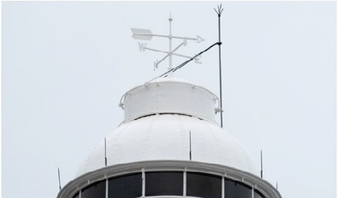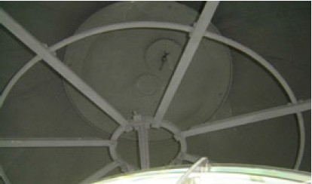

**Lighthouse feature: Lantern glazing**

#### lantern windows Description and condition

1901 French-made, cylindrical in form.

* Panes – Curved rectangular glass, three tiers.
* Astragals – Vertical and horizontal astragals of rectangular section iron, bolted to gutter ring at top, and to lantern base below.
* Downpipes – Two copper downpipes. Four

short spitters inserted in bottom of gutter.

* 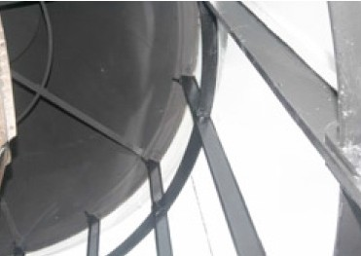Handholds – Three cast metal handholds bolted to each vertical astragal, except where downpipes are/were fitted.

|  |  |
| --- | --- |
| **Finish** | astragals and glazing strips painted |
| **Condition** | intact and sound |
| **Integrity** | high |
| **Significance** | high |
| **Maintenance** | keep in service; reglaze as necessary, prepare and repaint at normal intervals |
| **Rectification**  **works** | none |

#### lantern view through windows Heritage significance: High

The lantern glazing is an essential part of a lighthouse associated with the development of marine aids to navigation along the NSW coast (criterion a).

**Lighthouse feature: Internal catwalk**

#### internal catwalk Description and condition

1901 cast iron lattice floor panels supported on solid

cast iron brackets bolted to lantern base.

* Ladder – Fixed ladder with cast iron treads on

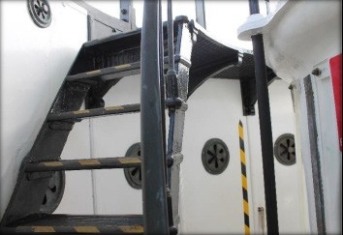wrought iron strings.

|  |  |
| --- | --- |
| **Finish** | painted |
| **Condition** | intact and sound |
| **Integrity** | high |
| **Significance** | high |
| **Maintenance** | keep in service, prepare and  repaint at normal intervals |
| **Rectification**  **works** | none |

#### Heritage significance: High

The internal catwalk is an original and essential part of a lighthouse associated with the development

of marine aids to navigation along the NSW coast

(criterion a).

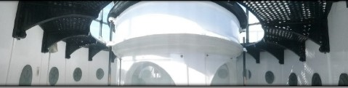

**Lighthouse feature: External catwalk**

#### external catwalk Description and condition

1901 cast iron lattice floor panels supported on openwork cast iron brackets bolted to lantern base with modern socket head bolts.

* 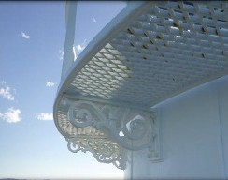Handrail – Rectangular section metal stanchions, round topped section rail, bolted to floor panels.

|  |  |
| --- | --- |
| **Finish** | painted |
| **Condition** | intact and sound |
| **Integrity** | high |
| **Significance** | high |
| **Maintenance** | keep in service, prepare and  repaint at normal intervals |
| **Rectification**  **works** | none |

#### Heritage significance: High

The external catwalk is an original and essential part of a lighthouse associatd with the development of marine aids to navigation along the NSW coast (criterion a).

The external catwalk contributes to the aesthetic

value of the lighthouse (criterion e).

**Lighthouse feature: Lantern base**

#### plaque reads replacement of turret roof carried out 26/9/09 Description and condition

1901, cylindrical in form. Curved panels of cast iron bolted together with flanged joints.

* 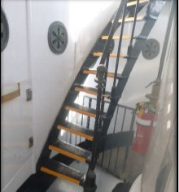Internal lining – Curved iron plates screwed to

the outer cast iron panels.

* Vents – Horizontal slot near the middle of exterior of each panel, covered with cast metal cowl with opening in the bottom, feeding air into the void behind the internal lining. Large round copper alloy regulators below internal catwalk, small ones above.
* Door – 2009, fibreglass door re-fitted with internal brass vent and door handle (a replica of original iron framed and sheeted door) hung on copper alloy hinges.

|  |  |
| --- | --- |
| **Finish** | painted |
| **Condition** | intact and sound |
| **Integrity** | medium – high |
| **Significance** | high |
| **Maintenance** | keep in service, prepare and  repaint at normal intervals |
| **Rectification**  **works** | none |

#### door to lantern room Heritage significance: High

The lantern base is an original and essential part of a lighthouse associated with the development of marine aids to navigation along the NSW coast (criterion a).

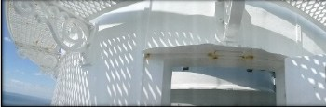

**Lighthouse feature: Lantern floor**

#### pedestal Description and condition

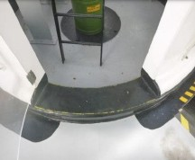1901 cast iron panels supported on rolled steel joists.

|  |  |
| --- | --- |
| **Condition** | intact and sound |
| **Integrity** | high |
| **Significance** | high |
| **Maintenance** | keep in service, prepare and  repaint at normal intervals |
| **Rectification**  **works** | none |

#### Heritage significance: High

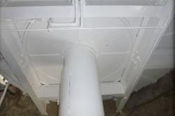The lantern floor is an original and essential part of a lighthouse associated with the development of marine aids to navigation along the NSW coast (criterion a).

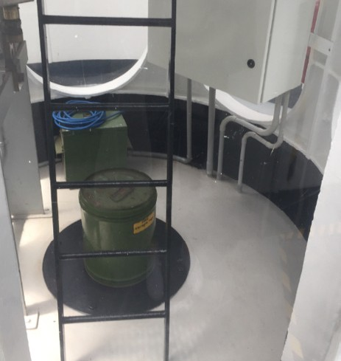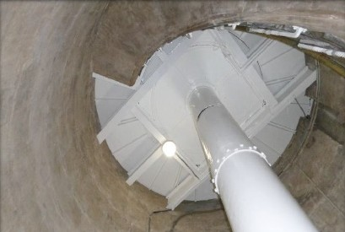

**Lighthouse feature: Light source**

#### lens Description and condition

Sealite SL-LED-324-W; 12 sided – 36 Light-emitting diode (LED) light source mounted on original cast iron pillar.

|  |  |
| --- | --- |
| **Condition** | intact and sound |
| **Integrity** | high |
| **Significance** | original pillar – high other parts – low |
| **Maintenance** | keep in service, prepare and  repaint pillar at normal intervals. |
| **Rectification**  **works** | none |

#### Heritage significance: High

The pillar is an original and essential part of a lighthouse associated with the development of marine aids to navigation along the NSW coast (criterion a).

**Lighthouse feature: Lens assembly**

#### lens close-up Description and condition

1901 Henry-Lepaute assembly of Fresnel central lenses and surrounding prisms set in gunmetal frame. A rotating bi-valve assembly.

**Condition** intact and sound

**Integrity** high

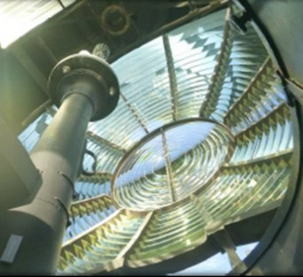**Significance** high

intervals

**Maintenance** keep in service, clean at normal

**Rectification**

**works**

none

#### Heritage significance: High

The lens assembly is an original and essential part of a lighthouse associated with the development of marine aids to navigation along the NSW coast (criterion a).

The lighthouse’s Henry-Lapaute lens is the only example within Australia (criterion b; criterion f).

The lens assembly contributes to the aesthetic

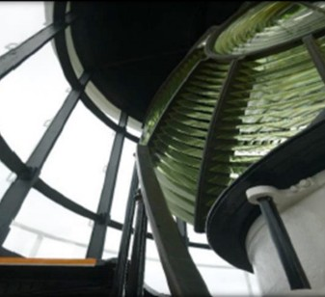value of the lighthouse (criterion e).

**Lighthouse feature: Pedestal**

#### mercury pedestal Description and condition

1901 Henry-Lepaute mercury-float pedestal, in the form of a large cylinder supporting the mercury trough.

* Mercury trough – Cast iron circular trough, still

in service.

* Mercury float – Cast iron annular float supported by mercury inside the trough. Three screw jacks are attached to the pedestal for lifting the float out of the mercury.
* Lamp platform – Cast iron platform.
* 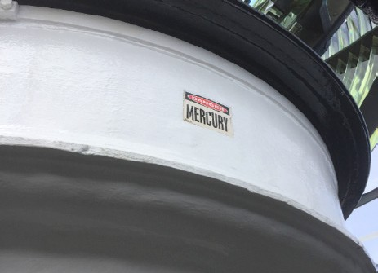Drive mechanism – Electric motor and gearbox. Original clock removed to ground floor.

|  |  |
| --- | --- |
| **Condition** | intact and sound |
| **Integrity** | high |
| **Significance** | high |
| **Maintenance** | keep in service, prepare and  repaint at normal intervals |
| **Rectification**  **works** | none |

#### Heritage significance: High

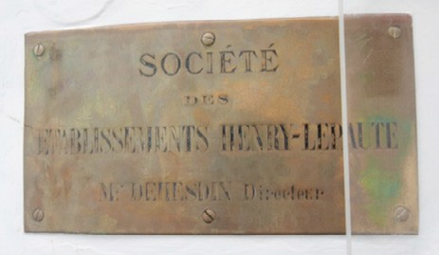The pedestal is an original and essential part of a lighthouse associated with the development of marine aids to navigation along the NSW coast (criterion a).

The pedestal’s first order mercury float mechanism is only one of six (6) found in Australian lighthouses (criterion b; criterion f).

**Lighthouse feature: Balcony floor**

#### balcony floor Description and condition

1901 stone slab floor, with integral gutter and spitters. Recent built up waterproof membrane. Perpend joints are aligned with the spitters, and are vulnerable to water penetration. These joints were repointed in 2008.

|  |  |
| --- | --- |
| **Finish** | membrane painted; other visible  surfaces are bare stone |
| **Condition** | intact and sound |
| **Integrity** | medium |
| **Significance** | high |
| **Maintenance** | keep in service, maintain paint coating and monitor for failure of membrane, replace membrane as necessary. Monitor pointing integrity in spitters |
| **Rectification**  **works** | none |

#### Heritage significance: High

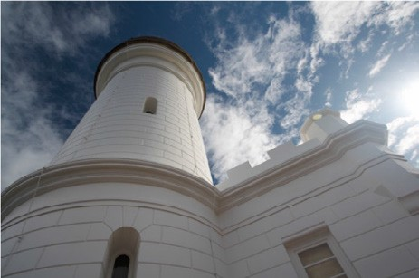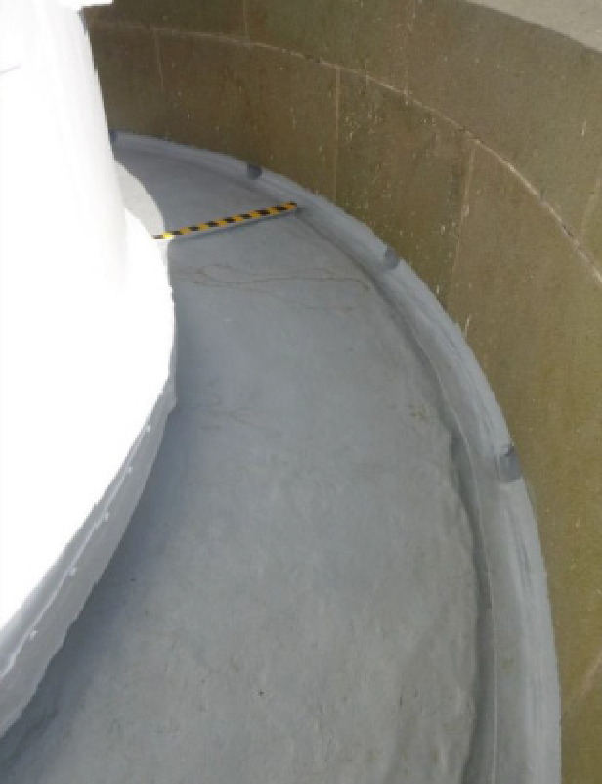

The balcony floor is an original and essential part of a lighthouse associated with the development of marine aids to navigation along the NSW coast (criterion a).

**Lighthouse feature: Balcony balustrade**

#### balcony balustrade brickwork Description and condition

1901 Solid stone wall of Bowral trachyte, with sunk panels and engaged piers and moulded coping showing to outside.

* 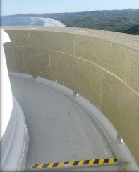Finish – Bare stone.

|  |  |
| --- | --- |
| **Condition** | intact and sound.  Re-pointed in 2008 |
| **Integrity** | high |
| **Significance** | high |
| **Maintenance** | keep in service; monitor for failure of pointing; repoint as necessary |
| **Rectification**  **works** | none |

#### Heritage significance: High

The balcony balustrade is an original and essential part of a lighthouse associated with the

development of marine aids to navigation along the

NSW coast (criterion a).

The balcony balustrade contributes to the aesthetic

value of the lighthouse (criterion e).

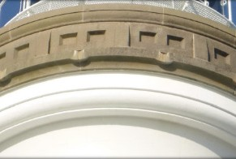

**Lighthouse feature: Walls**

#### tower walls Description and condition

1901 cylindrical tower of precast concrete units with joints expressed externally.

* 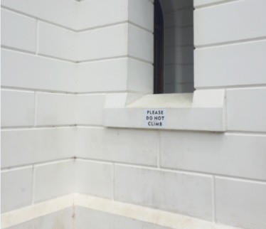Lightning conductor.

|  |  |
| --- | --- |
| **Finish** | painted |
| **Condition** | intact and sound, some cracking showing in concrete walls just below lantern floor |
| **Integrity** | medium |
| **Significance** | high |
| **Maintenance** | keep in service, prepare and repaint at normal intervals – monitor cracks below lantern floor for movement and ingress of water |
| **Rectification**  **works** | none |

#### Heritage significance: High

The walls are an original and essential part of a lighthouse associated with the development of marine aids to navigation along the NSW coast (criterion a).

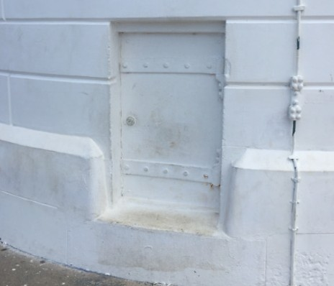The form, fabric and height of the tower walls contribute to the aesthetic value of the lighthouse (criterion e).

The walls are an early example of concrete block

construction in Australian lighthouses (criterion f).

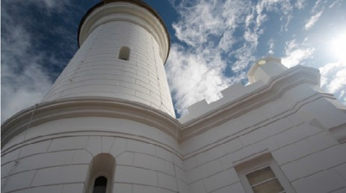

**Lighthouse feature: Windows**

#### window of tower Description and condition

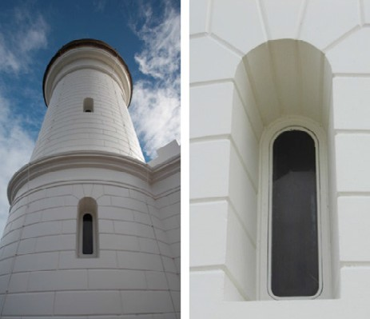1901 cast copper alloy metal frames set into masonry. Cast copper alloy sashes, opening inwards with copper alloy hinges and locking handles.

|  |  |
| --- | --- |
| **Finish** | painted, except for inside of sashes |
| **Condition** | intact and sound |
| **Integrity** | high |
| **Significance** | high |
| **Maintenance** | keep in service, prepare and  repaint at normal intervals |
| **Rectification**  **works** | none |

#### Heritage significance: High

The window openings are original and essential parts of a lighthouse associated with the development of marine aids to navigation along the NSW coast (criterion a).

The windows contribute to the aesthetic value of the

lighthouse (criterion e).

**Lighthouse feature: Auxiliary light**

#### auxiliary light in foyer Description and condition

Window is similar to other tower windows, except

for widely splayed embrasure.

* Beacon – Tideland ML-300 self-contained fixed beacon with red lens, on a fabricated steel post.

|  |  |
| --- | --- |
| **Condition** | sound and intact |
| **Integrity** | high |
| **Significance** | window – high beacon – low |
| **Maintenance** | keep in service, prepare and  repaint at normal intervals |
| **Rectification**  **works** | none |

#### Heritage significance: Moderate

The auxiliary light is an essential part of a lighthouse associated with the development of marine aids to navigation along the NSW coast (criterion a).

**Lighthouse feature: Door**

#### cedar door into tower foyer Description and condition

The door into the tower at ground floor is 1901 cedar four-panel framed door with bolection moulds and fielded panels.

* Clear glazed fanlight
* Original brass door furniture and mortise lock.

Added modern cylinder rim lock.

|  |  |
| --- | --- |
| **Finish** | polished |
| **Condition** | intact and sound |
| **Integrity** | high |
| **Significance** | high |
| **Maintenance** | keep in service, prepare and  maintain polish at normal intervals |
| **Rectification**  **works** | none |

#### door into tower Heritage significance: High

The door is an original and essential part of a lighthouse associated with the development of marine aids to navigation along the NSW coast (criterion a).

The door contributes to the aesthetic value of the

lighthouse (criterion e).

**Lighthouse feature: Intermediate floors**

#### bottom of stairwell Description and condition

1901 reinforced concrete, topping of square black and white ceramic tiles, rendered on other surfaces.

|  |  |
| --- | --- |
| **Finish** | render bare |
| **Condition** | intact and sound |
| **Integrity** | high |
| **Significance** | high |
| **Maintenance** | keep in service |
| **Rectification**  **works** | none |

#### top of staircase, looking down Heritage significance: High

The intermediate floors are an original and essential part of a lighthouse associated with the development of marine aids to navigation along the NSW coast (criterion a).

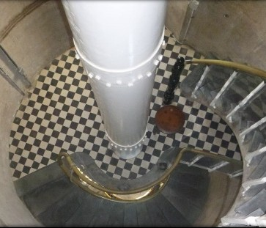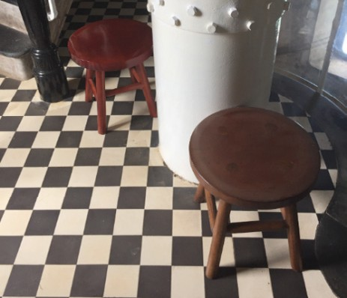

**Lighthouse feature: Stairs**

#### bottom stairs Description and condition

1901 precast concrete, topping of slate, rendered

on other surfaces.

* 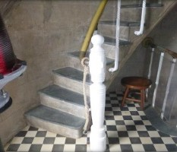Balustrade – Copper alloy tubular hand rail on wrought iron balusters. Later barrier of clear plastic sheet reversibly fixed to balusters with clamps.

|  |  |
| --- | --- |
| **Finish** | Render – Bare Balusters – Painted Slate treads – Bare |
| **Condition** | intact and sound |
| **Integrity** | high |
| **Significance** | high |
| **Maintenance** | keep in service, prepare and repaint  balusters at normal intervals |
| **Rectification**  **works** | none |

#### Heritage significance: High

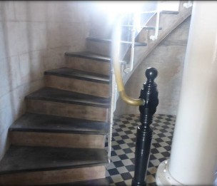The stairs are an original and essential part of a lighthouse associated with the development of marine aids to navigation along the NSW coast (criterion a).

**Lighthouse feature: Ground floor**

#### ground floor balustrade Description and condition

1901 reinforced concrete slab, topped with black

and white square ceramic tiles.

* Clockwork mechanism – The clockwork mechanism is kept at the ground floor level adjacent to the visible clock weights to form a display for lighthouse tours. The clockwork

mechanism has had the crank handle removed

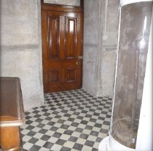and the gears fixed to make it inoperable.

|  |  |
| --- | --- |
| **Finish** | ceramic tiles |
| **Condition** | intact and sound |
| **Integrity** | high |
| **Significance** | high |
| **Maintenance** | keep in service, clean at normal  intervals |
| **Rectification**  **works** | none |

#### Heritage significance: High

The ground floor is an original and essential part of a lighthouse associated with the development of marine aids to navigation along the NSW coast (criterion a).

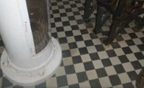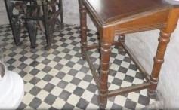

**Lighthouse feature: Weight tube**

#### weight tube looking up to intermediate floor Description and condition

Iron circular trunk running up the centre of the tower

from the ground floor to the lantern floor.

The curved door into the weight tube at ground floor level has been removed, and the opening covered with clear plastic sheeting to allow the clock weights to be seen.

|  |  |
| --- | --- |
| **Finish** | painted |
| **Condition** | intact and sound |
| **Integrity** | high |
| **Significance** | high |
| **Maintenance** | keep in service, maintain and  repaint at normal intervals |
| **Rectification**  **works** | none |

#### weight tube looking up to lantern room Heritage significance: High

The weight tube is a historic and essential part of a lighthouse associated with the development of marine aids to navigation along the NSW coast (criterion a).

**Lighthouse feature: Pavilion room walls**

#### external pavilion wall Description and condition

1901 walls of pre-cast concrete units with joints

expressed externally. Rendered inside.

|  |  |
| --- | --- |
| **Finish** | painted externally, bare internally |
| **Condition** | intact and sound |
| **Integrity** | high |
| **Significance** | high |
| **Maintenance** | keep in service, prepare and repaint  external face at normal intervals |
| **Rectification**  **works** | none |

#### external pavilion wall with window and portico Heritage significance: High

The pavilion room walls are an original and essential part of a lighthouse associated with the development of marine aids to navigation along the NSW coast (criterion a).

The pavilion room walls contribute to the aesthetic

value of the lighthouse (criterion e).

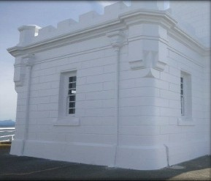

**Lighthouse feature: Pavilion roof**

#### pavilion roof door Description and condition

Flat roof of reinforced concrete, topped with recent built-up waterproof membrane.

|  |  |
| --- | --- |
| **Finish** | membrane |
| **Condition** | intact and sound |
| **Integrity** | high |
| **Significance** | roof and parapets: high roof door: low |
| **Maintenance** | keep in service, monitor membrane; prepare and re-apply at normal intervals |
| **Rectification**  **works** | none |

#### balustrade of pavilion roof Heritage significance: High

The pavilion roof is an essential part of a lighthouse associated with the development of marine aids to navigation along the NSW coast (criterion a).

The pavilion roof contributes to the aesthetic value

of the lighthouse (criterion e).

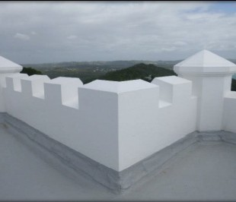

**Lighthouse feature: Pavilion doors**

#### pavilion cedar door with arched windows Description and condition

1901 cedar doors.

* Entrance door – Half-glazed cedar door in timber frame with sidelights and fanlight glazed with etched glass. External faces of glazing fitted with clear plastic sheets as anti-vandalism measure.
* 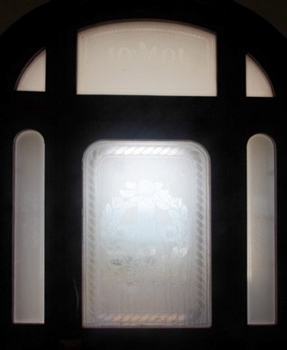Room doors – 4 panel doors.

|  |  |
| --- | --- |
| **Finish** | polished |
| **Condition** | intact and sound |
| **Integrity** | high |
| **Significance** | high |
| **Maintenance** | keep in service, prepare and polish  at normal intervals |
| **Rectification**  **works** | none |

#### Heritage significance: High

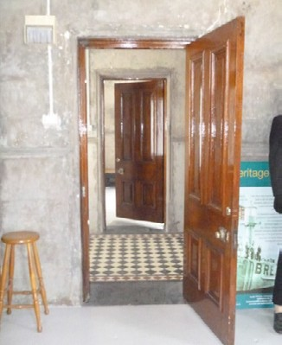The pavilion doors are original and essential parts of a lighthouse associated with the development of marine aids to navigation along the NSW coast (criterion a).

The pavilion doors contribute to the aesthetic value

of the lighthouse (criterion e).

**Lighthouse feature: Pavilion windows**

#### pavilion window external Description and condition

Early timber double hung sashes in timber frames.

|  |  |
| --- | --- |
| **Finish** | painted |
| **Condition** | Intact and sound. Repairs and replacement of parts during the period 2009–2015. Sash cords in museum room windows reinstated in 2017 |
| **Integrity** | high |
| **Significance** | high |
| **Maintenance** | keep in service, prepare, re-seal  and repaint at normal intervals |
| **Rectification**  **works** | none |

#### Heritage significance: High

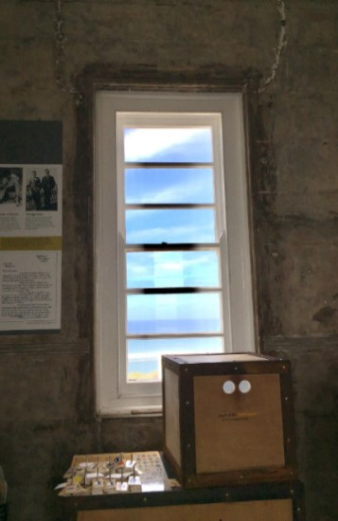The pavilion window openings are an essential part of a lighthouse associated with development of marine aids to navigation along the NSW coast (criterion a).

The pavilion windows contribute to the aesthetic

value of the lighthouse (criterion e).

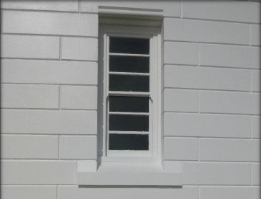

**Lighthouse feature: Pavilion rooms**

#### museum room on ground floor of tower Description and condition

The pavilion adjoining the base of the tower is divided into three separate rooms. The foyer divides the northern and southern rooms and provides an access thoroughfare to the tower.

* Southern room – Set up as a museum, currently

being used by the tourism operator.

* 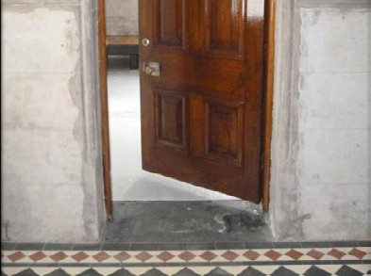Northern room – Open as part of the museum,

also houses equipment.

Both rooms are open to the general public.

|  |  |
| --- | --- |
| **Finish** | Ceilings are painted; walls are bare masonry, floors in northern and southern rooms are painted,  foyer floor is tiled in black and white  square ceramic tiles as is tower. All timber work shelving has been prepared and clear coated. |
| **Condition** | Intact and sound.  Early settlement cracks showing from window corners on internal walls. |
| **Integrity** | high |
| **Significance** | high |
| **Maintenance** | Keep in service, prepare and repaint at normal intervals. Monitor wall cracks for movement and moisture ingress. |
| **Rectification**  **works** | none |

#### Heritage significance: High equipment room on ground floor

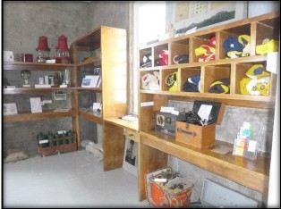The pavilion rooms are an original and essential part of a lighthouse associated with the development of marine aids to navigation along the NSW coast (criterion a).

The pavilion rooms contribute to the aesthetic value

of the lighthouse (criterion e).

Public accessibility to the pavilion rooms contributes to the social value of the lighthouse (criterion g).

Note: The curved timber desk within the pavilion is original and listed as a moveable artefact on the Cape Byron Lightstation NSW State Heritage List.

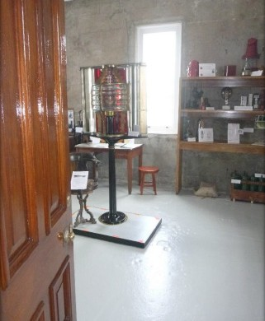 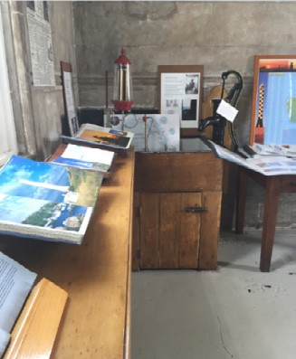

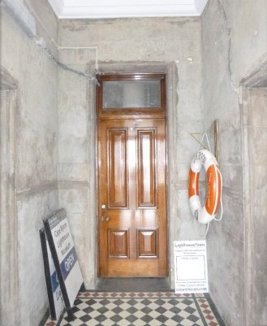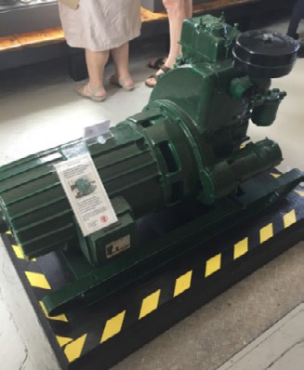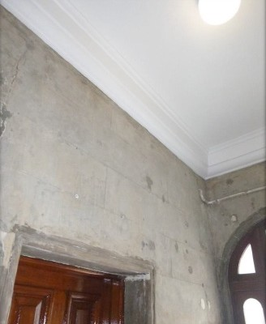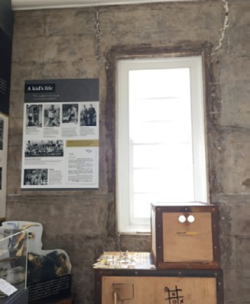

**Lighthouse feature: Apron paving**

#### apron paving around pavilion Description and condition

1901 cast concrete paving border around lighthouse perimeter.

|  |  |
| --- | --- |
| **Finish** | trowelled bare concrete |
| **Condition** | intact and sound with minor cracks visible |
| **Integrity** | high |
| **Significance** | high |
| **Maintenance** | keep in service, carry out minor  repairs as required |
| **Rectification**  **works** | none |

#### apron paving around tower Heritage significance: High

The apron paving is an essential part of a lighthouse associated with the development of marine aids to navigation along the NSW coast (criterion a).

### Related object and associated AMSA artefact

There is a collection of related objects/associated artefacts that are currently on display at the Cape Byron museum. This museum is located within the tower itself.

|  |  |  |
| --- | --- | --- |
| **Phone in Lantern Room**  phone in lantern room | **Maximo ID** |  |
| AR0624 |  |
| **Location in lighthouse** |  |
| Mounted on the internal lantern pedestal wall. |  |
| **Condition** |  |
| Good condition. |  |

|  |  |
| --- | --- |
| **Diesel lister SR3 genera**  diesel generator | **tor set Ex Cape Byron**  **Maximo ID** |
| AR0234 |
| **Location in lighthouse** |
| Ground floor – engine  room on plinth as a display. |
| **Condition** |
| Good, decommissioned  – set up at ground floor of lighthouse for tourist viewing. |

### Comparative analysis

In terms of design, the Cape Byron Lighthouse closely resembles that of Point Perpendicular Light (first lit 1899) diverging only in lens and lantern manufacture. Cape Byron’s unique Henry- Lepaute lens differed from Point Perpendicular’s

1st Order Fresnel lens. Cape Byron’s mercury bath mechanism allowed the lens to revolve at a faster rate (once every 10 seconds as opposed to Pt.

Perpendicular’s rate of once every 90 seconds).

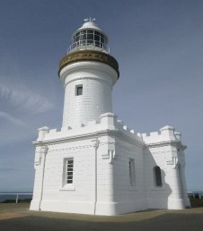

a

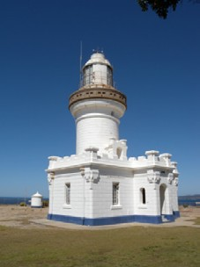

b

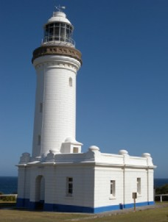

c

Figure 17. a) Cape Byron Lighthouse (lit 1901)

|  |  |  |
| --- | --- | --- |
| **Original clockwork mec**  clockwork mechanism | **hanism**  **Maximo ID** |  |
| AR0688 |  |
| **Location in lighthouse** |  |
| Ground floor inside tower  adjacent to weight tube. |  |
| **Condition** |  |
| Good, mechanism fixed  inoperable for public safety  – set up at ground floor of lighthouse for tourist viewing. |  |

1. Point Perpendicular Lighthouse (lit 1899)
2. Norah Head Lighthouse (lit 1903).

Cape Byron Lighthouse also shares design

similarities with Norah Head Light (first lit 1903).

Both Point Perpendicular and Norah Head were

designed by James Barnet.

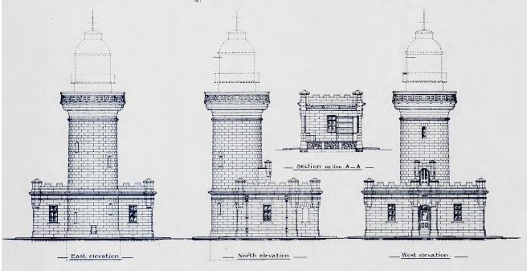

Figure 18. Cape Byron elevation blueprint (1899)

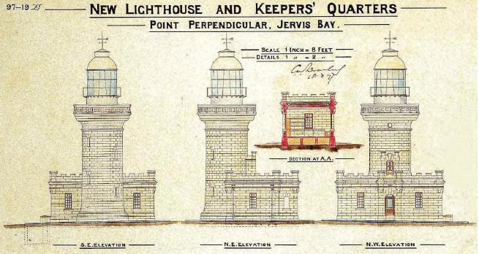

Figure 19. Point Perpendicular elevation blueprint (1897)

# Heritage significance

### Commonwealth heritage list – Cape Byron Lighthouse

#### Statement of Commonwealth heritage

**significance**

The following statement of significance is taken from the Cape Byron Lighthouse listing on the Australian Heritage Database (Place ID: 105599):

Cape Byron Lighthouse, opened in 1901, is significant as an important element in the establishment of marine aids to navigation along the New South Wales coast, and is important for its association with east coast

shipping since the beginning of the twentieth century. (Criterion a.) (Themes: 3.8.1 Shipping to and from Australian ports, 3.16.1 Dealing with hazards and disasters)

The Lighthouse is technically important for its early concrete block construction, for having been the first Australian installation of a mercury float mechanism pedestal, and for being the only Henry-Lepaute optic in Australia. (Criteria f. and b.)

The Lighthouse is dramatically located on

the top of a windswept cliff and is a dominant landscape feature free of modern intrusions. It has notable aesthetic values. (Criterion e.)

The place, located at the most easterly point of the Australian mainland, is visited by large numbers of people each year and has a high profile in the public imagination. It is well known as a key whale-watching spot. Its social value is considerable. (Criterion g.)

#### Commonwealth heritage values – criteria

There are nine criteria for inclusion in the Commonwealth Heritage List – meeting any one of these is sufficient for listing a place. These criteria are similar to those used in other commonwealth, state and local heritage legislation, although thresholds differ. In the following sections, the Cape Byron Lighthouse is discussed in relation to each of the criteria as based on the current Commonwealth heritage listing.

|  |  |  |
| --- | --- | --- |
| **Criterion**  **Criterion A – Processes**  This criterion is satisfied by places that have significant heritage value because of [their] importance in the course, or pattern, of Australia’s natural or cultural history. | **Relevant attributes identified** | **Explanation** |
| All of the historic fabric and detail associated with construction, personnel and operation of the Lighthouse and beacon. | Cape Byron Lighthouse, opened 1901, is significant as an important element in the establishment of marine aids to navigation along the New South Wales coast, and is  important for its association with east coast shipping since the beginning of the twentieth century. |
| **Criterion B – Rarity**  This criterion is satisfied by places that have significant heritage value because of [their] possession of uncommon, rare or endangered aspects of Australia’s natural or cultural history. | The optical apparatus including the Henry-Lepaute optic lens and the mercury float rotating pedestal. | The Henry-Lepaute optic is the only one installed in a lighthouse in Australia. |

|  |  |  |
| --- | --- | --- |
| **Criterion**  **Criterion C – Information**  This criterion is satisfied by places that have significant heritage value because of [their] importance  in demonstrating the principal characteristics of Australia’s natural or cultural history. | **Relevant attributes identified** | **Explanation** |
| No attributes identified |  |
| **Criterion D – Typicality**  This criterion is satisfied by places that have significant heritage values because of [their] importance  in demonstrating the principal characteristics of a class of Australia’s natural or cultural history. | No attributes identified |  |
| **Criterion E – Aesthetics**  This criterion is satisfied by places that have significant heritage value because of [their] importance in exhibiting particular aesthetic characteristics values by a community or cultural group. | Its setting, location, and its ability to be seen from a distance free of modern intrusions. | The lighthouse is dramatically located  on the top of a windswept cliff and is dominant landscape feature free of modern intrusions. It has notable aesthetic values. |
| **Criterion F – Achievement**  This criterion is satisfied by places that have significant heritage value because of [their] importance in demonstrating a high degree of creative or technical achievement at a particular period. | Concrete block construction and  mercury float mechanism pedestal.  The installation of the Henry-Lepaute  optic. | The lighthouse is technically important for its early concrete block construction, and for its use of the mercury float mechanism pedestal and the Henry-Lepaute optic. |
| **Criterion G – Community**  This criterion is satisfied by places that have significant heritage value because of [their] strong or  special association with a particular community or cultural group for social, cultural or spiritual reasons. | Accessibility by the visiting public. | The place, located at the most easterly point of the Australian mainland, is visited by large numbers of people each year and has a high profile in the public imagination. It is well known as a key whale-watching spot. Its social value is considerable. |
| **Criterion H – Significant people** This criterion is satisfied by places that have significant heritage value because of [their] special association with the life or works of a person, or group of persons, of importance in Australia’s cultural history. | No attributes identified |  |
| **Criterion I – Indigenous tradition** This criterion is satisfied by places that have significant heritage value because of [their] importance as part of indigenous tradition. | No attributes identified |  |

### NSW State Heritage Register – Cape Byron Lightstation

The following information details the Cape Byron Lightstation listing on the NSW State Heritage Register.

#### NSW State Heritage Register – statement of

**heritage significance**

The following statement is taken from the Cape Byron Lightstation listing on the NSW State heritage register (place ID: 02023):

The Cape Byron Lightstation (including moveable items) is of state heritage significance as one of the last major lightstations that completed the ‘highway of lights’ that has illuminated the NSW

coastline since the 19th century. Among the final components of the string of lights that provided protection, navigational guidance and safe passage to the important colonial shipping industry, the Cape Byron Lightstation is a representative example of the system

of lightstations that collectively reflect the logistical management and technical evolution of coastal infrastructure in NSW.

The design and layout of the Cape Byron Lightstation is architecturally consistent with the earlier stations but implemented technical advancements, such as precast concrete block construction and the Henry-Lepaute feu eclair lens system on a rotating mercury float mechanism, which were available at the turn of the 20th century. Today, these aspects of the Cape Byron Lightstation are considered to be rare in NSW.

The Cape Byron Lightstation includes three original moveable items which contribute to the significance of the site, including the 15 inch Chance Bros & Co red sector light (1889) on a cast iron pedestal; original curved timber desk (1899-1901); and clockwork winch used to drive the lens carriage (1901).

The spectacular scenery and beauty of the Cape Byron Lightstation, its siting on the most eastern point of the Australian mainland and the convergence of the natural and cultural environment on the headland is of great aesthetic significance. The evocative image of the tower standing against the expanse

of the Pacific Ocean resonates with the NSW community, making the lightstation an important landmark and tourist destination in

the state. What is now a recognisable and well known image both locally and internationally, the Cape Byron Lightstation is the most highly visited lightstation in Australia.

The Cape Byron headland is also of great traditional and contemporary significance to the Arakwal people. As custodians of their country, the Arakwal people hold an important and active role in the joint care and management of the reserve (which incorporates the lightstation) and undertake educational initiatives at the site to promote and raise awareness of the Aboriginal

cultural heritage of the cape. Named Walgun (meaning ‘The Shoulder’), today the Cape Byron headland is a place where both the traditional and contemporary cultural of the Arakwal people is practiced and celebrated.

#### NSW State heritage values – criterion

Information from the table below was taken from the Cape Byron Lightstation listing on the New South Wales State heritage register (Place ID: 02023):

|  |  |
| --- | --- |
| **State Heritage Register criterion (SHR)**  **SHR Criterion A – historical significance**  An item is important in the course, or pattern, of NSW’s cultural or natural history. | **Evidence/Explanation** |
| The Cape Byron headland is of state heritage significance:   * for its occupation by the Bundjalung people of the Byron Bay area for many thousands of years prior to European settlement. The cape and its environment provided the local aboriginal people with physical and spiritual resources which sustained both life and culture. * as one of the last major lightstations to complete the ‘highway of lights’ along the NSW coastline. Coastal transport of produce, goods and passengers was a booming industry and critical colonial service during the mid-to-late 19th century and installing a consistent and comprehensive network of lightstations to illuminate the coastline and provide navigational guidance to the growing maritime industry was a highly ambitious project. * with its retention, display and interpretation of the significant moveable items within the lighthouse, including the 15 inch Chance Bro & Co red sector light (1889) on a cast iron pedestal; original curved timber   desk (1899-1901); and clockwork winch used to drive the lens carriage (1901).  Ultimately successful and unique to NSW, the string of coastal lights operated throughout the 20th century and the Cape Byron Lightstation, amongst the suite of stations, continues to guide and provide safe passage to maritime industries and traffic along the NSW coastline today. |
| **SHR Criterion B – associative**  **significance**  An item has strong or special association with the life or works of a person, or group of persons, of importance in NSW’s cultural or natural history. | The Cape Byron headland is of local heritage significance for its  association with:   * the Bundjalung people of Byron Bay. Traditionally known as Cavanba, the cape and its environment provided the local Aboriginal people with physical and spiritual resources which sustained both life and culture, Today, this association continues with the Arakwal people who have an important role in the joint management, care and control of the Cape Byron Headland Reserve; * Charles Assinder Harding, specialist lighthouse architect for the Harbour and River Navigation Branch of the Public Works department; * Cecil W Darley, engineer-in-chief of the Public Works Department.   As colonial architect James Barnet had retired and the Marine Board of NSW disbanded, Harding and Darley were responsible for the design and construction of the last lightstations that would complete the ‘highway of lights’.  A significant, ambitious and ultimately successful project of Francis Hixon and Barnet in the mid-late nineteenth century, Harding designed the Cape Byron Lightstation with architectural styling that was consistent with Barnet’s earlier stations but incorporating technological advancements of the period.  In the design and construction of the Cape Byron Lightstation, Harding and Darley made an important contribution to the completion of Hixon and Barnet’s plan to illuminate the NSW coastline with lights and navigational aids. |

|  |  |
| --- | --- |
| **State Heritage Register criterion (SHR)**  **SHR Criterion C – aesthetic significance**  An item is important in demonstrating aesthetic characteristics and/or a high degree of creative or technical achievement in NSW. | **Evidence/Explanation** |
| The Cape Byron Lighthouse (including moveable items) is of state heritage significance for its aesthetic and technical values.  Located within the Cape Byron Headland Reserve and sited prominently on the most eastern point of the Australian mainland, the Cape Byron Lighthouse is a relatively small but well-proportioned tower that reflects the consistent architectural design of the stations making up the ‘highway of lights’ along the NSW coastline. Retaining its unique French manufactured Henry-Lepaute first order lantern, bi-valve two panel lens and rotating mercury float mechanism, the Cape Byron Lighthouse is flanked by a compact group of simple Victorian Georgian buildings (including head keeper’s and assistant keeper’s quarters) that are visually complementary in alignment, scale, proportion and material.  It is the spectacular scenery and beauty of its location, however, that gives the Cape Byron Lightstation its great aesthetic appeal. The convergence of the natural and cultural environment and the evocative image of the tower standing against the expanse of the Pacific Ocean resonates with the NSW community, making it a landmark in the state.  Technically, the Cape Byron Lightstation is also of state heritage significance as it contains Australia’s only Henry-Lepaute lantern and optic on a rotating mercury float mechanism. Considered leading optical technology at the turn of the 20th century, this optical system is still in operation as a marine aid to navigation today and its retention is of great value to the significance of the Cape Byron Lightstation. |
| **SHR Criterion D – social significance**  An item has strong or special association with a particular community or cultural group in NSW for social, cultural or spiritual reasons. | The Cape Byron Lightstation (including moveable items) is of state heritage significance for its social values.  As well as historic social value to the Bundjalung people of Byron Bay, the Cape Byron headland has a thriving contemporary social significance for the Arakwal people. With a formal and active role in the joint care and management of the Cape Byron Headland Reserve (which incorporates the lightstation), the Arakwal people continue their custodianship of country and cultural practice on the site. Although the construction of the  lightstation destroyed traditionally sacred and cultural sites, today’s Arakwal community run educative initiatives at the headland which raise public awareness and appreciation for the Aboriginal cultural heritage of the cape. Named Walgun by the local Arakwal people (meaning the shoulder), these initiatives aim to explore the traditional ownership of the headland by the Bundjalung people and how the Aboriginal cultural heritage values of the site or not confined to the past but are flourishing due to the joint care, control and custodianship of the reserve by the Arakwal people.  The Cape Byron Lightstation is also of state heritage significance for the local, national and international visitors who value the site. Today, the Cape Byron Lightstation is the most well-known and highly visited lightstation in Australia. The dramatic location and picturesque nature of the lightstation has made the site a tourist destination and the image of the tower  standing against the dramatic coastal environment serves as a potent and resonating symbol of human activity in an often wild and treacherous environment. |

|  |  |
| --- | --- |
| **State Heritage Register criterion (SHR) SHR Criterion E – research potential**  An item has potential to yield information that will contribute to an understanding of NSW’s cultural or natural history. | **Evidence/Explanation** |
| Within the Cape Byron Lightstation, there are opportunities to uncover further heritage values that may be of heritage significance.  The Cape Byron headland, more broadly, has the ability to demonstrate the occupation of the area by the Bundjalung people of Byron Bay prior to European occupation. There is recorded evidence in the area of middens, camp sites and artefact scatters, a bora ring and possible burial sites and there is further scope to elaborate on archaeological investigations of Aboriginal cultural heritage values to reveal new information on how the Bundjalung people interacted with the landscape.  Elements associated with the design, construction, early operation and occupation of the site as a lightstation may be of heritage significance.  Areas of substantial historical use which have undergone little to no disturbance (such as subfloor areas, privies and tips) may retain archaeological information.  The Cape Byron Lightstation includes the only example of a Henry- Lepaute feu éclair (lightning flasher) lens system on a rotating mercury float mechanism in Australia. Representing the best optical technology at the turn of the nineteenth century, the apparatus has technical value and could contribute to an understanding of the operation of lighthouses of the period. |
| **SHR Criterion F – rarity**  An item possesses uncommon, rare or endangered aspects of NSW’s cultural or natural history. | The Cape Byron Lightstation (including moveable items) is of state heritage significance for its rarity values as it was only the second lightstation in NSW to be built of precast concrete blocks rather than the traditional stone material. Due to the success of the prototype at Point Perpendicular Lightstation in 1899 (although the first example was built at Point Hicks in Victoria in 1888) and the benefits and cost savings it made to the lighthouse construction, the design of the Cape Byron Lightstation is almost an identical copy of that constructed at Point Perpendicular.  The Cape Byron Lightstation (including moveable items) is also of state heritage significance for the rarity of its optical system. Still in operation and use today, the Henry-Lepaute 2 sided (Bi-valve) lens system on a rotating mercury float mechanism was considered to be leading optical technology of the period and its retention is of great value to the significance of the Cape Byron Lightstation. |

|  |  |
| --- | --- |
| **State Heritage Register criterion (SHR)** | **Evidence/Explanation** |
| **SHR Criterion G – Representativeness**  An item is important in demonstrating the principal characteristics of a class of NSW’s:   * Cultural or natural places; or * Cultural or natural environments | The Cape Byron Lightstation (including moveable items) is of state heritage significance as a representative station along the NSW’s ‘highway of lights’, a system of navigational aids installed along the coastline in the mid-to-late 19th century. Important to the safe passage of shipping in NSW, the system of lightstations has a collective significance that reflects the logistical management for installing coastal infrastructure and the technical evolution of the stations.  There is also an architectural coherency between lightstations across NSW, particularly those designed by James Barnet as the Colonial Architect (1865-1890). Cape Byron Lightstation was designed by Barnet’s successor, Charles Assinder Harding, who contributed the strong architectural styling of Barnet while designing a tower and precinct for the Cape Byron headland that was distinctive and contemporary in its use of developing technology and construction techniques.  As a representative example, the design and compact nature of the building group at Cape Byron reflects the typical layout of regional lightstation complexes around Australia. |

These heritage values, identified and explained within the Commonwealth Heritage List and the State Heritage Register, will form the basis of the management of the Cape Byron Lighthouse. In the event of necessary works, all criterions will be consulted to inform best practice management of the values associated with the lightstation. (See Section 7 – Conservation management policies for further information on strategies to conserve Cape Byron Lighthouse’s heritage values).

### Condition and integrity of the Commonwealth heritage values

A heritage monitoring program was implemented in 2016. Each site is visited and reviewed every two years where the heritage fabric and values of the site is evaluated. Assessment of the condition and integrity of lighthouse’s values are derived from the latest available Heritage Asset Condition Report produced by AMSA’s maintenance contractor.

As a whole, the Cape Byron Lighthouse demonstrates fair-good condition. Minor cracking is visible within the concrete walls of the tower and pavilion rooms (routine monitoring of these cracks are carried out periodically). The lighthouse also

demonstrates medium-high integrity. Some changes to the lighthouse, such as the removal/alteration of

a) the weight tube clockwork mechanism, and b) the occulting mechanism, have had a slight impact on integrity.

|  |  |  |  |
| --- | --- | --- | --- |
| **Criteria**  **Criterion A - Process** | **Attributes** | **Condition** | **Integrity** |
| All of the historic fabric and detail associated with construction, personnel and operation of the Lighthouse and beacon. | Fair – Good | Medium – High |
| **Criterion B – Rarity** | The optical apparatus including:   * the Henry-Lepaute optic lens * Mercury float rotating pedestal. | Good Good | High High |
| **Criterion E – Aesthetics** | It is setting, location, and its ability to be seen from a distance free of modern intrusions. | Good | High |
| **Criterion F – Achievement** | * Concrete block construction. * Mercury float mechanism pedestal. * The installation of the Henry-   Lepaute optic. | Good Good Good | Medium High High |
| **Criterion G – Community** | Accessibility by the visiting public. | Good | High |

### Gain or loss of heritage values

Evidence for the potential gain or loss of heritage values will be documented within this section of future versions of this heritage management plan.

# Opportunities and constraints

### Implications arising from

**significance**

The statement of significance (section 5.1 above) demonstrates that the Cape Byron Lighthouse is a place of considerable heritage value due to its contribution to the establishment of New South

Wales’ ‘highway of lights’, and its assistance to east

coast shipping at the turn of the twentieth century.

The implication arising from this assessment is that key aspects of the place should be conserved to retain this significance. The key features requiring conservation include:

* the continued use of the lighthouse as an AtoN
* the architectural quality of the building
* the Henry-Lepuate lens, and rotating mercury

pedestal

* the moveable artefacts (Diesel lister SR3 generator ex Cape Byron, original clockwork mechanism, phone in lantern room, and original curved visitors desk)
* the interior spaces and features (which are notable for their design, details, and/or their original lighthouse function). These include:
  + North and south pavilion rooms
  + Intermediate floors
  + Ground floor
  + Spiral staircase and weight tube
  + Lantern room
  + Lens assembly
* the external spaces and features (which are notable for their design, details, and/or their original lighthouse function). These include:
  + Lantern roof and glazing
  + External catwalk, and balcony
  + Lighthouse walls, windows
  + Pavilion room walls and windows
  + Pavilion roof
  + Pavilion doors
  + Apron paving

#### Referral and approvals of action

The EPBC Regulations 2000 requires approval from the Minister for Sustainability, Environment, Water,

Population and Communities for all actions likely to have a significant impact on matters of National Environmental Significance (NES).

The Regulations provides that actions:

* taken on Commonwealth land which are likely to have a significant impact on the environment will require the approval of the Minister
* taken outside Commonwealth land which are likely to have a significant impact on the environment on Commonwealth land, will require the approval by the Minister
* taken by the Australian Government or its agencies which are likely to have a significant impact on the environment anywhere will require approval by the Minister.

The definition of ‘environment’ in the EPBC Regulations 2000 includes the cultural heritage values of places.

#### Heritage Strategy

If an Australian Government agency owns or controls one or more places with Commonwealth heritage values, it must prepare a heritage strategy within two years from the first time they own or control a heritage place (section 341ZA).

A heritage strategy is a written document that integrates heritage conservation and management within an agency’s overall property planning and management framework. Its purpose is to help an agency manage and report on the steps it has taken to protect and conserve the commonwealth heritage values of the properties under its ownership or control.

The heritage strategy for AMSA’s AtoN assets was completed and approved by the Commonwealth Minister for the Environment in 2018 and is available online.i

#### Heritage Asset Condition Report

A heritage asset condition report is a written document that details the heritage fabric of a site with an in-depth description of each architectural and structural element. The document includes: a brief history of the site, the Commonwealth Heritage statement of significance and value criteria, a heritage significance rating for each individual element, and a catalogue of artefacts on-site.

The document is also accompanied by up-to-date

photos of each structural element.

This document operates as a tool for heritage

monitoring, and is reviewed and updated biennially.

### Framework: sensitivity to change

Owing to the site’s desired intactness and aesthetic qualities, the Cape Byron Lighthouse is of high significance. Therefore, work actioned by AMSA

on the lighthouse’s fabric harnesses the potential to reduce or eradicate the significance of the site’s heritage values.

Conservation works, including restoration and reconstruction, or adaption works of the absolute minimum so as to continue the lighthouse’s usefulness as an AtoN are the only works that should be actioned by AMSA on Cape Byron Lighthouse. Some exceptions are made for health and safety requirements, however any and all work carried out must be conducted in line with heritage considerations and requirements of the EPBC Act.

The table below demonstrates the level of sensitivity attributed to the various elements of the fabric register in the face of change. These are measured on a high-moderate-low spectrum depending on the action’s possible threat to the site’s heritage values (definitions listed below).

#### High sensitivity

High sensitivity to change includes instances wherein a change would pose a major threat to the heritage value of a specific fabric, or the lightstation as a whole. A major threat is one that would lead to substantial or total loss of the heritage value.

#### Moderate sensitivity

Moderate sensitivity to change includes instances wherein a change would pose a moderate threat to the heritage value of a specific fabric, or would pose a threat to the heritage significance of a specific fabric in another part of the building. A moderate threat is one that would diminish the heritage value, or diminish the ability of an observer to appreciate the value.

#### Low sensitivity

Low sensitivity to change includes instances wherein a change would pose little to no threat to the heritage value of a specific fabric, and would pose little to no threat to heritage significance in another part of the building.

|  |  |  |
| --- | --- | --- |
| **Component**  **Cape Byron Lighthouse structure (including pavilion buildings)** | **Level of sensitivity** | **Nature of change impacting heritage values** |
| High | Changes to façade materials and design.  Reduction of the all-round visibility of the structure and its  setting on Cape Byron. |
| Low | Repainting of structure (in like colours).  Removal of asbestos/lead paint and/or other toxic materials.  Minor repairs to trowelled bare concrete apron paving. |
| **Ground floor, and pavilion**  **rooms** | High | Changes to façade materials and design. |
| Moderate | Permanent removal of museum objects from pavilion rooms and ground floor. |
| Low | Repainting of ground floor and pavilion rooms (in like-colours). |
| **Stairs, and weight tube** | High | Removal/replacement of stairs and weight tube. |
| Moderate | Permanent removal of clock weights from within weight  tube. |
| Low | Repainting of stairs and weight tube (in like colours). |
| **Intermediate floors** | Moderate | Removal of original 1901 black and white ceramic tiles. |
| Low | Repainting of intermediate floor levels (in like colours). |
| **Balcony** | High | Changes to façade materials and design. |
| Low | Repainting of balcony floor/balustrade (in like colours). |
| **Lens assembly, pedestal, and auxiliary light** | High | Removal of Henry-Lepaute lens and/or rotating mercury  bath pedestal.  Alterations to original material of lens and pedestal  (i.e. removal of mercury from pedestal). |
| Moderate | Building alteration that would cause obstruction of auxiliary beacon. |
| Low | Changing of the light’s character.  Alteration/replacement of Sealite SL-LED light source (not relating to supporting pillar).  Alteration of the auxiliary beacon.  Main light lens rotation change-out. |
| **Lantern room** | Low | Replacement of glazing.  Re-sealing of glazing. |

### Statutory and legislative requirements

The table below lists the relevant Acts, Regulations and Codes associated with the management of

AMSA’s Commonwealth heritage lightstations.

|  |  |
| --- | --- |
| **Act or Code**  *Environment Protection and Biodiversity Conservation Act 1999* | **Description** |
| *The Environment Protection & Biodiversity Conservation Act 1999 (EPBC Act)* requires agencies to prepare management plans that satisfy the obligations included in Schedule 7A and 7B of the EPBC Regulations 2000. |
| Environment Protection and Biodiversity Conservation Regulations 2000  Schedule 7B | The Commonwealth Department of the Environment and Energy has determined  these principles as essential for guidance in managing heritage properties.   * The objective in managing Commonwealth Heritage places is to identify, protect, conserve, present and transmit, to all generations, their Commonwealth Heritage values. * The management of Commonwealth Heritage places should use the best available knowledge, skills and standards for those places, and include ongoing technical and community input to decisions and actions that may have a significant impact on their Commonwealth Heritage values. * The management of Commonwealth Heritage places should respect all heritage values of the place and seek to integrate, where appropriate, any Commonwealth, state, territory and local government responsibilities for those places. * The management of Commonwealth Heritage places should ensure that their use and presentation is consistent with the conservation of their Commonwealth Heritage values. * The management of Commonwealth Heritage places should make timely and   appropriate provision for community involvement, especially by people who:   * 1. have a particular interest in, or associations with, the place; and   2. may be affected by the management of the place; * Indigenous people are the primary source of information on the value of their heritage and that the active participation of indigenous people in identification, assessment and management is integral to the effective protection of indigenous heritage values. * The management of Commonwealth Heritage places should provide for regular monitoring, review and reporting on the conservation of Commonwealth Heritage values. |
| AMSA Heritage Strategy 2018 | As the custodian of many iconic sites, AMSA has long recognised the importance  of preserving their cultural heritage.  This Heritage Strategy is in response to section 341ZA of the EPBC Regulations which obliges AMSA to prepare and maintain a heritage strategy, along with obliging AMSA to:   * Assist in identification, assessment and monitoring of places of heritage value in its care; * Prepare and maintain a register of its places of heritage value; * Protect the heritage value of places when they are sold or leased; * Provide this heritage strategy, and any subsequent major updates, to the   relevant minister.  The strategy derives from the AMSA Corporate Plan and achievements are reported through the AMSA Annual Report. The 2018-19 AMSA Annual report can be found online.j |

|  |  |
| --- | --- |
| **Act or Code**  *Navigation Act 2012* | **Description** |
| Part 5 of the Act outlines AMSA’s power to establish, maintain and inspect marine aids to navigation (such as the Cape Byron Lighthouse).   1. AMSA may:    1. Establish and maintain aids to navigation; and    2. Add to, alter or remove any aid to navigation that is owned or controlled by AMSA; and    3. Vary the character of any aid to navigation that is owned or controlled by   AMSA.   1. AMSA, or person authorised in writing by AMSA may, at any reasonable time   of the day or night:   * 1. Inspect any aid to navigation or any lamp or light which, in the opinion of AMSA or the authorised person, may affect the safety or convenience of navigation, whether the aid to navigation of the lamp or light is the property of:      1. A state or territory; or      2. An agency of a state or territory; or      3. Any other person; and   2. Enter any property, whether public or private, for the purposes of an inspection under paragraph (a); and   3. Transport, or cause to be transported, any good through any property, whether public or private, for any purpose in connection with:      1. The maintenance of an aid to navigation that is owned or controlled by AMSA; or      2. The establishment of any aid to navigation by AMSA. |
| *Australian Heritage Council Act 2003* | This Act establishes the Australian Heritage Council, whose functions are:   * To make assessments under Division 1A and 3A of Part 15 of the EPBC Act 1999; * To advise the Minister on conserving and protecting places included, or being considered for inclusion, in the National Heritage List or Commonwealth Heritage List; * To nominate places for inclusion in the National Heritage List or   Commonwealth Heritage List;   * To promote the identification, assessment, conservation and monitoring of heritage; * To keep the Register of the National Estate; * To organise and engage in research and investigations necessary for the   performance of its functions;   * To provide advice directly to any person or body or agency either if its own   initiative of at the request of the Minister; and   * To make reports as outlined in the Act. |

|  |  |
| --- | --- |
| **Act or Code**  *New South Wales Heritage Act 1977* | **Description** |
| This Act intends to:   * Promote understanding and conservation of the state’s heritage; * Provide for identifying and registering items of state heritage significance; * Provide for the interim protection of items, pending an assessment of their state heritage significance; * Encourage the adaptive reuse of items of state heritage significance; * Help owners conserve items of state heritage significance. |
| New South Wales Heritage  Regulation 2012 | This Regulation:   * Prescribes the forms to be used and fees applicable when making applications; * Prescribes the minimum standard of maintenance and repair of buildings, works and relics, ruins and moveable objects listed on the State Heritage Register or located in a precinct listed on the Register; * Prescribes classes of items that are required to be entered in a Heritage and Conservation Register; |
| *National Parks and Wildlife Act 1974* | Part 4, Division 2, Section 30F: Historic Sites   1. The purpose of reserving land as a historic site is to identify, protect and conserve areas associated with a person, event or historical theme, or containing a building, place, feature or landscape of cultural significance so as to enable those areas to be managed in accordance with subsection (2). 2. A historic site is to be managed in accordance with the following principles:    1. The conservation of places, objects, features and landscapes of cultural value,    2. The conservation of natural values,    3. Provision for sustainable visitor or tourist use and enjoyment that is compatible with the conservation of the historic site’s natural and cultural values,    4. Provision for the sustainable use (including adaptive reuse) of any buildings or structures or modified natural areas having regard to the conservation of the historic site’s natural and cultural values,       1. provision for the carrying out of development in any part of a special area in the historic site that is permitted under section 185A having regard to the conservation of the historic site’s natural and cultural values,    5. The promotion of public appreciation and understanding of the historic site’s natural and cultural values,    6. Provision for appropriate research and monitoring. |
| Building Code of Australia | The Code is the definitive regulatory resource for building construction, providing a nationally accepted and uniform approach to technical requirements for the building industry. It specifies matters relating to building work in order to achieve a range of health and safety objectives, including fire safety.  As far as possible, Commonwealth agencies aim to achieve compliance with the Code, although this may not be entirely possible because of the nature of and constraints provided by existing circumstances, such as an existing building. |

|  |  |
| --- | --- |
| **Act or Code** | **Description** |
| *Work Health and Safety Act 2011* | The objectives of this Act include:   1. The main object of this Act is to provide for a balanced and nationally consistent framework to secure the health and safety of workers and workplaces by:    1. protecting workers and other persons against harm to their health, safety and welfare through the elimination or minimisation of risks arising from work; and    2. providing for fair and effective workplace representation, consultation,   co-operation and issue resolution in relation to work health and safety; and   * 1. encouraging unions and employer organisations to take a constructive role in promoting improvements in work health and safety practices, and assisting persons conducting businesses or undertakings and workers to achieve a healthier and safer working environment; and   2. promoting the provision of advice, information, education and training in relation to work health and safety; and   3. securing compliance with this Act through effective and appropriate compliance and enforcement measures; and   4. ensuring appropriate scrutiny and review of actions taken by persons exercising powers and performing functions under this Act; and   5. providing a framework for continuous improvement and progressively higher standards of work health and safety; and   6. maintaining and strengthening the national harmonisation of laws relating to work health and safety and to facilitate a consistent national approach to work health and safety in this jurisdiction.  1. In furthering subsection (1)(a), regard must be had to the principle that workers and other persons should be given the highest level of protection against harm to their health, safety and welfare from hazards and risks arising from work as is reasonably practicable.   [Quoted from Division 2 of Act]  This has implications for the Cape Byron Lighthouse of Australia as it is related  to AMSA staff, contractors and visitors. |

### Operational requirements and occupier needs

As a working AtoN, the operational needs of the Cape Byron Lighthouse are primarily concerned with navigational requirements. Below are the operational details and requirements of the Cape Byron light as outlined by AMSA.

|  |  |  |
| --- | --- | --- |
| **1** | **Objective/rationale** | An AtoN is required at Cape Byron to mark the conspicuous rocky peninsular and to provide both a landfall mark from seaward and a mark for coastal navigation.  It is also required by ships to check their position in relation to the Environmentally Sensitive Sea Area (ESSA) that extends for 3 nautical miles offshore.  An auxiliary light is required to guard over Julien Rocks that lie 1.5 nautical miles offshore to the north of Cape Byron. This assists ships in navigating to charted anchorage that lies to the north west of Cape Byron. |
| 2 | Required type(s) of AtoN | A fixed structure is required to act as a day mark.  A distinctive light is required for use at night.  An additional sector light arrangement is required to mark Julien Rocks. |
| 3 | Priority/significance | An AtoN at this site is critical for the navigation of commercial ships. |
| 4 | Required measure of performance | The service performance of the AtoN must comply with the IALA Availability  Target Category 2 (99.0%) |
| 5 | Primary and secondary means (if any) of identification | The day mark must be conspicuous. The existing white masonry tower with lantern and service rooms meets this requirement.  The light must comply with the requirements of rhythmic characters of light as per the IALA Navguide. The light must have distinct characteristics that are easy to recognise and identify. The present single flashing white light every 15 seconds meets this requirement.  The auxiliary fixed red light also meets the requirement to mark the hazard of  Julien Rocks. |
| 6 | Visual range | During daytime, the AtoN structure should be visible from at least 5 nautical  miles.  At night, the white light must have a nominal range of at least 15 nautical miles  and the red light at least 8 nautical miles. |
| 7 | Radar conspicuousness | As the cape can be easily identified on radar, no additional radar enhancement is  required. |

The existing licence between AMSA and the NPWS for tour operation within the Cape Byron Lighthouse includes additional operational requirements.

Access is required by the licencee to conduct tours inside the lighthouse tower (in-keeping with AMSA work safety requirements). The tourism licencee must comply with any requirements, notices or

orders any government agency having jurisdiction or authority in respect of the land or the use of the land.

Tourism licencees must have an adequate understanding of the site’s heritage values, and new staff must be educated in the site’s history and significance.

#### AMSA’s goals

AMSA is responsible, under the *Navigation Act 2012*, for maintaining a network of marine aids to navigation around Australia’s coastline assisting mariners to make safe and efficient passages.

AMSA’s present network of approximately 480 marine aids to navigation at 385 sites includes traditional lighthouses (like the Cape Byron Lighthouse), beacons, buoys, racons, differential global positioning system, and automatic identification system stations, MET-Ocean sensors including broadcasting tide gauges, current meter, directional wave rider buoys and a weather station.

Technological developments in the area of vessel traffic management have also contributed to increase the safety of navigation and helped promote marine environment protection. AMSA aims to meet international standards for the reliability

of lighthouses set by the International Association of Marine Aids to Navigation and Lighthouse Authorities (IALA).

At the time of preparing this management plan, the major goal for the Cape Byron Lighthouse primarily encompassed continuing its utilisation as an AtoN (for as long as necessary), while up-keeping the appropriate maintenance to conserve and preserve the heritage values of the lightstation.

#### Lighthouse performance standards

AMSA aims to meet international standards for the reliability of lighthouses set by the International Association of Marine AtoN and IALA. The Cape Byron light is designated as an IALA Availability Category 2 aid to navigation (within a scale of Category 1 to Category 3, Category 1 aids are most critical). Category 2 aids have an availability target of 99.0 per cent.

#### Access to the lighthouse

One practical effect of this performance standard is that the operational equipment and structure of the light need to be kept in good repair by regular preventative maintenance and that equipment that fails while in service is repaired quickly.

Routine maintenance and emergency repairs are carried out by AMSA’s maintenance contractor. The contractor needs to have a reliable way to get access to the site for this work, and AMSA officers also need access for occasional inspections of the site including for auditing of the contractor’s performance.

### Proposals for change

Preventative maintenance works are carried out on the lightstation to maintain its status as a working marine AtoN and to assist in the site’s conservation.

A list of scheduled preventative maintenance work is identified within the 08/03/2019 AMSG site inspection report. The information provided below was taken from this report:

|  |  |
| --- | --- |
| **Maintenance description**  Cape Byron main light motor no. 1 changeout | **Expected maintenance date** |
| 31/12/2020 |
| Cape Byron main light motor no. 2  changeout | 31/12/2020 |
| Cape Byron reseal glazing | 26/05/2021 |
| Cape Byron lantern room paint | 26/05/2021 |
| Cape Byron auxiliary light lantern change | 03/02/2022 |
| Cape Byron LED array replacement | 01/06/2024 |
| Cape Byron structure paint | 01/06/2025 |

### Potential pressures

In the case of Cape Byron, the mercury float mechanism found within the lighthouse tower may create a hazardous environment in the event of a spill and the release of mercury vapours. AMSA continually reviews the presence of mercury on their sites.

AMSA’s long term strategy in maintaining heritage assets incorporates the future modification of the pedestal by removing the mercury when a suitable alternative is found. At the time of preparing this management plan, no plans have been made to modify the mercury float mechanism.

The increasing amount of tourism identified at Cape Byron harnesses the potential to cause additional wear and tear to the precinct.

### Process for decision-making

Processes for decision-making are required in the event of Incidents that impact the heritage values of the site. The following Incidents are included due to their likelihood of occurrence at the Cape Byron Lighthouse.

|  |  |
| --- | --- |
| **Incident** | **Procedure** |
| Damage to lighthouse’s fabric (heritage significance) | * Assess extent of damage (carried out by AMSA or selected contractors) * Seek heritage advice on restoration of heritage fabric impacted * Identify possible loss of heritage value (at both State and Commonwealth level) * Seek the appropriate approvals for restoration of heritage fabric impacted * Implement best practice management of restoration work – in-keeping with the   original character of the place   * In the case of a loss of heritage value, prepare report for submission * Update record-keeping of Incident and make available to relevant personnel. |
| Damage to lighthouse’s fabric (no heritage significance) | * Assess extent of damage (carried out by AMSA or selected contractors) * Identify possible impact on heritage fabric in any work carried out to restore fabric * Implement best practice management of restoration work * Update record-keeping of Incident and make available to relevant personnel. |
| Light upgrade | * Assess possible loss of heritage value in the event of an upgrade * Seek expert heritage advice on process of upgrade * Seek heritage approvals for the upgrade of light * Implement best practice management of light upgrade work * Update record-keeping and make available to relevant personnel. |
| Modification to lighthouse (eg adding of attachment) | * Assess possible obstruction to light * Seek heritage approvals for attachment to tower * Monitor attachment and update record-keeping. |

|  |  |
| --- | --- |
| **Incident**  Unforeseen discovery of  Indigenous artefacts on-site. | **Procedure** |
| * Immediate stop-work * Notify Tweed-Byron Land Council and NPWS * Delay work on site until artefacts have been appropriately extracted and further   investigations carried out in surrounding area   * Update record-keeping of unforeseen discovery and make available to relevant   personnel |
| Divestment of lighthouse from  AMSA | * Transfer ownership/control of heritage assets to NSW State Government * Terminate lease of Cape Byron site with NSW State Government * Transfer relevant records and historical information held by AMSA to the NSW Government. |

# Conservation management policies

#### Policies

Note: The management of sensitive information is not relevant to AMSA’s heritage strategy and therefore bears no relevance in this management plan.

#### Fabric and setting

**Policy 1 – Protect and conserve the significant external and internal fabric of the lightstation, including existing buildings, layout and setting.**

AMSA’s main purpose is to facilitate ongoing operation of the site as a marine AtoN while preserving the site’s heritage values. As part of a heritage monitoring program, Heritage Asset

Condition Reports are produced for each site every two years which evaluates the condition of the heritage fabric and values. Routine servicing is also carried out by maintenance contractors. Regular written reports from these visits will be sent to AMSA for review and any work requirements identified will be scheduled accordingly.

Should for some unforeseen reason the site no longer be viable as a marine AtoN, ownership will be passed to an appropriate state of federal authority to ensure preservation of the heritage assets.

Implementation strategy:

* Continue scheduled periodic maintenance of the lighthouse and marine aid to navigation to ensure its condition is monitored for early warning of deterioration.
* Continue the scheduled heritage monitoring visits to Cape Byron and review Heritage Asset Condition Reports.
* Arrange for maintenance to be carried out on the lighthouse as required while continuing to operate as an AMSA marine aid to navigation.
* Continue replacement and upgrading of marine aid to navigation equipment in the lighthouse as required to meet AMSA’s service commitment, in a manner that preserves the original fabric of the lighthouse.
* Maintain information on the heritage fabric of the lighthouse including any and all actions, treatments and inspection outcomes within the heritage fabric register. See section 4.1 for fabric register.
* Conserve all the fabric elements identified as significant in the heritage fabric register.
* If necessary, seek expert materials conservation advice when considering repair, restoration and reconstruction of historic fabric.
* Conserve the distinctive character of the lightstation by:

– Collecting photographic evidence and

historical documentation of the original fabric.

#### Uses

**Policy 2 – Install and operate equipment in the lighthouse, so that it continues to function as an effective marine aid to navigation, in such a way as to impose the least possible harm to the significant fabric.**

Cape Byron Lighthouse’s utilisation as a working marine aid to navigation is of high priority. The carrying out of maintenance (including upgrades to navigational equipment) is necessary to its function and to the continuation of marine safety along the NSW coast. In the event of the installation and/or upgrade to AtoN equipment, proper precaution will be taken to ensure the least possible harm is done to significant fabric.

Implementation strategy:

* Monitor Cape Byron’s AtoN equipment and propose maintenance in the instance of necessary installation/removal.
* Outline all possible risks to significant fabric (external and internal) associated with the installation/removal/operation of navigational equipment.
* Ensure works carried out are those that ensure

the least possible harm to significant fabric.

* When necessary, seek expert heritage conservation advice on best practice management of the site during installation/ removal/operation of AtoN equipment.

#### Policy 3 – Monitor possible impacts to the site resulting from tourism, and control appropriate access to the lighthouse for contractors and visitors.

The Cape Byron Lighthouse attracts hundreds of thousands of visitors per year and its location and layout allows relatively easy public access both night and day. Although access inside the lighthouse is restricted to authorised personnel only (for example contractors, AMSA employees), official tour groups also oversee the admittance of tourists from sunrise to sunset. AMSA personnel and contractors require easy access inside the lighthouse precinct and tower for periodical site visits to carry out inspections and routine maintenance.

Implementation strategy:

* Ensure control on access to all buildings within the precinct is maintained by periodically inspecting restricted-access areas on the precinct and enforcing security checks.
* Inspect lighthouse for signs of wear and tear attributed to visitor intake.
* The maintenance of the light holds priority over official tours being conducted inside the lighthouse (some delays in the tour guide

service may be required during inspections and

routine maintenance).

* Ensure access to the lightstation complies with workplace health and safety measures.
* Ensure general admittance inside the lighthouse

is managed and monitored by NPWS.

#### Interpretation

**Policy 4 – Accurate and relevant interpretation of the history and significance of the place should be made available to site users/visitors and for offsite external research.**

AMSA will continue to have this information available through the maintenance of site interpretive signage and via its publicly accessible website.

Implementation strategy:

* All relevant information concerning the history and significance of the place will be checked for accuracy and updated appropriately.
* Information will be presented in the form of on- site interpretative signage and online resource files — accessible to both relevant personnel and the general public.
* This information will be maintained and updated in accordance with changes to the history and significance of the place.

#### Management

**Policy 5 – AMSA will continue to conserve the lighthouse in accordance with Commonwealth and NSW State listing requirements.**

For work’s requiring heritage approval, AMSA will obtain permission from any relevant state or federal authorities. Conservation works will be undertaken as required.

Implementation strategy:

* Liaise with the relevant federal agencies when proposing work on the site.
* Approval in writing must be granted for any proposals for development.

#### Policy 6 – The cultural significance of the lightstation will be the basis for deciding how to manage it.

The heritage values (cultural significance) of

the place are to be conserved. This heritage management plan includes relevant background information to support this policy – in particular Section 3. ‘History’ above.

Implementation strategy:

* Conserve the lightstation to protect its heritage

values (cultural significance).

* When possible, strive to maintain the original

fabric of the lightstation.

* Utilise the Burra Charter as the primary guide for the treatment of fabric.
* Engage appropriately qualified heritage consultants when making decisions regarding impact on heritage values.
* Assess impacts on the heritage values of the place when considering proposed alterations or adaptations.

#### Policy 7 – Monitor, review and report the Commonwealth heritage values of the lightstation every five years or sooner if major changes to the lightstation occur.

The Commonwealth heritage values of the lighthouse are to be monitored and reported on a regular basis. A Heritage Asset Condition report is updated for Cape Byron Lighthouse every two

years which records historical information, condition, and maintenance requirements for fabric within the lighthouse to ensure a gain and/or loss of heritage value is identified.

Implementation strategy:

* Regularly monitor the lightstation for possible impacts on the identified Commonwealth heritage values.
* Review the current Commonwealth heritage values at least once every five years and assess any gain/loss of values.
* This review must be undertaken in the event of any major alterations to the lightstation.
* Report any changes to the Commonwealth heritage values of the lightstation.
* Update AMSA’s Heritage Strategy and this plan

to reflect any changes identified.

* Review and update Heritage Asset Condition Report biennially.

#### Policy 8 – Maintain historical, management and maintenance records within AMSA and make available these records.

As part of the proper process for managing change in significant places, the Burra Charter points out the importance of making records before any change, and advocates placing records in a permanent archive, and making them available where this

is appropriate. AMSA’s collection of records, which include documents pertaining to heritage intervention, management and maintenance, are

subjected to this process. Heritage Asset Condition Reports are routinely generated for each heritage lighthouse and are stored in AMSA’s record-keeping system. AMSA will continue to practice such processes via their records management systems.

Implementation strategy:

* Maintain, review and update records through

existing AMSA record management system.

* Ensure records can be made available to the relevant personnel and parties.

#### Policy 9 – Provide appropriate training and resources to all relevant AMSA staff, contractors and licencees.

The management of a heritage place is outlined within the statutory requirements of the EPBC Act and EPBC Regulations. In order to ensure best practice management of AMSA-operated

lighthouses, all staff, contractors and licencees are required to have access to the appropriate training and resources in order to provide best practice conservation of the site.

Implementation strategy:

* Provide staff, contractors and licencees access to up-to-date versions of the AMSA heritage strategy, heritage management plans and fabric registers.
* AMSA representatives will attend commonwealth-run heritage workshops, programs and conferences for up-to-date information on statutory requirements and best practice management of sites of national and state heritage significance.
* All current and incoming tour guides operating within AMSA lighthouses will be required to take the lighthouse tour guide safety induction e-learning module once every two years to stay informed on visitor safety and lighthouse duty- of-care and the site’s heritage values.
* All relevant staff will undertake a relevant induction to ensure comprehension of the Commonwealth heritage and EPBC Act (1999) statutory requirements.
* Contractors engaged with heritage sites will undertake a relevant induction to ensure comprehension of the Commonwealth heritage and EPBC Act (1999) statutory requirements.

#### Policy 10 – Utilise contractors and service providers with appropriate experience.

AMSA need to ensure parties carrying out work have appropriate knowledge and use effective methods to ensure the conservation of the lighthouse.

Implementation strategy:

* Engage staff and contractors with the relevant experience and expertise concerning conservation of the lightstation.
* If and when necessary, provide the appropriate training on heritage conservation matters for AMSA staff and other relevant parties who hold responsibility for heritage management.

#### Policy 11 – Seek heritage advice and apply best heritage practice.

AMSA will continue to utilise in-house heritage expertise, external consultancy, or a combination of both as required in order to successfully apply best heritage practice. Should in-house heritage

expertise be limited in responding to a requirement, external heritage expertise will be engaged to address the issue.

Implementation strategy:

* Apply in-house heritage expertise when required.
* Utilise guiding documents such as the Burra Charter and Working Together Managing Commonwealth Heritage Places: a guide for Commonwealth agencies (Commonwealth of Australia, 2019) in measuring the likely impact of proposals.
* Utilise guiding documents such as the

NSW State Heritage listing site specific exemptions, and Schedule C of the Heritage Act 1997: Notice of Listing on the State Heritage Register Under Section 37 (1)(b): Cape Byron Lightstation (including moveable

items), in managing the heritage values of the

Lightstation.

* Seek external heritage expertise in the event of

limited in-house capability.

#### Policy 12 – Appropriate protocol in the event of unforeseen discoveries or disturbances of heritage within the AMSA site.

AMSA’s scope of work rarely involves excavation. Should such work need be undertaken, AMSA will implement a suitable cultural heritage management plan (CHMP) and seek advice from suitably qualified personnel as required. In the event of

any unforeseen discovery/disturbance of heritage- related items within the AMSA site, notification to the appropriate organisation will occur in accordance with the conditions of the CHMP. This plan will also be updated accordingly.

Note: In most cases generally AMSA’s leases are limited to the immediate vicinity of the Lighthouse and therefore this scenario is not anticipated as a likely occurrence.

Implementation strategy:

* Seek appropriate heritage advice and apply best practice in the event of unforeseen discoveries/disturbances.

#### Policy 13 – Make this Heritage Management Plan available to all persons involved in decision- making on the management of the lighthouse and its setting.

The plan will be made available to all personnel intrinsic to management of the lighthouse and its setting, for example AMSA maintenance contractors, staff and other relevant parties.

Implementation strategy:

* Provide links to this plan via the AMSA publicly

accessible website.

* Provide copies to all relevant personnel and

parties.

#### Future developments

**Policy 14 – Adaptation of the place using methods or processes that minimize impact on heritage values and significance in accordance with Burra Charter principles.**

It is likely that over time the lighthouse will house new equipment as technology changes and improves. The Burra Charter principles will be used as the basis for decision-making.

Implementation strategy:

* Assess the likely impacts of changes on the

heritage values and significance of the place.

* Preserve the original fabric of the place and do only what is necessary for the continued use and care of the place.
* Engage expert heritage advice and utilise the Burra Charter in adapting the place.

#### Policy 15 – When required, engage with adjacent landowners to maintain an appropriate setting for the lighthouse in its visual and natural context.

Any changes to the surrounding land, or AMSA leased area, requires careful consideration. AMSA will liaise with all adjacent landowners in the event of any proposed changes that may affect the setting and attempt to influence a positive outcome.

Implementation strategy:

* Engage with adjacent landowners through consultation when changes are proposed regarding the wider visual and natural context.

#### Policy 16 – In the event of adaptive re-use/ divestment (an instance(s) which would no longer place the lighthouse under AMSA control), AMSA will strive to ensure the Commonwealth and NSW State heritage values of the site are recognised and preserved.

In the event the Cape Byron Lighthouse is no longer identified as a working AtoN, AMSA will withdraw their standing as lessee and hand over all authority to the lessor.

Implementation strategy:

* AMSA will negotiate with lessor to have site lease terminated.
* All available heritage information within AMSA’s collection, including this Heritage Management Plan, will be shared with the relevant parties

to ensure the Commonwealth and NSW State heritage values of the site are recognised and preserved.

#### Community involvement

**Policy 17 – Consult with indigenous and community stakeholders in the preparation of the management plan.**

AMSA will give community and Indigenous groups, as well as the general public, an opportunity to review and comment on this management plan through a public consultation process.

Implementation strategy:

* Undertake community consultation when preparing the heritage management plan in accordance with the EPBC Regulations 2000.
* Seek advice from any relevant Indigenous communities and refer to *Engage Early— Guidance for proponents on best practice Indigenous engagement for environmental assessments* under the *Environment Protection and Biodiversity Conservation Act 1999* (EPBC Act) 21.

#### Review

**Policy 18 – Review this plan within five years of its adoption or sooner if major changes are needed.**

This plan will be reviewed every five years. This

review should:

* Assess the content of the plan.
* Determine its effectiveness in protecting the identified heritage values.
* Provide any necessary recommendations for updating or re-writing of the plan. If major

changes occur at the site in the interim, this plan will be reviewed and updated earlier than the specified five years.

Implementation strategy:

* Review this heritage management plan at least

five years after its adoption.

* Review and update this heritage management plan in the event of a major change to the lightstation.
* Submit revised plan for approval.

1. *Engage Early—Guidance for proponents on best practice Indigenous engagement for environmental assessments* under the

*Environment Protection and Biodiversity Conservation Act 1999* (EPBC Act), Commonwealth of Australia (2016)

# Policy implementation schedule

### Heritage implementation plan

|  |  |  |  |  |  |
| --- | --- | --- | --- | --- | --- |
| **Key issue** | **Management Action/Task** | **Policies** | **Responsibility** | **Priority** | **Timeframe** |
| Conservation and preservation | Conserve the lightstation. | 1, 2, 3, 5, 6, 10,  11, 14 | AMSA | High | Ongoing |
| Review the heritage management plan every five years. | 18 | AMSA | Medium | Once every five years (minimum) |
| Make available this plan to  all relevant personnel. | 7, 13 | AMSA | High | Ongoing |
| Liaison dealings | If applicable, ensure communication is maintained with adjacent landowners. | 15 | AMSA | Medium | As required |
| Consult with Indigenous and community stakeholders in preparing the management plan. | 17 | AMSA | Medium | As required |
| Heritage values | Conduct heritage monitoring site visit and review Heritage Asset Condition Report every two years. | 1 | AMSA and chosen maintenance contractor | High | Ongoing |
| Consider heritage values when proposing new planning and/or developments. | 5, 6, 14 | AMSA | High | Ongoing |
| Ensure process of re-use/ divestment of the site recognises and preserves heritage values. | 16 | AMSA | High | As required |

|  |  |  |  |  |  |
| --- | --- | --- | --- | --- | --- |
| **Key issue** | **Management Action/Task** | **Policies** | **Responsibility** | **Priority** | **Timeframe** |
| Staff and community awareness | Provide relevant training and awareness for management personnel (contractors and site-users). | 9 | AMSA | Medium | As required |
| Ensure the availability of accurate and relevant  information on the history and significance of the lightstation for site-users/ visitors. | 4 | AMSA | Medium | Ongoing |
| Record-keeping/  access | Maintain adequate record-keeping of historical, management  and maintenance documents (Make available these records). | 8 | AMSA | High | Ongoing |
| Expert heritage advice | Ensure knowledge and advice of heritage experts is utilised. | 10, 11 | AMSA | Medium | Ongoing |
| Lighthouse maintenance | Schedule periodic maintenance. | 1 | AMSA | High | Ongoing |
| The implementation of unforeseen discovery / disturbance processes in the event of  an accidental discovery. | 12 | AMSA | Medium | As required |
| Lightstation access | Secure appropriate access to lightstation for contractor and visitors. | 3 | AMSA | Medium | Ongoing |

#### Monitoring and reporting

As stipulated by Schedule 7A and 7B of the EPBC Regulations 2000, the outlined implementation plan and associated policies (listed above) are required to be monitored and updated accordingly. This will be achieved by:

* Ensuring the implementation plan and policies

are readily available for all relevant personnel,

* Delegating AMSA staff to periodically check the implementation plan is up-to-date and being utilised appropriately by the relevant personnel,
* Ensuring the timeframes outlined within the plan

are followed,

* Delegating AMSA Response staff to review this plan and the associated policies at least every five years and determine whether its contents are relevant and effective in terms of continuing to conserve the place.

# Appendix 1. Glossary of heritage conservation terms

The Burra Charter, from its first (1979) version and its (2013) version, defined a set of terms that have since been widely adopted in Australian heritage conservation practice.

Where the following terms are used in their heritage management plan, the particular meanings defined in the charter are intended. The definitions are quoted from Article 1 of The Burra Charter.

**A**

**Adaptation** means modifying a place to suit the existing use or a proposed use.

**Associations** mean the special connections that exist between people and a place.

**C**

**Compatible** use means a use which respects the cultural significance of a place. Such a use involves no, or minimal, impact on cultural significance.

**Conservation** means all the processes of looking

after a place so as to retain its cultural significance.

**Cultural significance** means aesthetic, historic, scientific, social or spiritual value for past, present or future generations. Cultural significance is embodied in the place itself, its fabric, setting, use, associations, meanings, records, related places and related objects. Places may have a range of values for different individuals or groups.

**F**

**Fabric** means all the physical material of the place including components, fixtures, contents, and objects.

**I**

**Interpretation** means all the ways of presenting the

cultural significance of a place.

**M**

**Maintenance** means the continuous protective care of a place, and its setting. Maintenance is to be distinguished from repair which involves restoration or reconstruction.

**Meanings** denote what a place signifies, indicates,

evokes or expresses to.

**P**

**Place** means a geographically defined area. It may include elements, objects, spaces and view. Place may have tangible and intangible dimensions.

**Preservation** means maintaining a place in its existing state and retarding deterioration.

**R**

**Reconstruction** means returning a place to a known earlier state and is distinguished from restoration by the introduction of new material.

**Related object** means an object that contributes to the cultural significance of a place but is not at the place.

**Related place** means a place that contributes to the

cultural significance of another place.

**Restoration** means returning a place to a known earlier state by removing accretions or by reassembling existing elements without the introduction of new material.

**S**

**Setting** means the immediate and extended environment of a place that is part of or contributes to its cultural significance and distinctive character.

**U**

**Use** means the functions of a place, including the activities and traditional and customary practices that may occur at the place or at dependant on the place.

# Appendix 2. Glossary of historic lighthouse terms relevant to Cape Byron Lighthouse

**A**

#### Apron paving

The concrete paving surround the base of the lighthouse tower.

#### Auxiliary light

A self-contained fixed beacon with red lens, on a

fabricated steel post

**B**

#### Balcony floor

Floor of the balcony. Cape Byron Lighthouse is stone slab.

#### Balcony balustrade

A handrail together with its supports. The supports are called balusters. Simply a railing or wall on the outer perimeter of the balcony, to prevent people from falling off the balcony. Generally made of metal stanchions and rails – Cape Byron Lighthouse is embedded in a solid stone wall, with sunk panels, engaged piers and moulded coping showing to outside.

**C**

#### Chance Bros

English manufacturer of optical apparatus, lanterns, cast iron stairs, cast iron towers, and other lighthouse components. The Chance family established a glass-making business in Smethwick, England in 1824 and is often described as ‘near Birmingham’. The business was absorbed into the Pilkington group of companies in 1951 and now ceases to exist. It is believed that Chance Bros supplied Cape Byron Lighthouse’s lantern roof, glazing and base, and the internal and external catwalk.

**E**

#### Electric bells

A bell activated by the magnetic effect of an electric current. They were used for telephonic communications without the need of contact breakers and could be utilised for long service.

#### External catwalk

A landing around the external face of the tower complete with hand rail. Cape Byron Lighthouse’s external catwalk is composed of cast iron lattice floor panels supported on openwork cast iron brackets bolted to lantern base with modern socket- head bolts.

**H**

#### Henry-Lepaute

Renowned French watchmaker and mechanician prevalent throughout the early to mid 19th century. His optic lens mechanism is found within Cape Byron Lighthouse.

**I**

#### Incandescent kerosene

A light fuel once utilised by lighthouses to ignite and fuel the lantern. Cape Byron Lighthouse used kerosene to fuel its lantern before its introduction to electricity.

#### Intermediate floors

Levels found mid-way up a building. Cape Byron Lighthouse’s intermediate floors are found in its tower and are composed of reinforced concrete, topping of square black and white ceramic tiles, rendered on other surfaces.

#### Internal catwalk

An open landing inside the tower complete with handrail. Cape Byron Lighthouse’s internal catwalk is composed of cast iron lattice floor panels supported on solid cast iron brackets bolted to lantern base.

**L**

#### Lantern floor

The level in a lighthouse at which the lantern is installed, and by which access may be gained to the optical system and to the inside and outside of the lantern glazing. The lantern floor is generally at or near the same level as the catwalk and cane be made from steel, concrete, or timber.

#### Lantern glazing

The middle section of the lantern, circular or polygonal in plan, between the lantern roof above and the lantern base below, made up of glass panes held in a framework of glazing bars. On the landward side there may be blank panels in place of glass, or other opaque construction. Types of lantern glazing include: flat and curved trapezoidal panes and curved diamond/triangular panes. Cape Byron uses curved rectangular panes.

#### Lantern roof

The roof of the lantern. Usually made of copper sheeting over a framework of rafters.

#### Lens assembly

A transparent optically refracting element of glass. The surface is usually spherical in form.

#### Light source

Electric lamps and LEDs now illuminate most

lighthouses.

#### Lighthouse

The principal structure of a lightstation, generally made up of a lantern, balcony and tower.

#### Lightstation

A precinct containing a lighthouse structure and other related buildings, for example, Keepers’ cottages, Store room, Signal house.

**M**

#### Mercury float mechanism

A mechanism whereby the base of a lighthouse’s lens is submerged in a mercury-filled bath and is then rotated without friction.

**P**

#### Pavilion

A building or similar structure built for a specific purpose. Cape Byron Lighthouse’s pavilion is located around the base of the tower.

#### Pedestal

Part of the optical apparatus, consisting of a metal column or base standing on the balcony floor inside

the lantern and supporting the lens assembly and light source. Some later Chance documentation (such as their tariffs 1908) also refer to the lantern base as a pedestal.

**T**

#### Tower

Structure to support the lantern at a sufficient height

above the ground. The most common types are the masonry tower, timber-framed tower, cast iron tower, and lattice tower.

# Appendix 3. Current Cape Byron light details

**Cape Byron main light (AN347-01)**

|  |  |
| --- | --- |
| IALA AVAILABILITY CATEGORY: | 2 |
| POSITION: | Latitude: 28° 38.3131’ S  Longitude: 153° 38.1845’ E Datum: WGS84 |
| CHARTS: | Aus 813, BA 1029 |
| BA LIST OF LIGHTS: | K2838 |
| DAYMARK: | White round masonry tower and lantern with attached service rooms, 22 m high |
| COLOUR OF LIGHT: | White |
| CHARACTER: | Flashing: 15.00 s  Flash: 0.03 s  Eclipse: 14.97 s |
| LENS: | 2 panel 920mm f.r. Dioptric/Catadioptric bivalve. Refer Drg.CN2-47 |
| LENS SPEED: | One revolution every 30 sec (2 RPM) |
| PEDESTAL: | RP2B Twin motor/gearbox drive units  Motor: Oriental Motor Co Type 51K60RGU-CWE Gearbox: Oriental Motor Co Type 5GU120RAA Speed Control: Oriental Motor Co Type ESO2 |
| LIGHTSOURCE: | Lamp: LED Array Sealite SL324 Lantern Control SWBD: Sealite LED Controller Daylight Control Switch: PE Cell CR Control  Type L |
| LANTERN: | Chance Bros. 1st Order 13’0” dia. with curved lantern panes. Refer DrgCN9-110 |
| INTENSITY: | 2,060,353 cd |
| POWER SOURCE: | Mains Supply: 240V AC  Standby supply: 3KW 48Vdc to 230Vac single phase inverter Inverter: Outback Power Systems  VFX3048  Battery capacity: 320Ah  Modules: 2 x (48V, 160Ah)  Lantern Control  DC/DC Converter: Redarc V175D-12-48I 48 to 12V remote monitor |

|  |  |
| --- | --- |
| STRUCTURE: | White round masonry tower 13.5 metres from base to balcony. |
| ELEVATION: | 118 m |
| RANGE: | Nominal: 27 Nm  Geographical: 27 Nm |

# Appendix 4. Opening of the Cape Byron Lightstation (1901)

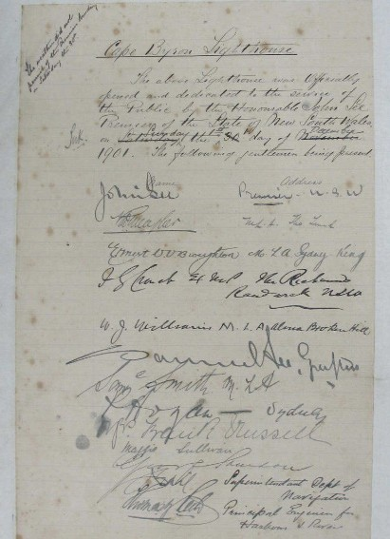Figure 20a. Document detailing the opening of the Cape Byron light and signatures, 1901.

### Transcription

*The weather did not permit of the Premiers landing on Saturday the 30th.*

#### Cape Byron Lighthouse

The above Lighthouse was Officially opened and dedicated to the service of the Public by the

Honourable John See Premier of the State of New South Wales on ~~Saturday~~ Sunday the ~~30th~~ 1st day of ~~November~~ December 1901. The following gentlemen being present.

(Rest of document filled with names and addresses of those present – many illegible.)

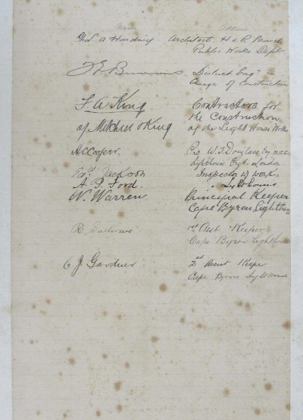

Figure 20b. Document detailing the opening of the Cape Byron light and signatures, 1901.

# Appendix 5. Table demonstrating compliance with the Environment Protection and Biodiversity Conservation Regulation (2000)

**Environment Protection and Biodiversity Conservation Regulations (2000) Schedule 7A – Management plans for Commonwealth heritage places**

|  |  |
| --- | --- |
| **Legislation** | **Satisfied within** |
| A management plan must: | |
| (a) Establish objectives for the identification, protection, conservation, presentation and transmission of the Commonwealth Heritage values of the place; and | Section 1 – Introduction |
| (b) Provide a management framework that includes reference to any statutory requirements and agency mechanisms for the protection of the Commonwealth Heritage values of the place; and | Section 2 – Introduction |
| (c) Provide a comprehensive description of the place, including information about its location, physical features, condition, historical context and current uses; and | Section 2 – Cape Byron Lightstation site Section 3 – History  Section 4 – Fabric |
| (d) Provide a description of the Commonwealth Heritage values and any other heritage values of the place; and | Section 5 – Heritage significance |
| (e) Describe the condition of the Commonwealth Heritage values of the place; and | Section 5 – Heritage significance |
| (f) Describe the method used to assess the Commonwealth Heritage values of the place; and | Section 5 – Heritage significance |
| (g) Describe the current management requirements and goals including proposals for change and any potential pressures on the Commonwealth Heritage values of the place; and | Section 6 – Opportunities and constraints |
| (h) Have policies to manage the Commonwealth Heritage values of a place, and include in those policies, guidance in relation to the following: |  |
| i. The management and conservation  processes to be used; | Section 7 – Conservation management policies (Policy 1, 2, 3, 5, 6,  10, 11, 14) |

|  |  |
| --- | --- |
| **Legislation**  ii. The access and security arrangements, including access to the area for indigenous people to maintain cultural traditions; | **Satisfied within** |
| Section 7 – Conservation management policies (Policy 3) |
| iii. The stakeholder and community  consultation and liaison arrangements; | Section 7 – Conservation management policies (Policy 15, 17) |
| iv. The policies and protocols to ensure that indigenous people participate in the management process; | Section 7 – Conservation management policies (Policy 17) |
| v. The protocols for the management of  sensitive information; | N/A |
| vi. The planning and management of works, development, adaptive reuse and property divestment proposals; | Section 7 – Conservation management policies (Policy 16) |
| vii. How unforeseen discoveries or disturbances of heritage are to be managed; | Section 7 – Conservation management policies (Policy 12) |
| viii. How, and under what circumstances, heritage advice is to be obtained; | Section 7 – Conservation management policies (Policy 10, 11) |
| ix. How the condition of Commonwealth Heritage values is to be monitored and reported; | Section 7 – Conservation management policies (Policy 5, 6, 14) |
| x. How records of intervention and maintenance of a heritage places register are kept; | Section 7 – Conservation management policies (Policy 7, 13) |
| xi. The research, training and resources needed to improve management; | Section 7 – Conservation management policies (Policy 9) |
| xii. How heritage values are to be  interpreted and promoted; and | Section 7 – Conservation management policies (Policy 4) |
| (i) Include an implementation plan; and | Section 8 – Heritage implementation schedule |
| (j) Show how the implementation of policies will be monitored; and | Section 8 – Heritage implementation schedule |
| (k) Show how the management plan will be  reviewed. | Section 7 – Conservation management policies (Policy 18) Section 8 – Heritage implementation schedule |

# Reference list

Beaglehole, J.C., (ed.), *The Journals of Captain James Cook on his Voyages of Discovery. I The Voyage of the Endeavour 1768-1771*, Cambridge University Press: Cambridge, 1955.

Boyd, W.E., J.P. Collins, & J. Bell, ‘The accumulation of charcoal within a midden at Cape Byron, northern New South Wales, during the last millennium’, *Australian Archaeology*, Vol 51, no. 1. 2000.

Brewis, C.R.W., ‘Report with Recommendations as to Existing Lights and Additional Lights’, *Lighting of the East Coast of Australia: Cape Moreton to Gabo Island (Including Coast of New South Wales)*, Department of Trade and Customs, 1913.

Brooks, G., & Associates Pty Ltd, *NPWS Lighthouses Conservation Management and Cultural Tourism Plan – Cape Byron Lighthouse: Supplementary Information*, prepared for NSW NPWS, 2001.

*The Burra Charter: The Australia ICOMOS Charter for Places of Cultural Significance*, Australia ICOMOS, 2013.

Ellsmore, D., and F. Ellsmore, *Cape Byron Lightstation Precinct Conservation Management Plan*, prepared for the NSW Department of Lands and Water Conservation, 2008.

*Engage Early—Guidance for proponents on best practice Indigenous engagement for environmental assessments under the Environment Protection and Biodiversity Conservation Act 1999* (EPBC Act), Commonwealth of Australia, 2016.

Pratten, C., and R. Irving., *Cape Byron Headland Reserve Heritage Study*, prepared for the Cape Byron Headland Reserve Trust, 1991.

Reid, G., *From Dusk till Dawn: A history of Australian lighthouses*, Aus: Macmillan Co., 1988. Serle, G., *First Order: Australia’s Highway of Lighthouses*, Glenelg, SA: Seaside Lights, 2013.

Stapleton, C. L., & Partners Pty Ltd, *Cape Byron Lightstation Conservation Management Plan*, prepared for AMSA, 1993.

Stubbs, B. J., *History of the Cape Byron Lightstation Precinct*, Crown, 2008.

*Working Together Managing Commonwealth Heritage Places: a guide for Commonwealth agencies*, Commonwealth of Australia, 2019.

Tomlinson, C., *Tomlinson’s Cyclopaedia of Useful Arts*, 1854.

“A lighthouse for Cape Byron,” *The Northern Star*, Dec 1st, 1897. https://trove.nla.gov.au/newspaper/ article/71758856?searchTerm=Cape%20Byron%20lighthouse%20%20%20%20%20%20%20%20%20%20

%20%20&searchLimits=dateFrom=1897-01-01|||dateTo=1901-12-31

“Byron Bay lighthouse damaged,” *Casino and Kyogle Courier and North Coast Advertiser*, Feb 20th, 1929. https://trove.nla.gov.au/newspaper/article/233837230?searchTerm=byron%20lighthouse&searchLimits=exactP hrase|||anyWords|||notWords|||requestHandler|||dateFrom=1901-01-01|||dateTo=2011-12-31|||sortby

“The Cape Byron lighthouse,” *The Northern Star*, Dec 4th, 1901. https://trove.nla.gov.au/newspaper/ article/72080223?searchTerm=Byron%20Lighthouse%20construction%20%20%20%20%20%20%20%20

%20%20%20%20&searchLimits=exactPhrase|||anyWords|||notWords|||requestHandler|||dateFrom=1899-01- 01|||dateTo=1901-12-31|||sortby

“Lighthouse reserve banned,” *Tweed Daily*, Sep 5th, 1939. https://trove.nla.gov.au/newspaper/ article/194657696?searchTerm=byron%20lighthouse&searchLimits=exactPhrase|||anyWords|||notWords|||requ estHandler|||dateFrom=1901-01-01|||dateTo=2011-12-31|||sortby

“Struck by lightning: Cape Byron lighthouse,” *The Telegraph*, Nov 23rd, 1920. https://trove.nla.gov.au/ newspaper/article/179639297?searchTerm=byron%20lighthouse&searchLimits=exactPhrase|||anyWords|||not Words|||requestHandler|||dateFrom=1901-01-01|||dateTo=2011-12-31|||sortby

“Weather station at lighthouse,” *The Northern Star*, Dec 1st, 1948. https://trove.nla.gov.au/newspaper/ article/99036744?searchTerm=byron%20lighthouse&searchLimits=exactPhrase|||anyWords|||notWords|||reque stHandler|||dateFrom=1901-01-01|||dateTo=2011-12-31|||sortby

# Website URLs

1. AMSA Heritage Lighthouses Interactive Map: [https://www.operations.amsa.gov.au/lighthouses/?_ga=2.236400321.1108408984.1535497123-](http://www.operations.amsa.gov.au/lighthouses/?_ga=2.236400321.1108408984.1535497123-) 1996646104.1535497123
2. A Supplementary Information report on Cape Byron by Graham Brooks and Associates Pty Ltd: [https://www.environment.nsw](http://www.environment.nsw.gov.au/-/media/OEH/Corporate-Site/Documents/Parks-reserves-).gov[.au/-/media/OEH/Corporate-Site/Documents/Parks-reserves-](http://www.environment.nsw.gov.au/-/media/OEH/Corporate-Site/Documents/Parks-reserves-) and-protected-areas/Conservation-management-plans/lighthouses-conservation-management- cultural-tourism-plan.pdf
3. A Conservation Management Plan was prepared in 2008 by Donald Ellsmore Pty Ltd: [https://www.environment.nsw](http://www.environment.nsw.gov.au/research-and-publications/publications-search/cape-byron-).gov[.au/research-and-publications/publications-search/cape-byron-](http://www.environment.nsw.gov.au/research-and-publications/publications-search/cape-byron-) lightstation-precinct-conservation-management-plan
4. Byron Shire Council: Native Animals and Plants: [https://www.byron.nsw](http://www.byron.nsw.gov.au/Services/Environment/Native-animals-and-plants).gov[.au/Services/Environment/Native-animals-and-plants](http://www.byron.nsw.gov.au/Services/Environment/Native-animals-and-plants)
5. Arakwal National Park Plan of Management:

[https://www.environment.nsw](http://www.environment.nsw.gov.au/research-and-publications/publications-search/arakwal-).gov[.au/research-and-publications/publications-search/arakwal-](http://www.environment.nsw.gov.au/research-and-publications/publications-search/arakwal-) national-park-plan-of-management

1. Cape Byron Lightstation Commonwealth Heritage Listing:

[http://www.environment.gov.au/cgi-bin/ahdb/search.pl?mode=place_detail;search=place_name%3D-](http://www.environment.gov.au/cgi-bin/ahdb/search.pl?mode=place_detail%3Bsearch%3Dplace_name%3D-) cape%2520byron%3Bkeyword_PD%3Don%3Bkeyword_SS%3Don%3Bkeyword_PH%3Don%3Blat- itude_1dir%3DS%3Blongitude_1dir%3DE%3Blongitude_2dir%3DE%3Blatitude_2dir%3DS%3Bin_ region%3Dpart;place_id=105599

1. Cape Byron Lightstation NSW State Heritage Listing:

[https://www.environment.nsw](http://www.environment.nsw.gov.au/heritageapp/ViewHeritageItemDetails.aspx?ID=5053293).gov[.au/heritageapp/ViewHeritageItemDetails.aspx?ID=5053293](http://www.environment.nsw.gov.au/heritageapp/ViewHeritageItemDetails.aspx?ID=5053293)

1. AMSA Heritage Strategy:

[https://www.amsa.gov.au/safety-navigation/navigation-systems/lighthouses/amsa-heritage-strategy-](http://www.amsa.gov.au/safety-navigation/navigation-systems/lighthouses/amsa-heritage-strategy-) 2018

1. 2018-19 AMSA Annual Report: [https://www.amsa.gov.au/sites/default/files/amsa_annual_report_2017-18_-_v12_lq.pdf](http://www.amsa.gov.au/sites/default/files/amsa_annual_report_2017-18_-_v12_lq.pdf)

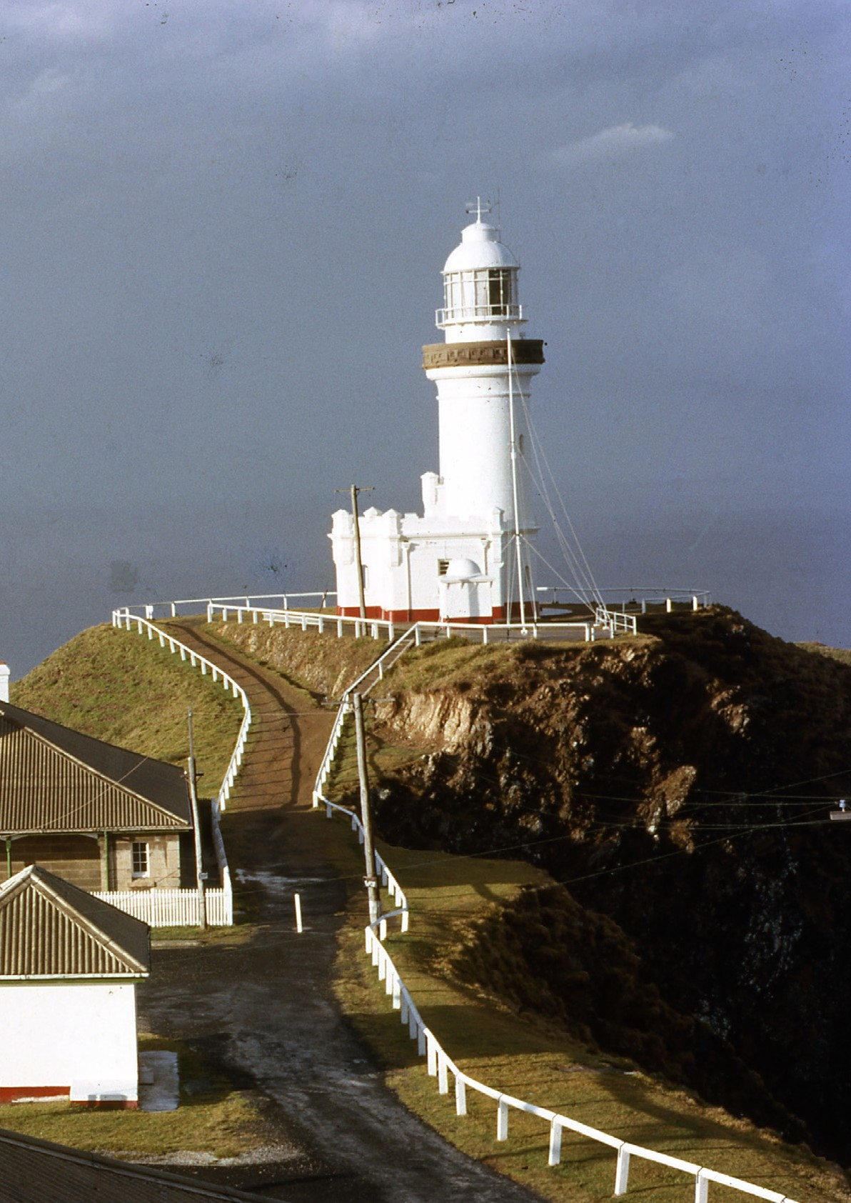

P190835