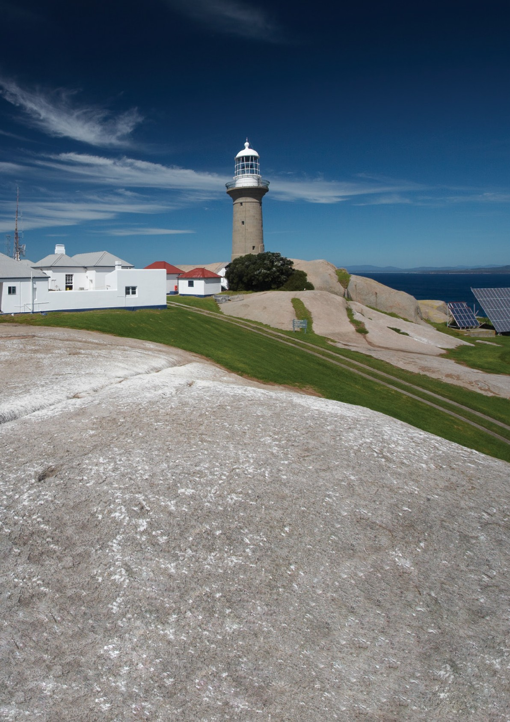

Montague Island Lighthouse

Heritage Management Plan

2020

The Australian Maritime Safety Authority, acting pursuant to Section 341s of the *Environment Protection and Biodiversity Conservation Act 1999*, makes this heritage management plan in relation to parts of the Montague Island Lighthouse within its ownership or control.



this 5th day of November 2020

Mick Kinley

Chief Executive Officer

**Copyright**

The Australian Maritime Safety Authority encourages the dissemination and exchange of information provided in this publication.

Except as otherwise specified, all material presented in this publication is provided under Creative Commons Attribution 4.0 International licence.

This excludes:

* the Commonwealth Coat of Arms
* this department’s logo
* content supplied by third parties.

The Creative Commons Attribution 4.0 International Licence is a standard form licence agreement that allows you to copy, distribute, transmit and adapt this publication provided that you attribute the work.

The details of the version 4.0 of the licence are available on the Creative Commons website, as is the full legal code for that licence.

**Acknowledgements**

The Australian Maritime Safety Authority acknowledges that the Lighthouse is in the traditional country of the Yuin People.

For additional information or any enquiries about this heritage management plan, contact the Australian Maritime Safety Authority, Manager Asset Capability, PO Box 10790, Adelaide Street, Brisbane QLD 4000

Phone: (02) 6279 5000 (switchboard) Email: [Heritage@amsa.gov.au](mailto:Heritage@amsa.gov.au) Website: [www.amsa.gov.au](http://www.amsa.gov.au/)

**Attribution**

AMSA’s preference is that you attribute this publication (and any material sourced from it) using the following wording:

Source: Australian Maritime Safety Authority *Montague Island Lighthouse Heritage Management Plan – 2020*

**Front cover image**

© Copyright Peter Marquis-Kyle

**More information**

For enquiries regarding copyright including requests to use material in a way that is beyond the scope of the terms of use that apply to it, please contact us through our website: [www.amsa.gov.au](http://www.amsa.gov.au/)





Montague Island Lighthouse

Heritage Management Plan

2020

# Contents

Executive summary 3

1. Introduction 4
   1. Background and purpose 4
   2. Heritage management plan objectives 4
   3. Methodology 5
   4. Status 5
   5. Authorship 5
   6. Acknowledgements 5
   7. Language 6
   8. Previous reports 6
   9. Sources of information and images 6
2. Montague Island lightstation site 7
   1. Location 7
   2. Setting and landscape 8
   3. Lease and ownership 9
   4. Listings 9
   5. Access 9
3. History 12
   1. General History of lighthouses in Australia 12
   2. The Commonwealth Lighthouse Service 14
   3. New South Wales lighthouse service

administration 15

* 1. Montague Island: a history 15
  2. Planning a lighthouse 16
  3. Lighthouse keepers 20
  4. Chronology of major events 21
  5. Changes and conservation over time 22
  6. Summary of current and former uses 23
  7. Summary of past and present associations 24
  8. Unresolved questions or historical conflicts 25
  9. Recommendations for further research 25

1. Fabric 25
   1. Fabric register 25
   2. Related object or associated AMSA artefact 51
   3. Comparative analysis 51
2. Heritage significance 53
   1. Commonwealth heritage Listing –

Montague Island Lighthouse 53

* 1. NSW State heritage register –

Montague Island Lighthouse 55

* 1. Condition and integrity of the

Commonwealth heritage values 58

* 1. Gain or loss of heritage values 59

1. Opportunities and constraints 60
   1. Implications arising from significance 60
   2. Framework – sensitivity to change 61
   3. Statutory and legislative requirements 63
   4. Operational requirements and occupier needs 67
   5. Proposals for change 68
   6. Potential pressures 69
   7. Process for decision-making 69
2. Conservation management policies 71
   1. Policies 71
3. Policy implementation schedule 77
   1. Heritage implementation plan 77
   2. Monitoring and reporting 77
4. Appendices 80

Appendix 1. Glossary of heritage conservation terms 80

Appendix 2. Glossary of historic lighthouse terms

relevant to Montague Island lighthouse 80

Appendix 3. Current Montague Island light details 82

Appendix 4. Table demonstrating compliance to the

EPBC Act (1999) and the EPBC Regulations 2000 86

Reference List 88

Website URLs 90

List of figures

|  |  |
| --- | --- |
| Figure 1 | Cover photo of Montague Island Lighthouse (Peter Marquis-Kyle) |
| Figure 2 | Planning process applied for heritage management (Australia ICOMOS, 1999) |
| Figure 3 | Location of lighthouse on Montague Island (Google Maps) |
| Figure 4 | Location of Montague Island along Australian coastline (Google Maps) |
| Figure 5 | Location of Montague Island along NSW coastline (Google Maps) |
| Figure 6 | Setting and landscape of Montague Island (2002) |
| Figure 7 | Cliffs surrounding Montague Island Lightstation (2003) |
| Figure 8 | Map of lease – Montague Island Lighthouse (2017) |
| Figure 9 | Montague Island Lightstation, NSW Heritage Register Plan |
| Figure 10 | Montague Island walking trail (NPWS) |
| Figure 11 | Early technology used in lighthouses |
| Figure 12 | Incandescent oil vapour lamp by Chance Brothers |
| Figure 13 | Dioptric lens on display at Narooma |
| Figure 14 | Dalén’s system – sunvalve, mixer, flasher and cylinder |
| Figure 15 | James Barnet (n.d) |
| Figure 16 | Montague Island Lighthouse first order dioptric holophotal fixed and flashing light (1878) |
| Figure 17 | Design plan for Montague Island Lighthouse and quarters (James Barnet, 1878) |
| Figure 18 | Montague Island Lighthouse site plan (James Barnet, 1878) |
| Figure 19 | View of Montague Island Lighthouse, 1917 (NAA, 4746689) |
| Figure 20 | Evolution of Montague Island Lighthouse lens/lanterns (Searle, 2013, pg. 209) |
| Figure 21 | South Solitary Island Lighthouse elevation blueprint (James Barnet, 1878) |

# Executive Summary

Montague Island Lighthouse was included in the Commonwealth Heritage List in 2004. It has played a significant part in the history of Australian shipping and it is known for its offshore position, design

and craftsmanship, association with renowned architect James Barnet and its contribution to the development of marine Aids to Navigation (AtoN) on the New South Wales coast. The lighthouse is well- regarded for its social values as a prominent site for tourism and its aesthetic qualities.

The Montague Island Lighthouse was placed on the NSW State heritage register in 1999 for its historical, aesthetic and social significance, and for its research potential, rarity and representativeness. The site holds immense cultural value for the Yuin People and the island is a gazetted Aboriginal Place.

Situated approximately 10 kilometres south-east of Narooma, NSW, and approximately 350 kilometres south of Sydney, NSW, the lighthouse is located

in the centre of Montague Island. Montague Island Lighthouse was built in 1881 to improve vessel safety along the New South Wales coastline following the trading boom of the late 19th century. Its granite tower, tapering walls, outwardly curved platform and balustrade were designed by colonial architect, James Barnet who was responsible for a number of lighthouses on the NSW coastline at the time. As a working AtoN, the lighthouse tower remains the property of the Australian Maritime Safety Authority (AMSA).

Although the lighthouse originally housed a

1st Order Chance Bros. lantern, the tower now exhibits a solar-powered Vega VRB-25 beacon and runs on an automated mechanism as part of our network of AtoN. The equipment is serviced by our maintenance contractor who visits at least once each year. AMSA officers visit on an ad hoc basis for auditing, projects, and community liaison purposes.

The lightstation includes the keepers’ quarters which lie outside our lease and are managed by the New South Wales National Parks and Wildlife Service (NPWS).

This heritage management plan is concerned mainly with the lighthouse, but addresses the management of the surrounding precinct and land. The plan is intended to guide our decisions and actions. We have prepared this plan to integrate the heritage values of the lightstation in accordance with the *Environment Protection and Biodiversity Conservation Act 1999* (*EPBC Act 1999*) and

the Environment Protection and Biodiversity Conservation Regulations 2000 (EPBC Regulations 2000).

Well-built and generally well-maintained, the lighthouse is in relatively good, stable condition. The policies and management guidelines set out in this heritage management plan strive to ensure that the Commonwealth heritage values of the Montague Island Lighthouse are recognised, maintained and preserved for future generations.

# Introduction

### Background and purpose

AMSA is the Commonwealth agency responsible for marine AtoN. Our network includes the Montague Island Lighthouse in NSW built in 1881.

The *EPBC Act 1999* requires the preparation of management plans that satisfy the obligations included in Schedule 7A and 7B of the EPBC Regulations 2000. The principal features of this management plan are:

* a description of the place, its heritage values, their condition and the method used to assess its significance
* an administrative management framework
* a description of any proposals for change
* an array of conservation policies that protect and manage the place
* an implementation plan
* ways the policies will be monitored and how the management plan will be reviewed.

We have commissioned this heritage management plan to guide the future conservation of the place.

This plan provides the framework and basis for the conservation and best practice management of the Montague Island Lighthouse in recognition of its heritage values. The policies in this plan indicate the objectives for identification, protection, conservation and presentation of the Commonwealth heritage values of the place. Figure 2 shows the basic planning process applied.

### Heritage management plan objectives

The objectives of this heritage management plan are to:

* protect, conserve and manage the Commonwealth

heritage values of the Montague Island Lighthouse

* interpret and promote the Commonwealth heritage values of the Montague Island Lighthouse
* manage use of the lightstation
* use best practice standards, including ongoing technical and community input, and apply

best available knowledge and expertise when considering actions likely to have a substantial impact on Commonwealth heritage values.

**Understand significance**

**Understand management obligations and constraints**

**Develop policy**

**Manage in accordance with policy**

Figure 2. Planning process applied for heritage management (*Australia ICOMOS, 1999*)

In undertaking these objectives, this plan aims to:

* Provide for the protection and conservation of the heritage values of the place while minimising any impacts on the environment by applying

the relevant environmental management requirements in a manner consistent with Commonwealth heritage management principles.

* Take into account the significance of the

Island as a cultural landscape associated with Aboriginal people over many thousands of years.

* Recognise that the site has been occupied by

lease holders since the early 20th century.

* Encourage site use that is compatible with the historical fabric, infrastructure and general environment.
* Record and document maintenance works, and changes to the fabric, in the Montague Island fabric register (See Section 4 Fabric).

The organisational planning cycle and associated budgeting process is used to confirm requirements, allocate funding, and manage delivery of maintenance activities. Detailed planning for the aids to navigation network is managed through our internal planning processes and budgeting.

An interactive map showing many AMSA’s heritage

sites, including Montague Island, can be found on AMSA’s online Interactive Heritage Lighthouse Map.a

### Methodology

The methods to prepare this plan are consistent with the recommendations of The Burra Charter. The plan addresses:

* The history of the site based on information sourced from archival research, expert knowledge and documentary resources.
* The description of the site based on information sourced from site inspection reports and fabric registers.
* The Commonwealth heritage criterions satisfied by Montague Island as set out by the *EPBC Act 1999* and EPBC Regulations (2000).

The EPBC Regulations (2000) Schedule 7A

(h) (i-xiii) was used to develop the necessary policies for management of the Montague Island Lighthouse, and the Department of the Environment and Energy advised on best practice management approaches.

The draft management plan was advertised in accordance with the *EPBC Act 1999* and EPBC Regulations (2000). A response was received proposing the placement of a concessionaire on the Island. This request was passed onto NSW NPWS and was not incorporated into the final document.

The Wagonga Local Aboriginal Land Council (WLALC) was consulted with in April 2020, and information on the Island’s history, and

aboriginal associations were incorporated into the management plan. The Council’s request to erect a symbol on the island was also incorporated in this management plan and will be included within the Fabric Register section in future versions of this plan.

Consultations with the WLALC are still currently ongoing and we anticipate further feedback. This feedback will be included in an amended version of the plan.

The New South Wales National Parks and Wildlife Service was consulted with in March 2020 and provided AMSA with feedback on the plan as a whole. Their edits relating to the history of the Island, the site’s current uses, and policies on management were incorporated into the final document.

A developed draft was submitted to the Minister through the Department of Agriculture, Water and the Environment where advice was sought from the Australian Heritage Council. On 26 August 2020, the Australian Heritage Council advised that the plan was not inconsistent with the Commonwealth Heritage Management Principles, and gave approval..

No updates or amendments have been made in this version of the plan. Future updates and

amendments will be listed here in later versions.

### Status

This plan has been adopted by AMSA in accordance with Schedule 7A (Management plans for Commonwealth Heritage places) and Schedule 7B (Commonwealth Heritage management principles) of the EPBC Regulations (2000) to guide the management of the place and for inclusion in the Federal Register of Legislative Instruments.

### Authorship

This plan has been prepared by AMSA. At the initial time of publication, Australian Maritime Systems Group (AMSG) is the contracted maintenance provider for the Commonwealth Government’s AtoN network including Montague Island Lighthouse.

### Acknowledgements

AMSA acknowledges the professional assistance of

Peter Marquis-Kyle, heritage architect.

### Language

For clarity and consistency, some words in this plan such as restoration, reconstruction, and preservation, are used with the meanings defined in the Burra Charter 1. See Appendix 1 Glossary of heritage conservation terms. Also see Appendix 2 Glossary of lighthouse terminology relevant to Montague Island Lighthouse, which sets out the technical terminology used in this plan.

### Previous reports

A Supplementary Information Report (NPWS Lighthouses – Conservation Management and Cultural Tourism Plan) was completed by Graham Brooks and Associates Pty Ltd in November 2001 for the NSW NPWS.

A Heritage Lighthouse Report was completed for AMSA by heritage architect Peter Marquis-Kyle in 2007.

### Sources of information and images

This plan has incorporated a number of sources including the National Archives of Australia (NAA), National Library of Australia (NLA), as well as the AMSA heritage collection.

Photos with no credit are solely owned by AMSA.

Website URLs are referenced via superscript (for example Montague Island Reportx) and located at the end of the document (See Website Links).

1 Australia ICOMOS *Burra Charter* (2013)

# Montague Island Lightstation site

### Location

The Montague Island lighthouse is located on Montague Island, a protected nature reserve found offshore from the South Coast region of New South Wales. The lighthouse and island are approximately

10 kilometres south-east of Narooma, NSW, and approximately 350 kilometres south of Sydney, NSW.

Lighthouse coordinates: 36° 15.1143 ‘S, 150°

13.6035 ‘E

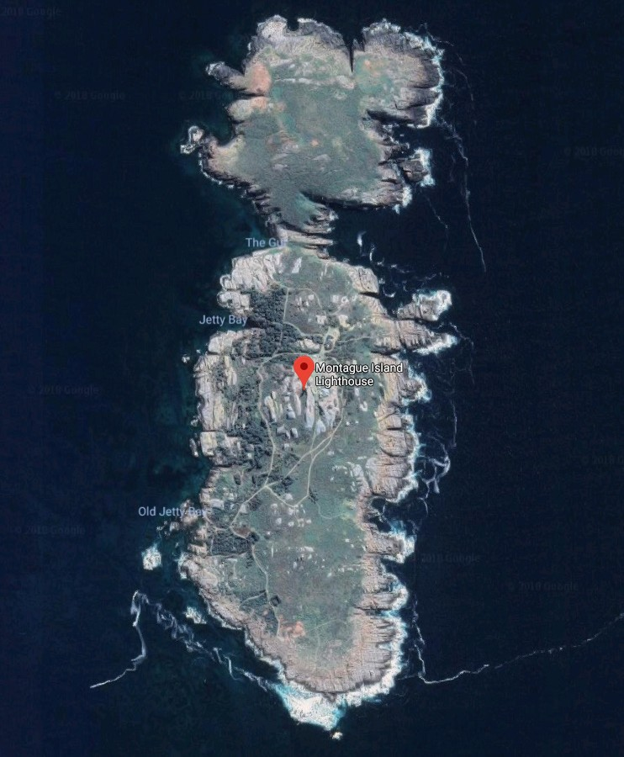

Figure 3. Location of lighthouse on Montague Island (Google Maps)

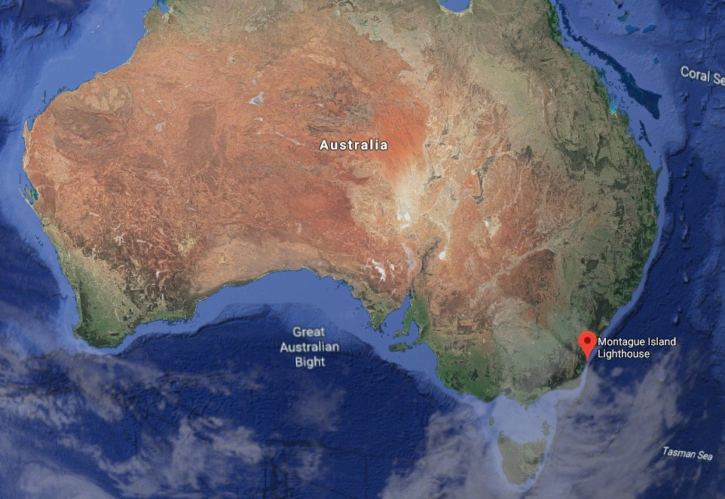

Figure 4. Location of Montague Island lighthouse along Australian coastline (Google Maps)

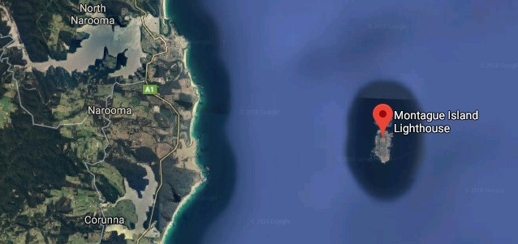

Figure 5. Location of Montague Island along NSW coastline (Google Maps)

### Setting and landscape

The lighthouse is located on the Montague Island

Nature Reserve, a protected reserve approximately

82 ha in size. The island is outlined with rugged, steep cliffs with landing only possible at two sheltered locations on the western side of the island. Montague Island is a gazetted Aboriginal Place.

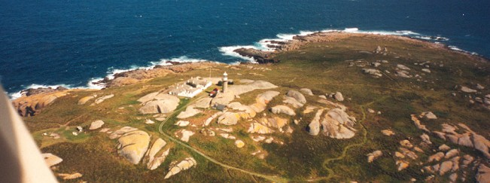

Figure 6. Setting and landscape of Montague Island (2002)

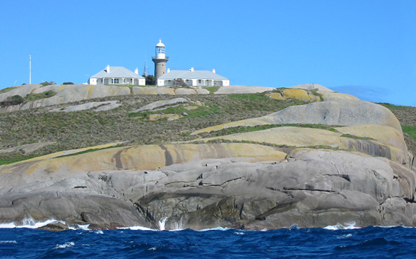

#### Fauna and flora

Classified as a nature reserve by NPWS, Montague Island is recognised for its abundance of unique fauna and flora.

The island supports NSW’s largest colony of *Eudyptula minor* (or little penguin) that breeds on the island. Additionally, Australian fur seals and New Zealand fur seals are regular visitors to the Island with up to 10,000 counted along the shores during peak season.

Humpback whales are frequently spotted passing Montague Island during spring, with some *Orcinus orca*, or killer whales, occasionally seen in nearby waters.

The island has approximately 90 bird species that migrate to the area throughout the year. Of these, 12 species are known to nest on the island including short-tailed shearwaters, wedge-tailed shearwaters, Gould’s kites, peregrine falcons, swamp harriers, crested terns, and silver gulls.

Over 200 plant species have been identified on Montague Island.2 Whilst many are introduced to the island, the majority of the island is covered by *Lomandra longifolia* (mat-rush). Other flora recorded includes:

* tussock grass, found along the Island’s northern

slopes

* *Westringia fruticosa*
* *Pelargonium austral*
* *Melaleuca armillaris*
* *Correa alba*, found along the cliff edges
* coastal wattle

A Montague Island Nature Reserve Plan of Management was published in 1996 and offers additional information on the environmental management of the reserve.b NPWS is currently undertaking a review of this plan.

### Lease and ownership

The Montague Island lighthouse and surrounding land is managed by the New South Wales State Government. AMSA lease the lighthouse and land from NPWS.

The AMSA lease consists of one parcel of land (Lot 1) which encompasses the lighthouse tower alone.

The current lease was signed on 9 July 1998, commencing on 1 July 1997 and terminating on 30 June 2022, with an option to renew for a further 25 years. The lease stipulates that AMSA must comply with any applicable management plan and state environmental laws.

Due to public interest in Montague Island and the lighthouse, a tourism license was signed between AMSA and the NSW Minister for the Environment commencing 1 July 1997, ceasing on 30 June 2022 with a renewal option for a further 25 years.

Montague Island is a gazetted Aboriginal Place and a Native Title claim application is currently active under the South Coast People.

1. Heyligers, P.C., and L.G. Adams, ‘Flora and vegetation of Montague Island – past and present‘, Cunninghamia 8, 2004 pg. 285–305

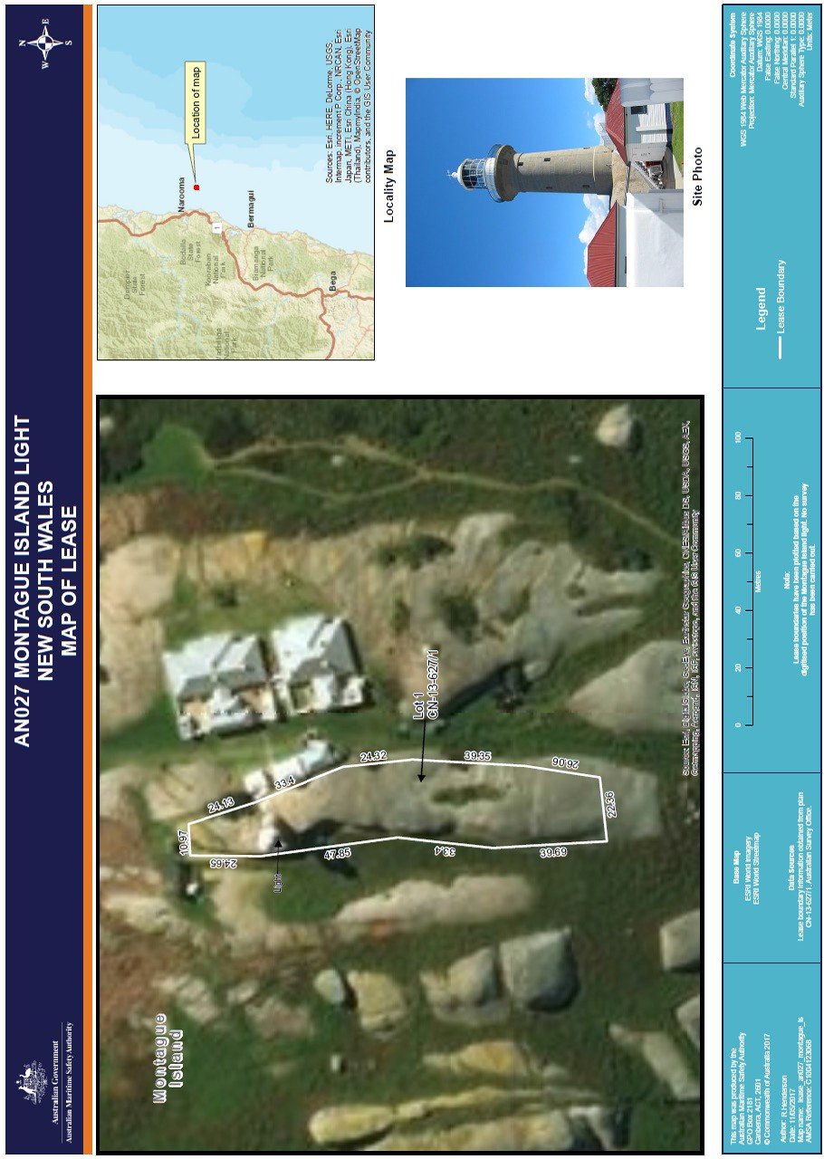

Figure 8. Map of lease - Montague Island lighthouse (2017)

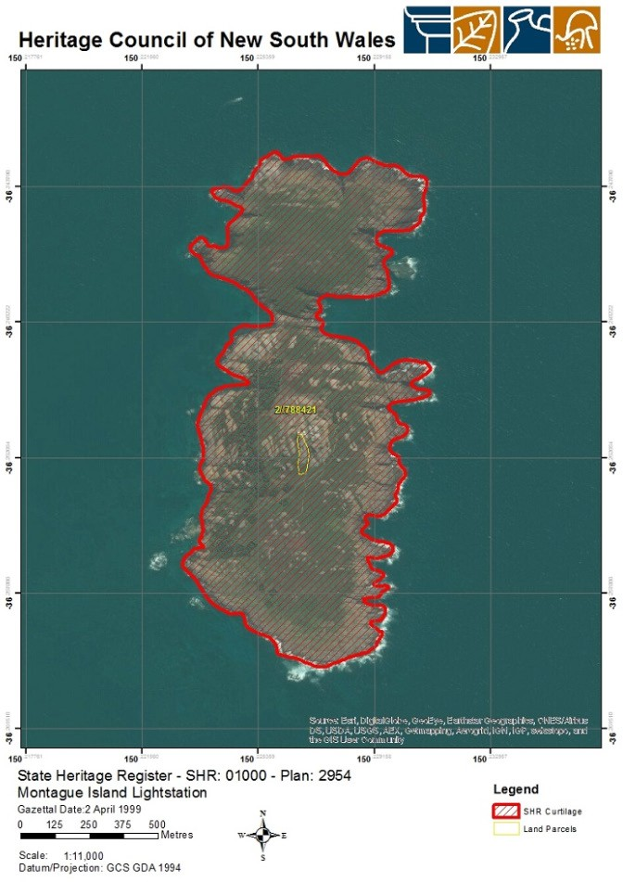

Figure 9. Montague Island Lightstation, NSW Heritage Register Plan 2954 (NSW Heritage Council, 1994)

### Listings

The table below details the various heritage listings of the Montague Island Lightstation.

|  |  |
| --- | --- |
| **Register**  Commonwealth Heritage List | **ID** |
| 105601c |
| NSW State Heritage List | 01000d |
| Register of the National Estate | 103602e |

### 2.4 Access

Montague Island is only accessible to authorised vessels and approved contracted boat operators. No private vessel landing is permitted. Vehicular access from the landing site at Jetty Bay to the lighthouse is available for authorised vehicles only. Access trails, some of which are historically significant, are maintained on the southern section of the island. The Montague Island Lightstation features as a landmark on the Montague Island walking track which ensures pedestrian access to

the site. Access inside the lighthouse is restricted to authorised personnel and tour groups only.

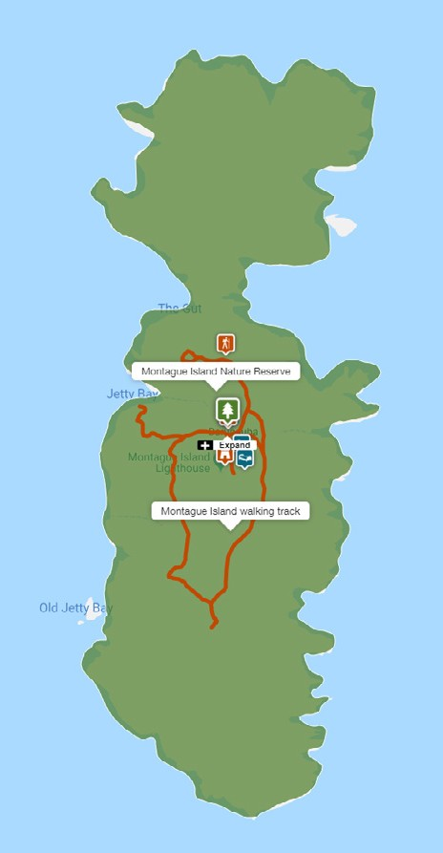

Figure 10. Montague Island walking trail (NPWSf)

# History

### General history of lighthouses in Australia

The first lighthouse to be constructed along Australian soil was Macquarie Lighthouse, located at the entrance to Port Jackson, NSW. First lit in 1818, the cost of the lighthouse was recovered through the introduction of a levy on shipping. This was instigated by Governor Lachlan Macquarie, who ordered and named the light.

The following century oversaw the construction of hundreds of lighthouses around the country. Constructing and maintaining a lighthouse were costly ventures that often required the financial support of multiple colonies. However, they were deemed necessary aids in assisting the safety of mariners at sea. Lighthouses were firstly

managed by the colony they lay within, with each colony developing their own style of lighthouse and operational system. Following Federation in 1901, which saw the various colonies unite under one Commonwealth government, lighthouse management was transferred from state hands to the Commonwealth Lighthouse Service.3

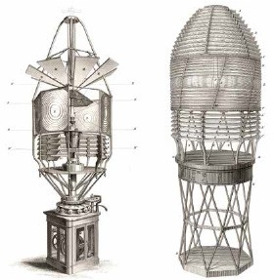

Figure 11. Early technology used in lighthouses 3

#### Lamps and optics – an overview

Lighthouse technology has altered drastically over the centuries. Eighteenth century lighthouses were lit using parabolic mirrors and oil lamps.

Documentation of early examples of parabolic mirrors in the United Kingdom, circa 1760, were documented as consisting of wood and lined with pieces of looking glass or plates of tin. As described by Searle, “When light hits a shiny surface, it is reflected at an angle equal to that at which it hit.

With a light source is placed in the focal point of a parabolic reflector, the light rays are reflected parallel to one another, producing a concentrated beam”4.

In 1822, Augustin Fresnel invented the dioptric glass lens. By crafting concentric annular rings with a convex lens, Fresnel had discovered a method

of reducing the amount of light absorbed by a lens. The Dioptric System was adopted quickly with Cordouran Lighthouse (France), which was fitted with the first dioptric lens in 1823. The majority

of heritage-listed lighthouses in Australia house dioptric lenses made by others such as Chance Brothers (United Kingdom), Henry-LePaute (France), Barbier, Bernard & Turenne (BBT, France) and Svenska Aktiebolaget Gasaccumulator (AGA

of Sweden). These lenses were made in a range of standard sizes, called orders—see ‘Appendix 2. Glossary of lighthouse Terms relevant to Montague Island Lighthouse’.

Early Australian lighthouses were originally fuelled by whale oil and burned in Argand lamps, and multiple wicks were required in order to create a large flame that could be observed from sea. By the 1850s, whale oil had been replaced by colza oil, which was in turn replaced by kerosene, a mineral oil.

In 1900, incandescent burners were introduced. This saw the burning of fuel inside an incandescent mantle which produced a brighter light with less fuel

within a smaller volume. Light keepers were required to maintain pressure to the burner by manually pumping a handle as can be seen in Figure 12.

In 1912, Swedish engineer Gustaf Dalén, was awarded the Nobel Prize in physics for a series of inventions relating to acetylene-powered navigation lights. Dalén’s system included the sun valve,

the mixer, the flasher, and the cylinder containing compressed acetylene. Due to their efficiency and reliability, Dalén’s inventions led to the gradual demanning of lighthouses. Acetylene was quickly adopted by the Commonwealth Lighthouse Service from 1915 onwards.

Large dioptric lenses, such as that shown in Figure 13, gradually decreased in popularity due to cost and the move towards unmanned automatic lighthouses. By the early 1900s, Australia had stopped ordering these lenses with the last installed at Eclipse Island in Western Australia in 1927.

Smaller Fresnel lenses continued to be produced and installed until the 1970s when plastic lanterns, still utilising Fresnel’s technology, were favoured instead. Acetylene remained in use until it was finally phased out in the 1990s.

### The Commonwealth lighthouse service

When the Australian colonies federated in 1901, it was decided that the new Commonwealth Government would be responsible for coastal

lighthouses. This included only the major lights used by vessels travelling from port to port, not the minor lights used for navigation within harbours and rivers. There was a delay before this new arrangement came into effect and the existing lights continued to be operated by the states.

Since 1915, various Commonwealth departments have managed lighthouses. The Australian Maritime Safety Authority (AMSA), established under the *Australian Maritime Safety Authority Act 1990*, is now responsible for operating Commonwealth lighthouses and other marine aids to navigation, along with its other functions.

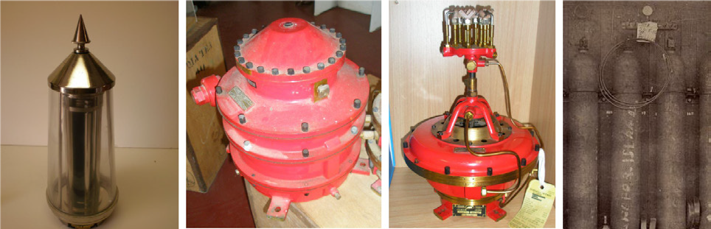Figure 12. Incandescent oil vapour lamp by Chance Brothers Figure 13. Dioptric lens on display at Narooma

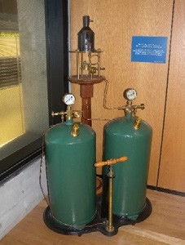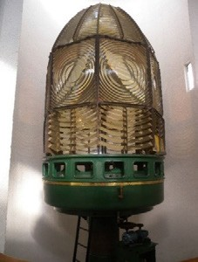

Figure 14. Dalén’s system – sunvalve, mixer, flasher and cylinder

1. Figure 11 – Early example of a rotating catadioptric apparatus, made for the 1844 lighthouse at Skerryvore, Western Scotland

(Steel engraving from *Tomlinson’s Cyclopaedia of Useful Arts*, 1854)

1. Searle. G, *First Order: Australia’s Highway of Lighthouses*, (2013). Page 34.
   1. **New South Wales lighthouse service administration**

The table below details the timeline of lighthouse service administration from 1915 to present.

|  |  |
| --- | --- |
| **Time Period**  1915 – 1927 | **Administration** |
| Lighthouse Branch No. 3 District New South Wales, Victoria and Tasmania, Sydney headquarters. |
| 1927 – 1963 | Deputy Director of Lighthouses and Navigation, New South Wales. |
| 1963 – 1972 | Department of Shipping and Transport, Regional Controller, New South Wales. |
| 1972 – 1977 | Department of Transport [III], New South Wales Region / (from 1973) Surface Transport Group,  New South Wales region. |
| 1977 – 1982 | Department of Transport [III],  New South Wales region. |
| 1982 – 1983 | Department of Transport and Construction, regional office, New South Wales. |
| 1983 – 1987 | Department of Transport [IV], New South Wales regional office. |
| 1987 – 1990 | Department of Transport and Communications (Transport Group), New South Wales regional office. |
| 1991 – | Australian Maritime Safety Authority (AMSA). |

## Montague Island: a history

#### Indigenous history

Vivienne Mason, Chairperson of Wagonga Local Aboriginal Land Council, Elder and Knowledge Holder of the Yuin Tribe shared knowledge of the land the light house sits on:

“A Dreamtime Story of my people, the Yuin, is that Barranguba (Montague Island) is the son of Gulaga, the mother mountain, (Mt Dromedary). Barranguba being the eldest son wanted to leave his mother, Gulaga. Gulaga agreed that Barranguba could move, but only on the condition that she would

be able to watch over him. Barranguba went off- shore to live, far enough away from his mother but close enough for her to watch over him. Gulaga’s youngest son, Nadjanuka also wanted to leave but Gulaga insisted he stayed close by on the land to protect the Budjarns (Birds). To this day Barranguba, Nadjanuka and Gulaga are connected through her umbilical cord (an Underwater Freshwater Stream running from Gulaga to Barranguba and Nadjanuka. There is a fresh water spring on Barranguba but the location has been lost.”

‘Also, we were told, many years ago, that Aboriginal paintings were found on Barranguba, but they are now hidden due to the changes to the land. Legend has it that Barranguba is a Men’s Place but this is debated, it depend on who you speak to.”

It is recorded in a newspaper article from the first settlers of Narooma (copy at the National Library), that a tragedy befell a group of young Aboriginal men and women, who were returning from their annual seabird egg gathering expedition from Barranguba. These young people were lost at sea when a freak wave hit them.

#### Early European history

In 1770, British navigator and cartographer James

Cook sailed along the New South Wales coast. Although recording the ‘camel-shaped mountain’ which he named Mount Dromedary, Cook did not recognise the island as separate to the mainland and mistakenly recorded it as part of the headland.

It was not until 1790 that the convict ship *Surprise*

determined Montague was in fact an island.

It is alleged the island was named after George Montague Dunk, the Earl of Halifax.

Research on the early European history of the island yielded little information. During the mid- 19th century, a gold rush occured in Nerrigundah, north of Narooma, and it is alleged sea bird eggs were collected from Montague to sell to the miners. Records indicate a number of fishing shacks existed at some point on the western shore of the island, however no substantial structures were built and no remains have been located.9

* 1. **Planning a lighthouse**

#### Why Montague Island?

Due to its offshore and elevated position, Montague Island offered the perfect vantage point for a light.

In 1873, the erection of a lighthouse on Montague Island (known then as Montagu) was first proposed during a conference between the principal officers of the Marine Departments of the Australian Colonies chaired by Captain Hixson. However, it was not until 1877 that funds were allocated by the New South Wales Government to carry out the project.10

#### Design

James Barnet, colonial architect for New South Wales, was placed in charge of designing the plans for a light at Montague Island. Barnet, alongside prospective tenders, visited the Island and assisted in

selecting the best location for a lightstation. His blueprints, which were created following this visit, featured a granite tower 12-m in height with tapering walls and one upper platform.

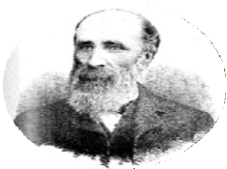

Figure 15. James Barnet (n.d)

**James Barnet (1827-1904)**

Born 1827, Barnet studied drawing, design and architecture in London before he and his family migrated to Australia c.1854. Appointed Clerk of Works for Sydney University, Barnet later joined the Colonial Architect’s Office in 1860. By 1865, he was named Colonial Architect, a position he held until his retirement in 1890. In that timeframe, Barnet was responsible for the architectural design of numerous public works including alledgedly 15 lighthouses. His design style, adopted from Francis Greenway’s Macquarie Light (1818), served as the quintessential NSW style until the end of the 19th century.

#### Construction

Tenders for the construction of a light at Montague Island were called October 1878. The initial successful contractor, J Musson and Co., had their offer of £13,900 accepted for an estimated 15-month construction period. The contract was signed on the 5 February 1879.

Work commenced with Mr John Kelly acting as foreman of works on behalf of the government, and Mr James Peters for the contractors.

However, poor management and inadequate materials hindered work running smoothly on- site. The lighthouse was to stand on a large boulder overlooking the Island, and Barnet strictly instructed the boulder not to be touched. Contrary

to these express orders, the contractor fired a shot at the boulder which detached a large mass and caused the position of the Tower to be altered by

1. Brooks, G., and Assoc. NPWS Lighthouses (2001), pg. 4.
2. Brooks, G., Assoc. NPWS Lighthouses (2001), pg. 4.

several feet. Following this, J Musson and Co. gave up the contract. Tenders were called once more in July of 1879, however no successful contracts were secured.11

Fresh tenders were called again in 1880 following renewed interest from the government and WH Jennings was deemed the successful contractor for £16,950. On Barnet’s blueprints for the

tower, (See Figure 17) the names of the original contractors can be seen crossed out and replaced by WH Jennings.

The foundation stone was laid on St Patricks Day 1881. Jennings recorded the progress of the construction:

The top of the island, in the neighbourhood of the lighthouse and keepers’ quarters, presents a busy appearance. Every available piece of ground at all level is occupied by masons, carpenters, plasterers, plumbers, blacksmiths, and their assistants. There is a tramway from the site of the buildings to the landing place, where a powerful crane is fixed, and moorings are made fast to the rocks and to buoys which are secured by heavy anchors in the sea. The landing of goods and materials is done quickly, 60,000 bricks, 100 casks cement, and 75 sheep having been landed in less than 24 hours. The lighthouse will be a solid and elegant structure….

…..[the walls are] 3 feet 8 inches thick at base,

tapering to 2 feet 2 inches….

…..the quarters will accommodate three keepers…. 12

Work was carried out effectively and the lighthouse was completed in October 1881, four months within the contract time. The overall cost of the construction, including apparatus, amounted to

£25,981 following completion.

1. Searle, G., First Order (2013), pg. 203.
2. Quoted in Searle, G., First Order (2013), pg. 203.

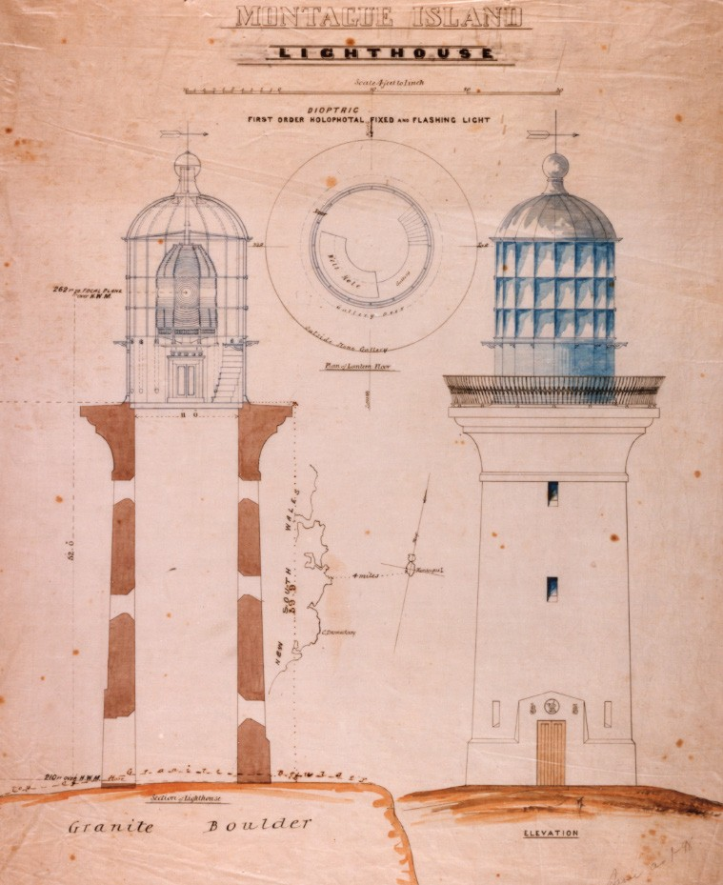

Figure 16. Montague Island Lighthouse first order dioptric holophotal fixed and flashing light (1878)

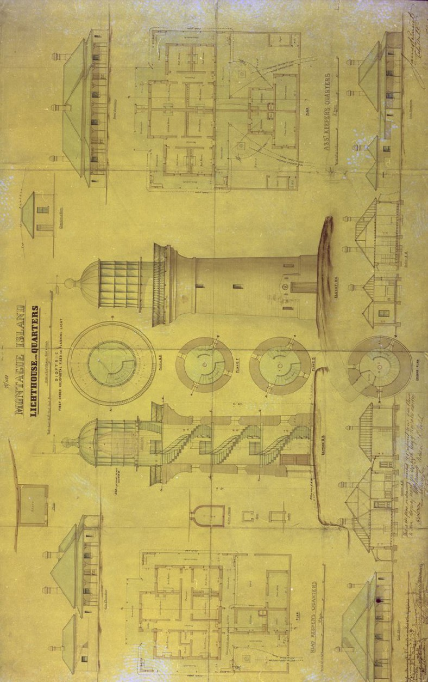

Figure 17. Design plan for Montague Island Lighthouse and quarters (James Barnet, 1878)

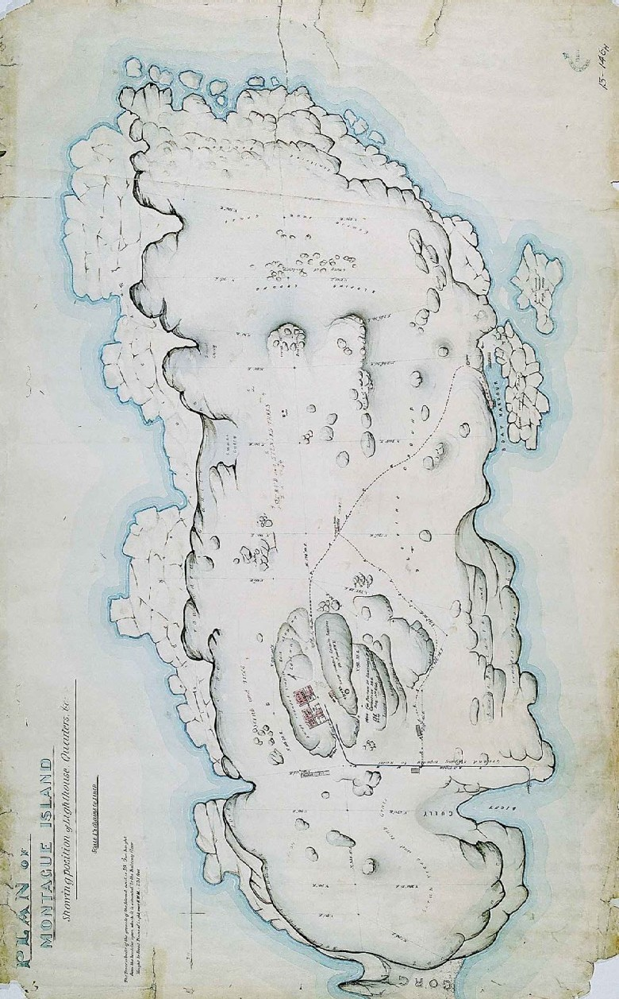

Figure 18. Montague Island Lighthouse site plan (James Barnet, 1878)

#### Equipment when built

Following construction, Montague lighthouse stood as a 21 m tall circular granite tower with a light source powered by kerosene, providing an intensity of 45,000 cd.

The 910 mm focal radius, 8 panels, 1st Order Chance Bros. lantern and lens rotated on a roller pedestal which operated by clockwork mechanism and weights in the central tube within the tower.

The lens revolved every four minutes with:

“a steady flare for 30 seconds, then an eclipse for 13 seconds, and then a brilliant flash lasting four seconds, followed by another eclipse of 13 seconds’ duration.” 13

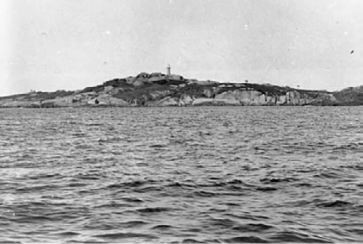

Figure 19. View of Montague Island Lighthouse, 1917 (NAA, 4746689)

### Lighthouse keepers

Due to the island’s isolation, lightkeeping was

a demanding livelihood. The arrival of food and supplies from passing steamers lay at the mercy of

the weather and swell of the surrounding waters. In 1952, the lightkeepers and their families went without fresh food for 10 days, eventually resorting to hunting wild goats roaming the Island. 14

Tragedy was also a common theme on the island. The lack of medical assistance available, and the inability to traverse the passage separating the island from the mainland, meant deaths among lightkeepers and their families occured. Head keeper, John Burgess, lost two of his children in the 1880s, one to whooping cough and the other to an unknown illness, and an assistant keeper Charles Townsend died after being thrown from his horse in 1894.

Mrs John Burgess’s letter to the local newspapers exemplified the consequences of isolation in 1894:

I have been a lighthouse keeper’s wife for nearly fifteen years, both at South Solitary and Montague Islands.

During that period several deaths have occurred in my family and those of the assistants, also accidents. We never could procure assistance till too late; although steamers pass both north and south frequently, they do not seem to see when we have a distress signal flying from our flagstaff. 15

The graves of the Burgess children and Mr Townsend, which are located nearby the lighthouse and cottages, are a stark reminder of the dangers faced in taking up lightkeeping in isolated locations.16

The move to automate the lighthouse in the 1980s faced controversy among keepers and local communities who feared it would lead to its dilapidation.17

Eventually however, the lighthouse was officially de-manned in 1986 following the station’s automation.

1. Quoted in Searle, G., *First Order* (2013), pg. 205.
2. Searle, G., *First Order* (2013), pg. 204-205.
3. “Shipping: Montague Island,” *Evening News*, Dec 19, 1894
4. Searle, G., First Order (2013), pg. 205.
5. “Island’s future threatened by automation,” *The Canberra Times*, Jan 7, 1983 https://trove.nla.gov.au/newspaper/arti- cle/116441586?-searchTerm=montague%20island%20lighthouse&searchLimits=exactPhrase|||anyWords|||notWords|||reques- tHandler|||dateFrom|||dateTo|||sortby

### Chronology of major events

The table below details the major events to have occurred at the Montague Island Lightstation.

|  |  |
| --- | --- |
| **Date**  1881 | **Event Details** |
| The Montague Island Lighthouse officially lit for the first time. |
| 3 Dec 1894 | Assistant lightkeeper, Mr Townsend, killed in cart accident on Montague Island. |
| 13 Dec 1894 | Light keeper, Mr Emanuel Francis, wounded in an accident involving a burst gun on Montague Island. Francis had only recently arrived on the island to replace the previous assistant lightkeeper, the late Mr Townsend, who had been killed the week before.18 |
| 5 Aug 1895 | Tremors experienced at Montague Island Lighthouse – no damage to lighthouse.19 |
| Sep 1907 | First scientific visit conducted on the island by ornithologist, AF Basset Hull. |
| Apr 1908 | The Department of Navigation received word from the Montague Island Lighthouse that owing to a strike, no supply vessels had delievered food to the lighthouse for over a fortnight.20 |
| Mar 1910 | Acetylene gas Morse signal lamp installed on Montague Island – allowing improved communication with Pilot Station in Narooma. |
| 1938-39 | Transceiver radio telephone outfits installed at Montague Island Lighthouse. 21 |
| Circa  1930s-1940s | The island used as a defence facility by the Royal Australian Navy. |
| 1952 | Cyclones leave lightkeepers marooned without supplies on Montague Island.22  RAAF parachutes food on island for keepers.19 |
| 1953 | Montague Island named a wildlife sanctuary under the control of the National Trust of Australia (NSW) |
| 21 Oct 1980 | Montague Island Lighthosue included on the Register of the National Estate |
| 11 Mar 1983 | Public meeting held to discuss the government’s proposal to automate the Montague Island Lighthouse.23 |
| 14 Sept 1986 | First order lens turned off and removed to mainland. Lighthouse officially de-manned. |
| 1987-89 | Management of the island transferred to NPWS.  The Department of Transport retained the lighthouse tower and continued its operation as an AtoN.24 |
| 16 Dec 1989 | The first day tours to the island permitted. |
| 17 Jan 1990 | Montague Island named a nature reserve. |
| 1993 | NPWS begins $180,000 project to conserve the Montague Island Lighthouse precinct.25 |
| 1999 | Montague Island Lightstation listed on the NSW Heritage Register. |
| 22 June 2004 | Montague Island Lighthouse included on the Commonwealth Heritage List |

1. “Fatal accident at Montagu Island,” The Daily Telegraph, Dec 10, 1894 https://trove.nla.gov.au/newspaper/article/236111212?searchTerm=montague%20island%20 lighthouse&searchLimits=exactPhrase|||anyWords|||notWords|||requestHandler|||dateFrom|||dateTo|||sortby
2. “The Montague Island Lighthouse: Another Accident,” The Daily Telegraph, Dec 14, 1894 https://trove.nla.gov.au/newspaper/article/236115874?searchTerm=montague%20island%20 lighthouse&searchLimits=exactPhrase|||anyWords|||notWords|||requestHandler|||dateFrom|||dateTo|||sortby
3. “Earthquake at Montague Island,” The Daily Telegraph, Aug 6, 1895 https://trove.nla.gov.au/newspaper/article/238512032?searchTerm=montague%20island%20 lighthouse&searchLimits=exactPhrase|||anyWords|||notWords|||requestHandler|||dateFrom|||dateTo|||sortby
4. “In urgent need of food: A message from Montague Island,” The Daily Telegraph, Apr 8, 1908 https://trove.nla.gov.au/newspaper/article/238150413?searchTerm=montague%20island%20 lighthouse&searchLimits=exactPhrase|||anyWords|||notWords|||requestHandler|||dateFrom|||dateTo|||sortby
5. “Lighthouse Radios,” The Argus, Oct 28, 1938 https://trove.nla.gov.au/newspaper/article/12526670?searchTerm=montague%20 island%20lighthouse&searchLimits=exactPhrase|||anyWords|||notWords|||requestHandler|||dateFrom|||dateTo|||sortby
6. “Lighthouse families marooned,” The Newcastle Sun, Aug 7, 1952 https://trove.nla.gov.au/newspaper/article/160330044?searchTerm=montague%20island%20 lighthouse&searchLimits=exactPhrase|||anyWords|||notWords|||requestHandler|||dateFrom|||dateTo|||sortby
7. “R.A.A.F. parachutes food on Montague Island,” The Canberra Times, Aug 9, 1952 https://trove.nla.gov.au/newspaper/article/2861423?searchTerm=montague%20island%20 lighthouse&searchLimits=exactPhrase|||anyWords|||notWords|||requestHandler|||dateFrom|||dateTo|||sortby
8. “Meeting to discuss lighthouse plans,” The Canberra Times, Feb 27, 1983 https://trove.nla.gov.au/newspaper/article/116453018?searchTerm=montague%20island%20 lighthouse&searchLimits=exactPhrase|||anyWords|||notWords|||requestHandler|||dateFrom|||dateTo|||sortby
9. “Montague Island wildlife haven,” The Canberra Times, Sept 20, 1992 https://trove.nla.gov.au/newspaper/article/126943947?searchTerm=montague%20island%20 lighthouse&searchLimits=exactPhrase|||anyWords|||notWords|||requestHandler|||dateFrom|||dateTo|||sortby
10. “Old lighthouse,” The Canberra Times, Jan 28, 1993 https://trove.nla.gov.au/newspaper/article/126972384?searchTerm=montague%20island%20 lighthouse&searchLimits=exactPhrase|||anyWords|||notWords|||requestHandler|||dateFrom|||dateTo|||sortby

### Changes and conservation over time

The Montague Island Lighthouse has undergone minimal changes since its construction in 1901. Changes that have been made were largely in relation to the light source and electrical systems. The following sections detail the changes made to the lightstation.

#### The Brewis Report (1913)

In 1911, Commander CRW Brewis, retired naval surveyor, was commissioned by the Commonwealth Government to report on the condition of existing lights and to recommend any additional ones.

Brewis visited every lighthouse in Australia between June and December 1912 and produced a series of reports published in their final form in March 1913. These reports were the basis for future decisions.

Brewis’ recommendations for Montague Island included changing the character of the light, inserting a new clockwork mechanism and pedestal and installing new wireless telegraph equipment.

|  |
| --- |
| **Brewis Report: Montagu Island Light 28** |
| 25 miles from Burrewarra Point, 73 miles from Perpendicular Head.  Lat. 36º 15’S., Long. 150º 14’E., Chart No. 1018. – Established 1880. Last altered 1910.  *Character – Main Light:* One white, dioptric. Fixed and flashing every 70 seconds, thus:-Flash, 5 seconds; eclipse, 16 seconds; fixed, 33 seconds; eclipse, 16 seconds. Candle-power: Flashing, about 45,000; fixed, 7,500 c.p.  Illuminant, vaporized kerosene; 55 mm. mantle.  Circular grey granite tower, 53 feet. Height of focal plane, 262 feet.  *Visibility:* In clear weather, all round the horizon, for a distance of about 20 nautical miles.  *Optical Apparatus:* Chance Bros., 1879. Eight panels. Focal radius, 36 inches. One revolution every 4 minutes  40 seconds.  *Condition and State of Efficacy:* The tower, lantern, optical apparatus, and dwellings are in good condition.  The light is too slow for modern requirements. Three light-keepers are stationed here.  *Communication:* Provisions and mails once weekly by coastal steamer. Government stores yearly. The lighthouse is not connected by telephone with the mainland, but messages by distant signals during the day and by Morse lamp at night may, under favourable conditions, be sent and received via the signal station at Narooma (distant 5 miles), which has telephonic communication with the main telegraph system.  Electric Morse lamp at lighthouse.  *Fogs:* From January to March, fogs may be experienced and may last as long as nine hours.  *Soundings:* From 5 miles off Thubbul River to about 1 mile westward of Montagu Island, this soundings range from 51 to 17 fathoms on a sandy bottom, but at 7 miles south-eastward of the island there is no bottom at 100 fathoms.  RECOMMENDED:   1. The speed of the flashes be increased by inserting new mechanism (pedestal and clock), so as to give one revolution every 80 seconds, and produce a character of fixed and flashing every 20 seconds, thus: Fixed, 9 ½ seconds; eclipse, 4 ½ seconds; flash, 1 ½ seconds; flash, 1 ½ seconds; eclipse, 4 ½ seconds. 2. Wireless telegraph equipment be installed. Nearest main wireless station, Gabo Island, distant about 84 miles. |

1. CRW Brewis, *Lighting of the East Coast of Australia: Cape Moreton to Gabo Island Including Coast of New South Wales* (1913),

pg. 21.

#### Alterations to the Light

Due to developments in technology, the Montague Island Lighthouse was modified multiple times to improve its use as an AtoN.

|  |  |
| --- | --- |
| **Date**  1910 | **Alteration** |
| 55 mm Schmidt-Ford vaporised kerosene powered mantle installed. Intensity: 250,000 candlepower (cp) |
| 13 April 1923 | New mantle installed.  Intensity: 357,000 cp |
| 19 July 1926 | Roller pedestal removed. Mercury  bath pedestal installed.  Four of the original eight panels screened off – light now only produces a flashing light. |
| 20 June 1969 | Conversion to diesel electric operation – 1000 W Tungsten- halogen lamp installed.  Four optic panels (ex-Green Cape  lighthouse) installed.  Intensity: 1,000,000 cp |
| 14 Sept 1986 | First order lens turned off and  removed to the mainland. |
| 28 Nov 1986 | Solar-powered PRP-24 beacon  installed. Lighthouse fully-automated. |
| 6 April 2006 | Solar-powered Vega VRB-25 beacon installed. Intensity: 132,736 cp |

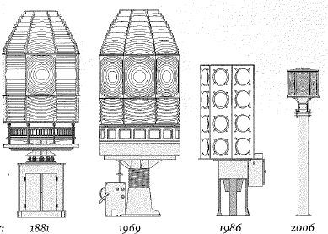

Figure 20. Evolution of Montague Island Lighthouse lens/

lanterns (Searle, 2013, pg. 209)

#### Conservation Works

The table below details the major rectification works carried out on the Montague Island Lighthouse.These works have been undertaken as proactive measures to preserve the tower’s fabric and materials.

|  |  |
| --- | --- |
| **Date** | **Works Completed** |
| Circa 1980s | Lantern room refurbished |
| Sept 1986 | Original lantern and lens removed  from tower |

### Summary of current and former uses

From its construction in 1881, the Montague Island Lightouse has been used as a marine AtoN. Its AtoN capabilities remain its primary use.

The Montague Island Lighthouse as a key tourism site developed over recent decades following

the transferral of the Island to the NPWS, and the keepers’ cottages are now used for tourist accomodation.

The Montague Island Lightstation precint is now used:

* to house NPWS staff stationed on the island, as well as accomodating researchers and tour guides
* a key tourism site, with facilities.

### Summary of past and present community associations

#### Aboriginal associations

The Wagonga Local Aboriginal Land Council shared with AMSA the following:

“The language spoken is Dhurga. Both Walbunja Yuin and Djirridjan Yuin claim connection to Barranguba. Please note that all Yuin people have a connection to Barranguba, Nadjanuka and Gulaga as they forever protect their people.

Today our people are restricted from accessing our special places which is due to white man’s laws and regulations.”

AMSA is currently working to erect a symbol on the island to acknowledge the Yuin people’s Elders, past, present and future generation.

#### Local, National, and International associations

Montague Island maintains firm state and national associations owing to its standing as a nature reserve under the NPWS. Montague Island Nature Reserve hosts one of the longest running seabird research programs in the world. This, combined with the unique species present, the accessibility of the island and its geographical location and significant size highlights the importance of Montague Island ecologically and scientifically.

The nature reserve offers a protective sanctuary to

species of local and national concern.

The lighthouse itself maintains strong associations with past lighthouse keeping families owing to

the significant period of time the lightstation was

manned.

### Unresolved questions or historical

**conflicts**

A number of dates are disputed amongst past research.

The year the lighthouse was de-manned is disputed. Some sources credit 1985, others credit 1986. There is also uncertainty over which year the island was handed over to the NPWS with sources citing 1987-89.

Despite much of its history being recorded, information on the lighthouse keepers of Montague Island is relatively limited. The list of names and years of service is incomplete and very little is known about the majority of those that occupied the site for more than 80 years.

### Recommendations for further research

Archaeological investigation of the site may reveal further information on prehistoric and historic uses of Montague Island to broaden understandings of the site’s intrinsic value.

# Fabric

### Fabric register

The cultural significance of the Montague Island Lighthouse resides in its fabric, and also in its intangible aspects, such as the meanings people ascribe to it, and its connections to other places and things. The survival of its cultural value depends on a well-informed understanding of what is significant, and on clear thinking about the consequences of change. The Burra Charter sets out good practice for conserving cultural significance. Criterion under ‘Heritage Significance’ refer to the criterion satisfied within the specific Commonwealth heritage listing (see section 5.1)

**Lighthouse feature: Lantern roof**

#### Description and condition

1880 Chance Bros part-spherical dome of copper

sheets lapped and screwed to ribs.

* Ribs – Chance Bros cast iron radial ribs
* Inner skin – none (removed)
* Ventilator – ball type with wind vane attached
* Lightning conductor – vertical pole mounted on dome, with four spikes at top, and two braces to roof sheets, eight vertical spikes attached near the gutter
* Gutter – circular ring of cast iron pieces bolted together. Drawings indicate the lantern roof may have been overhauled around 1981.
* Ladder rail – attached to underside of gutter
* Drip tray – copper dish suspended under ventilator, with central hole for heat tube
* 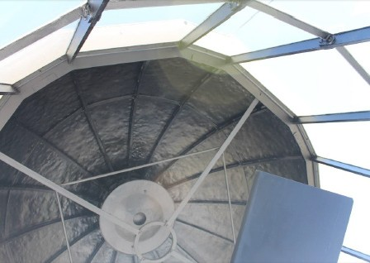Heat tube support – framework with four radial members of rolled ferrous T-section, attached to gutter and to central ring

#### Heritage significance: High

The lantern roof is both an original and essential part of the lighthouse, exhibiting one style of late- 19th century lighthouses (criterion a, criterion d).

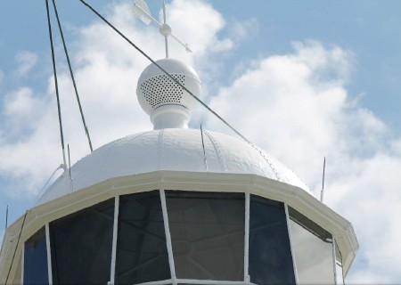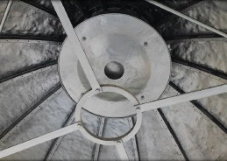

|  |  |
| --- | --- |
| **Finish** | painted |
| **Condition** | intact and sound |
| **Integrity** | high |
| **Significance** | high |
| **Maintenance** | keep in service; prepare and repaint at normal intervals |
| **Rectification**  **works** | none |

**Lighthouse feature: Lantern glazing**

#### Description and condition

Chance Bros, polygonal in plan.

* panes – flat trapezoidal glass, three tiers
* astragals – Chance Bros vertical and horizontal astragals of rectangular and triangular section, bolted to gutter ring at top, and to lantern base below
* 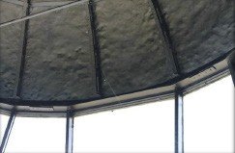downpipes – two short spitters inserted in bottom of gutter. Downpipes have been removed.
* handholds – two sets, fixed to cover strips

|  |  |
| --- | --- |
| **Finish** | astragals and glazing strips painted |
| **Condition** | intact and sound |
| **Integrity** | high |
| **Significance** | high |
| **Maintenance** | keep in service; reglaze as necessary, prepare and repaint at normal intervals |
| **Rectification**  **works** | none |

#### Heritage significance: High

The lantern glazing is an essential part of the lighthouse – exhibiting one style of late-19th century lighthouses (criterion a, criterion d).

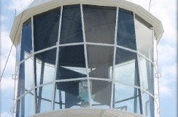

**Lighthouse feature: Internal catwalk**

#### Description and Condition

Original catwalk decking removed and replaced with a new floor supported on the original openwork cast iron brackets bolted to the upper section of the lantern base.

* 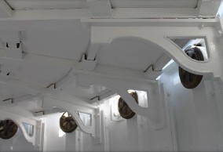floor – sheet flooring in segments, supported on pre-fabricated aluminium radial beams and cross beams, supported on the original iron brackets on the outside, and on a fabricated steel column in the middle
* ladder – fixed aluminium ladder

|  |  |
| --- | --- |
| **Finish** | painted |
| **Condition** | intact and sound |
| **Integrity** | medium |
| **Significance** | high |
| **Maintenance** | keep in service, prepare and  repaint at normal intervals |
| **Rectification**  **works** | none |

#### Heritage significance: High

Highly significant for these reasons:

The internal catwalk is an original and essential part of the lighthouse (criterion a).

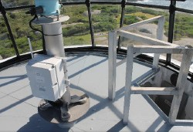

**Lighthouse feature: External catwalk**

#### Description and condition

1880 Chance Bros, cast iron lattice floor panels supported on openwork cast iron brackets bolted to lantern base with modern socket-head bolts.

* 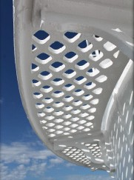handrail – none

|  |  |
| --- | --- |
| **Finish** | painted |
| **Condition** | intact and sound |
| **Integrity** | high |
| **Significance** | high |
| **Maintenance** | keep in service, prepare and  repaint at normal intervals |
| **Rectification**  **works** | none |

#### Heritage significance: High

The external catwalk is both an original and essential part of the lighthouse – exhibiting one style of late- 19th century lighthouses (criterion a, criterion d).

The external catwalk contributes to the aesthetic value of the lighthouse (criterion e).



**Lighthouse feature: Lantern base**

#### Description and condition

1880 Chance Bros, cylindrical in form. Curved panels of cast iron bolted together with flanged joints.

* internal lining – none (removed)
* 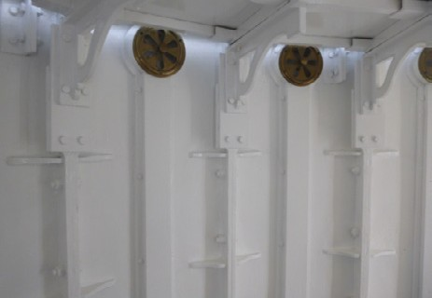vents round air inlet near the bottom of exterior of each panel (sealed), with internal cast iron trunk bolted on. Single large circular opening on inside of each trunk, the regulators have been removed.
* 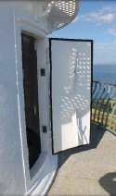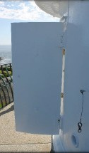door – iron door leaf, curved to match the lantern base. Internal frame, lining and lock all removed. Fitted with rubber weather seals, and two strongbacks, threaded studs and nuts to secure the door closed. Copper alloy hinges.

|  |  |
| --- | --- |
| **Finish** | painted |
| **Condition** | sound |
| **Integrity** | high |
| **Significance** | high |
| **Maintenance** | keep in service, prepare and  repaint at normal intervals |
| **Rectification**  **works** | none |

#### Heritage significance: High

The lantern base is both an original and essential part of the lighthouse – exhibiting one style of late- 19th century lighthouses (criterion a, criterion d).

**Lighthouse feature: Lantern floor**

#### Description and condition

1880 floor of iron checker plate supported on rolled iron I section and channel beams built into the stone tower walls.

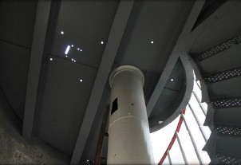Holes indicate the former location of optic pedestal and clock.

|  |  |
| --- | --- |
| **Finish** | painted |
| **Condition** | intact and sound |
| **Integrity** | high |
| **Significance** | high |
| **Maintenance** | keep in service, prepare and  repaint at normal intervals |
| **Rectification**  **works** | none |

#### Heritage significance: High

The lantern floor is both an original and essential part of the lighthouse – exhibiting one style of late- 19th century lighthouses (criterion a, criterion d).

**Lighthouse feature: Light source**

#### Description and condition

Vega VRB-25 beacon.

|  |  |
| --- | --- |
| **Condition** | not assessed |
| **Integrity** | medium |
| **Significance** | low |
| **Maintenance** | not assessed |
| **Rectification**  **works** | none |

#### Heritage significance: Low

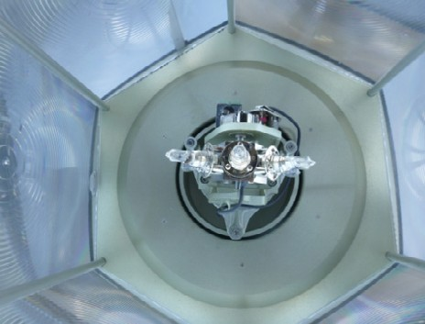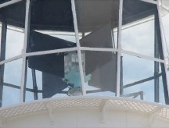

**Lighthouse feature: Pedestal**

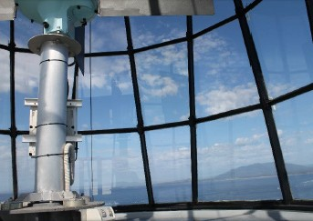**Description and condition**

Recent welded tubular aluminium post.

|  |  |
| --- | --- |
| **Finish** | bare metal |
| **Condition** | intact and sound |
| **Integrity** | medium |
| **Significance** | low |
| **Maintenance** | none |
| **Rectification**  **works** | none |

#### Heritage significance: Low

**Lighthouse feature: Balcony floor**

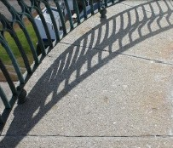**Description and condition**

1880 granite slab floor, supported on the stone tower wall and cornice. Resilient joint caulking.

|  |  |
| --- | --- |
| **Finish** | bare stone |
| **Condition** | intact and sound |
| **Integrity** | high |
| **Significance** | high |
| **Maintenance** | keep in service, replace joint  caulking at normal intervals |
| **Rectification**  **works** | none |

#### Heritage significance: High

The balcony floor is both an original and essential part of the lighthouse – exhibiting one style of late- 19th century lighthouses (criterion a, criterion d).

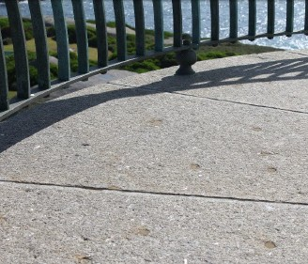

**Lighthouse feature: Balcony balustrade**

#### Description and condition

1880 gunmetal railing, with closely spaced balusters of rectangular section and curved profile, cruciform stiffeners bolted to balusters, rectangular bottom rail, half-round top rail, turned bulbous fixing bolts at bottom.

|  |  |
| --- | --- |
| **Finish** | bare metal |
| **Condition** | intact and sound |
| **Integrity** | high |
| **Significance** | high |
| **Maintenance** | keep in service |
| **Rectification**  **works** | none |

#### Heritage significance: High

The balcony balustrade is both an original and essential part of the lighthouse – exhibiting one style of late-19th century lighthouses (criterion a, criterion d).

The balcony balustrade contributes to the aesthetic value of the lighthouse (criterion e).

The balcony balustrade demonstrates fine elements

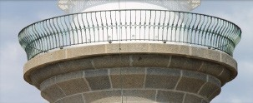of design and craftsmanship (criterion f).

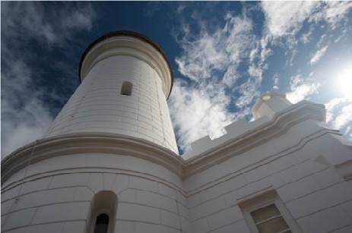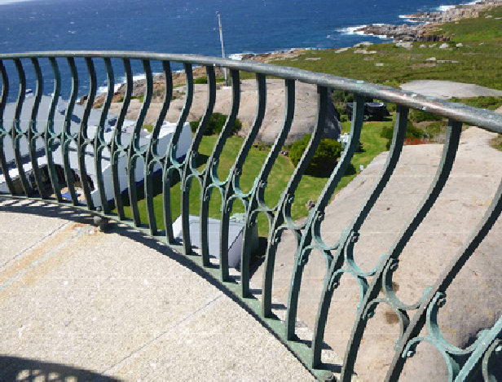

**Lighthouse feature: Walls**

#### Description and condition

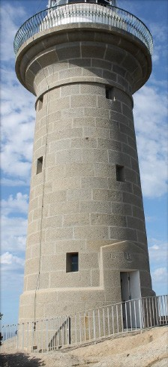1880 walls of granite with finely punched faces and drafted margins, inside and out.

|  |  |
| --- | --- |
| **Finish** | bare stone outside window reveals painted  formerly painted or lime washed inside |
| **Condition** | intact and sound |
| **Integrity** | high |
| **Significance** | high |
| **Maintenance** | keep in service  maintain painted window reveals do not paint other interior parts |
| **Rectification**  **works** | none |

#### Heritage significance: High

The tower walls are both original and essential parts of the lighthouse – exhibiting one style of late-19th century lighthouses (criterion a, criterion d).

The granite stonework of the tower walls contribute to the aesthetic value of the lighthouse (criterion e).

The tapering tower walls demonstrate fine elements

of design and craftsmanship (criterion f).

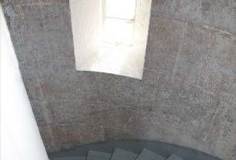

**Lighthouse feature: Windows**

#### Description and condition

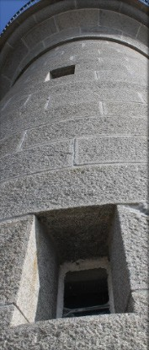1880 windows with gunmetal casement sashes, hinges, latches and frames, built into stone walls.

|  |  |
| --- | --- |
| **Finish** | frames and sashes: painted glass: clear |
| **Condition** | intact and sound |
| **Integrity** | high |
| **Significance** | high |
| **Maintenance** | keep in service, prepare and  repaint at normal intervals |
| **Rectification**  **works** | none |

#### Heritage significance: High

The windows are both original and essential parts of the lighthouse – exhibiting one style of late-19th century lighthouses (criterion a, criterion d).

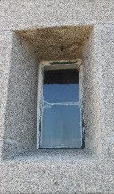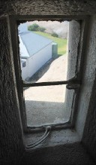

**Lighthouse feature: Door**

#### Description and condition

1880 door opening with external stone architrave with royal insignia and date 1881.

Two timber framed and sheeted door leaves hung on butt hinges in timber frame. Secured with two hasps and staples with padlocks.

|  |  |
| --- | --- |
| **Finish** | painted |
| **Condition** | sound and intact |
| **Integrity** | high |
| **Significance** | high |
| **Maintenance** | keep in service, prepare and  repaint at normal intervals |
| **Rectification**  **works** | none |

#### Heritage significance: High

The tower door is both an original and essential part of the lighthouse (criterion a).

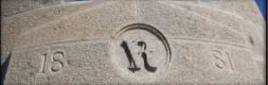

**Lighthouse feature: Stairs**

#### Description and condition

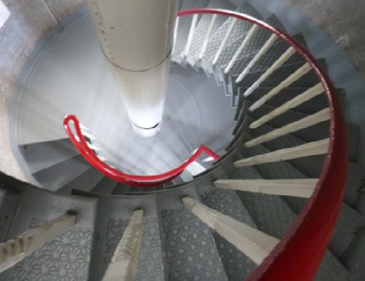1880 geometric stair with cast iron treads attached to the tower walls. Wrought iron handrail and stanchions.

|  |  |
| --- | --- |
| **Finish** | painted |
| **Condition** | intact and sound |
| **Integrity** | high |
| **Significance** | high |
| **Maintenance** | keep in service, prepare and repaint  at normal intervals |
| **Rectification**  **works** | none |

#### Heritage significance: High

The internal tower stairs are both an original and essential part of the lighthouse (criterion a).

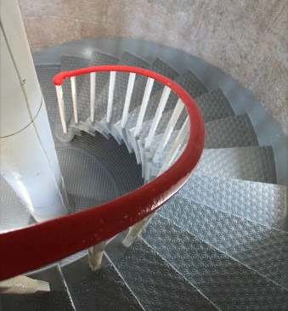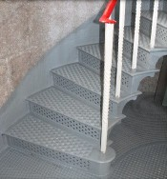

**Lighthouse feature: Ground floor**

#### Description and condition

1880 concrete slab.

|  |  |
| --- | --- |
| **Finish** | painted |
| **Condition** | intact and sound |
| **Integrity** | high |
| **Significance** | high |
| **Maintenance** | keep in service |
| **Rectification**  **works** | none |

#### Heritage significance: High

The ground floor is an original and essential part of

the lighthouse (criterion a).

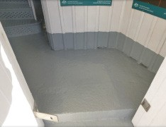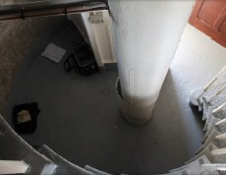

**Lighthouse feature: Weight tube**

#### Description and condition

1880 riveted iron tube in the centre of the tower, between the lantern floor and the ground floor.

|  |  |
| --- | --- |
| **Finish** | painted |
| **Condition** | intact and sound |
| **Integrity** | high |
| **Significance** | high |
| **Maintenance** | preserve; prepare and repaint at normal intervals |
| **Rectification**  **works** | none |

#### Heritage significance: High

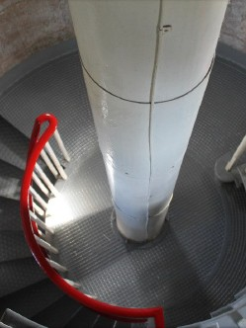The weight tube is both an original and essential part of the lighthouse (criterion a).

**Lighthouse feature: Entrance vestibule**

#### Description and condition

1880 timber framed, sheeted and ceiled wind lock vestibule, fitted with timber four-panel door.

|  |  |
| --- | --- |
| **Finish** | painted |
| **Condition** | intact and sound |
| **Integrity** | high |
| **Significance** | high |
| **Maintenance** | keep in service; prepare and repoint at normal intervals |
| **Rectification**  **works** | none |

#### Heritage significance: High

The entrance vestibule is both an original and essential part of the lighthouse (criterion a).

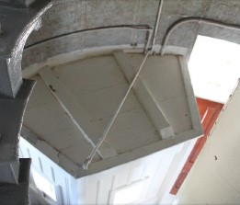

**Lighthouse feature: Walkway / walkway stairs**

#### Description and condition

1880 stone stair from keepers’ quarters area up to the base of the tower. Recent concrete path and aluminium railing.

|  |  |
| --- | --- |
| **Condition** | intact and sound |
| **Integrity** | high |
| **Significance** | stair: high railing: low |
| **Maintenance** | none |
| **Rectification**  **works** | none |

#### Heritage significance: High

The walkway stairs are both an original and essential part of the lighthouse (criterion a).

**Lighthouse feature: Solar panels**

#### Description and condition

14 solar panels on aluminium frame on concrete base, near the base of the tower, beside the much larger solar array used by the NPWS.

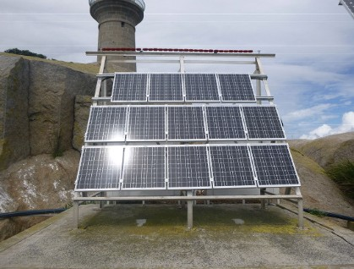Two cabinets containing batteries and control equipment at the rear of solar array.

|  |  |
| --- | --- |
| **Condition** | sound |
| **Integrity** | high |
| **Significance** | low |
| **Maintenance** | none |
| **Rectification**  **works** | none |

**Heritage significance: Low**

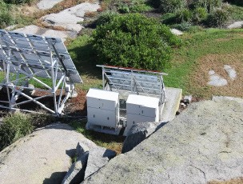

### Related object or associated AMSA artefact

There are no AMSA registered artefacts.

### Comparative analysis

The South Solitary Island Lighthouse, first lit in 1880, bears the closest resemblance to the

Montague Island Lighthouse in design and style.

Designed by James Barnet, South Solitary Island Lighthouse stands as a mass concrete structure. Similar to Montague Island, South Solitary’s cylindrical tower was originally constructed to be slightly tapered in design with an outwardly sloping gunmetal balcony railing fitted around a Chance Bros. lantern room. The two lighthouses also share similar fittings such as the geometric cast iron stairs located within the tower. The lighthouses were both originally fitted with 1st Order Chance Bros. optical assemblies.

Unlike Montague Island, South Solitary’s tower was painted white and the base of the tower was enclosed by a small annex which contained the oil store.

The close stylistic resemblances of Montague Island and South Solitary Island, built one year apart, are indicative of James Barnet’s vision for NSW’s ‘highway of lights’. Despite some variation between the designs, both of the isolated island towers represent late-19th century craftsmanship and technical achievement.

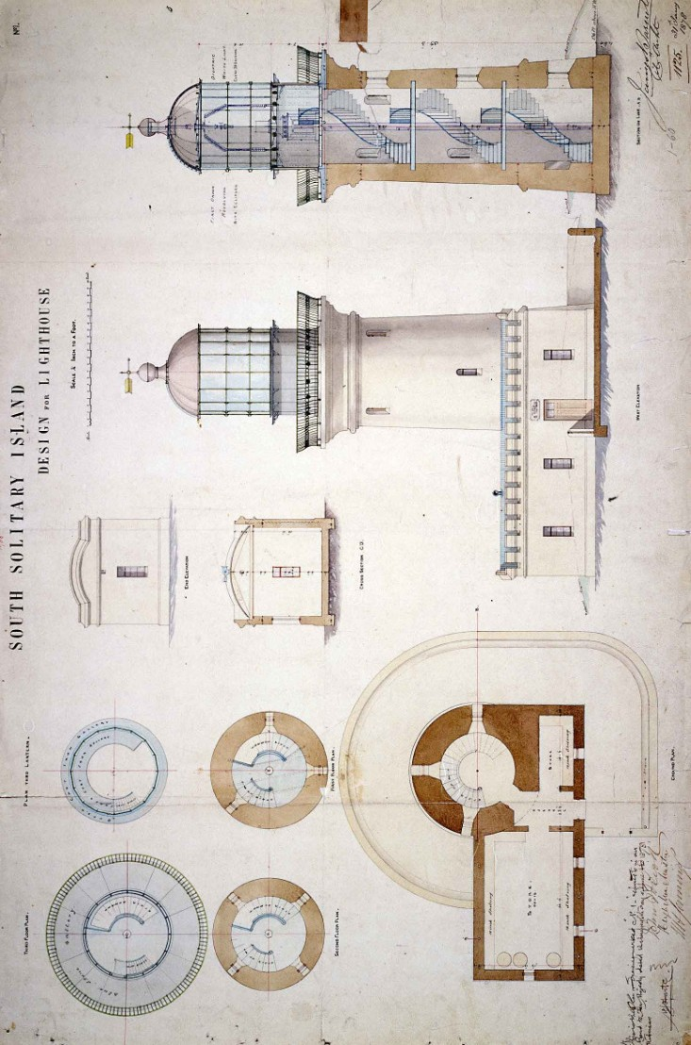

Figure 21. South Solitary Island Lighthouse elevation blueprint (James Barnet, 1878)

# Heritage Significance

### Commonwealth heritage list – Montague Island Lighthouse

#### Statement of Commonwealth heritage

**significance**

The following statement of significance is taken from the Montague Island Lighthouse listing on the Australian Heritage Database (Place ID: 105601)c

The Montague Island Lighthouse tower, opened in 1881, is significant for its long association with the development and provision of maritime aids along the New South Wales coast, and for its part in

the history of Australian shipping over a considerable period (criterion a). (Themes:

3.8.1 Shipping to and from Australian ports,

3.16.1 Dealing with hazards and disasters)

The granite tower, with tapering walls, outward curving platform and curved balustrade, is a well-proportioned structure displaying very fine elements of design and craftsmanship.

The tower is also a good example of a late- 19th century light tower on the NSW coast (criterion f, criterion d).

The Montague tower is one of the only two offshore island lighthouses along the NSW coast (criterion b).

Additionally significant is the fact that the tower was designed by NSW Colonial Architect James Barnet. Barnet played a seminal role into the development of the colony’s architecture over 25 years (criterion h).

The island and the lightstation are socially significant on account of the large numbers of visitors to Montague, the tower’s high visibility from the coast and the incorporation of the tower into local tourism (criterion g).

The tower’s fine design and granite stonework, its landmark status along this part of the coast, the lack of modern visual intrusions, and the tower’s contrast with the island’s rounded granite slabs and treeless topography are all responsible for the tower having considerable aesthetic qualities (criterion e).

#### Commonwealth heritage values – criteria

There are nine criteria for inclusion in the Commonwealth Heritage List and meeting any one of these is sufficient for listing a place. These criteria are similar to those used in other commonwealth, state and local heritage legislation, although thresholds differ. In the following sections, the Montague Island Lighthouse is discussed in relation to each of the criteria as based on the current Commonwealth Heritage Listing Place ID 105601.

|  |  |  |
| --- | --- | --- |
| **Criterion**  **Criterion A – Processes**  This criterion is satisfied by places that have significant heritage value because of [their] importance in the course, or pattern, of Australia’s natural or cultural history. | **Relevant Attributes Identified** | **Explanation** |
| All of the structure’s historic fabric,  form and siting | Opened in 1881, the Montague Island Lighthouse is significant for its long association with the development  and provision of maritime aids along the New South Wales coast, and for its part in the history of Australian shipping over a considerable period. |
| **Criterion B – Rarity**  This criterion is satisfied by places that have significant heritage value because of [their] possession of uncommon, rare or endangered aspects of Australia’s natural or cultural history. | All of the place including its landscape setting. | The Montague tower is one of only two offshore island lighthouses along the NSW coast. |
| **Criterion D – Characteristic values** This criterion is satisfied by places that have significant heritage values because of [their] importance  in demonstrating the principal characteristics of a class of Australia’s natural or cultural history. | The granite tower, with tapering walls, outward curving platform and curved balustrade, as well as the quality of design and craftsmanship. | The Montague Island Lighthouse tower is a good example of a late- 19th century light tower on the NSW coast. |
| **Criterion E – Aesthetic characteristics**  This criterion is satisfied by places that have significant heritage value because of [their] importance in exhibiting particular aesthetic characteristics values by a community or cultural group. | The historic form and fabric, its visibility and the lack of modern intrusions and landscape setting. | The tower’s fine design and granite stonework, its landmark status, the lack of modern visual intrusions, and the tower’s contrast with the island’s rounded granite slabs and treeless topography are all responsible for the tower’s considerable aesthetic qualities. |
| **Criterion F – Technical achievement** This criterion is satisfied by places that have significant heritage value because of [their] importance in demonstrating a high degree of creative or technical achievement at a particular period. | The quality of construction and design evident in all elements of the tower, both internally and externally. | The granite tower, with tapering walls, outward curving platform and curved balustrade, is well proportioned structure displaying very fine elements of design and craftsmanship. |
| **Criterion G – Social value**  This criterion is satisfied by places that have significant heritage value because of [their] strong or  special association with a particular community or cultural group for social, cultural or spiritual reasons. | The tower’s visibility and its ongoing accessibility to the public. | The island and the light station are socially significant on account of the large numbers of visitors to  Montague, the tower’s high visibility from the coast and the incorporation of the tower into local tourism. |
| **Criterion H – Significant people** This criterion is satisfied by places that have significant heritage value because of [their] special association with the life or works of a person, or group of persons, of importance in Australia’s cultural history. | The tower’s historic design and integrity. | NSW colonial architect James Barnet designed the tower and played a seminal role in the development of the colony’s architecture over 25 years. |

### NSW State heritage register – Montague Island Lighthouse

The statement of heritage significance and the information from the table below was taken from the Montague Island Lightstation listing on the New South Wales State Heritage Register (SHR). Listing ID: 01000.d

#### NSW State heritage register – statement of

**heritage significance**

Montague Island Lightstation and its setting

are highly significant as one of a collection of lighthouses which combine the natural values of a rugged coastal island with the cultural values of a prominent landmark and isolated outpost associated with the development of coastal shipping in the late 19th century.

#### NSW State heritage values – criterion

|  |  |
| --- | --- |
| **SHR Criterion**  **SHR Criterion A – Historical**  **significance**  An item is important in the course, or pattern, of NSW’s cultural or natural history. | **Evidence/Explanation** |
| Montague is a fine and intact example of a lightstation constructed in NSW during the late 19th century and part of the most productive phase of lighthouse construction during the 1880s.  The light is an important part of the NSW network and the so-called ‘highway lights’ and offered protection to the intrastate traffic to Narooma, Tathra and Eden. It is one of only two major lighthouses in NSW located on off-shore islands. |
| **SHR Criterion B – Associative**  **significance**  An item has strong or special association with the life or works of a person, or group of persons, of importance in NSW’s cultural or natural history. | No attributes identified |
| **SHR Criterion C – Aesthetic**  **significance**  An item is important in demonstrating aesthetic characteristics and/or a high degree of creative or technical achievement in NSW. | The Montague lighthouse, constructed of granite quarried on the island, with its tapering walls and outward curving upper platform and curved balustrade, is a well-proportioned structure displaying very fine elements of design and craftsmanship.  The tower provides a strong visual contrast to the rounded granite slabs and sparse vegetation topography of the Island.  The white painted buildings with their collection of chimneys, pitched roofs, verandahs and enclosed courtyards clustered on the highest point of the Island present a visual unity and harmony in form, style and materials. The residences are a strong reminder of the era of manned lightstations on the coast of Australia. |

|  |  |
| --- | --- |
| **SHR Criterion**  **SHR Criterion D – Social significance**  An item has strong or special association with a particular community or cultural group in NSW for social, cultural or spiritual reasons. | **Evidence/Explanation** |
| Montague Island is of exceptional significance for both its Aboriginal and European connections and associations. It is significant through its association with the National Trust of Australia as a wildlife sanctuary, CSIRO as a research site, and with the NPWS as a nature reserve.  Graves associated with the lighthouse as a poignant testimony to the  isolated lifestyle of keepers and their families.  The lightstation is a notable design of NSW colonial architect James Barnet and is associated with the nature conservation work of Judith Cassel.  Many of the alterations to the buildings and site are a reflection of technological improvements and reflect changed in the system as well as changed in living standards in an isolated outpost. |
| **SHR Criterion E – Research potential**  An item has potential to yield information that will contribute to an understanding of NSW’s cultural or natural history. | The island is one of the most significant seabird breeding areas in NSW  and was once the most important seal haul-out site in the state.  Bird life was first studied on the island early in the 21st century and the sea life has been studied for nearly half a century using the island as a research base.  The island is a significant resource for research into the effects of  occupation of European settlement in an isolated natural environment.  The numerous archaeological sites on the Island are significant and relate to Aboriginal, European and natural elements on the Island. |
| **SHR Criterion F – Rarity**  An item possesses uncommon, rare or endangered aspects of NSW’s cultural or natural history. | Rare for association with natural values. |
| **SHR Criterion G – Representativeness**  An item is important in demonstrating the principal characteristics of a class of NSW’s:   * Cultural or natural places; or * Cultural or natural environments | A fine intact example of the work of James Barnet, NSW colonial architect. |

These heritage values, identified and explained within the Commonwealth Heritage List and the State Heritage Register, will form the basis of the management of the Montague Island Lighthouse. In the event of necessary works, all criteria will be consulted to inform best practice management of the values associated with the lightstation. (See Section 7 – Conservation management policies for further information on strategies to conserve Montague Island Lighthouse heritage values).

### Condition and integrity of the commonwealth heritage values

A heritage monitoring program was implemented in 2016. Each site is visited and reviewed every two years where the heritage fabric and values of the site are evaluated. Assessment of the condition and integrity of lighthouse’s values are derived from the

latest available Heritage Asset Condition Report

produced by AMSA’s maintenance contractor.

As a whole, the Montague Island Lighthouse demonstrates good condition. The lighthouse also demonstrates medium-high integrity. Some changes to the lighthouse, such as the removal of the original Chance Bros. lens and lantern and original internal catwalk, have had a slight impact on integrity.

|  |  |  |  |
| --- | --- | --- | --- |
| **Criteria**  **Criterion A – Processes** | **Attributes** | **Condition** | **Integrity** |
| All of the structure’s historic fabric,  form and siting. | Good | High |
| **Criterion B – Rarity** | All of the place including its landscape setting. | Good | High |
| **Criterion D – Characteristic Values** | The quality of design and craftsmanship of the:   * Granite tower * Tapering walls * Outward curving platform * Curved balustrade | Good Good Good Good | High High High High |
| **Criterion E – Aesthetic characteristics** | * The lighthouse’s historic form and fabric * The lighthouse’s visibility * The lack of modern intrusions * The lighthouse’s landscape setting | Fair Good Good Good | Medium High High High |
| **Criterion F – Technical Achievement** | Quality of construction and design of  all parts of the tower. | Good | High |
| **Criterion G – Social value** | * Lighthouse’s visibility. * Lighthouse’s accessibility to the public. | Good Good | High High |
| **Criterion H – Significant people** | Tower’s design and integrity | Good | High |

### Gain/loss of heritage values

Evidence for the potential gain or loss of heritage values will be documented within this section of future versions of this heritage management plan.

# Opportunities and Constraints

### Implications arising from

**significance**

The Commonwealth statement of significance (see Section 5.1) demonstrates the Montague Island Lighthouse is a place of considerable heritage value due to its contribution to the establishment of New South Wales ‘highway of lights’, and its assistance to the east coast shipping at the turn of the twentieth century.

The implication arising from this assessment is that key aspects of the place should be conserved to retain this significance. The key features requiring conservation include:

* the continued use of the lighthouse as an AtoN
* the architectural quality of the building
* The interior spaces and features, which are notable for their design, details, and/or their original lighthouse function. These include:
  + intermediate floors
  + ground floor
  + spiral staircase and weight tube
  + lantern room
  + entrance vestibule
* The external spaces and features, which are notable for their design, details, and/or their original lighthouse function. These include:
  + lantern roof and glazing
  + external catwalk and balcony, including fixtures
  + lighthouse tower walls
  + windows and doors
  + walkway/walkway stairs

#### Referral and approvals of action

The EPBC Act (1999) requires approval from the Minister for Sustainability, Environment, Water, Population and Communities for all actions likely to have a significant impact on matters of National Environmental Significance (NES).

The Act provides that actions:

* taken on Commonwealth land which are likely to have a significant impact on the environment will require the approval of the Minister
* taken outside Commonwealth land which are likely to have a significant impact on the environment on Commonwealth land, will require the approval by the Minister
* taken by the Australian Government or its agencies which are likely to have a significant impact on the environment anywhere will require approval by the Minister.

The definition of ‘environment’ in the EPBC Act (1999) includes the cultural heritage values of places.

#### Heritage Strategy

If an Australian Government agency owns or controls one or more places with Commonwealth heritage values, it must prepare a heritage strategy within two years from the first time they own or control a heritage place (section 341ZA).

A heritage strategy is a written document that integrates heritage conservation and

management within an agency’s overall property planning and management framework. Its purpose is to help an agency manage and report on the steps taken to protect and conserve the Commonwealth heritage values of the properties under its ownership or control.

The heritage strategye for AMSA’s AtoN assets was completed and approved by the Minister in 2018.

### Framework: sensitivity to change

A heritage asset condition report is a written document that details the heritage fabric of a site with an in-depth description of each architectural and structural element. The document includes: a brief history of the site, the Commonwealth Heritage statement of significance and value criteria, a heritage significance rating for each individual element, and a catalogue of artefacts on-site.

The document is also accompanied by up-to-date photos of each structural element.

This document operates as a tool for heritage

monitoring, and is reviewed and updated biennially.

Due to the site’s desired intactness and aesthetic qualities, the Montague Island Lighthouse is of high significance. Therefore, work actioned by AMSA

on the lighthouse’s fabric harnesses the potential to reduce or eradicate the significance of the site’s heritage values.

Conservation works, including restoration and reconstruction, or adaption works of the absolute minimum so as to continue the lighthouse’s usefulness as an AtoN are the only works that should be actioned by AMSA on Montague Island Lighthouse. Some exceptions are made for health and safety requirements, however any and all work carried out must be conducted in line with heritage considerations and requirements of the EPBC Act.

The table below demonstrates the level of sensitivity attributed to the various elements of the fabric register in the face of change. These are measured on a high-moderate-low spectrum depending on the action’s possible threat to the site’s heritage values (definitions listed below).

#### High sensitivity

High sensitivity to change includes instances wherein a change would pose a major threat to the heritage value of a specific fabric, or the lightstation as a whole. A major threat is one that would lead to substantial or total loss of the heritage value.

#### Moderate sensitivity

Moderate sensitivity to change includes instances wherein a change would pose a moderate threat to the heritage value of a specific fabric, or would pose a threat to the heritage significance of a specific fabric in another part of the building. A moderate threat is one that would diminish the heritage value, or diminish the ability of an observer to appreciate the value.

#### Low sensitivity

Low sensitivity to change includes instances wherein a change would pose little to no threat to the heritage value of a specific fabric, and would pose little to no threat to heritage significance in another part of the building.

|  |  |  |
| --- | --- | --- |
| **Component**  **Montague Island Lighthouse structure** | **Level of sensitivity** | **Nature of change impacting heritage values** |
| High | Major changes to façade materials and design.  Reduction of the all-round visibility of the structure and its  setting on Montague Island. |
| Low | Repainting of structure (in like colours).  Removal of asbestos/lead paint and/or other toxic  materials.  Minor repairs to apron paving. |
| **Ground floor, including entrance**  **vestibule** | High | Changes to façade materials and design.  Removal of 1880 timber framed wind lock vestibule. |
| Low | Repainting of ground floor (in like-colours). |
| **Stairs, and weight tube** | High | Removal of 1880 geometric stairs. Removal of 1880 riveted iron weight tube. |
| Moderate | Permanent removal of clock weights from within weight tube. |
| Low | Repainting of stairs and weight tube (in like colours). |
| **Intermediate floors** | Moderate | Removal of 1880 windows. |
| Low | Repainting of intermediate floor levels (in like colours). |
| **Balcony** | High | Major changes to façade materials and design. |
| Low | Repainting of balcony floor/balustrade (in like colours). |
| **Optical apparatus and pedestal** | Low | Alteration or replacement of the Vega VRB-25 Beacon.  Changing of the light’s character.  Alteration or replacement of aluminium post pedestal |
| **Lantern room** | High | Removal of 1880 Chance Bros. part spherical dome. |
| Low | Replacement of glazing. Re-sealing of glazing. |

### Statutory and legislative requirements

Below are listed the various Acts and Code that influence the management of the Montague Island Lighthouse in terms of heritage, navigation, and work health and safety.

|  |  |
| --- | --- |
| **Act or Code**  *Environment Protection and Biodiversity Conservation Act 1999* | **Description** |
| *The Environment Protection & Biodiversity Conservation Act* (EPBC Act) requires agencies to prepare management plans that satisfy the obligations included in Schedule 7A and 7B of the EPBC Regulations 2000. |
| Environment Protection and Biodiversity Conservation Regulations 2000  Schedule 7B | The Commonwealth Department of the Environment and Energy has determined  these principles as essential for guidance in managing heritage properties.   * The objective in managing Commonwealth heritage places is to identify, protect, conserve, present and transmit, to all generations, their Commonwealth Heritage values. * The management of Commonwealth heritage places should use the best available knowledge, skills and standards for those places, and include ongoing technical and community input to decisions and actions that may have a significant impact on their Commonwealth Heritage values. * The management of Commonwealth heritage places should respect all heritage values of the place and seek to integrate, where appropriate, any Commonwealth, State, Territory and local government responsibilities for those places. * The management of Commonwealth heritage places should ensure that their use and presentation is consistent with the conservation of their Commonwealth Heritage values. * The management of Commonwealth heritage places should make timely and   appropriate provision for community involvement, especially by people who:   * 1. have a particular interest in, or associations with, the place; and   2. may be affected by the management of the place; * Indigenous people are the primary source of information on the value of their heritage and that the active participation of indigenous people in identification, assessment and management is integral to the effective protection of indigenous heritage values. * The management of Commonwealth heritage places should provide for regular monitoring, review and reporting on the conservation of Commonwealth heritage values. |
| AMSA Heritage Strategy 2018 | As the custodian of many iconic sites, AMSA has long recognised the importance  of preserving their cultural heritage.  This Heritage Strategy is in response to section 341ZA of the EPBC Regulations which obliges AMSA to prepare and maintain a heritage strategy, along with obliging AMSA to:   * assist in identification, assessment and monitoring of places of heritage   value in its care;   * prepare and maintain a register of its places of heritage value; * protect the heritage value of places when they are sold or leased; * provide this heritage strategy, and any subsequent major updates, to the   relevant minister.  The strategy derives from the AMSA Corporate Plan and achievements are reported through the AMSA Annual Report. The 2018-19 AMSA Annual report can be found online.f |

|  |  |
| --- | --- |
| **Act or Code**  *Navigation Act 2012* | **Description** |
| Part 5 of the Act outlines AMSA’s power to establish, maintain and inspect  marine aids to navigation (such as the Montague Island Lighthouse).   1. AMSA may:    1. establish and maintain aids to navigation; and    2. add to, alter or remove any aid to navigation that is owned or controlled   by AMSA; and   * 1. vary the character of any aid to navigation that is owned or controlled by AMSA.  1. AMSA, or person authorised in writing by AMSA may, at any reasonable time   of the day or night:   * 1. inspect any aid to navigation or any lamp or light which, in the opinion of AMSA or the authorised person, may affect the safety or convenience   of navigation, whether the aid to navigation of the lamp or light is the  property of:   * + 1. a State or Territory; or     2. an agency of a State or Territory; or     3. any other person; and   1. enter any property, whether public or private, for the purposes of an   inspection under paragraph (a); and   * 1. transport, or cause to be transported, any good through any property, whether public or private, for any purpose in connection with:      1. the maintenance of an aid to navigation that is owned or controlled by AMSA; or      2. the establishment of any aid to navigation by AMSA. |
| *Australian Heritage Council Act 2003* | This Act establishes the Australian Heritage Council, whose functions are:   * To make assessments under Division 1A and 3A of Part 15 of the EPBC Act   1999;   * To advise the Minister on conserving and protecting places included, or being considered for inclusion, in the National Heritage List or Commonwealth Heritage List; * To nominate places for inclusion in the National Heritage List or Commonwealth Heritage List; * To promote the identification, assessment, conservation and monitoring of   heritage;   * To keep the Register of the National Estate; * To organise and engage in research and investigations necessary for the performance of its functions; * To provide advice directly to any person or body or agency either if its own initiative of at the request of the Minister; and * To make reports as outlined in the Act. |

|  |  |
| --- | --- |
| **Act or Code**  *New South Wales Heritage Act 1977* | **Description** |
| This Act intends to:   * promote understanding and conservation of the state’s heritage; * provide for identifying and registering items of state heritage significance; * provide for the interim protection of items, pending an assessment of their state heritage significance; * encourage the adaptive reuse of items of state heritage significance; * help owners conserve items of state heritage significance. |
| New South Wales Heritage  Regulation 2012 | This Regulation:   * prescribes the forms to be used and fees applicable when making applications; * prescribes the minimum standard of maintenance and repair of buildings, works and relics, ruins and moveable objects listed on the State Heritage Register or located in a precinct listed on the Register; * prescribes classes of items that are required to be entered in a Heritage   and Conservation Register. |
| *National Parks and Wildlife Act 1974* | Part 4, Division 2, Section 30F: Historic Sites   1. The purpose of reserving land as a historic site is to identify, protect and conserve areas associated with a person, event or historical theme, or containing a building, place, feature or landscape of cultural significance so as to enable those areas to be managed in accordance with subsection (2). 2. A historic site is to be managed in accordance with the following principles:    1. the conservation of places, objects, features and landscapes of cultural value,    2. the conservation of natural values,    3. provision for sustainable visitor or tourist use and enjoyment that is compatible with the conservation of the historic site’s natural and cultural values,    4. provision for the sustainable use (including adaptive reuse) of any buildings or structures or modified natural areas having regard to the conservation of the historic site’s natural and cultural values,       1. provision for the carrying out of development in any part of a special area in the historic site that is permitted under section 185A having regard to the conservation of the historic site’s natural and cultural values,    5. the promotion of public appreciation and understanding of the historic   site’s natural and cultural values,   * 1. provision for appropriate research and monitoring. |
| Building Code of Australia | The Code is the definitive regulatory resource for building construction, providing a nationally accepted and uniform approach to technical requirements for the building industry. It specifies matters relating to building work in order to achieve a range of health and safety objectives, including fire safety.  As far as possible, Commonwealth agencies aim to achieve compliance with the Code, although this may not be entirely possible because of the nature of and constraints provided by existing circumstances, such as an existing building. |

|  |  |
| --- | --- |
| **Act or Code** | **Description** |
| *Work Health and Safety Act 2011* | The objectives of this Act include:   1. The main object of this Act is to provide for a balanced and nationally consistent framework to secure the health and safety of workers and workplaces by:    1. protecting workers and other persons against harm to their health, safety and welfare through the elimination or minimisation of risks arising from work; and    2. providing for fair and effective workplace representation, consultation,   co-operation and issue resolution in relation to work health and safety; and   * 1. encouraging unions and employer organisations to take a constructive role in promoting improvements in work health and safety practices, and assisting persons conducting businesses or undertakings and workers to achieve a healthier and safer working environment; and   2. promoting the provision of advice, information, education and training in   relation to work health and safety; and   * 1. securing compliance with this Act through effective and appropriate   compliance and enforcement measures; and   * 1. ensuring appropriate scrutiny and review of actions taken by persons exercising powers and performing functions under this Act; and   2. providing a framework for continuous improvement and progressively higher standards of work health and safety; and   3. maintaining and strengthening the national harmonisation of laws relating to work health and safety and to facilitate a consistent national approach to work health and safety in this jurisdiction.  1. In furthering subsection (1)(a), regard must be had to the principle that workers and other persons should be given the highest level of protection against harm to their health, safety and welfare from hazards and risks arising from work as is reasonably practicable.   [Quoted from Division 2 of Act]  This has implications for the Montague Island Lighthouse of Australia as it is  related to AMSA staff, contractors and visitors. |

### Operational requirements / occupier needs

As a working AtoN, the operational needs of the Montague Island Lighthouse are primarily concerned with navigational requirements.

#### Operational details and requirements

Below are the operational details and navigational requirements of the Montague Island light as outlined by AMSA.

#### Navigational requirement for AMSA AtoN site

|  |  |  |
| --- | --- | --- |
| 1 | Objective/rationale | An AtoN is required on Montague Island, 30 miles south of Batemans Bay, to warn of the island itself and that it lies 3.8 miles off of the coast.  This AtoN also warns of the unmarked Aughinish Rock which lies one mile to the  south.  This AtoN is required as a navigation mark for vessels transiting north–south along the eastern Australian coast.  Ocean Data Acquisition System (ODAS) at depths of 15 metres are shown 3.1  miles north and 4.2 miles north east of the island. |
| 2 | Required type(s) of AtoN | A fixed structure is required to act as a day mark.  A distinctive light is required for use at night. |
| 3 | Priority/significance | An AtoN at this site is important for the navigation of commercial ships. |
| 4 | Required measure of  performance | IALA Availability Target Category 2 (99 per cent). |
| 5 | Primary and secondary means (if any) of identification | The day mark must be conspicuous. The existing 21 m high grey granite tower at an elevation of 80 m meets this requirement.  The light must comply with the requirements of rhythmic characters of light as per the IALA Navguide. The light must have distinct characteristics that are easy to recognise and identify. The present flashing white light every 15 seconds meets this requirement. |
| 6 | Visual range | During daytime, the AtoN structure should be visible from at least 5 nautical  miles.  At night, the white light must have a nominal range of at least 20 nautical miles. |
| 7 | Radar conspicuousness | As the island itself will provide a good radar echo, no additional radar  enhancement is required for this site. |

The existing licence between AMSA and the NPWS for tour operation within Montague Island Lighthouse includes additional operational requirements. Access is required by the licencee to conduct tours inside the lighthouse tower (in- keeping with AMSA work safety requirements). The tourism licencee must comply with any

requirements, notices or orders any government agency having jurisdiction or authority in respect of the land or the use of the land.

Tourism licencees must have an adequate understanding of the site’s heritage values, and new staff must be educated in the site’s history and significance.

#### AMSA’s goals

Under the *Navigation Act 2012*, AMSA is responsible for maintaining a network of marine AtoN around Australia’s coastline assisting mariners to make safe and efficient passages. AMSA’s present network of 500 marine aids to navigation include traditional lighthouses (like the Montague Island Lighthouse), beacons, buoys, racons,

and automatic identification system stations,

broadcasting tide gauges and a current meter.

Technological developments in the area of vessel traffic management have also contributed to increase the safety of navigation and helped promote marine environment protection. AMSA aims to meet international standards for the reliability

of lighthouses set by the International Association of Marine Aids to Navigation and Lighthouse Authorities (IALA).

At the time of preparing this management plan, the major goal for the Montague Island Lighthouse primarily encompassed continuing its utilisation

as an AtoN, while up-keeping the appropriate maintenance to conserve and preserve the heritage values of the lightstation.

#### Lighthouse performance standards

AMSA aims to meet international standards for the reliability of lighthouses set by IALA. The Montague Island light is designated as an IALA Availability Category 2 aid to navigation (within a scale of Category 1 to Category 3, Category 1 aids are most critical). Category 2 aids have an availability target of 99.0 per cent.

#### Access to the Lighthouse

One practical effect of this performance standard is that the operational equipment and structure of the light need to be kept in good repair by regular preventative maintenance and equipment that fails is repaired quickly. Routine maintenance and emergency repairs are carried out by AMSA’s maintenance contractor. The contractor needs reliable access to the site for this work, and AMSA

officers also need access for occasional inspections

of the site including for auditing of the contractor’s performance.

### Proposals for change

Preventative maintenance works are carried out on the lightstation to maintain its status as a working marine AtoN and to assist in the site’s conservation.

A list of scheduled preventative maintenance work is identified within the 12/03/2020 AMSG maintenance inspection report. The information provided below was taken from this report:

|  |  |
| --- | --- |
| **Maintenance Description**  Montague Island lantern room – paint | **Expected Maintenance Date** |
| 2022 |
| Montague Island structure – paint | 2023 |
| Montague Island – reseal glazing | 2023 |
| Montague Island – lantern change | 2024 |

### Potential pressures

A significant pressure that harnesses the potential to effect the Commonwealth heritage values of the place would be the obligation to remove or replace original fabric materials from the lightstation owing to unavoidable and irreversible deterioration.

Increasing tourism on Montague Island has potential to cause additional wear and tear to the precinct.

### Process for decision-making

Processes for decision-making are required in the event of incidents that impact the heritage values of the site. The following incidents are included due to their likelihood of occurrence at the Montague Island Lighthouse.

|  |  |
| --- | --- |
| **Incident** | **Procedure** |
| Damage to lighthouse’s fabric (heritage significance) | * AMSA or selected contractor to assess extent of damage * Seek heritage advice on restoration of heritage fabric impacted * Identify possible loss of heritage value at both State and Commonwealth level * Seek appropriate approvals for restoration of heritage fabric impacted * Implement best practice management of restoration work in keeping with the original character of the place * In the case of a loss of heritage value, prepare report for submission * Update record-keeping of incident and make available to relevant personnel. |
| Damage to lighthouse’s fabric (no heritage significance) | * AMSA or selected contractor to assess extent of damage * Identify possible impact on heritage fabric in any work carried out to restore fabric * Implement best practice management of restoration work * Update record-keeping of incident and make available to relevant personnel. |
| Light upgrade | * Assess possible loss of heritage value in the event of an upgrade * Seek expert heritage advice on process of upgrade * Seek heritage approvals for the upgrade of light * Implement best practice management of light upgrade work * Update record-keeping and make available to relevant personnel. |
| Modification to lighthouse (e.g.  adding of attachment) | * Assess possible obstruction to light * Seek heritage approvals for attachment to tower * Monitor attachment and update record-keeping. |
| Unforeseen discovery of  Indigenous artefacts on-site. | * Immediate stop-work * Notify Land Council and NPWS * Delay work on site until artefacts have been appropriately extracted and further   investigations carried out in surrounding area   * Update record-keeping of unforeseen discovery and make available to relevant   personnel. |
| Divestment of lighthouse from  AMSA | * Transfer ownership or control of heritage assets to the NSW State Government * Terminate lease of Montague Island site with the NSW state government * Transfer relevant records and historical information held by AMSA to the NSW   State Government. |

# Conservation management policies

#### Policies

Note: The management of sensitive information is not relevant to AMSA’s heritage strategy and therefore bears no relevance in this management plan.

#### Fabric and setting

**Policy 1 – Protect and conserve the significant external and internal fabric of the lightstation, including existing buildings, layout and setting.**

AMSA’s main purpose is to facilitate ongoing operation of the site as a marine AtoN while preserving the site’s heritage values. As part of a heritage monitoring program, Heritage Asset Condition Reports are produced for each site every two years which evaluates the condition of the heritage fabric and values. Routine servicing is also carried out by maintenance contractors.

Regular written reports from these visits will be sent to AMSA for review and any work requirements identified will be scheduled accordingly. Should

for some unforeseen reason the site no longer be viable as a marine AtoN, ownership will be passed to an appropriate state of federal authority to ensure preservation of the heritage assets.

Implementation strategy:

* Continue scheduled periodic maintenance of the lighthouse and marine aid to navigation to ensure its condition is monitored for early warning of deterioration.
* Continue the scheduled heritage monitoring visits to Montague Island and review Heritage Asset Condition Reports.
* Arrange for maintenance to be carried out on the lighthouse as required while continuing to operate as an AMSA marine aid to navigation.
* Continue replacement and upgrading of marine aid to navigation equipment in the lighthouse as required to meet AMSA’s service commitment, in a manner that preserves the original fabric of the lighthouse.
* Maintain information on the heritage fabric of the lighthouse including any and all actions, treatments and inspection outcomes within the heritage fabric register. See section 4.1 for fabric register.
* Conserve all the fabric elements identified as significant in the heritage fabric register.

#### Uses

**Policy 2 – Install and operate equipment in the lighthouse, so that it continues to function as an effective marine aid to navigation, in such a way as to impose the least possible harm to the significant fabric.**

Montague Island Lighthouse’s use as a working marine AtoN is a high priority. The carrying out of maintenance, including upgrades to navigational equipment, is necessary to its function and to the continuation of marine safety along the New South Wales coast. In the event of the installation and/or upgrade to AtoN equipment, proper precaution will be taken to ensure the least possible harm is done to significant fabric.

Implementation strategy:

* Monitor Montague Island’s AtoN equipment and propose maintenance in the instance of necessary installation or removal.
* Outline all possible risks to significant fabric, external and internal, associated with the installation, removal and operation of navigational equipment.
* Ensure works carried out are those that ensure

the least possible harm to significant fabric.

* When necessary, seek expert heritage conservation advice on best practice management of the site during installation, removal and operation of navigational equipment.

#### Policy 3 – Monitor possible impacts to the site resulting from tourism, and control appropriate access to the lighthouse for contractors and visitors.

The Montague Island Lighthouse attracts hundreds of visitors each year. Although access inside the lighthouse is restricted to authorised personnel only such as contractors and AMSA employees, official tour groups also oversee the admittance of tourists from sunrise to sunset. AMSA personnel and contractors require easy access inside the lighthouse precinct and tower for periodical

site visits to carry out inspections and routine maintenance.

Implementation strategy:

* Ensure control on access to all buildings within the precinct is maintained by periodically inspecting restricted access areas on the precinct and enforcing security checks.
* Inspect lighthouse for signs of wear and tear attributed to visitor intake.
* The maintenance of the light holds priority over official tours inside the lighthouse and some delays in the tour guide service may be required during inspections and routine maintenance.
* Ensure access to the lightstation complies with workplace health and safety measures.
* Ensure general public access admittance inside the lighthouse is monitored and supervised by NPWS.
* Ensure access to lighthouse site is available for Indigenous people to maintain cultural traditions.

#### Interpretation

**Policy 4 – Accurate and relevant interpretation of the history and significance of the place should be made available to site users/visitors and for offsite external research.**

AMSA will continue to have this information available through the maintenance of onsite interpretive signage and its website.

Implementation strategy:

* All relevant information concerning the history and significance of the place will be checked for accuracy and updated appropriately.
* Information will be presented in the form of

on-site interpretive signage and online resource files, accessible to both relevant personnel and the general public.

* This information will be maintained and updated in accordance with changes to the history and significance of the place.

#### Management

**Policy 5 – AMSA will continue to conserve the lighthouse in accordance with Commonwealth listing requirements.**

For works requiring heritage approval, AMSA will obtain permission from any relevant state or federal authorities. Continuous or as-needed conservation works will be undertaken as required.

Implementation strategy:

* Liaise with the relevant federal agencies when proposing work on the site.
* Approval in writing from the appropriate federal and/or state authorities must be granted for any proposals for development.

#### Policy 6 – The cultural significance of the lightstation will be the basis for deciding how to manage it.

AMSA’s lease encompasses land within a State Nature Reserve and gazetted Aboriginal Place, and the heritage, natural and cultural significance of the place are to be conserved. This heritage management plan includes relevant background information to support this policy (See Section 3. History).

Implementation strategy:

* Conserve the lightstation to protect its heritage

values and cultural and natural significance.

* When possible, strive to maintain the original

fabric of the lightstation.

* Use the Burra Charter as the primary guide for

the treatment of fabric.

* Engage appropriately qualified heritage consultants when making decisions regarding impact on heritage values.
* Assess impacts on the heritage values of the place when considering proposed alterations or adaptations.
* Assess impacts on the cultural and natural values of the Nature Reserve and gazetted Aboriginal Place when considering proposed alterations or adapations.

#### Policy 7 – Monitor, review and report the Commonwealth heritage values of the lightstation every five years or sooner if major changes to the lightstation occur.

The Commonwealth heritage values of the lightstation are to be monitored and reported on a regular basis. This is to ensure a gain and/or loss of heritage value is identified.

Implementation strategy:

* Regularly monitor the lightstation for possible impacts on the identified Commonwealth heritage values.
* Review the current Commonwealth heritage values at least once every five years and assess any gain or loss of values.
* This review must be undertaken in the event of any major alterations to the lightstation.
* Report any changes to the Commonwealth

heritage values of the lightstation.

* Update AMSA’s heritage strategy and this plan to reflect any changes identified.
* Review and update Heritage Asset Condition Report biennially.

#### Policy 8 – Maintain historical, management and maintenance records within AMSA and make available these records.

As part of the proper process for managing change in significant places, the Burra Charter points out the importance of making records before any change.

It advocates placing records in a permanent archive, and making them available where this is appropriate. AMSA’s collection of records, which include documents pertaining to heritage

intervention, management and maintenance, are subject to this process. Heritage asset condition reports are routinely generated for each lighthouse and are stored in AMSA’s recordkeeping system. AMSA will continue to practice such processes via their records management systems (RMS).

Implementation strategy:

* Maintain, review and update records through existing AMSA RMS.
* Ensure records can be made available to the relevant personnel and parties.

#### Policy 9 – Provide appropriate training and resources to all relevant AMSA staff, contractors and licencees.

The management of a heritage place is outlined within the statutory requirements of the EPBC Act and EPBC Regulations. In order to ensure best practice management of AMSA-operated

lighthouses, all staff, contractors and licencees are required to have access to the appropriate training and resources in order to provide best practice conservation of the site.

Implementation strategy:

* Provide staff, contractors and licencees access to up-to-date versions of the AMSA heritage strategy, heritage management plans and fabric registers.
* AMSA representatives will attend Commonwealth-run heritage workshops, programs and conferences for up-to-date information on statutory requirements and best practice management of sites of national and state heritage significance.
* Inductions relating to AMSA’s Commonwealth Heritage obligations and the EPBC Act (1999) will be made available to relevant AMSA staff and contractors engaged with heritage sites.
* All current and incoming tour guides operating within AMSA lighthouses will be required to take the lighthouse tour guide safety induction e-learning module once every two years to stay informed on visitor safety and lighthouse duty- of-care and the site’s heritage values.
* Training will also be achieved through: engagement with AMSA’s Heritage Strategy and Heritage Management Plans, ongoing consultation with heritage professionals and Traditional owners, and access to key best practice guides such as Ask First, the Burra Charter, and the EPBC Act (1999).

#### Policy 10 – Utilise contractors and service providers with appropriate experience.

AMSA should ensure parties carrying out work have appropriate knowledge and use effective methods to ensure the conservation of the lighthouse.

Implementation strategy:

* Engage staff and contractors with the relevant experience and expertise concerning conservation of the lightstation.
* If and when necessary, provide the appropriate training on heritage conservation matters for AMSA staff and other relevant parties who hold responsibility for heritage management.

#### Policy 11 – Seek heritage advice and apply best heritage practice.

AMSA will continue to use in-house heritage expertise, external consultancy, or a combination of both as required in order to successfully apply best heritage practice. Should in-house heritage

expertise be limited in responding to a requirement, external heritage expertise will be engaged to address the issue.

Implementation strategy:

* Apply in-house heritage expertise when required.
* Use tools such as the Burra Charter and Working Together: Managing Commonwealth Heritage Places (Commonwealth of Australia, 2019) in measuring the likely impact of proposals.
* Seek external heritage expertise in the event of limited in-house capability.

#### Policy 12 – Appropriate protocol in the event of unforeseen discoveries or disturbances of heritage within the AMSA site.

AMSA’s scope of work rarely involves excavation. Should extensive work need to be undertaken, AMSA will implement a suitable cultural heritage management plan (CHMP) and seek advice

from suitably qualified personnel as required. Assessments will be carried out on any potential impacts to the place’s cultural or natural significance as a nature reserve and gazetted Aboriginal

Place. In the event of any unforeseen discovery or disturbance of heritage-related items within the AMSA site, notification to the appropriate organisation will occur in accordance with the conditions of the CHMP. This plan will also be updated accordingly.

Note: In most cases generally AMSA’s leases are limited to the immediate vicinity of the lighthouse and therefore this scenario is not anticipated as a likely occurrence.

Implementation strategy:

* Carry out assessments on any potential impact to natural or cultural significance prior to any excavations.
* Seek appropriate heritage advice and apply best practice in the event of unforeseen discoveries or disturbances.

#### Policy 13 – Make this Heritage Management Plan available to all persons involved in decision- making on the management of the Lighthouse and its setting.

The plan will be made available to all personnel intrinsic to management of the lighthouse and its setting, for example AMSA maintenance contractors, staff and other relevant parties.

Implementation strategy:

* Provide links to this plan via the AMSA publicly accessible website.
* Provide copies to all relevant personnel and parties.

#### Future Developments

**Policy 14 – Adaptation of the place using methods or processes that minimize impact on heritage values and significance in accordance with Burra Charter principles.**

It is likely that over time the lighthouse will house new equipment as technology changes and improves. The Burra Charter principles will be used as the basis for decision-making.

Implementation strategy:

* Assess the likely impacts of changes on the

heritage values and significance of the place.

* Preserve the original fabric of the place and do only what is necessary for the continued use and care of the place.
* Engage expert heritage advice and utilise the

Burra Charter in adapting the place.

#### Policy 15 – When required, engage with adjacent landowners to maintain an appropriate setting for the lighthouse in its visual and natural context.

As the site is a nature reserve and a gazetted Aboriginal Place, any changes to the surrounding land, or AMSA leased area, requires careful consideration. AMSA will liaise with all adjacent landowners in the event of any proposed changes that may affect the setting and attempt to influence a positive outcome.

Implementation strategy:

* Engage with adjacent landowners through consultation when changes are proposed regarding the wider visual and natural context.

#### Policy 16 – In the event of adaptive re-use or divestment (an instance(s) which would no longer place the lighthouse under AMSA control), AMSA will strive to ensure the

**Commonwealth and NSW State heritage values of the site are recognised and preserved.**

In the event the Montague Island Lighthouse is

no longer identified as a working AtoN, AMSA will withdraw their standing as lessee and hand over all authority to the lessor as required s 341ZE of the *EPBC Act* (1999).

Implementation strategy:

* AMSA will negotiate with lessor to have site lease terminated.
* All available heritage information within AMSA’s collection, including this plan, will be shared with the relevant parties to ensure the

Commonwealth and NSW State heritage values values of the site are recognised and preserved.

#### Community Involvement

**Policy 17 – Consult with indigenous and community stakeholders in the preparation of the management plan.**

AMSA will give community and Indigenous groups, as well as the general public, an opportunity to review and comment on this management plan through a public consultation process.

Implementation strategy:

* Undertake community consultation when preparing the heritage management plan in accordance with EPBC Regulations (2000).
* Seek advice from any relevant Indigenous communities and refer to Engage Early— Guidance for proponents on best practice Indigenous engagement
* for environmental assessments under the Environment Protection and Biodiversity Conservation Act 1999 (EPBC Act).

#### Review

**Policy 18 – Review this plan within five years of its adoption or sooner if major changes are needed.**

This plan will be reviewed every five years. This

review should:

* Assess the content of the plan.
* Determine its effectiveness in protecting the identified heritage values.
* Provide any necessary recommendations for updating or re-writing of the plan. If major

changes occur at the site in the interim, this plan will be reviewed and updated earlier than the specified five years.

Implementation strategy:

* Review this heritage management plan at least five years after its adoption.
* Review and update this heritage management plan in the event of a major change to the lightstation.
* Submit revised plan for approval.

# Policy implementation schedule

### Heritage implementation plan

|  |  |  |  |  |  |
| --- | --- | --- | --- | --- | --- |
| **Key Issue** | **Management Action/Task** | **Policies** | **Responsibility** | **Priority** | **Timeframe** |
| Conservation and | Conserve the | 1, 2, 3, 5, 6, 10, | AMSA | High | Ongoing |
| preservation | lightstation. | 11, 14 |  |  |  |
|  | Review the | 18 | AMSA | Medium | Once every five |
|  | heritage  management |  |  |  | years (minimum) |
|  | plan every five |  |  |  |  |
|  | years. |  |  |  |  |
|  | Make available | 8, 13 | AMSA | High | Ongoing |
|  | this plan to |  |  |  |  |
|  | all relevant |  |  |  |  |
|  | personnel. |  |  |  |  |
| Liaison dealings | If applicable, ensure communication is maintained with adjacent landowners. | 15 | AMSA | Medium | As required |
| Consult with Indigenous and community stakeholders in preparing the management plan. | 17 | AMSA | Medium | As required |
| Heritage values | Consider heritage | 5, 6, 7, 14 | AMSA | High | Ongoing |
|  | values when |  |  |  |  |
|  | proposing new |  |  |  |  |
|  | planning and/or |  |  |  |  |
|  | developments. |  |  |  |  |
|  | Ensure process | 16 | AMSA | High | As required |
|  | of re-use/ |  |  |  |  |
|  | divestment of the |  |  |  |  |
|  | site recognises |  |  |  |  |
|  | and preserves |  |  |  |  |
|  | heritage values. |  |  |  |  |
|  | Conduct heritage | 1 | AMSA and | High | Ongoing |
|  | monitoring site |  | chosen |  |  |
|  | visit and review Heritage Asset  Condition Report |  | maintenance contractor |  |  |
|  | every two years |  |  |  |  |

|  |  |  |  |  |  |
| --- | --- | --- | --- | --- | --- |
| **Key Issue** | **Management Action/Task** | **Policies** | **Responsibility** | **Priority** | **Timeframe** |
| Staff and community awareness | Provide relevant training and awareness for management personnel (contractors and site-users). | 9 | AMSA | Medium | As required |
|  | Ensure the availability of accurate and relevant  information on the history and significance of the lightstation for site-users/ visitors. | 4 | AMSA | Medium | Ongoing |
| Record-keeping/  access | Maintain adequate | 8 | AMSA | High | Ongoing |
|  | record-keeping |  |  |  |  |
|  | of historical, |  |  |  |  |
|  | management |  |  |  |  |
|  | and maintenance |  |  |  |  |
|  | documents (make |  |  |  |  |
|  | available these |  |  |  |  |
|  | records). |  |  |  |  |
| Expert heritage advice | Ensure knowledge and | 10, 11 | AMSA | Medium | Ongoing |
|  | advice of heritage |  |  |  |  |
|  | experts is utilised. |  |  |  |  |
| Lighthouse maintenance | Schedule periodic maintenance. | 1 | AMSA | High | Ongoing |
|  | The | 12 | AMSA | Medium | As required |
|  | implementation |  |  |  |  |
|  | of unforeseen |  |  |  |  |
|  | discovery or |  |  |  |  |
|  | disturbance |  |  |  |  |
|  | processes in |  |  |  |  |
|  | the event of |  |  |  |  |
|  | an accidental |  |  |  |  |
|  | discovery. |  |  |  |  |
| Lightstation access | Secure appropriate | 3 | AMSA | Medium | Ongoing |
|  | access to |  |  |  |  |
|  | lightstation for |  |  |  |  |
|  | contractor and |  |  |  |  |
|  | visitors. |  |  |  |  |

#### Monitoring and Reporting

As stipulated by Schedule 7A of the EPBC Regulations (2000), the outlined implementation plan and associated policies listed above are required to be monitored and updated accordingly. This will be achieved by:

* Ensuring the implementation plan and policies

are readily available for all relevant personnel,

* Delegating AMSA staff to periodically check the implementation plan is up-to-date and being utilised appropriately by the relevant personnel,
* Ensuring the timeframes outlined within the plan

are followed,

* Delegating AMSA Response staff to review this plan and the associated policies at least every five years and determine whether its contents are relevant and effective in terms of continuing to conserve the place.

# Appendix 1. Glossary of heritage conservation terms

The Burra Charter, from its first (1979) version and its (2013) version, defined a set of terms that have since been widely adopted in Australian heritage conservation practice.

Where the following terms are used in their heritage management plan, the particular meanings defined in the charter are intended. The definitions are quoted from Article 1 of The Burra Charter. 29

**A**

**Adaptation** means modifying a place to suit the existing use or a proposed use.

**Associations** mean the special connections that exist between people and a place.

**C**

**Compatible use** means a use which respects the cultural significance of a place. Such a use involves no, or minimal, impact on cultural significance.

**Conservation** means all the processes of looking

after a place so as to retain its cultural significance.

**Cultural significance** means aesthetic, historic, scientific, social or spiritual value for past, present or future generations. Cultural significance is embodied in the place itself, its fabric, setting, use, associations, meanings, records, related places and related objects. Places may have a range of values for different individuals or groups.

**F**

**Fabric** means all the physical material of the place including components, fixtures, contents, and objects.

**I**

**Interpretation** means all the ways of presenting the

cultural significance of a place.

**M**

**Maintenance** means the continuous protective care of a place, and its setting. Maintenance is to be distinguished from repair which involves restoration or reconstruction.

**Meanings** denote what a place signifies, indicates,

evokes or expresses to.

**P**

**Place** means a geographically defined area. It may include elements, objects, spaces and view. Place may have tangible and intangible dimensions.

**Preservation** means maintaining a place in its existing state and retarding deterioration.

**R**

**Reconstruction** means returning a place to a known earlier state and is distinguished from restoration by the introduction of new material.

**Related object** means an object that contributes to the cultural significance of a place but is not at the place.

**Related place** means a place that contributes to the

cultural significance of another place.

**Restoration** means returning a place to a known earlier state by removing accretions or by reassembling existing elements without the introduction of new material.

**S**

**Setting** means the immediate and extended environment of a place that is part of or contributes to its cultural significance and distinctive character.

**U**

**Use** means the functions of a place, including the activities and traditional and customary practices that may occur at the place or at dependant on the place.

29 Marquis-Kyle, P. and M. Walker., The Illustrated Burra Charter, Australia ICOMOS (2004), pg. 11.

# Appendix 2. Glossary of Historic Lighthouse Terms relevant to Montague Island Lighthouse

**A**

#### Apron paving

The concrete paving surrounding the base of the lighthouse tower.

#### Astragal

The bars which support the glazing of a lantern. They may also support the roof. Simply a framing member between the glazing bars in the lantern glazing. In its true meaning an astragal is a moulding that has a rounded profile. In lanterns this is almost never the case

**B**

#### Balcony

A walk way around the outside of the lantern, used for maintenance and, when lighthouses were manned, for observing ships. Principal parts are the balcony floor and the balcony balustrade. (Synonym: gallery deck).

#### Balcony floor

Floor of the balcony. Montague Island’s balcony

floor is 1880 granite slab.

#### Balcony balustrade

A handrail together with its supports. The supports are called balusters. Simply a railing or wall on the outer perimeter of the balcony, to prevent people from falling off the balcony. Generally made of metal stanchions and rails – Montague Island’s is 1880 gunmetal railing.

#### Balcony door

Door in the lantern base to give access to the balcony. In AMSA lanterns two doors are sometimes fitted but only one is operational. (Synonym: parapet hatch, service room door).

#### Brass

An alloy of copper and zinc, commonly used for corrosion-resistant fixings and plumbing fittings.

#### Bronze

An alloy of copper and tin.

**C**

#### Cast iron

A mixture of iron and carbon with a relatively high carbon content and a low melting point, produced directly from a blast furnace.

#### Chance Bros

English manufacturer of optical apparatus, lanterns, cast iron stairs, cast iron towers, and other lighthouse components. The Chance family established a glass-making business in Smethwick, England in 1824 and is often described as ‘near Birmingham’. The business was absorbed into the Pilkington group of companies in 1951 and now ceases to exist.

#### Character

Pattern of flashes of light emitted by a lighthouse,

designed to identify that particular lighthouse.

#### Copper

A red malleable metal of low resistivity.

**E**

#### Entrance vestibule

Enclosed passage or room between the outer door and the interior of the building.

#### External catwalk

Landing around the external face of the tower complete with hand rail. Montague Island’s is 1880 Chance Bros. cast iron lattice.

**G**

#### Glazing

Middle section of the lantern, circular or polygonal in plan, between the lantern roof above and the lantern base below, made up of glass panes held in a framework of glazing bars and astragals.

**I**

#### Intermediate floors

Levels found mid-way up a building. Montague

Island has two intermediate floors of iron plate.

#### Internal catwalk

Open landing inside the tower complete with

handrail. Montague Island’s original internal catwalk was removed and replaced with sheet flooring supported on the original openwork cast iron brackets.

#### Iron

There were two common types of iron used in lighthouse construction: wrought and cast. Older lights will almost certainly contain these iron types. Wrought iron has been worked by hand and is an iron alloy with a very low carbon content in contrast to steel, it also has fibrous inclusions. Cast iron is iron which has been heated until it liquefies, and is then poured into a mould to solidify.

**L**

#### Lantern

The glazed enclosure, usually of cylindrical or polygonal shape, at the top of a lighthouse, which surrounds and protects the optical apparatus. It contains the optical apparatus, made up of the lantern roof, lantern glazing and lantern base sections.

#### Lantern floor

The level in a lighthouse at which the lantern is installed, and by which access may be gained to the optical system and to the inside and outside of the lantern glazing. The lantern floor is generally at or near the same level as the catwalk and can be made from steel, concrete, or timber.

#### Lantern glazing

The middle section of the lantern, circular or polygonal in plan, between the lantern roof above and the lantern base below, made up of glass panes held in a framework of glazing bars. On the landward side there may be blank panels in place of glass, or other opaque construction. Types of lantern glazing include: flat and curved trapezoidal panes and curved diamond/triangular panes. Montague Island uses three tiers of flat trapezoidal glass.

#### Lantern roof

Roof of the lantern. Usually made of copper sheeting over a framework of rafters. Montague Island houses an 1880 Chance Bros. part spherical dome.

#### Lens

Assembly transparent optically refracting element of glass. The surface is usually spherical in form.

#### Light source

Electric bulbs and LEDs now illuminate most

lighthouses.

#### Lighthouse

The principal structure of a lightstation, generally made up of a lantern, balcony and tower.

#### Lightstation

A precinct containing a lighthouse structure and other related buildings, for example. Keepers Cottages, store room, signal house

**O**

#### Order

Shorthand expression of the size of an optical apparatus or lantern. At the time the system of orders was established, when kerosene burners were used, longer range lights needed larger burners, and larger burners needed lens assemblies of longer focal length to ensure a sharply defined beam. In turn the lantern rooms were required to

be larger to house these lens assemblies. AMSA historic lantern rooms range from 1st to 4th order.

**P**

#### Pedestal

Part of the optical apparatus, consisting of a metal column or base standing on the balcony floor inside the lantern and supporting the lens assembly and light source. Some later Chance documentation

,such as their tariffs 1908, also refer to the lantern

base as a pedestal.

**T**

#### Tower

Structure to support the lantern at a sufficient height

above the ground. The most common types are the masonry tower, timber-framed tower, cast iron tower, and lattice tower.

# Appendix 3.

Current Montague Island light Details

**Montague Island Light (AN027)**

|  |  |
| --- | --- |
| IALA AVAILABILITY CATEGORY: | 2 |
| CATEGORY TARGET | 99.0 per cent |
| POSITION: | Latitude: 36° 15.1143’ S  Longitude: 150° 13.6035’ E Datum: WGS84 |
| CHARTS: | Aus 806, 807 |
| BA LIST OF LIGHTS: | K2576 |
| DAYMARK: | Grey round granite tower, 21 metres high |
| COLOUR OF LIGHT: | White |
| CHARACTER: | Flashing: 14.93 (15s)  Flash: 0.16 s  Eclipse: 14.77 s |
| LANTERN: | Chance Bros. 12’ 1.5” dia |
| BEACON: | Vega VRB-25 |
| LENS SPEED: | 0.67 RPM |
| LIGHTSOURCE: | Lamp: 12V, 75W, C8 Halogen LP PR30s  Lampchanger: 6 position |
| INTENSITY: | 132, 736 cd |
| POWER SUPPLY: | Solar panels: 14 x 50W  (inclined 60° to horizontal)  Regulators: 7 x 10A  Battery capacity: 1130Ah  Modules: 7 x (24V, 165Ah) |
| STRUCTURE: | Grey granite tower, 12 metres high to base of lantern. |
| ELEVATION: | 80 metres |
| RANGE: | Nominal: 20 nautical miles  Geographical: 23 nautical miles |

# Appendix 4. Table demonstrating compliance with the EPCB Act (1999) and the EPBC Regulations (2000)

### Environment Protection and Biodiversity Conservation Regulations 2000 Schedule 7A

**– Management Plans for Commonwealth Heritage Places**

|  |  |
| --- | --- |
| **Legislation** | **Satisfied within** |
| A management plan must: | |
| (a) Establish objectives for the identification, protection, conservation, presentation and transmission of the Commonwealth Heritage values of the place; and | Section 1 – Introduction |
| (b) Provide a management framework that includes reference to any statutory requirements and agency mechanisms for the protection of the Commonwealth heritage values of the place; and | Section 1 – Introduction |
| (c) Provide a comprehensive description of the place, including information about its location, physical features, condition, historical context and current uses; and | Section 2 – Montague Island Lightstation site  Section 3 – History  Section 4 – Fabric |
| (d) Provide a description of the Commonwealth heritage values and any other heritage values of the place; and | Section 5 – Heritage significance |
| (e) Describe the condition of the Commonwealth  heritage values of the place; and | Section 5 – Heritage significance |
| (f) Describe the method used to assess the Commonwealth Heritage values of the place; and | Section 5 – Heritage significance |
| (g) Describe the current management requirements and goals including proposals for change and any potential pressures on the Commonwealth heritage values of the place; and | Section 6 – Opportunities and constraints |
| (h) Have policies to manage the Commonwealth heritage values of a place, and include in those policies, guidance in relation to the following: |  |
| i. The management and conservation processes to be used; | Section 7 – Conservation management policies (Policy 1, 2, 3, 5, 6,  10, 11, 14) |

|  |  |
| --- | --- |
| **Legislation**  ii. The access and security arrangements, including access to the area for indigenous people to maintain cultural traditions; | **Satisfied within** |
| Section 7 – Conservation management policies (Policy 3) |
| iii. The stakeholder and community consultation and liaison arrangements; | Section 7 – Conservation management policies (Policy 15, 17) |
| iv. The policies and protocols to ensure that indigenous people participate in the management process; | Section 7 – Conservation management policies (Policy 17) |
| v. The protocols for the management of sensitive information; | N/A |
| vi. The planning and management of works, development, adaptive reuse and property divestment proposals; | Section 7 – Conservation management policies (Policy 16) |
| vii. How unforeseen discoveries or disturbances of heritage are to be managed; | Section 7 – Conservation management policies (Policy 12) |
| viii. How, and under what circumstances,  heritage advice is to be obtained; | Section 7 – Conservation management policies (Policy 10, 11) |
| ix. How the condition of Commonwealth heritage values is to be monitored and reported; | Section 7 – Conservation management policies (Policy 5, 6, 7, 14) |
| x. How records of intervention and maintenance of a heritage places register are kept; | Section 7 – Conservation management policies (Policy 8, 13) |
| xi. The research, training and resources  needed to improve management; | Section 7 – Conservation management policies (Policy 9) |
| xii. How heritage values are to be interpreted and promoted; and | Section 7 – Conservation management policies (Policy 4) |
| (i) Include an implementation plan; and | Section 8 – Heritage implementation schedule |
| (j) Show how the implementation of policies will be monitored; and | Section 8 – Heritage implementation schedule |
| (k) Show how the management plan will be reviewed. | Section 7 – Conservation management policies (Policy 18) Section 8 – Heritage Implementation Schedule |

# Reference List

Brewis, C. R. W., *Lighting of the East Coast of Australia: Cape Moreton to Gabo Island (including coast of New South Wales) Report with recommendations as to existing lights and additional lights*. Department of Trade and Customs, Australia, 1913.

Brooks, G., and Associates PTY LTD, *NPWS Lighthouses Conservation Management and Cultural Tourism Plan: Montague Island Lighthouse Supplementary Information.* NSW NPWS, 1999.

Engage Early—Guidance for proponents on best practice Indigenous engagement for environmental assessments under the *Environment Protection and Biodiversity Conservation Act 1999* (EPBC Act), Commonwealth of Australia (2016)

Heyligers, P.C., and L.G. Adams, ‘Flora and vegetation of Montague Island – past and present‘, Cunninghamia 8, 2004 pg. 285–305

Marquis-Kyle, P., *Heritage Lighthouse Report: Montague Island Lighthouse*, AMSG, 2007.

Marquis-Kyle, P., & Walker, M. *The Burra Charter: The Australia ICOMOS Charter for Places of Cultural*

*Significance, Australia I*COMOS, 2013.

Reid, G., *From Dusk till Dawn: A history of Australian lighthouses*, Aus: Macmillan Co., 1988.

Searle, G., *First Order: Australia’s Highway of Lighthouses*, Glenelg, SA: Seaside Lights, 2013.

Tomlinson, C., *Tomlinson’s Cyclopaedia of Useful Arts*, 1854.

“Shipping: Montague Island,” Evening News, Dec 19, 1894 https://trove.nla.gov.au/newspaper/article/108888099?searchTerm=montague%20island%20 lighthouse&searchLimits=exactPhrase|||anyWords|||notWords|||requestHandler|||dateFrom|||dateTo|||sortby

“Island’s future threatened by automation,” *The Canberra Times*, Jan 7, 1983 https://trove.nla.gov.au/newspaper/article/116441586?searchTerm=montague%20island%20 lighthouse&searchLimits=exactPhrase|||anyWords|||notWords|||requestHandler|||dateFrom|||dateTo|||sortby

“Fatal accident at Montagu Island,” *The Daily Telegraph*, Dec 10, 1894 https://trove.nla.gov.au/newspaper/article/236111212?searchTerm=montague%20island%20 lighthouse&searchLimits=exactPhrase|||anyWords|||notWords|||requestHandler|||dateFrom|||dateTo|||sortby

“The Montague Island Lighthouse: Another Accident,” *The Daily Telegraph*, Dec 14, 1894 https://trove.nla.gov.au/newspaper/article/236115874?searchTerm=montague%20island%20 lighthouse&searchLimits=exactPhrase|||anyWords|||notWords|||requestHandler|||dateFrom|||dateTo|||sortby

“Earthquake at Montague Island,” *The Daily Telegraph*, Aug 6, 1895 https://trove.nla.gov.au/newspaper/article/238512032?searchTerm=montague%20island%20 lighthouse&searchLimits=exactPhrase|||anyWords|||notWords|||requestHandler|||dateFrom|||dateTo|||sortby

“In urgent need of food: A message from Montague Island,” *The Daily Telegraph*, Apr 8, 1908 https://trove.nla.gov.au/newspaper/article/238150413?searchTerm=montague%20island%20 lighthouse&searchLimits=exactPhrase|||anyWords|||notWords|||requestHandler|||dateFrom|||dateTo|||sortby

“Lighthouse Radios,” *The Argus*, Oct 28, 1938 https://trove.nla.gov.au/newspaper/article/12526670?searchTerm=montague%20island%20 lighthouse&searchLimits=exactPhrase|||anyWords|||notWords|||requestHandler|||dateFrom|||dateTo|||sortby

“Lighthouse families marooned,” *The Newcastle Sun*, Aug 7, 1952 https://trove.nla.gov.au/newspaper/article/160330044?searchTerm=montague%20island%20 lighthouse&searchLimits=exactPhrase|||anyWords|||notWords|||requestHandler|||dateFrom|||dateTo|||sortby

“R.A.A.F. parachutes food on Montague Island,” *The Canberra Times*, Aug 9, 1952 https://trove.nla.gov.au/newspaper/article/2861423?searchTerm=montague%20island%20 lighthouse&searchLimits=exactPhrase|||anyWords|||notWords|||requestHandler|||dateFrom|||dateTo|||sortby

“Meeting to discuss lighthouse plans,” *The Canberra Times*, Feb 27, 1983 https://trove.nla.gov.au/newspaper/article/116453018?searchTerm=montague%20island%20 lighthouse&searchLimits=exactPhrase|||anyWords|||notWords|||requestHandler|||dateFrom|||dateTo|||sortby

“Montague Island wildlife haven,” *The Canberra Times*, Sept 20, 1992 https://trove.nla.gov.au/newspaper/article/126943947?searchTerm=montague%20island%20 lighthouse&searchLimits=exactPhrase|||anyWords|||notWords|||requestHandler|||dateFrom|||dateTo|||sortby

“Old lighthouse,” *The Canberra Times*, Jan 28, 1993 https://trove.nla.gov.au/newspaper/article/126972384?searchTerm=montague%20island%20 lighthouse&searchLimits=exactPhrase|||anyWords|||notWords|||requestHandler|||dateFrom|||dateTo|||sortby

# Website URLs

1. AMSA Heritage Lighthouses Interactive Map: [https://www.operations.amsa.gov.au/lighthouses/?_ga=2.236400321.1108408984.1535497123-](http://www.operations.amsa.gov.au/lighthouses/?_ga=2.236400321.1108408984.1535497123-) 1996646104.1535497123
2. NSW NPWS, Montague Island Lighthouse: Montague Island Nature Reserve [https://www.nationalparks.nsw](http://www.nationalparks.nsw.gov.au/things-to-do/historic-buildings-places/montague-island-light-).gov[.au/things-to-do/historic-buildings-places/montague-island-light](http://www.nationalparks.nsw.gov.au/things-to-do/historic-buildings-places/montague-island-light-)- house/map
3. Commonwealth Heritage List:

Montague Island Lightstation Place ID 105601

[https://www.environment.gov.au/cgi-bin/ahdb/search.pl?mode=place_detail;search=place_](http://www.environment.gov.au/cgi-bin/ahdb/search.pl?mode=place_detail%3Bsearch%3Dplace_) name%3Dmontague%2520island%3Bkeyword_PD%3Don%3Bkeyword_SS%3Don%3Bkeyword_ PH%3Don%3Blatitude_1dir%3DS%3Blongitude_1dir%3DE%3Blongitude_2dir%3DE%3Blati- tude_2dir%3DS%3Bin_region%3Dpart;place_id=105601

1. NSW State Heritage Register: Montague Island Lightstation List ID: 01000 [https://www.environment.nsw](http://www.environment.nsw.gov.au/heritageapp/ViewHeritageItemDetails.aspx?ID=5014097).gov[.au/heritageapp/ViewHeritageItemDetails.aspx?ID=5014097](http://www.environment.nsw.gov.au/heritageapp/ViewHeritageItemDetails.aspx?ID=5014097)
2. Register of the National Estate: Montague Island Lighthouse List ID: 103602 [https://www.environment.gov.au/cgi-bin/ahdb/search.pl?mode=place_detail;search=place_](http://www.environment.gov.au/cgi-bin/ahdb/search.pl?mode=place_detail%3Bsearch%3Dplace_) name%3Dmontague%2520island%3Blist_code%3DRNE%3Bkeyword_PD%3Don%3Bkeyword_ SS%3Don%3Bkeyword_PH%3Don%3Blatitude_1dir%3DS%3Blongitude_1dir%3DE%3Blongi- tude_2dir%3DE%3Blatitude_2dir%3DS%3Bin_region%3Dpart;place_id=103602
3. AMSA Heritage Strategy

[https://www.amsa.gov.au/files/amsa-heritage-strategy-2018pdf](http://www.amsa.gov.au/files/amsa-heritage-strategy-2018pdf)

1. AMSA Annual Report 2017-18

[https://www.amsa.gov.au/about/corporate-publications/annual-report-2017-18?page=1](http://www.amsa.gov.au/about/corporate-publications/annual-report-2017-18?page=1)

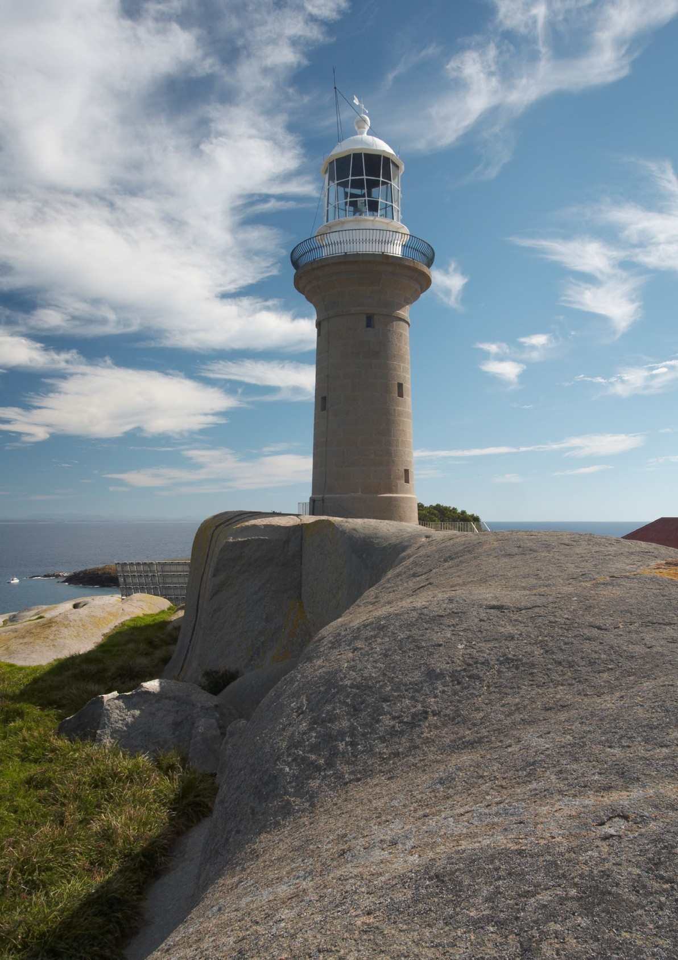

P191004