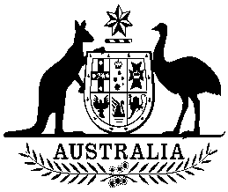
Commonwealth of Australia

Amendment to the list of threatened species made under section 178 of the Environment Protection and Biodiversity Conservation Act 1999 (234)

I, GEOFF RICHARDSON, delegate for the Minister for the Environment, under section 184(d) of the Environment Protection and Biodiversity Conservation Act 1999 , amend the list of threatened species (the List) made under section 178 of that Act by:

1) Updating the names of the following species in the List:

Sauropus macranthus to Breynia macrantha
Bruguiera hainesii to Bruguiera x hainesii
Chaeropus ecaudatus to Chaeropus ecaudatus and Chaeropus yirratji
Oligosoma lichenigera to Oligosoma lichenigerum
Petrogale lateralis MacDonnell Ranges race to Petrogale lateralis centralis

This instrument commences the day after registration.

Geoff Richardson
…….................……………………….………........………

Delegate for the Minister for the Environment

Dated ……………..4 December 2020……

