

Consumer Goods (Button/Coin Batteries) Information Standard 2020

I, Michael Sukkar, Minister for Housing and Assistant Treasurer, make the following information standard.

Dated 18 December 2020

Michael Sukkar

Minister for Housing and Assistant Treasurer

Contents

Part 1—Preliminary 1

1 Name 1

2 Commencement 1

3 Authority 1

4 Definitions 1

5 Meaning of *internationally recognised “keep out of reach of children” symbol* 2

6 Meaning of *internationally recognised safety alert symbol* 2

7 Application 3

Part 2—Requirements 4

8 Requirements to be complied with on and after application day 4

9 Warnings required on packaging of button/coin batteries 4

10 Warnings must comply with size, legibility and durability standards 5

11 Certain lithium button/coin batteries must be marked with internationally recognised “keep out of reach of children” symbol 5

Part 3—Recommendations 6

12 Purpose of this Part 6

13 Button/coin batteries should be marked with internationally recognised “keep out of reach of children” symbol 6

14 Button/coin batteries supplied with electronic platform should include warnings 6

15 Contact information for Australian Poisons Information Centre should be included with button/coin batteries 7

16 Advice about the safe disposal of button/coin batteries should be included with button/coin batteries 7

Part 1—Preliminary

1 Name

This instrument is the *Consumer Goods (Button/Coin Batteries) Information Standard 2020*.

2 Commencement

(1) Each provision of this instrument specified in column 1 of the table commences, or is taken to have commenced, in accordance with column 2 of the table. Any other statement in column 2 has effect according to its terms.

| Commencement information | | |
| --- | --- | --- |
| Column 1 | Column 2 | Column 3 |
| Provisions | Commencement | Date/Details |
| 1. The whole of this instrument | The day after this instrument is registered. | 22 December 2020 |

Note: This table relates only to the provisions of this instrument as originally made. It will not be amended to deal with any later amendments of this instrument.

(2) Any information in column 3 of the table is not part of this instrument. Information may be inserted in this column, or information in it may be edited, in any published version of this instrument.

3 Authority

This instrument is made under subsection 134(1) of the Australian Consumer Law.

Note: The reference to the Australian Consumer Law is a reference to Schedule 2 to the *Competition and Consumer Act 2010* as it applies as a law of the Commonwealth, States and Territories: see section 140K of that Act and corresponding provisions of Acts of States and Territories applying that Schedule.

4 Definitions

In this instrument:

***application day*** means the day after the period of 18 months beginning on the day this instrument commences.

***button/coin battery*** means a small, single cell battery with a diameter greater than the battery’s height.

***Design Principles*** means the International Standard *ISO 3864‑2:2016 Graphical Symbols*—*Safety colours and safety signs*—*Part 2: Design principles for product safety labels*, published by the International Organization for Standardization, as in force or existing at the time when this instrument commences.

Note: The Design Principles could in 2020 be purchased from the International Organization for Standardization’s website (https://www.iso.org). The Australian Competition and Consumer Commission can make a copy of the standard available for viewing at one of its offices, subject to licensing conditions.

***electronic platform*** means a business that allows other businesses to supply goods or services to consumers over the internet (whether by a website, an online marketplace or other means).

***internationally recognised “keep out of reach of children” symbol***: see section 5.

***internationally recognised safety alert symbol***: see section 6.

***lithium button/coin battery*** means a button/coin battery of lithium chemistry.

***non‑lithium button/coin battery*** means a button/coin battery of a chemistry other than lithium.

***Primary Batteries Standard*** means the International Standard *IEC 60086‑4:2019 Primary Batteries—Part 4: Safety of lithium batteries*, published by the International Electrotechnical Commission, as in force or existing at the time when this instrument commences.

Note: The Primary Batteries Standard could in 2020 be purchased from SAI Global’s website (https://www.saiglobal.com). The Australian Competition and Consumer Commission can make a copy of the standard available for viewing at one of its offices, subject to licensing conditions.

5 Meaning of *internationally recognised “keep out of reach of children” symbol*

A suitable example of an ***internationally recognised “keep out of reach of children” symbol*** includes the safety signs set out in figure F.1 of clause F.4 of Annex F of the Primary Batteries Standard.

Note: The following is an example of those safety signs:



6 Meaning of *internationally recognised safety alert symbol*

A suitable example of an ***internationally recognised safety alert symbol*** includes symbol ISO 7010‑W001.

Note 1: ISO 7010‑W001 could in 2020 be found and purchased from the International Organization for Standardization’s website (https://www.iso.org).

Note 2: The following is an example of ISO 7010‑W001:



7 Application

(1) This instrument applies in relation to button/coin batteries.

(2) However, this instrument does not apply in relation to button/coin batteries supplied in bulk if:

(a) the batteries are supplied with the intention to be used in trades, professions or industries; and

(b) the batteries are not intended for sale to the general public.

Part 2—Requirements

8 Requirements to be complied with on and after application day

On and after the application day, a button/coin battery and the packaging of a button/coin battery must comply with the requirements set out in this Part that apply in relation to the battery and the packaging.

9 Warnings required on packaging of button/coin batteries

(1) Thepackaging of a button/coin battery must be marked with a warning that is clearly visible, prominent and legible.

(2) The warning must include the substance of all of the following:

(a) an alert word (such as DANGER, WARNING or CAUTION) with the letters of the alert word in upper case;

(b) a combination of an internationally recognised safety alert symbol and an internationally recognised “keep out of reach of children” symbol;

(c) a statement to the effect that the battery is hazardous and is to be kept away from children (whether the battery is new or used);

(d) if the battery is a lithium button/coin battery—a statement to the effect that the battery can cause severe or fatal injuries in 2 hours or less if it is swallowed or placed inside any part of the body;

(e) if the battery is a non‑lithium button/coin battery—a statement to the effect that the battery can cause serious injuries if it is swallowed or placed inside any part of the body;

(f) advice to the effect that medical attention should be sought immediately if it is suspected the battery has been swallowed or placed inside any part of the body.

(3) Without limiting where the warning is marked on the packaging, the warning may be marked on the packaging by:

(a) if there is sufficient space, marking all the matters specified in subsection (2) on the front of the packaging; or

(b) if there is insufficient space, marking the packaging as follows:

(i) marking the front with the matters specified in paragraphs (2)(a) to (c);

(ii) marking the other matters specified in subsection (2) elsewhere on the packaging.

(4) A warning on the packaging of a lithium button/coin battery includes the matters specified in subsection (2) if the warning is in the form specified in figure 9 of clause 7.2 of the Primary Batteries Standard.

Note: The following is a reproduction of figure 9 of clause 7.2 of the Primary Batteries Standard:

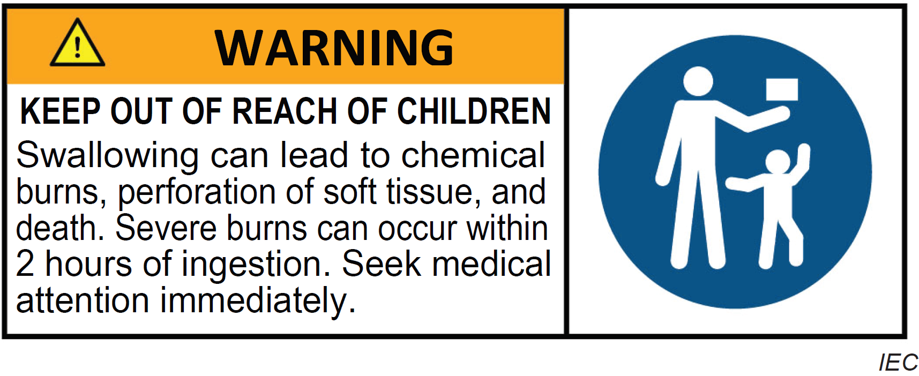

10 Warnings must comply with size, legibility and durability standards

A warning on the packaging of a button/coin battery that is required under this Part must comply with the following:

(a) clause D.5 (size and legibility of product safety labels) of Annex D of the Design Principles;

(b) clause D.7 (durability of product safety labels) of that Annex.

11 Certain lithium button/coin batteries must be marked with internationally recognised “keep out of reach of children” symbol

(1) This section applies if a button/coin battery is a lithium button/coin battery with a diameter of 20mm or more.

(2) The battery must be marked with an internationally recognised “keep out of reach of children” symbol that:

(a) has a diameter of at least 6mm; and

(b) is clearly visible, prominent and indelible.

Part 3—Recommendations

12 Purpose of this Part

(1) The purpose of this Part is to set out recommendations in relation to button/coin batteries.

(2) To avoid doubt, a person does not contravene this instrument if:

(a) the person supplies, or offers for supply, a button/coin battery that does not comply with this Part; or

(b) the person manufactures, possesses or has control of a button/coin battery that does not comply with this Part.

13 Button/coin batteries should be marked with internationally recognised “keep out of reach of children” symbol

(1) If there is sufficient space, a button/coin battery should be marked with an internationally recognised “keep out of reach of children” symbol that:

(a) has a diameter of at least 6mm; and

(b) is clearly visible, prominent and indelible.

(2) This section is subject to the requirement in section 11.

14 Button/coin batteries supplied with electronic platform should include warnings

(1) If a person conducts a business with an electronic platform to supply button/coin batteries, the person should cause a warning about the batteries to be included in the batteries’ description provided by the platform that is clearly visible, prominent and legible.

(2) The warning should include the substance of all of the following matters:

(a) an alert word (such as DANGER, WARNING or CAUTION) with the letters of the alert word in upper case;

(b) an internationally recognised safety alert symbol;

(c) a statement to the effect that the battery is hazardous and is to be kept away from children (whether the battery is new or used);

(d) if the battery is a lithium button/coin battery—a statement to the effect that the battery can cause severe or fatal injuries in 2 hours or less if it is swallowed or placed inside any part of the body;

(e) if the battery is a non‑lithium button/coin battery—a statement to the effect that the battery can cause serious injuries if it is swallowed or placed inside any part of the body;

(f) advice to the effect that medical attention should be sought immediately if it is suspected the battery has been swallowed or placed inside any part of the body.

15 Contact information for Australian Poisons Information Centre should be included with button/coin batteries

A button/coin battery shouldbe supplied with a warning on the battery’s packaging that:

(a) is clearly visible, prominent and legible; and

(b) advises to the effect that, if it is suspected the battery has been swallowed or placed inside any part of the body, a person should contact the Australian Poisons Information Centre immediately for 24/7 fast, expert advice; and

(c) includes the phone number for the Australian Poisons Information Centre.

16 Advice about the safe disposal of button/coin batteries should be included with button/coin batteries

A button/coin battery should be supplied with advice on the battery’s packaging that is clearly visible, prominent and legible about how to safely dispose of the battery.