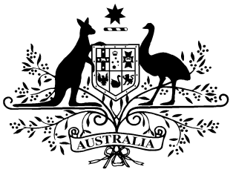

**National Health (Supplies of out-patient medication) Amendment Determination 2020**

**PB 132 of 2020**

___________________________________________________________________________

I, Caroline Turnour, Acting Assistant Secretary, Pricing and PBS Policy Branch, Technology Assessment and Access Division, Department of Health, delegate of the Minister for Health, make the following determination*.*

Dated 21 December 2020

Caroline Turnour

Acting Assistant Secretary

Pricing and PBS Policy Branch

Technology Assessment and Access Division

Department of Health

___________________________________________________________________________

Contents

1 Name 1

2 Commencement 1

3 Authority 1

4 Schedules 1

Schedule 1—Amendments 2

National Health (Supplies of out-patient medication) Determination 2019 (No. 2) 2

1 Name

This instrument is the *National Health (Supplies of out-patient medication) Amendment Determination 2020.*

This instrument may also be cited as PB 132 of 2020.

2 Commencement

1. Each provision of this instrument specified in column 1 of the table commences, or is taken to have commenced, in accordance with column 2 of the table. Any other statement in column 2 has effect according to its terms.

| Commencement information | | |
| --- | --- | --- |
| Column 1 | Column 2 | Column 3 |
| Provisions | Commencement | Date/Details |
| 1. The whole of this instrument | 1 January 2021. |  |

Note: This table relates only to the provisions of this instrument as originally made. It will not be amended to deal with any later amendments of this instrument.

(2) Any information in column 3 of the table is not part of this instrument. Information may be inserted in this column, or information in it may be edited, in any published version of this instrument.

3 Authority

This instrument is made under section 84BA of the *National Health Act 1953*.

4 Schedules

Each instrument that is specified in a Schedule to this instrument is amended or repealed as set out in the applicable items in the Schedule concerned, and any other item in a Schedule to this instrument has effect according to its terms.

Schedule 1—Amendments

National Health (Supplies of out-patient medication) Determination 2019 (No. 2)

1 Section 8(1)

Repeal the paragraph, substitute:

1. The maximum value of the supply of out-patient medication to a person who is a general patient and who is not the holder of a concession card is $33.00.