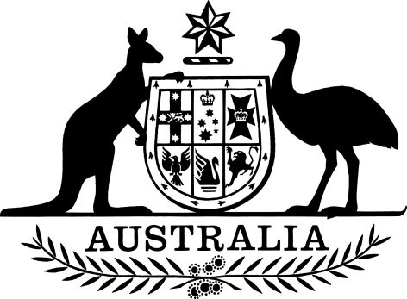

Road Vehicle Standards Rules Commencement Instrument (No. 1 of 2020)
I, Michael McCormack, Deputy Prime Minister and Minister for Infrastructure, Transport and Regional Development, do the following:
1. Acting under item 4 of the table in subsection 2(1) of the Road Vehicle Standard Rules 2019, fix the commencement date for sections 53 to 54 of those Rules as
6 May 2020.
2. Acting under item 7 of the table in subsection 2(1) of Road Vehicle Standards Rules 2019, fix the commencement date for sections 108 to 124 of those Rules as
6 May 2020.
3. Acting under item 11 of the table in subsection 2(1) of Road Vehicle Standards Rules 2019, fix the commencement date for sections 189 to 202 of those Rules as
6 May 2020.
4. Acting under item 13 of the table in subsection 2(1) of Road Vehicle Standards Rules 2019, fix the commencement date for sections 221 to 232 of those Rules as
6 May 2020.
5. Acting under item 15 of the table in subsection 2(1) of Road Vehicle Standards Rules 2019, fix the commencement date for sections 234, 235 and 237 to 253 of those Rules as 6 May 2020.
6. Acting under item 15 of the table in subsection 2(1) of Road Vehicle Standards Rules 2019, fix the commencement date for section 236 of those Rules as
4 May 2020.
Dated 23/4/2020
Michael McCormack
Deputy Prime Minister and Minister for Infrastructure, Transport and Regional Development

