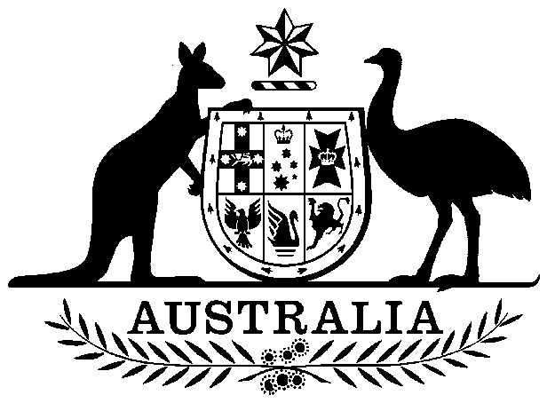

**COMMONWEALTH OF AUSTRALIA**

*Environment Protection and Biodiversity Conservation Act 1999*

**DECLARATION OF AN APPROVED WILDLIFE TRADE OPERATION FOR THE HARVEST AND COMMERCIAL EXPORT OF WALLABY PRODUCTS   
FROM TASMANIA**

I, SUSSAN LEY, Minister for the Environment:

(a) having noted that no public comments were received in response to an invitation under section 303FR(1) of the *Environment Protection and Biodiversity Conservation Act 1999* (Cth) (EPBC Act); and

(b) being satisfied as to those matters set out in section 303FN of the EPBC Act,

declare that the *Wildlife Trade Operation for the Harvest and Commercial Export of Wallaby Products from Tasmania* (the operation) is an **approved wildlife trade operation** for the purposes of section 303FN of the EPBC Act.

Unless amended or revoked, this declaration has effect subject to the following conditions applied under section 303FT:

1. The wildlife trade operation is valid for three years from its date of registration on the Federal Register of Legislation.
2. The wildlife trade operation relates to the processing of meat, skins and fur (fibre) only from Bennett's Wallaby *(Macropus rufogriseus)* and Tasmanian Pademelon *(Thylogale billardierii).*
3. An annual report must be submitted to Wildlife Trade Assessments, Department of Agriculture, Water and the Environment by 30 April each year. The annual report will cover the preceding calendar year.
4. The harvest referred to must be carried out in accordance with the *Wildlife Trade Operation for the Harvest and Commercial Export of Wallaby Products from Tasmania.*

Dated this …12th..…. day of ……May…….. 2020

………Sussan Ley……….

Minister for the Environment