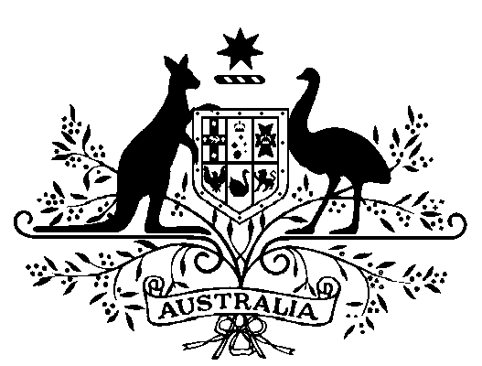

Auditing and Assurance Standards Board — Appointment of Acting Chair

*Australian Securities and Investments Commission Act 2001*

I, Michael Sukkar, Minister for Housing and Assistant Treasurer, acting under subsection 236H(1) of the *Australian Securities and Investments Commission Act 2001*, appoint William Edge to act as Chair of the Auditing and Assurance Standards Board for a period of 3 months commencing on 1 January 2021.

Under the subparagraph 33A(1)(b)(i) of the *Acts Interpretation Act 1901*, I determine the terms and conditions of this appointment (including remuneration, allowances and leave) to be the same as the terms and conditions that apply, as at the date of this appointment, to a member of the AUASB under section 236FA of the *Australian Securities and Investments Commission Act 2001*. I further determine under subparagraph 33A(1)(b)(i) that this appointment is on a part-time basis.

Dated 17 December 2020

Michael Sukkar

Minister for Housing  
Assistant Treasurer