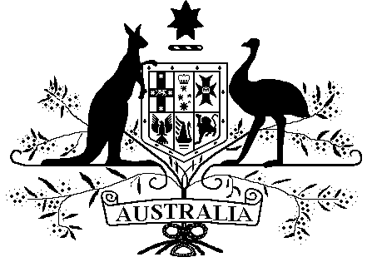

*Veterans’ Entitlements Act 1986*

**Veterans’ Entitlements (Exempt Lump Sum –Payments of compensation by the Scottish Government from the Advance Payment Scheme) Determination 2021**

Instrument 2021 No. R2

I, Simon Hill, delegate of the Repatriation Commission, make the following determination under paragraph 5H(12)(c) of the *Veterans’ Entitlements Act 1986*.

Dated this 3rd day of February 2021

Simon Hill

**Simon Hill**

Assistant Secretary,

Policy Development Branch**1 Name**

This determination is the *Veterans’ Entitlements (Exempt Lump Sum – Payments of compensation by the Scottish Government from the Advance Payment Scheme) Determination 2021.*

**2 Commencement**

This determination is taken to have commenced on 25 April 2019.

**3 Authority**

This determination is made under paragraph 5H(12)(c) of the *Veterans’ Entitlements Act 1986*.

**4 Definitions**

In this determination:

***“income support supplement”*** means the payment called the income support supplement payable under Part IIIA of the *Veterans’ Entitlements Act 1986*.

**“*compensation payment from the Advance Payment Scheme on behalf of the Scottish Government*”** means a payment of compensation from the Advance Payment Scheme made by the Scottish Government to individuals who have suffered abuse as children while in care in Scotland prior to December 2004.

***“service pension”*** has the same meaning as it has in subsection 5Q(1) of the *Veterans’ Entitlements Act 1986*.

***“veteran payment”*** means the payment called the veteran payment payable under an instrument made under section 45SB of the *Veterans’ Entitlements Act 1986*.

**5 Exempt lump sum**

If:

1. a person or a person’s partner receives a *compensation payment from the Advance Payment Scheme on behalf of the Scottish Government*; and
2. the person is eligible for, or in receipt of:
3. an *income support supplement*; or
4. a *service pension*; or
5. a *veteran payment*;

then, the amount of the *compensation payment from the Advance Payment Scheme on behalf of the Scottish Government* received by the person or the person’s partner is an exempt lump sum.