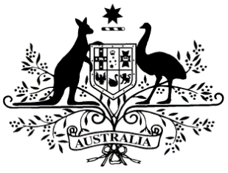

**PB 15 of 2021**

**National Health (Commonwealth Price and Conditions for Commonwealth Payments for Supply of Pharmaceutical Benefits) Amendment Determination 2021 (No. 1)**

*National Health Act 1953*

___________________________________________________________________________

I, THEA CONNOLLY, Assistant Secretary, Pricing and PBS Policy Branch, Technology Assessment and Access Division, Department of Health, delegate of the Minister for Health and Aged Care, make this Instrument under paragraph 98C(1) of the   
*National Health Act 1953*.

Dated 24 February 2021

**THEA CONNOLLY**

Assistant Secretary

Pricing and PBS Policy Branch

Technology Assessment and Access Division

Department of Health

___________________________________________________________________________

1. **Name of Instrument**
2. This Instrument is the *National Health (Commonwealth Price and Conditions for Commonwealth Payments for Supply of Pharmaceutical Benefits) Amendment Determination 2021 (No. 1)*.
3. This Instrument may also be cited as PB 15 of 2021.
4. **Commencement**

This Instrument commences on 1 March 2021.

1. **Amendments to *National Health (Commonwealth Price and Conditions for Commonwealth Payments for Supply of Pharmaceutical Benefits) Determination 2019***

Schedule 1 amends the *National Health (Commonwealth Price and Conditions for Commonwealth Payments for Supply of Pharmaceutical Benefits) Determination 2019*.

**Schedule 1 Amendments**

1. Schedule 4, entry for Desmopressin

insert as first entry:

|  |  |
| --- | --- |
| Desmopressin | Nasal spray (pump pack) containing desmopressin acetate 10 micrograms per actuation, 50 actuations, 5 mL |

1. Schedule 4, after entry for Ketoconazole in the form Cream 20 mg per g, 30 g

insert:

|  |  |
| --- | --- |
| Ketoconazole | Shampoo 10 mg per g, 100 mL |

1. Schedule 4, after entry for Oxybutynin

insert:

|  |  |
| --- | --- |
| Ozanimod | Pack containing 4 capsules 230 micrograms and 3 capsules 460 micrograms |