Aboriginal and Torres Strait Islander Heritage Protection (Wahluu Mount Panorama Site) Emergency Declaration 2021
I, SUSSAN LEY, Minister for the Environment, make the following Emergency Declaration.
Dated 5th March 2021
SUSSAN LEY
Minister for the Environment

Contents
1 Name 3
2 Commencement 3
3 Authority 3
4 Definitions 3

Part 1 - Preliminary matters
- Name

This instrument is the Aboriginal and Torres Strait Islander Heritage Protection (Wahluu Mount Panorama Site) Emergency Declaration 2021.
- Commencement

This instrument commences on the day after registration.
- Authority

This instrument is made under section 9 of the Aboriginal and Torres Strait Islander Heritage Protection Act 1984.
- Definitions

Act means the Aboriginal and Torres Strait Islander Heritage Protection Act 1984.

specified area means the area described in part 2, section 1 of this instrument.

Part 2 - Declaration of an area as a significant Aboriginal area to be preserved and protected from injury or desecration
- Specified area

For the purposes of subsection 9(1) of the Act, the specified area to which this declaration applies is an area on Wahluu Mount Panorama in Bathurst in New South Wales, indicated as the ‘Section 9 Specified Area’ in the map below.

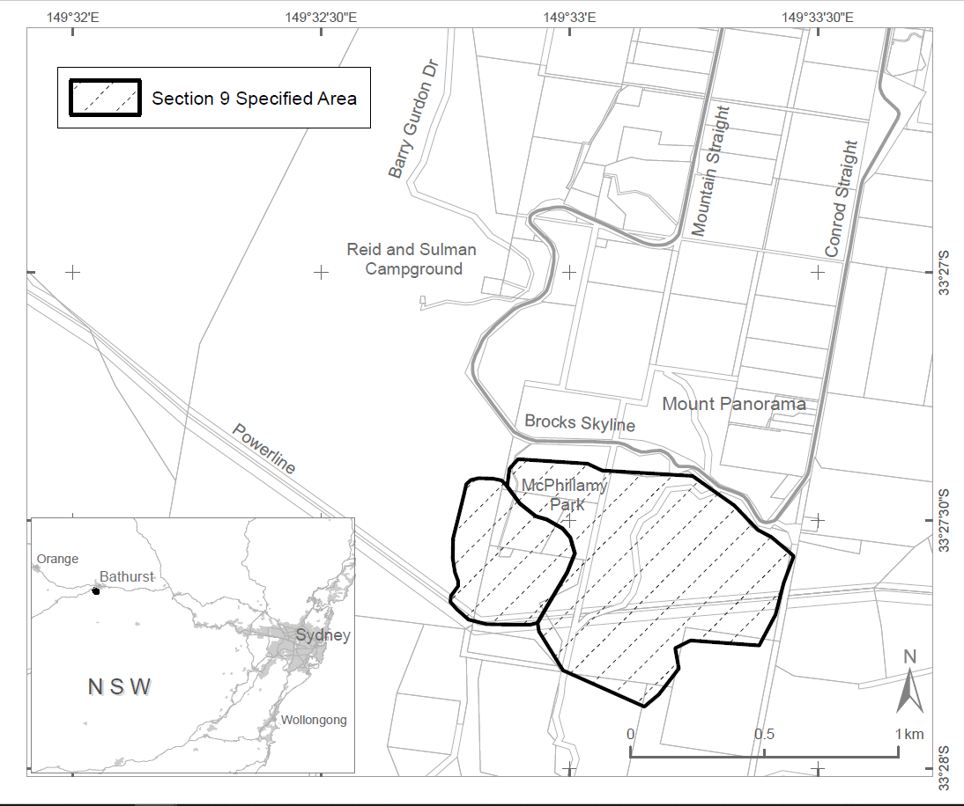
- Declaration
    - Under section 9 of the Act the specified area is to be preserved and protected from injury or desecration in the manner specified in the following paragraphs (b) and (c).
    - A person must not:
      - undertake any action that will, or is likely to, adversely affect the use or significance of the specified area in accordance with Aboriginal tradition.
      - conduct any clearing activities, preliminary activities associated with clearing, or any other act that will, or is likely to, injure or desecrate the specified area.

Note: Under subsection 22(1) of the Act, a person commits an offence if the person engages in conduct that contravenes a provision of a declaration made under Part II of the Act in relation to a significant Aboriginal area.

Penalty: (a) if the person is a natural person - imprisonment for 5 years or 100 penalty units, or both; or

(b) if the person is a body corporate - 500 penalty units.
    - Without limiting subsection (b), a person must not undertake any action that will, or is likely to, directly threaten the topography of the specified area.
- Period of effect

This instrument has effect for 30 days beginning on the date this instrument commences.
- Repeal

This instrument is repealed the day after the end of the period specified in part 2, section 3 of this instrument.

