

**Food Standards (Application A1175 – Rapeseed protein isolate as a novel food) Variation**

The Board of Food Standards Australia New Zealand gives notice of the making of this variation under section 92 of the *Food Standards Australia New Zealand Act 1991*. The variation commences on the date specified in clause 3 of the variation.

Dated 19 March 2021

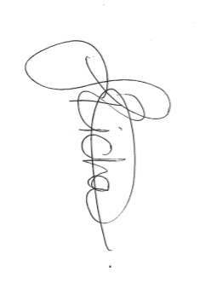

Joanna Richards

Standards Management Officer

Delegate of the Board of Food Standards Australia New Zealand

**Note:**

This variation will be published in the Commonwealth of Australia Gazette No. FSC 139 on 26 March 2021 This means that this date is the gazettal date for the purposes of clause 3 of the variation.

**1 Name**

This instrument is the *Food Standards (Application A1175 – Rapeseed protein isolate as a novel food) Variation*.

2 Variation to standards in the *Australia New Zealand Food Standards Code*

The Schedule varies Standards in the *Australia New Zealand Food Standards Code*.

3 Commencement

The variation commences on 30 June 2021.

**Schedule**

**[1] Schedule 3** is varied by

[1.1] inserting the following row into the table to S3—2(2), in alphabetical order –

|  |  |
| --- | --- |
| rapeseed protein isolate | section S3—40 |

[1.2] inserting after section S3—39

S3—40 Specification for rapeseed protein isolate

For rapeseed protein isolate, the specifications are the following:

(a) Composition:

(i) Total protein (%) – no less than 90; and

(ii) Carbohydrates (%) – no more than 7; and

(iii) Fat (%) – no more than 5; and

(iv) Ash (%) – no more than 5; and

(v) Moisture (%) – no more than 7;

(b) Purity:

(i) Glucosinolates (μmol/g) – no more than 1;

(ii) Erucic acid (%) – no more than 0.005;

(iii) Phytates (% w/w) – no more than 1.5;

(c) Metals:

(i) Lead (mg/kg) – no more than 0.5;

(d) Microbiological:

(i) Total plate count (cfu/g) no more than 10,000; and

(ii) *E. coli* (cfu/10g) absent; and

(iii) *Salmonella* spp. (cfu/25g) absent; and

(iv) Yeasts and moulds (cfu/g) less than 100.

**[2] Schedule 25** is varied by inserting into the table to section S25—2, in alphabetical order

|  |  |
| --- | --- |
| Rapeseed protein isolate | 1. Must be derived from rapeseed press cake retained after oil pressing from the seeds of one or more of:  (a) *Brassica napus*;  (b) *Brassica rapa*; or  (c) *Brassica juncea.*  2. Must not be added to:  (a) infant formula products; and  (b) food for infants.  3. Must comply with the specifications for rapeseed protein isolate listed in section S3—40. |
|  |  |