Aboriginal and Torres Strait Islander Heritage Protection (Wahluu Mount Panorama Site) Declaration 2021
_________________________________________________________________
I, SUSSAN LEY, Minister for the Environment, make the following declaration under subsection 10(1) of the Aboriginal and Torres Strait Islander Heritage Protection Act 1984.
Dated 30th April 2021

SUSSAN LEY
Minister for the Environment
_________________________________________________________________

Contents
1 Name 3
2 Commencement 3
3 Authority 3
4 Definitions 3

Part 1 - Preliminary matters
- Name

This instrument is the Aboriginal and Torres Strait Islander Heritage Protection (Wahluu Mount Panorama Site) Declaration 2021.
- Commencement

This instrument commences on 5 May 2021.
- Authority

This instrument is made under section 10 of the Aboriginal and Torres Strait Islander Heritage Protection Act 1984.
- Definitions

Act means the Aboriginal and Torres Strait Islander Heritage Protection Act 1984 (Cth).

Bulk earthworks means the excavation or other movement of large quantities of soil or rock with the intent or effect of changing the level or elevation of an area of land.

Clearing of vegetation means the removal by any means of groups of trees, shrubs or other vegetation for the purpose of establishing a cleared area, but does not include targeted maintenance or removal of individual plants.

Declared area means the area described in Part 2, section 5 of this instrument.

Part 2 - Declaration of an area as a significant Aboriginal area to be preserved and protected from injury or desecration.
- Declared area

For the purposes of subsection 10(1) of the Act, the specified area to which this declaration applies is an area on Wahluu / Mount Panorama in Bathurst in New South Wales, indicated as the “declared area” in the map below.

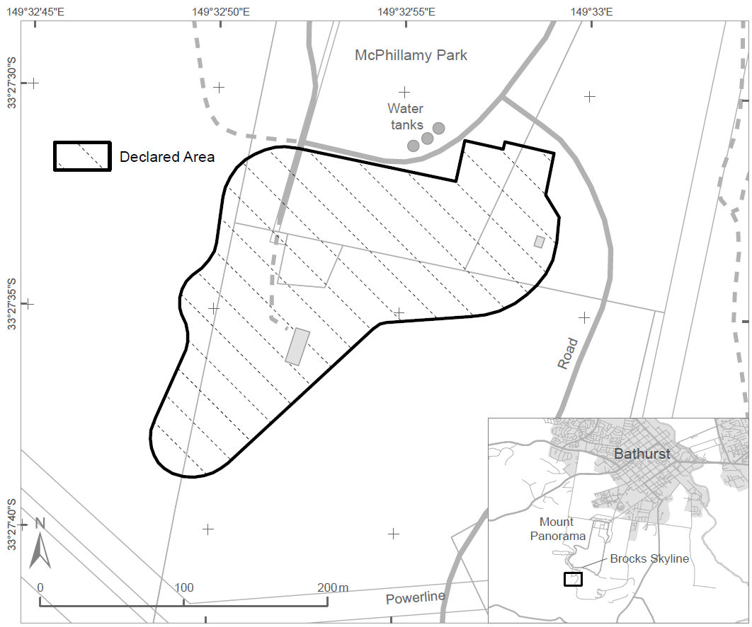

- Declaration
- For the purposes of section 10 of the Act, the declared area is a significant Aboriginal area that is to be preserved and protected from injury and desecration in the manner specified in subsection (2).
- A person must not:
  - undertake any clearing of vegetation within the declared area; or
  - undertake any bulk earthworks within the declared area; or
  - construct any buildings on the declared area or seal any part of the declared area, including with bitumen or concrete; or
  - undertake any action that will, or is likely to, directly alter the topography or landform of the declared area.

Note: Under subsection 22(1) of the Act, a person commits an offence if the person engages in conduct that contravenes a provision of a declaration made under Part II of the Act in relation to a significant Aboriginal area.

Penalty: (a) if the person is a natural person - imprisonment for 5 years or 100 penalty units, or both; or

(b) if the person is a body corporate - 500 penalty units.
- For the avoidance of doubt, subsection (2) does not prohibit the following in relation to the declared area:
  - enjoyment of a lawful right of access to or use of land within the declared area;
  - use of the declared area as a campsite;
  - use the declared area otherwise as a public open space; and
  - any activities necessary to maintain safety consistent with use as public open space,

so long as the use, access or activities do not involve any of the activities mentioned in subsection (2).
- Period of effect

This instrument has effect for 10 years beginning on the date this instrument commences.

